

Holton Township Comprehensive Land Use Plan Update

September 2006



WEST MICHIGAN SHORELINE
REGIONAL DEVELOPMENT COMMISSION
(WMSRDC)

The WMSRDC is a regional council of governments representing 127 local governments in the West Michigan counties of Lake, Mason, Muskegon, Newaygo, Oceana, and northern Ottawa.

The mission of WMSRDC is to promote and foster regional development in West Michigan… through cooperation amongst local governments.

Rillastine Wilkins, Chairperson
Evelyn Kolbe, Vice-Chairperson
Rosswell Fulton Jr., Secretary

Sandeep Dey, Executive Director

Project Staff:

Erin Kuhn, Senior Planner
Table of Contents

- Introduction 1
Purpose of the Plan 1
Legal Basis 1
The Planning Process 2
How to Use this Plan 2
The Land Use Plan’s Relationship with Zoning 2

- Location and Setting 4
Regional Location 4
Community History 5

- Natural Resources and the Environment 14
Soils and Topography 14
Septic Suitability 16
Climate 17
Water Resources 18
Agriculture and Woodlands 21
Other Natural Resources 22

- Community Characteristics 23
Community Profile 23
Population Trends 23
Age & Gender 24
Households 25
Racial Composition 26
Income and Poverty 27
Educational Levels 28
Labor Force Composition 29
Economic Outlook 30
Unemployment 32
Community Facilities and Services 33
Township Government 33
Transportation 35
Parks & Recreation 36
Fire & Police 37
Schools 37
Other Public/Quasi Public Facilities 37

- Existing Land Uses 38
Existing Land Use and Land Cover 38

- Development Strategy 39
Township Visions and Goals 39

- Implementation 47
Future Land Use 47
Future Land Use Categories 48
Future Land Use Map 51
Planning Implementation Tools and Techniques 53
Public Involvement 54

- Conclusion 55

Bibliography 56

Appendix A 57

Tables/Graphs/Maps

Table 1: Limitations of Soils 17
Table 2: Population Trends and Projections 23
Table 3: Age Distribution 24
Table 4: Gender Distribution 25
Table 5: Housing Occupancy 25
Table 6: Ethnicity 26
Table 7: Income 27
Table 8: Household Income Distribution 27
Table 9: Educational Attainment 28
Table 10: Area Industry 29
Table 11: Class of Workers 30
Table 12: Employment by Sector 30
Table 13: Economic Projections 31
Table 14: Labor Force 32
Table 15: Holton Township Budget 34

Graph 1: Year Housing Units Built 26
Graph 2: Poverty Status 28
Graph 3: Unemployment Rates 32

Map 1: Regional Location 4
Map 2: Topography 15
Map 3: Water Features 20
Map 4: Transportation 35
Map 5: Parks and Recreation 36
Map 6: Land Use and Cover 38
Map 7: Future Land Use Map 51
Map 8: Future Land Use Map (more densely population portion) 52
- INTRODUCTION

Purpose of the Plan

This plan is intended to be a policy plan to guide future township actions and decisions. It is not intended to establish precise boundaries of land use areas or exact locations of future types of developments. Its function is to guide growth toward long-range, broad-based goals.

The goal of any comprehensive plan is to combine the needs and desires of the citizenry with the land’s suitability and capability for sustaining those uses, according to the ability and desire of the municipality to provide public services throughout its jurisdiction. Such planning will minimize the potential for land use conflicts and inappropriate uses of land, for the betterment of all residents.

Legal Basis

Although this plan is enabled by Michigan law, it does not have the force of statutory law or ordinance. Its foundation is rooted in the Rural Township Planning Act (Act 168 of the Public Acts of 1959), which states, in part, that:

Sec. 3. (1). The township board of any township may create, by resolution, a township planning commission with power to make, adopt, extend, add to or otherwise amend, and to carry out plans for the unincorporated portions of the township…

Sec. 2. The purpose of plans prepared pursuant to this act shall be to promote public health, safety and general welfare; to encourage the use of resources in accordance with their character and adaptability; to avoid the overcrowding of land by buildings or people; to lessen congestion on public roads and streets; to facilitate provision for a system of transportation, sewage disposal, safe and adequate water supply, recreation and other public improvements; and to consider the character of each township and its suitability for particular uses judged in terms of such factors as the trend in land and population development.

A plan comprehensive enough to meet this requirement must begin with an analysis of the township’s existing conditions, facilities, natural resources, population characteristics, economy, and land uses. Where appropriate, historical trends were analyzed to assist in making predictions of the future.

The Planning Process

In early 2005, Holton Township contracted with the West Michigan Shoreline Regional Development Commission to assist in the update of the 1992 Land Use Plan. Every effort has been made to present information that is both current and accurate. The Holton Township Board, the Holton Township Planning Commission, and the West Michigan Shoreline Regional Development Commission shall not be held liable for any errors and/or omissions that are related to this Plan. This Plan is a general document; therefore, a thorough investigation with original research materials should be undertaken before proceeding with any specific implementation decisions.

Citizen input is paramount in identifying and discerning the issues facing Township residents as a whole. Therefore, all citizens were invited and encouraged to take part, as well as the bordering municipalities. The opportunity for input and comments was provided through Planning Commission meetings, a special meeting held by the Planning Commission, and a public hearing. Notices of these meetings were published in the Muskegon Chronicle (the local area newspaper).

The goals and objectives set forth in this Plan for the Township should be reviewed on a regular basis. When appropriate, the Land Use Plan should be modified to reflect changes of a physical nature or those of general public sentiment. By new legislation, the Land Use Plan must be consistent in maintaining the community’s goals. The planning process strives to combine the needs and desires of the citizenry with the land’s suitability and capability for sustaining those uses. It also balances the Township’s ability and desire to provide public services throughout its jurisdiction.

How to Use this Plan

The Holton Township Comprehensive Development Plan is intended to function as a guide for directing and managing development within the township boundaries. This plan is not a zoning ordinance, which is a legally enforceable document. This plan is a policy-planning document that provides a legal rationale for zoning. It presents a written analysis of the township’s physical and social characteristics, as well as visions and goals for future development. In addition, implementation strategies are identified and are intended to guide policy makers towards accomplishing the established visions and goals of the Holton Township Comprehensive Development Plan. Any development decisions for the township should be based on the data and information presented in this plan, and be consistent with the established visions and goals.

The Land Use Plan’s Relationship with Zoning

Following is an excerpt from the Crystal Township (Oceana County) 2004 Comprehensive Land Use Plan which demonstrates the relationship between a Land Use Plan and Zoning Ordinance and Map.

While most understand that there is a relationship between a land use plan (with its land use map) and a zoning ordinance (with its zoning map), it is often misinterpreted and used inappropriately. The relationship is a very important one, because you can not utilize one without having the other. A formal definition of a land use plan is simply that it is a policy document in which the zoning ordinance(s) is/are a regulatory tool that is used to implement the goals and objectives of the land use plan. In other words, the land use plan and map are designed to provide the community with a glimpse of where they desire their community to head, and a zoning ordinance and map provides the means to arrive at this point.

The primary difference between a future land use plan and a zoning ordinance is a familiar one. Changes to a zoning ordinance or zoning map are the primary tools available to change the regulations affecting land or the types of use land may be used for. The land use plan and map are used to guide the process of changing land uses. In other words, the future land use plan and map will be utilized to regulate what zoning changes will occur and where they will occur. For example, rezoning requests are often required to be consistent with the future land use plan’s designations as they identify the community’s desires for their future.

Effective December 15th, 2002, it is mandatory that all municipalities and counties have a Land Use Plan in effect. Also, any amendments to a community’s plan must be submitted, for review and comment, to all bordering jurisdictions and the acting regional planning commission, if applicable. The comments derived from those then must be submitted to the County where they are reviewed and a final comment is made on the changes to the plan and is then submitted back to the originating municipality. While presently these comments have no regulatory implications, it is the first step in working towards a collaborative effort amongst bordering municipalities encouraging similar land uses on adjacent parcels.

- LOCATION AND SETTING

Regional Location

Holton Township is located in the Northeast corner of Muskegon County. The county is on the shores of Lake Michigan approximately halfway between Traverse City and the Michigan/Indiana border.

Holton Township is bordered by Greenwood Township, Oceana County, to the north; Sheridan Township, Newaygo County, to the east; and Cedar Creek Township and Blue Lake Township, Muskegon County, to the south and west respectively. The county seat is the City of Muskegon which is located approximately 22 miles to the southwest.

Map #1
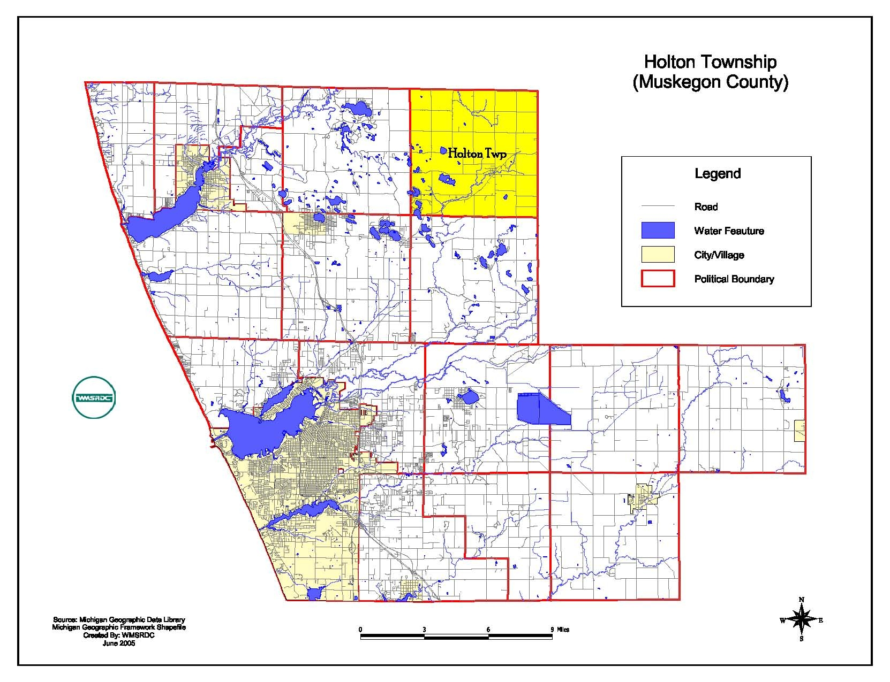

Community History

A brief history of Holton Township is invaluable to establishing the chronology of its development, both physically and culturally. Encompassing more than 120 years of formally documented development, Holton Township has a rich heritage that has roots in primary occupations such as farming and lumbering. This heritage includes a strong community commitment with a small-town atmosphere which is felt by many to be its greatest asset.

Early Settlers

The Ottawa Indians were the first to settle in the area now known as Holton Township. This was not due to their natural patterns of migration, but because the land had been given to the tribe in partial exchange for lands being settled by whites in the Grand River valley. While the Ottawas did take up residence here, “…the fishing and hunting territory was not to their liking, so they made little attempt to actually take possession of the land (Centennial, page 1).”

The first white settlers in Holton Township were Norman Cunningham and Rufus Skeels, who came to the area in 1855, settling in the northern part, which was then in White River Township. In 1859, two Norwegians named Christian Olson and Tollief Hendrickson came to the territory “direct from the old country (ibid),” thus attracting other Scandinavian people to cluster into a sizable settlement by the mid-1860’s. The seventh generation of Hendricksons live in Holton today.

Harry L. Spooner, in his article published in the “Muskegon Chronicle” in 1926 on the history of Holton Township, summarized Holton’s early settlement troubles:

“Although not as old as some other towns of northern Michigan, this village has an interesting history. That it is not as old as other places in the county is due to the fact that for some time it was an Indian reservation and for even a long time after the red man left for more congenial places, the title to the land could be obtained only after much red tape. Some of the early settlers, after settling on portions of the territory and making considerable headway in clearing and otherwise improving it, were required to give it up by the government and lost what they had paid on it. This chaotic state of affairs is what delayed the real settlement to a later date than some other parts of the county (ibid, page 20).”

Although soils are sandy and ill-suited for farming in many parts of Muskegon County, early settlers were able to search out the best plots of ground and establish a stable farming community. Some settlers planted orchards, which are still a part of Holton Township’s agricultural livelihood.

Holton Becomes A Community

Two entrepreneurs named Blodgett and Byrne were the first to begin building in the community of Holton, purchasing 4,500 acres in 1870 for $15,500, thereby acquiring a wealth of virgin white pines. Their first improvements were to construct a sawmill with a dam on the Cedar Creek just upstream from the present bridge on Main Street. They next build a general store, having to transport their wares from Muskegon over rough roads, and finally platted the village in 1871.

The name of Holton was selected in honor of Muskegon resident Henry H. Holt, who was then the Lieutenant Governor of Michigan. Since the village Holt in present-day Ingham County had already been established, the name was changed slightly to “Holton” to prevent duplication. Holton Township was officially organized on March 23, 1871, as the fourteenth township in Muskegon County.

The Blodgett and Byrne sawmill was reported to be one of the largest in the country during its peak production, but by the early 1880s, all of the salable timber on the 4,500-acre tract had been cut and the mill closed down. Other mills had experienced a similar cycle, records showing a decline from 13 sawmills in 1859 to only eight in 1881.

While these were certainly an economic blow to the community, Holton remained a trade center, as other businesses were becoming established:

“By 1881 the village had risen to a population of around 500 and had a large number of business houses as follows: George E. Allen General Store and Elevator; Rand and Jennings, General Store and Furniture; Thompson Brothers, Wagon and Carriage Shop; William Apel, Boots and Shoes; Charles Tyson, European House; Isaac Cassidy, Blacksmith and Wagon Shop; John Hawkey, Jeweler; Ensing & Son, Boots and Shoes; M. J. Crahen, Wagon and Carriage Shop; William Badeauz, Saloon; James S. Rhodes, Livery and Barber; D. A. McDonell, Drugstore; M. Mumbrae, Photography; Mrs. M. Mumbrae, Millinery; and Edward Vaughn, Harness Shop (ib9d, page 15).”

Following the lumbermen came an influx of farmers to settle the now-cleared land, assisted by the completion of the railroad to the area in 1872. This spawned the establishment of two shingle mills, a brickyard, a grist mill, and a creamery. Unfortunately, due to normal aging and fires, few of these buildings stand today, the last of them being John Glade’s mercantile, the second store established in Holton, which was finally razed in the early 1940s.

As in all early settlements, fire was a constant hazard:

“During the period of 1890 to 1900, three serious fires hit the community. The first fire was started July 4, 1890 by a firecracker in the townhall. The entire West side of the street was burned. On December 25, 1892, a fire of unknown origin swept through the buildings on the East side of the street. July 19, 1895, another blaze attached the buildings on the East side of Main Street (ibid, page 17).”

Telephone service came to Holton in 1901, and was housed in the Holton Mercantile Company and “used for long-distance calls only (ibid, page 18).” Professional services such as lawyers and physicians came and went with the settlers’ movements. The first bank was established in 1909 as the Holton Savings Bank, but was forced to close in 1937 “due to insufficient business (ibid, page 19).”

The Holton Fire Department was officially organized in 1948 with construction of a new fire barn, which cost $6,000. Prior to that, the community assembled to fight fires when the Methodist Church bell was rung (the bell was donated by Lt. Gov. Holt), or, after 1942, when the new siren was sounded. In the days of the telephone switchboard system, the operator used a special ring code to alert the volunteers of a fire.

Some unusual businesses and activities throughout Holton Township’s history include a fox farm, which was reported to be “recognized as one of the best in the industry (ibid, page 23);” a 2-acre ginseng “garden,” where buyers from New York would come to export the ginseng to China; the “Emma Club,” in which all members must be named, of course, Emma; and the Holton Ground Observer Corps, who manned a Civil Defense airplane spotter tower until the end of the Korean War.

Ethnic and Religious Heritage

While Holton Township is quite homogeneous today, its settlers came from a variety of locations, primarily in western Europe. These immigrants brought with them the family traditions that may still be seen in the Celebrations and everyday lives of their descendants.

An example of this may be seen in a cookbook that was produced by the Holton Evangelical Lutheran church in honor of a family named Trygstad. The Trygstad family established its roots in Holton Township in the 1880s when a newly-married couple emigrated from Norway. In 1885, they established the farm north of Holton where their descendants reside today. Swedish traditions were intermingled in the family through marriage to another immigrant family, and the cookbook relates memories of Christmas suppers consisting of Lutfisk, spare ribs, and Christmas Rice. Other recipes not often seen in American Cookbooks include Swedish Coffee Yerk, Kalvadance, Smalands Kringlar, and Swedish Fruit Soup.

Many Settlers continued their traditions from the old country by establishing churches, which were usually constructed at cooperative work sessions on donated land. Several of Holton Township’s churches in particular have had long, interesting histories, including the Evangelical Lutheran Church, the United Methodist Church, and St. Michael’s Church.

The Holton Evangelical Lutheran Church’s history spans more than 130 years, the congregation having been organized in 1869. The church was first named the Scandinavian Evangelical Lutheran Church by eleven members of the Scandinavian colony that was established in 1864 in the Holton area. A family named Olsen provided land for the cemetery, church, and parsonage, and the first structure was completed in 1881 at a total cost of $500. This building was destroyed by a lighting strike in 1934, and replaced by a wooden church on Brickyard Road in 1938. The church seen today on Marvin Road was completed in 1986.

The Holton United Methodist Church was begun in 1874 as the Holton Methodist Episcopal Church. Its original location was the northeast corner of the Holton-Duck Lake Road and Marvin Road intersection, on land donated by the Blodgett and Byrnes Lumber Company. In 1877, the wooden structure was transported up the hill to the church’s former location on Second Street (Holton-Whitehall Road). A new brick church was built in 1915 there, with the wooden building being once more moved to its final destination on the corner of Main Street and Holton-Whitehall Road. The bell given to the church by then-Lieutenant Governor Holt was placed in the belfry subsequently moved to a new church which is located north of town on Holton Duck Lake Road.

St. Michael’s Church is located on the east side of Maple Island Road in the community of Brunswick, Newaygo County. Holton citizens figure prominently in its history. In 1885, the “Station County Line Mission,” a mission of St. Mary’s Church in Big Rapids, was organized and began services in the home of Peter DeMarrs in Newaygo County. The George Koonsman family donated land for a church building which was built and dedicated in 1887 at the current location.

This original structure, a wooden building, was struck by lighting and subsequently torn down, its replacement dedicated in 1953. A parish hall was built first and was used for services until the new stone building was ready. St. Michael’s is the “Mother Church” for Catholic churches in Fremont and Hesperia and operates a Catholic Church School for the three communities. (Source: Catholic Directory of the United Lists of Catholic Missions and Centennial Directory of St. Michael’s Church.)

Centennial Farms

One of the elements of a community that provides stability to it is the large number of families who have resided there for many generations. Holton Township is fortunate to have many families that have resided in the same home for more that 100 years, thereby earning the distinction of being named “Centennial Farms.”

Centennial families include:

Ruben Hayes, Brunswick Road, 1866
Charles and Elizabeth Proctor, Skeels Road, 1869
Gorgen and Karen Sophia Anderson, Marvin at Brickyard Roads, 1872
Mrs. Philemen Monette, Maple Island Road, 1875
Ben and Caroline Svenson, Brunswick Road 1878
Alexander Anderson, Maple Island Road 1881
David W. and Marie Trygstad, Holton-Duck Lake Road, 1882
Olaus and Beret marie Trygstad, Holton-Duck Lake Road, 1884
John and Monica (Wagner) Slater, Raymond Road, 1886
Gust and Marie (Jensen) Holmes, Holton-Duck Lake Road, 1886
Chris and Lena M. Swenson, Swenson Road, 1891

The only family having continuous family ties within the platted area of Holton is the Husted family. Eugene and Julia E. Husted purchased a block of platted lots in 1893 on Ward Street. One of these lots was purchased by Eugene’s son, and a daughter of the son still resides on that lot.

Holton Schools

As in many rural communities, the school system in Holton Township has played a vital role in not only educating children, but in acting as the institution that binds the community together. The first school in Holton Township may have been in Inglehart log cabin school located in Section 26 of the township, which was built and used to teach Lutheran Church students. It is also known that public school sessions were held in 1872 at or near the site of the Catholic Church, which was the DeMars home on Maple Island Road. A private school was available in 1873 in the Methodist Church, where for $1.50 tuition, a student could receive three months of schooling.

During the next year, 1874, school was held in the Methodist Church for “District #5 of the Holton Fractional School District.” At that time, a one-room frame structure was erected on school property on or near the location of the present bus garage. Other schools in the Fractional District were the Brunswick, Bunce, Olson, and School House Lake Schools in Holton Township and such schools as Evans, Maple Grove, McCauum, Ryerson, and a now-nameless school on the corner of Brunswick and Linderman Roads in neighboring communities.

In ten years, another room was added to the one-room schoolhouse for grades one through eight. The current High School was organized in 1916 by four men who were directed by the township board and the residents to establish a high school, as they were “very anxious and interested in educating their children locally instead of sending them on to Fremont and Muskegon (Centennial, page 1). “ Mrs. Cilley, the teacher in the first private school, helped circulate the petition in favor of this proposal.

The first classes were held in the G.A.R. Building (then the Holton Town Hall) located on the northwest corner of Main and Second Streets, led by “a tall, gracious and intelligent lady with an alert and enthusiastic sparkle in her eye (ibid),” Principal Etta Paulson Evans. Mrs. Evans taught English, math, history, science, music, Latin, and agriculture for a starting salary of $80 a month.

While the subjects listed may appear to be similar to those taught in today’s schools, a 1921 Detroit newspaper article illustrates the differences:

“(the school) taught boys advanced methods of farming, and girls baking and other duties of the farm home – among other things the proper diet for baby --- (and that once weekly the students heard an area) practical farmer and a women well versed in the duties of a farmer’s wife…(ibid, page 2).”

This unique curriculum resulted in the school being designated as a “Rural Agriculture High School,” one of only three or four to be so designated in the state. Agricultural classes continued to be a part of the curriculum until the 1970s when declining finances and enrollment in the classes caused their removal from the program. These many decades of agricultural education have strongly contributed to Holton’s continue rural character.

In 1921, the High School year commenced in the Maccabee Hall across the street and as growth continued, using again rooms in the G.A.R. Building and the Martin Building on Main Street. Many changed in the physical facilities have occurred since the first building in 1874. IN 1923, Junior-High students were moved to the G.A.R. Building until 1932, when reunited with the K-8 grades in the new 3-room brick building that was constructed to replace the original schoolhouse.

In 1938-39, a second story was added to accommodate Senior High students in one location. 1939 saw the first graduating class receive their diplomas in the combined school, grades k-12. The current Elementary School complex was begun in 1965 with the last addition and renovation having been made in 2001. The current complex housing the high school students was completed in 1973-74.

With the passage of a bond proposal, a new middle school (grades 5-8) was completed in 2001. The school has now grown to see typical graduating class size of 70-80 students, and has modernized its curriculum and facilities.

Holton Area Centennial, 1971

On August 26-28, 1971, Holton Township residents celebrated their 100th anniversary with both old-fashioned and modern entertainments, culminating many months of work and fund-raising that was probably enjoyed as much as the festival itself!

A ribbon-cutting kickoff was held on April 1st, and participants were solicited for contests such as Centennial Queen, Beard Growing, and Cross-Cut Saw Log Cutting. Fund-raising events held throughout the spring and summer consisted of square dances, a box social, a raffle for a bicycle-built-for-two, a flea market, a bake sale, and a “Miss America Doll Contest,” which featured the male sector of Holton.

The celebration was truly an event that involved the entire community, as school-aged children were recruited to design and paint signs downtown, a boy scout pack had a clean-up day project, and the first day of the 3-day festival was pronounced “Children’s Day.” All events were well-attended, and the cooperation among all ages and sectors of the citizens provided a very successful 100-year celebration.

Civic Activities

Civic involvement is the key to success of any community. When citizens are actively involved in shaping their surroundings and making opportunities for positive things to happen, the entire community benefits. Often, civic groups begin by organizing around some institution that is in place.

Such is the case with the Parent-Teachers Association in Holton Township, which was formally organized in 1933, but informally active for years prior to the. Although affiliation with the national PTA ended in 1977, a local Parent-Teacher Organization is active in the school today.

Another outgrowth of school activity is Holton’s 4-H clubs. Established during the early days of the Holton school system, today’s 4-H leaders keep the agricultural school concept a part of Holton through civic projects and participation in local, county, and state fairs. Other school-centered groups include Boy Scouts, Girl Scouts, Athletic Boosters, and Music Boosters.

Some civic groups center their activities around municipal services provided to the residents. Three examples of this in Holton Township are the Fire Explorer Unit, the Holton Fire Department Auxiliary, and the Friends of the Library. The Fire Explorer Unit is a group of school-age children (age 14 and up) who participate in firefighter and leadership training. This unit, which is the only one of its kind in the area, is an example of the dedication of the firefighters to the community’s youth.

The Holton Fire Department Auxiliary has been in existence for a more than twenty years working together to raise money to support the firefighters. Annual fund raisers are held to provide meals for the firefighters during lengthy fires and to contribute toward purchasing special equipment.

“Friends of the Library” was organized in 1988. As noted by the librarian, “this group has provided the branch with many of the added activities and books otherwise unaffordable to the library of this size (Community Brochure, page 5).” The activities of this group extends far beyond simply buying books: they sponsor a flu shot clinic, provide information on home health care, among other things.

Many communities benefit from the existence of a business association. Although downtown Holton has only a dozen or so stores, their Business and Civic Association now numbers 44 memberships. Business and Civic Association, for the purpose of promoting “the growth and development in Holton for the enrichment of its citizens (Business Directory, page 3).”

This group, which meets monthly, has been the primary impetus for accomplishing a number of things in the Holton area, including the creation of a community brochure designed to attract professional caregivers, development of a memorial park in the downtown area, Town Spring Cleanup Day, Spring Plant Sale, Community Day Ox Roast, McGruff Halloween Bags, and the annual Christmas Program in the Park. Proceeds from these events go towards upkeep of the memorial park, maintaining community welcome signs, general beautification, and Christmas decorations.

One of the Association’s biggest projects was the creation of Severt Swenson Holton Township Park. The site of this park, located in the “heart” of the Holton business community, was formerly an old business that had experienced some fire damage. After the debris was removed and the site leveled, many residents commented that it would be a good location for a park.

Acting upon these comments, the Holton Business and Civic Association decided in November, 1987 to begin by planting a spruce tree in memory of long-time township supervisor Severt Swenson. This was done, and it was decorated that Christmas, beginning an annual community tradition. Plans quickly were implemented the following spring to install a sprinkler system, plan flowers and shrubs, and to do other landscaping. Because of the efforts of many dedicated, civic-minded citizens, the park was dedicated on July 30, 1988, just four months after it was begun.

The community brochure that was written by the Business and Civic Association in the hopes of attracting a doctor, dentist, or pharmacist to the area reflects the positive attitudes of many in the township, from elected officials to community leaders to ordinary citizens. The creation of this booklet illustrates the degree of commitment and drive this membership contributes to the community.

The oldest civic organization in Holton Township is the Holton Ladies Aid Society, which was formed in 1902. Its purpose is to perform Christian charitable work in the community. The two primary projects undertaken each year are the sewing of quilts to be given to fire victims and the preparation and distribution of “Comfort Boxes” to cancer patients for Christmas.

Holton’s agricultural background fostered the existence of the Holton Alumina Grange 585 in the mid-1800’s. Unlike many Michigan granges, the Alumina Grange 585 did not have its own grange hall, but met in a variety of locations, once renting use of a building for $26 a year. Typical grange activities were engaged in, from discussions on agriculture to current political issues.

At one meeting in 1890, it was decided that “Land Plaster” should be purchased to beautify the homes in Holton. The grange apparently then bought “15 tons of it by train car load at $9.80 per ton (Centennial, page 28).” Later that same year, a discussion of state political topics included debates on three questions: “Are you in favor of reducing railroad fare for passengers to two cents a mile? Are you in favor to change the Constitution of this State so that mortgages may be assess as real estate? And are you in favor of Women (sic) Sufferage (sic)?” The Holton Alumina Grange 585 is no longer active in Holton but is fondly remembered by many.

Senior citizens in Holton Township are unified in an association that meets for lunch programs on various topics. Providing activities for this segment of the population is becoming increasingly important in many communities as the average age climbs upward.

One of the most active community groups is the Cobb-Trygstad-Anderson American Legion Post 397. 386 residents are members, plus another 151 auxiliary members and 80 “Sons of American Legion,” representing a sizable portion of the community! The post was established in 1958 and hold nearly a dozen different activities each year (some running weekly), and its members assist those in need in the community through loan of medical supplies, providing luncheons for families after funerals, blood bank donations, and providing an Honor Guard for area events.

The American Legion was instrumental in creating the memorial park at the township cemetery. On land donated by Elizabeth Perysian, a memorial to those serving in our nation’s wars was established in 1972. Many hours of labor were expended by members of the legion to clear and landscape the small area on the southeast side of the cemetery, overlooking M-120.

- NATURAL RESOURCES AND THE ENVIRONMENT

Soils and Topography

The surface features of Holton Township are of glacial origin, consisting of old lake plains, outwash plains, beach ridges, dunes, and glaciated uplands. According to the 1968 Soil Survey of Muskegon County, U.S. Department of Agriculture, Soil Conservation Service, there are several different soil series located in Holton Township. The four most prominent series include the Rubicon Series, Rousseau Series, Nester Series, and Grayling Series.

The largest soil series found in the township is the Rubicon Series which consists of well-drained, deep, sandy soils on the nearly level, dry outwash plain and the rolling sandhills of the county. The original vegetation of this series was white pine, red pine, black oak, and white oak. These soils are permeable, have a low supply of plant nutrients, and are low in available moisture capacity. Rubicon soils are well suited to plantations of Christmas trees and to other forest products.

The Rousseau series consists of well drained and moderately well drained soils. These soils occur in nearly level to gently sloping areas of the lake plain in the eastern part of Holton Township. Mixed hardwoods including black oak and white oak were the dominate native vegetation for this series. Rousseau soils have a rapid permeability and are easily eroded by wind or water. Corn, small grains, and hay are the principal crops grown in this series.

The Nester series consists of well drained and moderately well drained soils. These soils occupy rolling to hilly areas on till plains and moraines. The native vegetation consisted mostly of mixed hardwoods, dominantly sugar maple, beech, and ash. Nester soils make up some of the best cropland in the county. These soils are naturally fertile and have high available moisture capacity and moderately slow permeability.

The Grayling series consists of well-drained sandy soils on the rolling sand hills of the county. The native vegetation consisted of white pine, red pine, aspen, black oak, and white oak. These soils have rapid permeability and their natural fertility and available moisture capacity are low.

Soil series that encompass the entire township and are comprised of a combination of soils also need to be viewed. Table 1 is a brief summary of septic suitability and building site development for these four series.

The elevation in the township ranges from a low of 689 feet above sea level in section 19 near Pine Island Lake to 788 feet at the intersection of M-120 and Meinert Road in the northeastern part of the township. Total relief then, is 80 – 120 feet over the entire township. The topographic map below illustrates the overall relief of Holton Township.
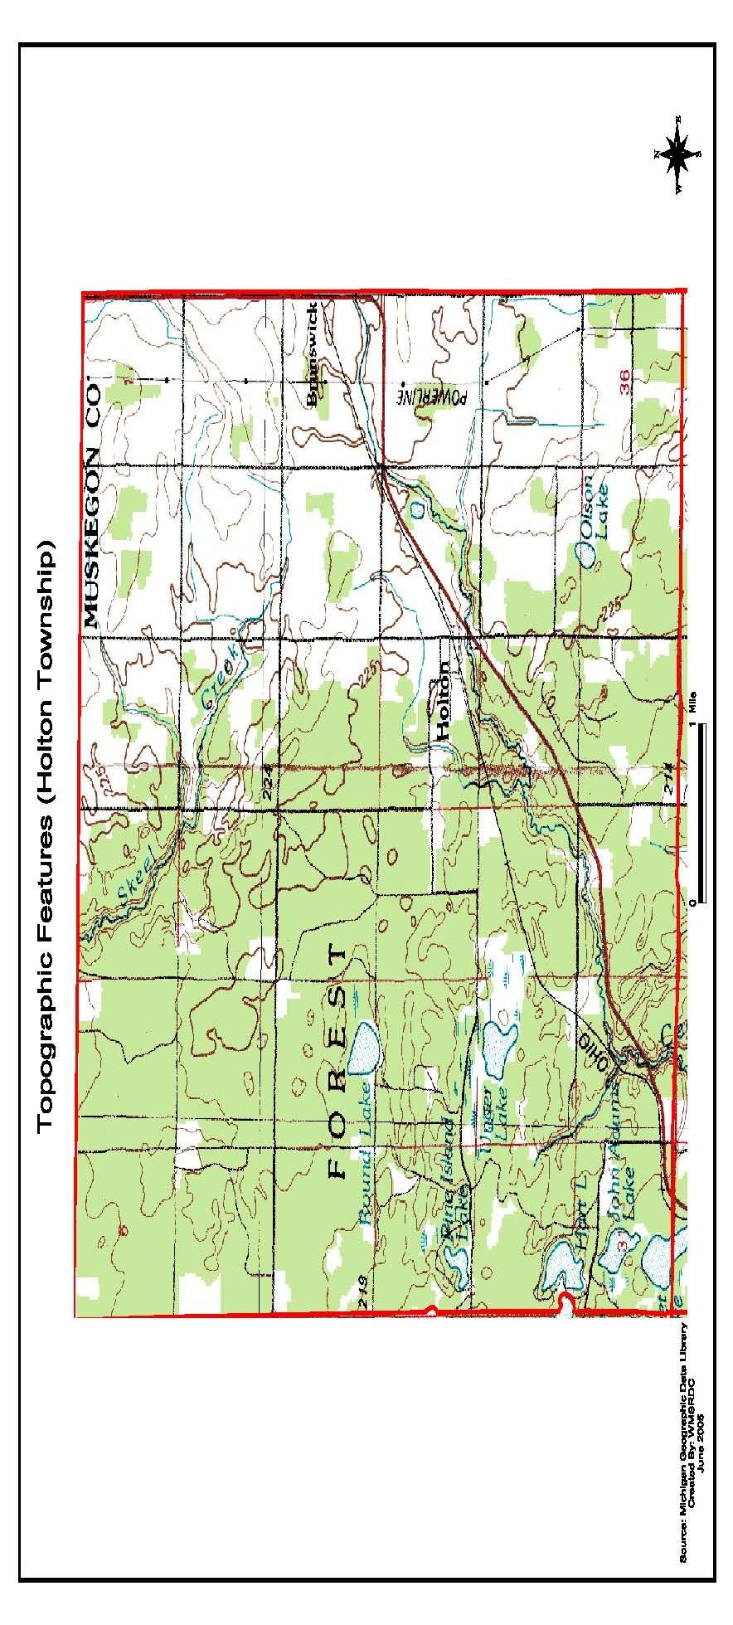
Map #2
Septic Suitability

The location of soils, suitable for septic systems to properly function, is critical in determining the extent and location where development can occur without the need for public utilities. The soil is not considered to be suitable for septic systems if it has excessively high or low permeability, if the slope is excessive, or the water table is too close to the surface. The permeability and coarseness of soil has a direct impact on its ability to properly filter toxins (i.e. septic material) as they pass through the soil.

According to the Soil Survey for Muskegon County, nearly all of the eastern one-third of Holton Township has been rated as having soils with severe restrictions for septic fields. In addition, a sizable portion of the center of the township (parts of sections 15, 21, and 22) are similarly rated. The four-section cluster in the extreme southwestern portion of the township includes both “severe” and “very severe” ratings, particularly around low-lying areas adjacent to surface water bodies and tributaries of Cedar Creek. For the above mentioned reasons, it is most important the soil survey, per parcel, be completed prior to starting any development and the necessary measures taken to protect the environment from contamination.

In order to reduce the amount of pollution released from septic tanks, citizens should refrain from disposing of household chemicals such as ammonia, bleach, or other hazardous substances into the septic system and perform routine proper septic maintenance. Septic tanks should be maintained on a regular schedule by adding necessary chemicals and cleaning and using them only to capacity.

The main concern with septic suitability is the pollution of groundwater. When the soil becomes saturated due to intense rain or flooding, toxins are removed from septic tanks and flow into groundwater or surface water. Septic systems contain materials such as household cleaners, bacteria, and other toxic nuisances that are more hazardous than human waste.

Therefore, when a septic system fails, many different pollutants are released into both groundwater and surface water. This means that a septic system should be emptied at a minimum of every seven years, but preferable is every other year.

Table 1
Holton Township Limitations of Soils for Building Site Development Residential and Light Industry and Commercial Development and Roadways
Soil Series | Degree of Limitations Affecting Use For -
Soil Series | Residential Development | Sanitary Facilities: Septic tank absorption fields | Sewage Lagoon Areas | Buildings for Commercial and Light Industrial | Local roads  & streets
Rubicon | Slight | Severe, poor filter | Severe, seepage | Slight | Severe: droughtly
Rousseau | Slight | Slight | Moderate | Slight | Slight
Nester | Severe | Severe, perks slow | Moderate to severe | Severe | Severe
Grayling | Moderate | Severe, poor filter | Severe, seepage to sandy | Severe | Severe: droughtly
Slight - Soil properties and site features are generally favorable for the indicated use and limitations are minor and easily overcome.
Moderate - Soil properties or site features are not favorable for the indicated use and special planning, design, or maintenance is needed to overcome or minimize the limitations.
Severe - Soil properties or site features are so unfavorable or so difficult to overcome that special design, significant increases in construction costs, and possibly increased maintenance are required.
Source: United States Department of Agriculture, Natural Resources Conservation Service, and Forest Service. Soil Survey of Muskegon County, Michigan 1968/addendum 1995

Climate

The varying climate in Holton Township, as in all of Michigan, provides what many people perceive to be a pleasant quality of life. While weather conditions range from sun to snow, the township’s proximity to Lake Michigan tends to moderate temperature swings on both a daily and seasonal basis. Summers are cooler and winters milder in the western side of the lower peninsula of Michigan than in other areas of the state.

The following climatic data has been collected from the City of Muskegon, 22 miles to the southwest, from the period 1931 – 1964. Temperature data shows that January and February rate fairly equally as the coldest months with an average daily maximum of 32 degrees (Fahrenheit) and an average daily minimum of 18 – 19 degrees, while July and August are the warmest months with an average daily maximum of 80 – 81 degrees and minimums of 59 – 60 degrees.

Precipitation is generally well-distributed throughout the year, with the crop season of May to October receiving an average of nearly 14 inches, or 45% of the average annual total. September, with 3.14 inches, is the wettest month, while February, with a 1.78 inch average, is the driest. The average annual snowfall is 74 inches, and one inch or more of snow is on the ground on an average of 80 days per season.

Muskegon County is classified as having “quasi-marine” and “continental” climates. When the prevailing westerly winds pass over the large expanse of Lake Michigan, they become moderated in temperatures and laden with moisture. When the wind becomes south-easterly or easterly, however, the air arrives in Muskegon County after having traversed over a large amount of land, and the climate adopts continental characteristics.

Water Resources

There are portions of two major watersheds located in Holton Township including the South Branch of the White River, and Cedar Creek. Both flowages move in a westerly direction, ultimately emptying into Lake Michigan. The confluence of the South Branch of the White River with the North Branch occurs just over the Oceana/Muskegon County border, thence flowing more or less directly to Lake Michigan. Cedar Creek empties into the Muskegon River, which is the major tributary westward to Lake Michigan. There are eight named lakes in Holton Township. Ranging in size from the 16-18 acres in Olsen Lake to Deer (Unger) Lake’s 60-70 acres, these surface water bodies occupy 356 acres in total.

All of Holton Township’s citizens depend upon groundwater as their only source of potable water. Due to the sandiness of the soil so predominant in the township, the community is very vulnerable to widespread contamination through spillage or dumping of toxic material.

A 1977 water quality study prepared by the West Michigan Shoreline Regional Development Commission described the characteristics of the groundwater quantity and quality in Holton Township. The following three paragraphs are reprinted from a volume of that publication.

Groundwater Location: Aquifer locations in Holton Township vary considerably due to the fact that the glacial drift is composed of intermittent clay, sand, and gravel. Most of the wells in the Township seem to be in an aquifer which ranges from 50 to 100 feet from the surface. A few wells are, however, found in the 20 to 50 feet deep range. A thick layer of blue clay begins in the glacial drift about 200 feet beneath the earth’s surface and thereby decreases the possibility of finding an available aquifer beneath that depth. The bedrock formation located beneath the glacial drift in Holton Township includes both the Michigan and Marshall Formations. The Michigan Formation is not expected to have an available aquifer, but the Marshall Formation might.

Groundwater Quality: Holton Township is a rural township, which has experienced few developmental pressures and thus very few groundwater contamination problems. The Muskegon County Health Department reports scattered instances where wells have been contaminated with nitrates. The presence of nitrates is, in this case, thought to be the result of natural phenomena such as decaying vegetation beneath the earth’s surface. The Marshall Sandstone aquifer located beneath the Michigan Formation is probably too highly mineralized for most uses. The Marshall aquifer located directly beneath the glacial drift might have water of suitable quality.

Potential Groundwater Degradation: There are several areas within Holton Township which have rather shallow glacial drift aquifers. These areas are particularly susceptible to surface contaminants. The now-closed Holton Township Landfill in Section 34 is estimated as being within 20 feet of groundwater, which does not meet the Department of Natural Resource’s (DNR) recommended isolation distance. There are no known industrial-municipal groundwater discharges in Holton Township. (Source: Sourcebook for Water Quality Planning, Part VI, Appendix C, Assessment of Groundwater Quality, West Michigan Shoreline Regional Development Commission, 1977, page 75).

Map #3
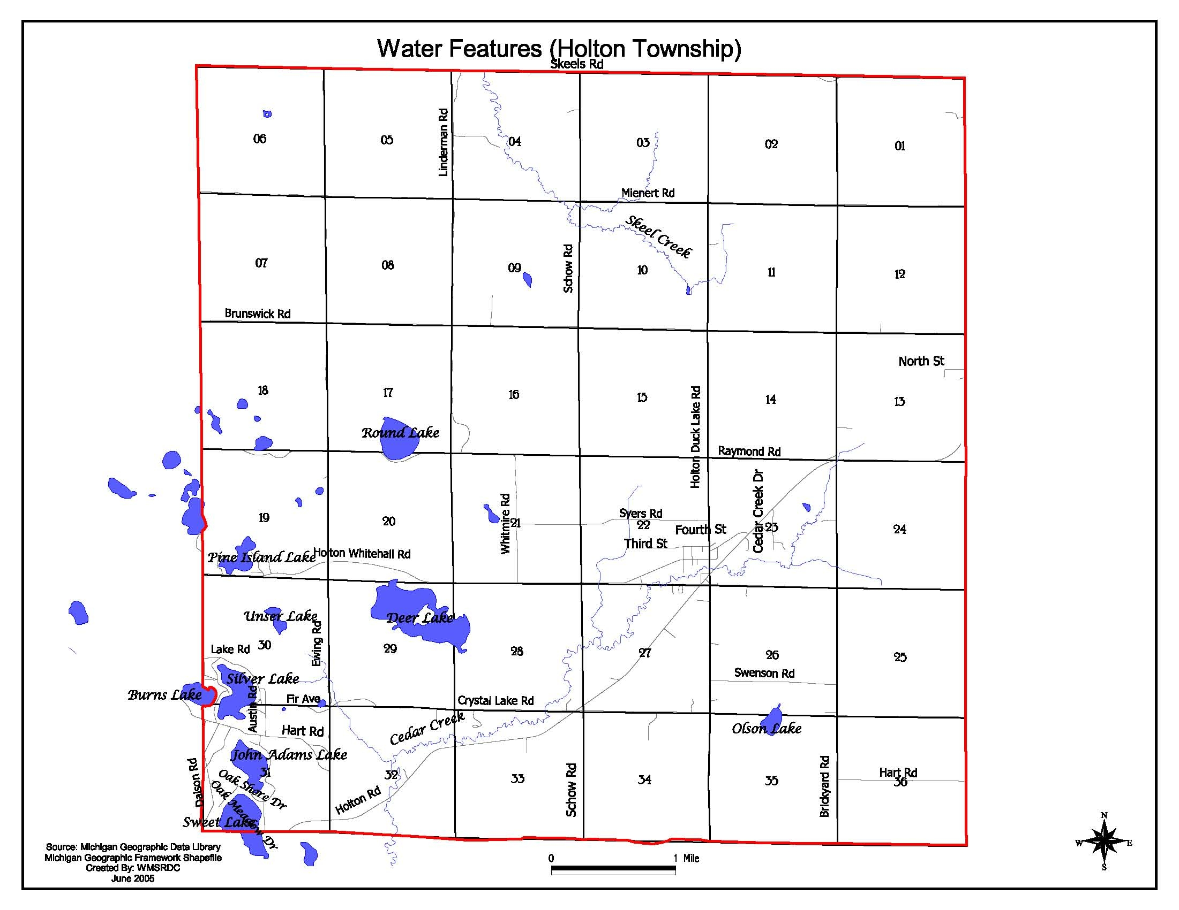

Agriculture and Woodlands

Prime farm lands, which are defined by the U.S. Department of Agriculture, Soil Conservation Service, are those which have the:

“best combination of physical and chemical characteristics for producing food, feed, forage, fiber, and oilseed crops, and are also available for those uses. They have the soil quality, growing season and moisture supply needed to economically produce sustained high yields of crops when treated and managed, including water management, according to acceptable farming methods. …Prime farmlands have an adequate and dependable water supply from precipitation or irrigation, a favorable temperature and growing season, acceptable acidity or alkalinity, acceptable salt and sodium content, and few or no stones. They are permeable to water and air, …(and) are not excessively erodible or saturated with water for a long period of time, and they either do not flood frequently or are protected from flooding.”

Holton Township processes approximately 3,800 acres of soils rated as being prime, concentrated primarily in the northeastern quadrant of the township. Prime soils occupy nearly 17 percent of the township’s total land area.

In addition, the State of Michigan has identified a number of soils in two additional categories: “Soils of Local Importance” and “Unique Farm Land.” Soils of Local Importance are those soils that may not be prime farm land, but still possess characteristics that, when administered properly on a site-specific basis, yield good properties for food and fiber.

Unique Farm Lands are those other than prime farm land which are “used for the production of specific high value food and fiber crops. It has the special combination of soil quality, location, growing season and moisture supply needed to economically produce sustained high quality and/or high yields of a specific crop when treated and managed according to acceptable farming methods. Examples of such crops are tree nuts, cranberries, fruits and vegetables.”

The majority of Holton Township’s land cover is upland hardwood, approximately 46 percent, which is found extensively in the western two-thirds of the township. This land cover consists of native shrubs including staghorn sumac, fire cherry, greenbrier, winter green, and blueberry. Hardwoods common to this cover include aspen and birch; white and black oaks; beech, maple, red oak, hickory, and elm, ash, red maple, cottonwood, as well as, other upland hardwoods and swamp hardwoods. The woodland wildlife found in the upland hardwood land cover include birds and mammals such as the ruffed grouse, woodcock, thrushes, vireos, scarlet tanagers, gray, red, and fox squirrels, white-tailed deer, and raccoons.

The second-largest land cover is cropland, covering 29 percent of the area. This category, which includes row crops, hay fields, and small grain fields, is found primarily in the eastern third of the township. The next two-largest categories are pine forests and shrub lands, each occupying six percent of the land. Single-family residential homes consume approximately three percent of the township. This development is centered mainly in the community of Holton, and along M-120. Scattered pockets of homes are also found along Brunswick Road in sections 9 and 10, along Holton-Duck Lake Road south of M-120, on Holton-Whitehall Road near Unger Lake, and around Hart Lake.

Other Natural Resources

As defined through the Michigan Resource Information System (MIRIS), there are approximately 583 acres of wetlands in Holton Township. Of those acres, nearly 75 percent are shrub vegetation, 20 percent are aquatic bed vegetation, and the remainder is emergent vegetation. The most concentrated area of wetlands is in the southwest quadrant of the township, around the open-water lakes in sections 18, 19, 29, 30, and 31. There are also large, scattered pockets in section 35, and both Skeel Creek and Cedar Creek are bordered by lowland hardwood vegetation.

- COMMUNITY CHARACTERISTICS

Community Profile

Population characteristics such as growth, age distribution, income, educational level, and households, help planners make predictions based on historic patterns. A clear picture can be painted of the future by analyzing these population factors. The following sections provide a community profile of Holton Township as defined by the 2000 U.S. Census of Population and Housing.

Population Trends

Table 2
Holton Township
Population Trends and Projections
Year | 1970 | 1980 | 1990 | 2000 | *2005
Population | 1,499 | 2,022 | 2,318 | 2,532 | 2,625
Year | *2010 | *2015 | *2020 | *2025 | *2030
Population | 2,711 | 2,800 | 2,892 | 2,986 | 3,084
Sources: Census Bureau, Internal Revenue Service and U.S. Department of Health and Human Services
*Forecasted by the West Michigan Shoreline Regional Development Commission

Holton Township has had a steady population growth from 1970 to 2000 which is equivalent to the area surrounding the township. Between 1980 and 2000, Holton Township experienced a growth rate of 20% or an increase of 510 residents. According to the 2000 Census, the Holton Township population of 2,532 was 1.5% of the population in Muskegon County totaling 170,200 residents.

Projections conducted by the West Michigan Shoreline Regional Development Commission show that Holton Township will continue its growth pattern over the next several years. The township is predicted to grow by an additional 18% by the year 2030 bringing the total township population to 3,084.

Age & Gender

Table 3
Age Distribution
Holton Township and Muskegon County
 | Holton Township | Muskegon County
TOTAL POPULATION | 2,532 | 170,200
Under 5 years | 158 (6.2%) | 11,675 (6.9%)
5 – 9 years | 205 (8.1%) | 13,307 (7.8%)
10 – 14 years | 243 (9.6%) | 13,783 (8.1%)
15 – 19 years | 217 (8.6%) | 12,679 (7.5%)
20 – 24 years | 119 (4.7%) | 10,247 (6.0%)
25 – 34 years | 306 (12.1%) | 22,173 (13.0%)
35 – 44 years | 437 (17.2%) | 27,163 (16.0%)
45 – 54 years | 362 (14.3%) | 22,999 (13.5%)
55 – 59 years | 149 (5.9%) | 7,957 (4.7%)
60 – 64 years | 81 (3.2%) | 6,330 (3.7%)
65 – 74 years | 165 (6.5%) | 11,280 (6.6%)
75 – 84 years | 71 (2.8%) | 8,051 (4.7%)
85 years and over | 19 (0.8%) | 2,556 (1.5%)
Median Age | 35.5 | 35.5
Source: 2000 U.S. Bureau of the Census

The above table illustrates the age distribution in Holton Township, as well as Muskegon County. The largest age category for Holton Township are the ages 25 to 54 representing approximately 43.6% of the population. The second largest category are school aged children 18 and under. These categories represent 32.5% of Holton’s total population. This demonstrates a healthy population distribution. In addition, the following table identifies a healthy distribution between males and females in the township.

Table 4
Gender Distribution
Holton Township and Muskegon County
 | Male | Female
Holton Township | 1,326 (52.4%) | 1,206 (47.6%)
Muskegon County | 84,359 (49.6%) | 85,841 (50.4%)
Source: 2000 U.S. Bureau of the Census

Households

Table 5
Housing Occupancy
Holton Township and Muskegon County
 | Total Housing Units | Occupied | Vacant
Holton Township | 980 | 903 (92.1%) | 77 (7.9%)
Muskegon County | 68,556 | 63,330 (92.4%) | 5,226 (7.6%)
Source: 2000 U.S. Bureau of the Census

Housing and any significant changes in an area’s housing stock have a key impact on planning decisions. It is important to note that changing trends related to housing stock are often the first indications that important changes are taking place with the population base and land use.

The housing characteristics for Holton Township are based upon the 2000 U.S. Census of Population and Housing summary date, and therefore, to not reflect changes that have occurred in the past five years. One vital aspect of housing stock is the presence of a variety of house types within the township (i.e. traditional single-family homes, duplexes, and mobile homes). Varying housing types contribute to affordable housing opportunities for township residents. Of the 980 housing units located in Holton Township, 57% have been built within the last 35 years.

Holton Township’s average household size is 2.8 persons per household. It is important to note that with the township’s projected additional population growth of 552 residents by the year 2030, it will be necessary to add an additional 197 dwelling units to house those persons. Therefore, Holton Township will need to remain proactive in addressing housing issues.

Graph 1
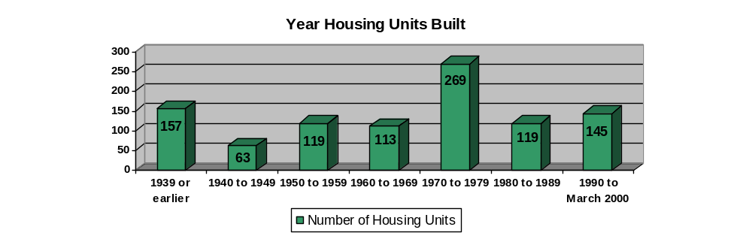
Source: 2000 U.S. Bureau of the Census

Racial Composition

Table 6
Ethnicity
Holton Township and Muskegon County
 | Holton Township | Muskegon County
TOTAL POPULATION | 2,532 | 170,200
White | 2,431 | 138,291
Black or African American | 11 | 24,166
American Indian and Alaska Native | 31 | 1,401
Asian | 6 | 718
Native Hawaiian and Other Pacific Islander | 0 | 21
Some Other Race | 4 | 2,184
Two or More Races | 49 | 3,418
* Hispanic or Latino (of any race) | 45 | 6,001
Source: 2000 U.S. Bureau of the Census

* Hispanic origin is included in all races, therefore, totals will not equal the Total Persons section.

Table 6 illustrates the racial distribution of Holton Township and Muskegon County. As can be derived by the table, the majority of Holton Township residents have a white ethnic background. The racial distribution for the township is similar to other townships in the area.

Income and Poverty

Table 7
Income
Holton Township and Muskegon County
 | Per Capita Income | Median Household Income
Holton Township | $16,210 | $37,813
Muskegon County | $17,967 | $38,008
Source: 2000 U.S. Bureau of the Census

Table 8
Household Income Distribution
in Holton Township
Total | 930
Less than $10,000 | 63 (6.7%)
$10,000 to $19,999 | 107 (11.5%)
$20,000 to $29,999 | 148 (15.9%)
$30,000 to $39,999 | 175 (18.8%)
$40,000 to $49,999 | 135 (14.5%)
$50,000 to $59,999 | 113 (12.2%)
$60,000 to $74,999 | 84 (9.0%)
$75,000 to $99,999 | 74 (8.0%)
$100,000 to $149,999 | 21 (2.3%)
$150,000 or more | 10 (1.1%)
Source: 2000 U.S. Bureau of the Census

The above tables identify the income levels in Holton Township which are fairly comparable to those at the county level. The following graph identifies poverty status by age. Of the 2,532 residents in Holton Township, 238 persons were below the poverty level. This totals approximately 9% of the population.

Graph 2
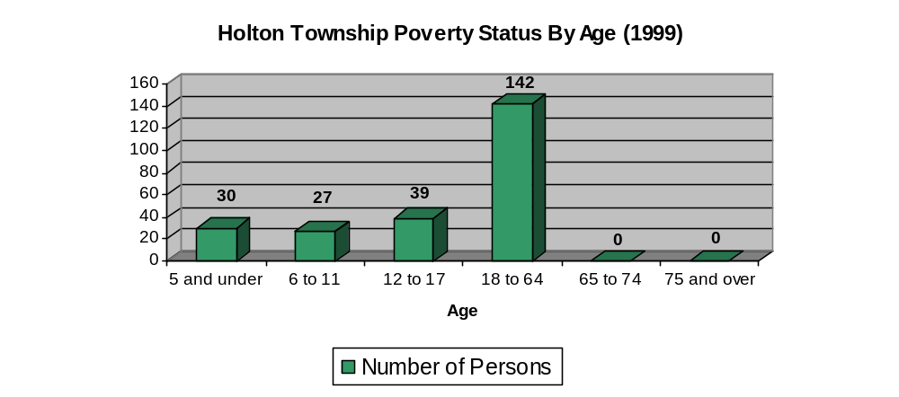
Source: 2000 U.S. Bureau of the Census

Educational Levels

Table 9
Educational Attainment: Persons 25 Years and Over
Holton Township and Muskegon County
 | Holton Township | Muskegon County
Less Than 9th Grade | 98 (6.0%) | 5,193 (4.8%)
9th – 12th Grade | 299 (18.1%) | 13,210 (12.1%)
High School Diploma | 645 (39.1%) | 38,552 (35.5%)
Some College | 370 (22.5%) | 27,349 (25.2%)
Associate Degree | 140 (8.5%) | 9,297 (8.6%)
Bachelor’s Degree | 60 (3.6%) | 10,215 (9.3%)
Graduate or Professional Degree | 36 (2.2%) | 4,875 (4.5%)
Source: 2000 U.S. Bureau of the Census

Labor Force Composition

Table 10
Area Industry: Employed civilian population 16 years and over in Holton Township
TOTAL | 1,178
Agriculture, forestry, fishing, hunting, and mining | 42 (3.6%)
Construction | 87 (7.5%)
Manufacturing | 397 (33.7%)
Wholesale trade | 25 (2.1%)
Retail trade | 157 (13.3%)
Transportation and warehousing, and utilities | 31 (2.6%)
Information | 27 (2.3%)
Finance, insurance, real estate, rental and leasing | 46 (3.9%)
Professional, scientific, management, administrative, and waste management services | 42 (3.6%)
Education, health and social services | 183 (15.5%)
Arts, entertainment, recreation, accommodation and food services | 57 (4.8%)
Other services (except public administration) | 57 (4.8%)
Public administration | 27 (2.3%)

Source: 2000 U.S. Bureau of the Census

In 2000, the labor force in Holton Township, which consists of residents 16 years and over, totaled 1,178 persons. Of those persons approximately 66% worked in Muskegon County with the remaining 34% traveling outside of the county for employment. The following tables identify the area of industry which these persons are employed in, as well as the class of workers.

Table 11
Holton Township Class of Workers
Employed civilian population 16 years and over
TOTAL | 1,178
Private for-profit wage and salary workers | 907 (77.0%)
Private not-for-profit wage and salary workers | 88 (7.5%)
Local government workers | 70 (6.0%)
State government workers | 33 (2.8%)
Federal government workers | 18 (1.5%)
Self-employed workers | 45 (3.8%)
Unpaid family workers | 17 (1.4%)

Source: 2000 U.S. Bureau of the Census

Economic Outlook

Table 12
Muskegon County Employment By Sector
2000 & 2002
Sector | 2000 | 2002 | % of Total 2000 | % of Total 2002
Construction | 4,727 | 4,561 | 5.7% | 5.4%
Manufacturing | 16,160 | 16,875 | 19.4% | 20.1%
Transportation | 2,457 | 2,409 | 3.0% | 2.9%
Wholesale | 4,147 | 4,443 | 5.0% | 5.3%
Retail | 17,164 | 17,507 | 20.6% | 20.8%
F.I.R.E. | 4,341 | 4,240 | 5.2% | 5.0%
Services | 22,741 | 23,406 | 27.3% | 27.8%
Government | 10,079 | 10,030 | 12.1% | 11.9%
Total Employment | 83,207 | 84,174

Source: Regional Economic Information System
West Michigan Shoreline Regional Development Commission
Table 13
Economic Projections
Employment Projections 1999 to 2004
 |  |  |  |  |  |  |  |  |  |  |  | Forecasted Employment
MUSKEGON COUNTY | 1988 | 1989 | 1990 | 1991 | 1992 | 1993 | 1994 | 1995 | 1996 | 1997 | 1998 | 2000 | 2001 | 2002 | 2003 | 2004 | 2005
Employment by Place of Work
Total employment | 68,728 | 69,960 | 70,760 | 68,868 | 68,744 | 68,204 | 70,260 | 72,742 | 74,711 | 76,221 | 77,147 | 81,711 | 82,897 | 84,101 | 85,323 | 86,562 | 87,819
By Type:
Wage and salary | 59,993 | 61,110 | 61,441 | 59,534 | 59,022 | 59,121 | 60,803 | 62,940 | 64,530 | 65,758 | 66,684 | 70,485 | 71,435 | 72,397 | 73,372 | 74,359 | 75,359
Proprietors | 8,735 | 8,850 | 9,319 | 9,334 | 9,722 | 9,083 | 9,457 | 9,802 | 10,181 | 10,463 | 10,463 | 11,226 | 11,463 | 11,704 | 11,951 | 12,203 | 12,460
- Farm | 518 | 512 | 500 | 496 | 500 | 478 | 473 | 490 | 475 | 468 | 451 | 454 | 449 | 443 | 438 | 433 | 428
- Nonfarm | 8,217 | 8,338 | 8,819 | 8,838 | 9,222 | 8,605 | 8,984 | 9,312 | 9,706 | 9,995 | 10,012 | 10,772 | 11,014 | 11,261 | 11,513 | 11,769 | 12,031
By Industry:
Farm | 911 | 840 | 861 | 871 | 841 | 798 | 818 | 841 | 792 | 779 | 676 | 659 | 641 | 624 | 607 | 591 | 575
Nonfarm | 67,817 | 69,120 | 69,899 | 67,997 | 67,903 | 67,406 | 69,442 | 71,901 | 73,919 | 75,442 | 76,471 | 81,052 | 82,256 | 83,477 | 84,715 | 85,971 | 87,244
- Private | 58,659 | 59,754 | 60,325 | 58,384 | 58,119 | 57,892 | 59,824 | 62,378 | 64,298 | 65,831 | 66,876 | 71,031 | 72,162 | 73,309 | 74,472 | 75,653 | 76,851
- Ag.serv.,for.,fish., and other* | 318 | 314 | 322 | 304 | (D) | (D) | (D) | (D) | 460 | 478 | (D) | (D) | (D) | (D) | (D) | (D) | (D)
- Mining | 152 | 142 | 146 | 148 | (D) | (D) | (D) | (D) | 115 | 111 | (D) | (D) | (D) | (D) | (D) | (D) | (D)
- Construction | 3,264 | 3,446 | 3,519 | 3,198 | 3,340 | 3,275 | 3,429 | 3,524 | 3,538 | 3,845 | 3,895 | 4,202 | 4,279 | 4,356 | 4,433 | 4,510 | 4,586
- Manufacturing | 17,738 | 17,504 | 16,877 | 16,234 | 15,721 | 14,832 | 14,857 | 15,264 | 15,221 | 15,818 | 16,532 | 16,975 | 16,865 | 16,750 | 16,630 | 16,505 | 16,374
- Transportation and public  utilities | 2,464 | 2,503 | 2,460 | 2,452 | 2,460 | 2,496 | 2,401 | 2,300 | 2,316 | 2,311 | 2,294 | 2,355 | 2,339 | 2,323 | 2,306 | 2,289 | 2,270
- Wholesale trade | 2,097 | 2,300 | 2,362 | 2,351 | 2,434 | 2,588 | 2,738 | 2,940 | 3,389 | 3,564 | 4,063 | 4,829 | 5,162 | 5,517 | 5,893 | 6,292 | 6,717
- Retail trade | 12,969 | 13,411 | 13,937 | 13,201 | 13,097 | 13,159 | 14,038 | 15,148 | 15,925 | 16,009 | 15,081 | 16,186 | 16,441 | 16,694 | 16,945 | 17,194 | 17,439
- Finance, insurance, & real  estate | 3,112 | 3,218 | 3,201 | 3,139 | 3,231 | 3,233 | 3,441 | 3,532 | 3,593 | 3,654 | 3,704 | 3,994 | 4,066 | 4,139 | 4,211 | 4,282 | 4,354
- Services | 16,545 | 16,916 | 17,501 | 17,357 | 17,445 | 17,882 | 18,420 | 19,123 | 19,741 | 20,041 | 20,659 | 22,490 | 23,008 | 23,529 | 24,054 | 24,581 | 25,110
- Government and government  enterprises | 9,158 | 9,366 | 9,574 | 9,613 | 9,784 | 9,514 | 9,618 | 9,523 | 9,621 | 9,611 | 9,595 | 10,020 | 10,094 | 10,168 | 10,243 | 10,318 | 10,393
- Federal, civilian | 419 | 421 | 440 | 407 | 403 | 389 | 390 | 410 | 402 | 393 | 392 | 399 | 397 | 395 | 393 | 391 | 388
- Military | 597 | 540 | 536 | 519 | 497 | 465 | 416 | 392 | 375 | 358 | 333 | 306 | 289 | 273 | 258 | 243 | 230
- State and local | 8,142 | 8,405 | 8,598 | 8,687 | 8,884 | 8,660 | 8,812 | 8,721 | 8,844 | 8,860 | 8,870 | 9,315 | 9,408 | 9,500 | 9,592 | 9,684 | 9,775
Source: Regional Economic Information System, Bureau of Economic Analysis, U.S. Department of Commerce
Michigan Department of Career Development/Employment Services Agency, Labor Market Analysis Section
Projections by: West Michigan Shoreline Regional Development Commission
*Figures in this category for 1991 and 1992 are estimated
(D) - According to REIS data source, data not shown to avoid disclosure of confidential information, therefore
projections of private employment by sector indicate trends only.
Numbers may not add due to rounding

Unemployment

Table 14
Labor Force
Based on 2004 Annual Average
 | Holton Township | Muskegon County | State of Michigan
Labor Force | 1,150 | 82,175 | 5,062,000
Employment | 1,050 | 75,250 | 4,720,000
Unemployment | 100 | 6,925 | 342,000
Rate | 9.2% | 8.4% | 6.8%

Source: Michigan Department of Labor & Economic Growth

The above table identifies the labor force for Holton Township in comparison to Muskegon County and the State of Michigan. The national unemployment rate based on the 2004 annual average is 5.5%. The below graph provides a brief analysis of the historical unemployment rates for Holton Township between 1980 and 2004.

Graph 3
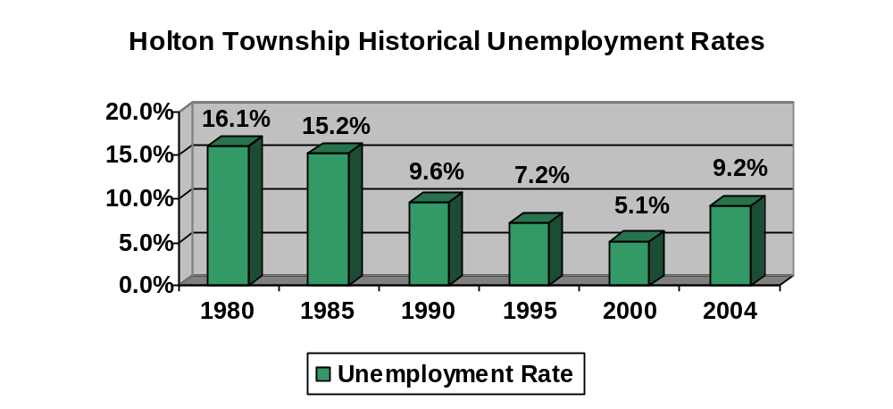

Source: Michigan Department of Labor & Economic Growth

Community Facilities and Services

Township Government

Holton Township was established as a general—law township in 1871. It is currently governed by a five-member township board consisting of a supervisor, treasurer, clerk, and two trustees, all of whom are elected representatives of the citizenry. The terms are held for four years, elections being held the same years as the presidential elections. The Holton Township Board of Trustees meets the second Tuesday of every month at 7:00 PM at the township hall located at 6511 Holton Whitehall Road, Holton, Michigan 49425.

Other township officials include a part-time building inspector, a part-time zoning administrator, and a part-time property assessor. There is no township manager or other paid, professional staff.

In 1982, the Holton Township Board of Trustees established a seven-member planning commission. Members are appointed to the planning commission by the township supervisor, with township board approval, and terms run three years, with staggered expiration dates. Officers consist of chairperson, vice-chairperson, secretary, and four members. All appointments are at-large and non-partisan. The commission is a recommending body for the most part, reporting directly to the township board, but it does have some authorities granted for decision-making in land use matters by the zoning ordinance.

A Zoning Board of Appeals also exists, its purpose being to decide questions of proper procedure in zoning decisions and to grant variances as allowed by the zoning ordinance. Comprised of three citizens and two alternates, this board meets upon the call of the chairperson when there is necessary business.

The Holton Township Board of Trustees administers the annual township budget, which begins on July 1. The primary source of revenue for Michigan townships, such as Holton is the local government’s share of the state sales tax, which has been drastically cut in recent years. Other revenue is garnered from the millage rate applied to the local property tax fees from the solid waste transfer station, fees for building permits and planning commission/zoning board of appeals review fees, and sale of cemetery plots. Holton Township capital improvement plans are in effect for our parks and our cemetery however, there are no plans in effect for improving roads or county drains. The basis of the township’s budget is the General Fund. Following is the July 2004 through June 2005 budget for Holton Township.

Table 15
Holton Township Budget July 2004 – June 2005
Township Board | $22,273
Supervisor | $12,546
Elections | $4,450
Fire Fund | $131,500
Fire Department | $2,000
Assessor & BD of Review | $23,850
Liquor Fund | $1,600
Clerk | $14,346
Fire Department Equipment Fund | $34,000
Street Light Fund | $5,400
Treasurer | $14,505
Township Hall & Grounds | $57,280
Cemetery | $37,690
General Government | $59,600
Ordinance Enforcer | $4,838
Building Inspector | $18,000
Electrical Inspector | $4,600
Plumbing Inspector | $6,000
Mechanical Inspector | $3,800
Building Official | $1,200
Planning Commission | $12,480
County Drains | $500
Road, Sidewalks, Bridges | $11,000
Transfer Station | $37,659
Ordinance Administrator | $4,776
Board of Appeals | $590
Parks & Grounds | $14,950
Library | $11,200
Contingency Fund | $25,000
TOTAL BUDGET | $577,633
Transportation

Holton Township is located approximately 22 miles from the county-seat of the City of Muskegon. The township is serviced by one major artery, the M-120 corridor which runs north and east from the City of Muskegon to Hesperia, where it becomes M-20. The US 31 Expressway, a major north/south route that runs along Michigan’s western lakeshore, is roughly 14 miles to the west of Holton Township.

The Muskegon County International Airport located approximately 26 miles southwest of the township is another accessible form of transportation. The township consists of 33.83 miles of paved county primary and local roads, in addition to 40.56 miles of unpaved local roads.

Map #4
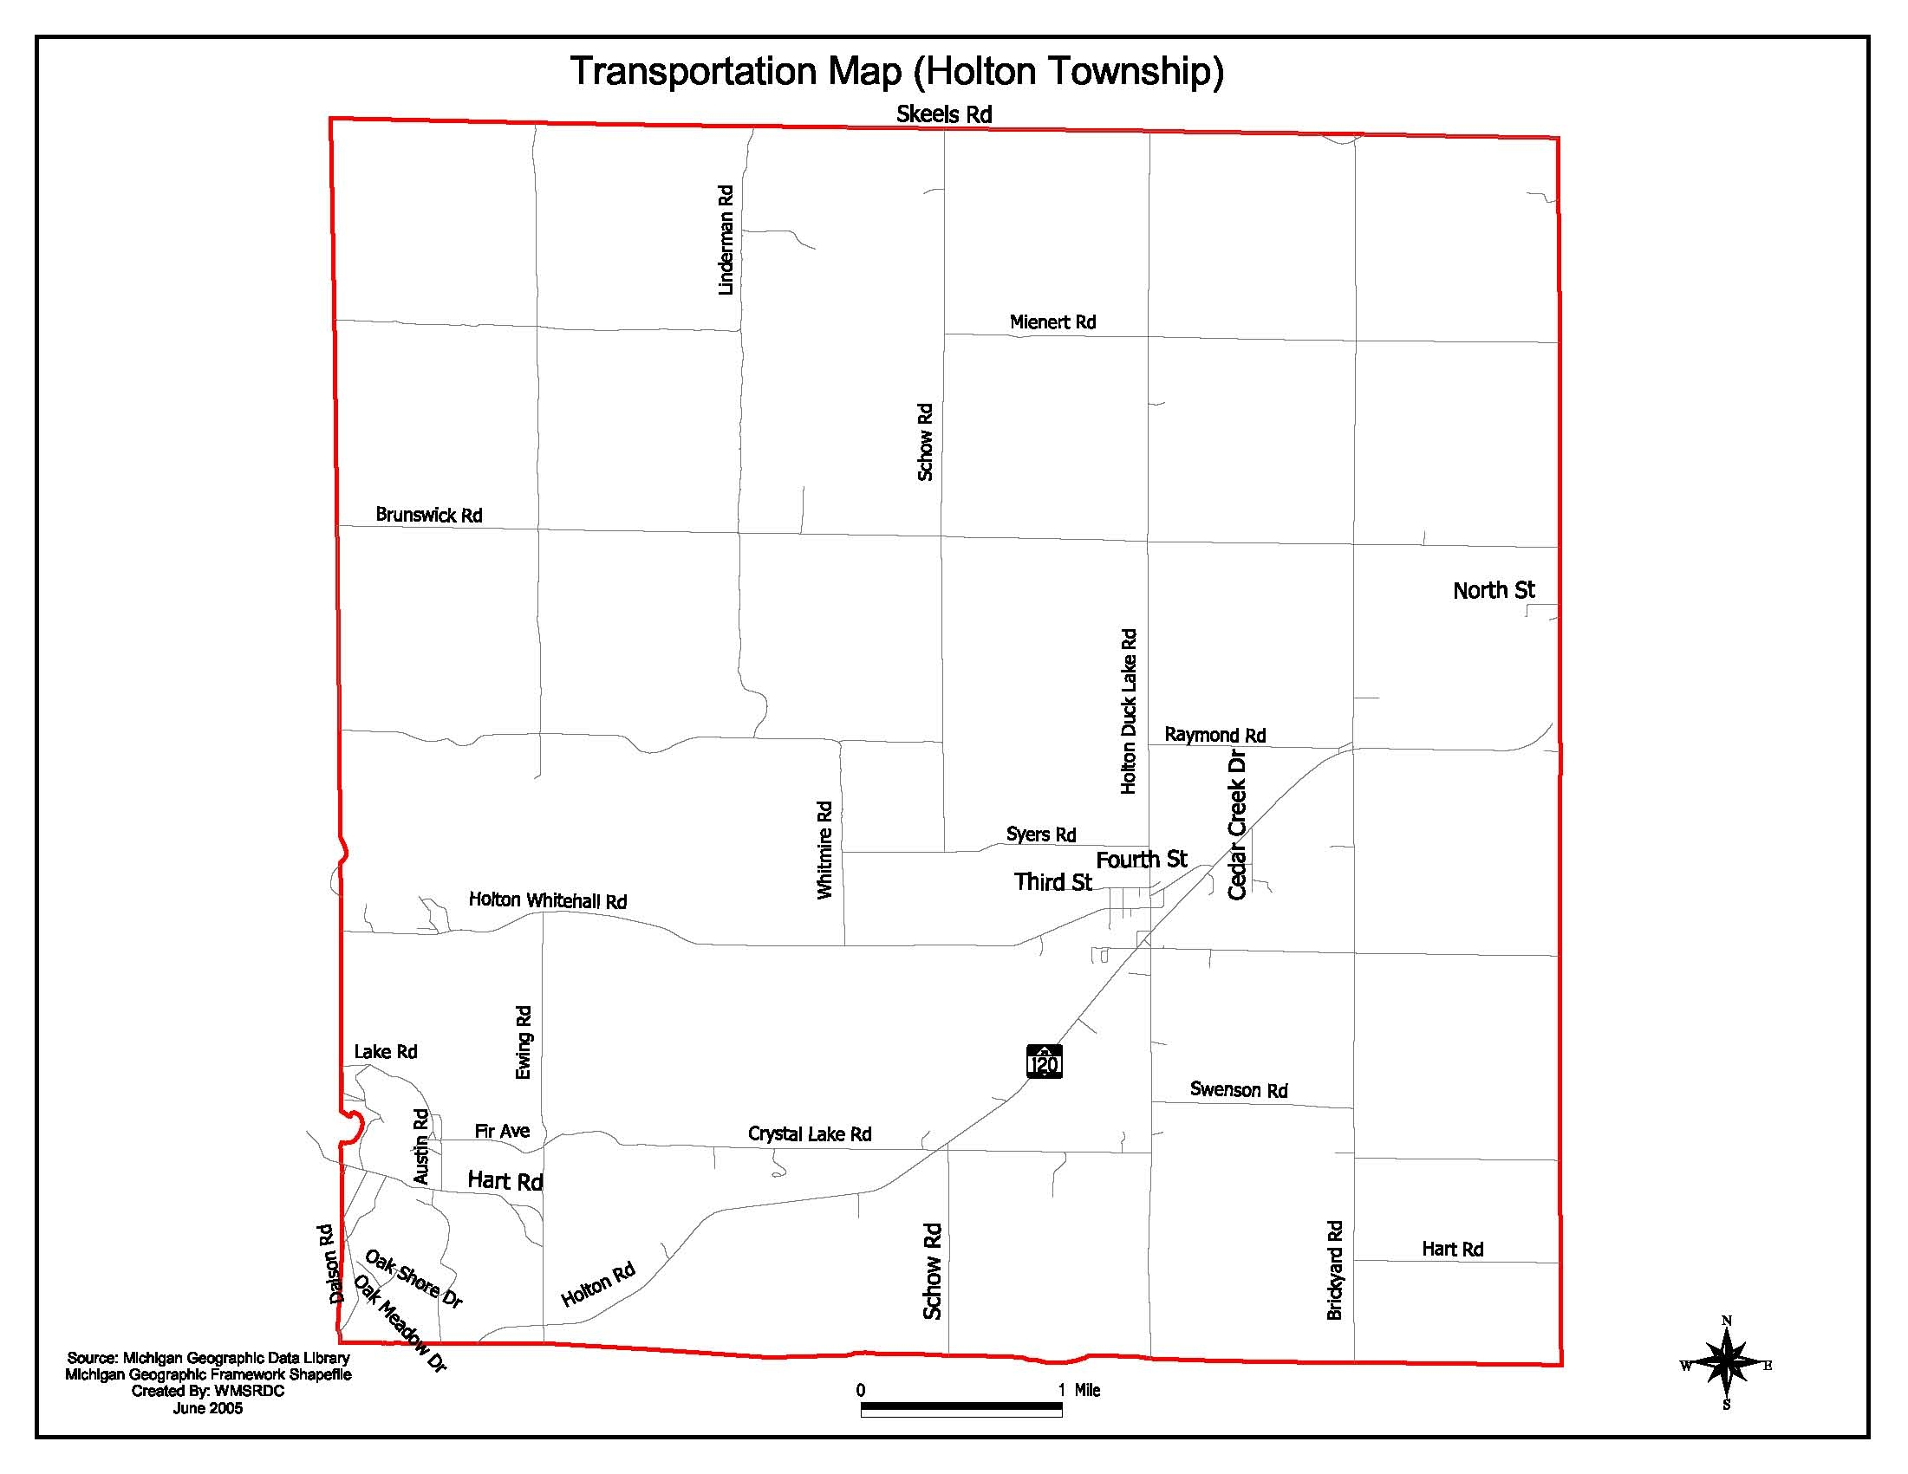

Parks and Recreation

Established park and recreation facilities in Holton Township are few, despite the vast amount of acreage owned by the state and federal governments. The township currently has one developed park, Severt Swenson Park. However, the township recently purchased property located near Syers Road and Schow Road which is being improved with a ball diamond and multi use fields with irrigation systems installed.

Map #5
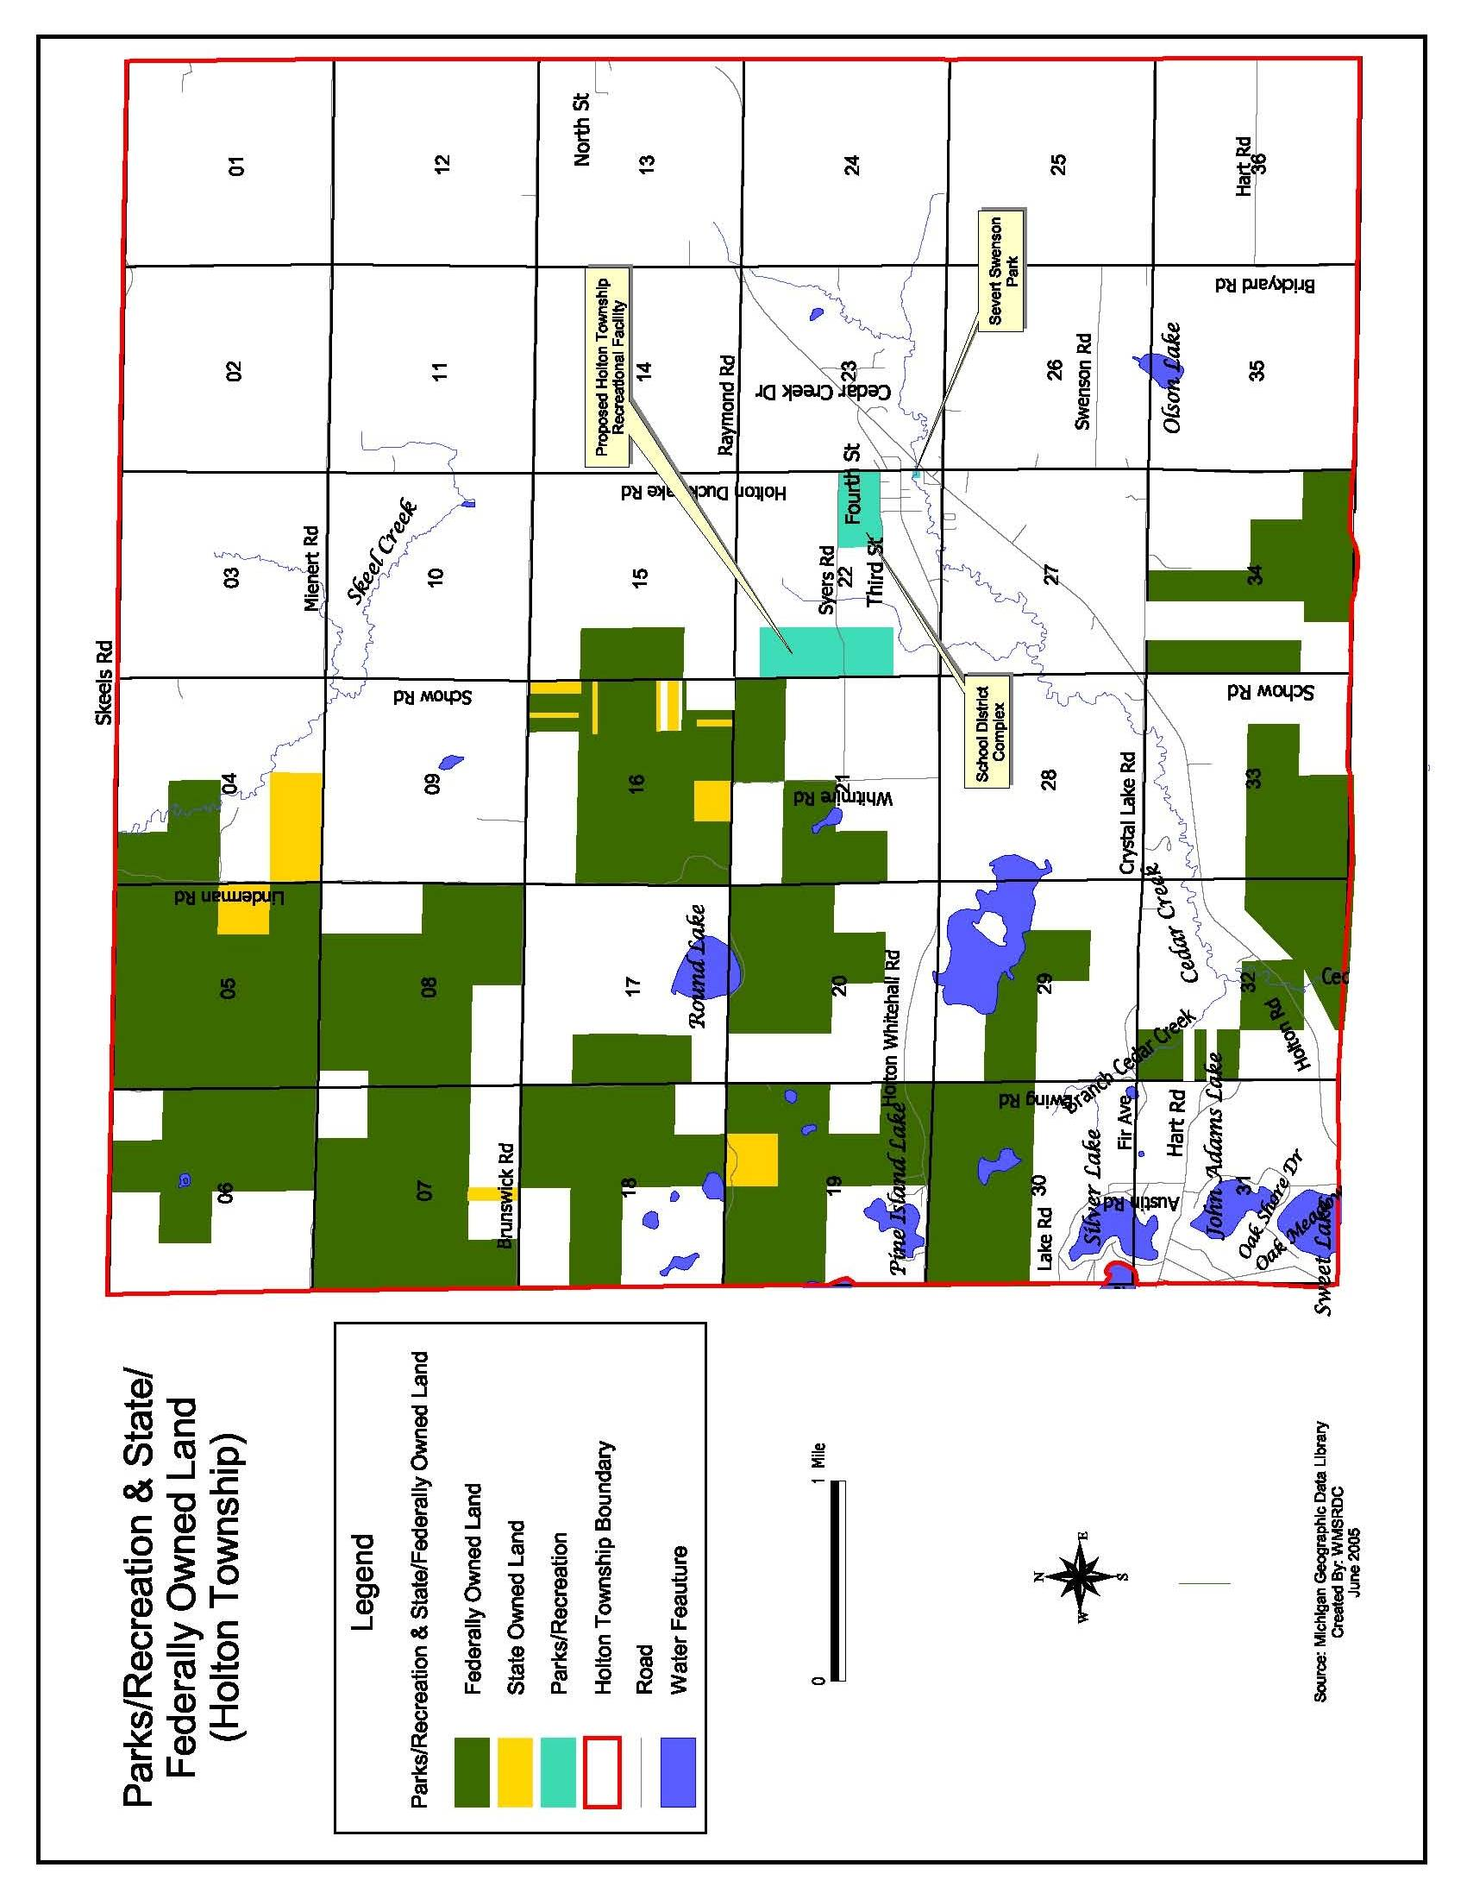
Fire and Police

The Holton Township Fire Department was established in the late 1940’s. The current fire department employs 20 part-time firefighters and is located on Holton Whitehall Road. It services all of Holton Township and the eastern half of Cedar Creek Township. Law enforcement is provided to Holton Township residents through the Muskegon County Sheriff’s Department and the Michigan State Police Post in Hart.

Schools

As in many rural communities, the school system in Holton Township has played a vital role in not only educating children, but in acting as the institution that binds the community together. The Holton public school system dates back to the early 1870s. Today, the Holton Public School District consists of one elementary building, one middle school, and a high school all located on one campus. For the 2000-2001 school year, the district was the second smallest in Muskegon County with a total of 1,112 students, 72 teachers, and a total staff of 80. In 2001-2002, a bond was passed for the existing Middle School. Future needs are; continued financing, student enrollment, improvements to the existing sports facilities, and additional course offerings for students in preparation for college or other interests.

Other Public/Quasi Public Facilities

Nearly all of the public and quasi-public facilities in Holton Township are located within a half-mile radius of the community of Holton. Such facilities include schools, parks, cemeteries, churches, and governmental buildings.

- EXISTING LAND USE

Existing Land Use and Land Cover

The majority of Holton Township, approximately the western two-thirds of the township, is forest land located in the Manistee National Forest. A good portion of the forested land is owned by the federal government and is categorized as public land. The second largest land use category in the township is agriculture which is found mostly in the eastern one-third of the township. There are also concentrations of commercial and residential development located mainly near the community of Holton.

Map #6
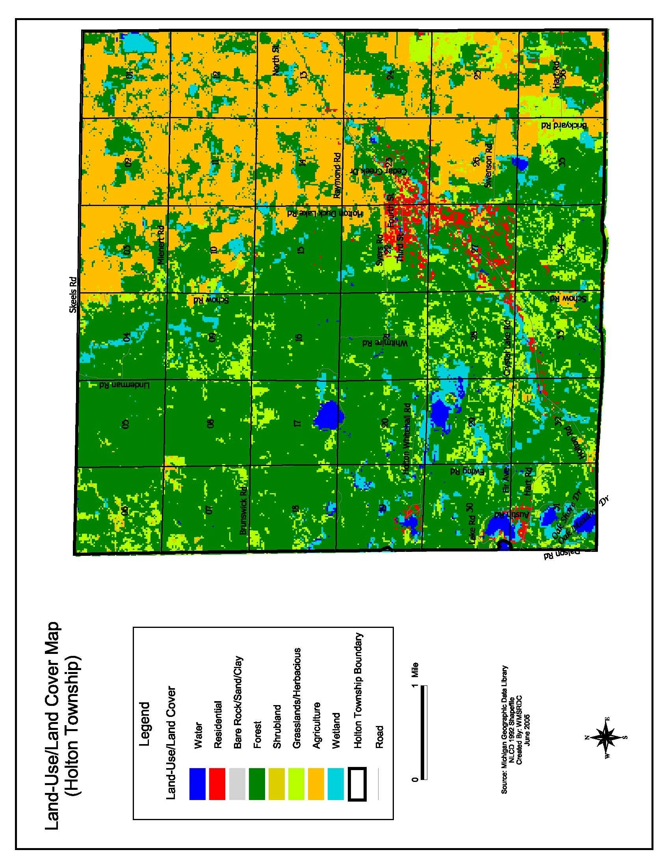
- DEVELOPMENT STRATEGY

Township Visions and Goals

During a public meeting held on March 15, 2005, attendees completed a Strengths, Weaknesses, Opportunities, and Threats (SWOT) Analysis in order to identify existing conditions, as well as, possible future conditions of the community. The results of the SWOT Analysis in addition to discussions with the Holton Township Board of Trustees and Planning Commission were used to formulate the following Visions and Goals. Overall, four main theme areas surfaced during this process. They are listed in no particular order.

Environment: Protecting and preserving the environment and natural resources in Holton Township.

Quality of Life: Maintaining the rural character of Holton Township.

Economic Development: Promote and foster economic development within Holton Township.

Land Use: Use practical land use decision making while upholding the rights of property owners.

The Comprehensive Land Use Plan is founded on the policies outlined in the following statements. The goals are intended to describe a desirable end state or condition of the township twenty to twenty-five years into the future. The goals and objectives are intentionally general but all are felt to be attainable through a collaborative community effort. The objective statements tend to be more specific and may be viewed as milestones used in the process to achieve the larger goal. The following goals and objectives are listed in no particular order.

GOAL: Infrastructure/Community Protection

Work with the Muskegon County Road Commission and other transportation agencies to develop and maintain roadway priorities. In addition, control the location, density, pattern, and type of future development in order to minimize unnecessary public expenditures for infrastructure. Maintain the Holton Township Fire Department in order to provide continued protection to area residents.

OBJECTIVES:

- Develop and maintain a working relationship with the Muskegon County Road Commission and other transportation agencies.

- Develop and implement a plan that balances maintenance of existing roads with the development of new roads.

- Develop and maintain a working relationship with the County Sheriff’s Department and the Michigan State Police in order to adequately meet the public safety needs in Holton Township.

- Develop and implement infrastructure improvements and maintenance programs including roads, sidewalks, and communications, incorporating streetscape improvements to be made by business owners and community members.

GOAL: Recreation/Community Facilities

Utilize and promote the vast amount of public land, open space, and forested areas in Holton Township for recreational purposes, by establishing parks and recreational facilities for all residents in the township and surrounding areas.

OBJECTIVES:

- Maintain and update the Holton Township Community Recreation Plan to prioritize community needs, mark progress towards task completion, and retain the township’s eligibility for available financial support.

- Develop techniques to build and strengthen the community consensus concerning recreation and the public’s role in providing the necessary facilities.

- Create and maintain a working relationship with Muskegon County park officials, as well as, state and federal officials to investigate possibilities of recreational facilities development within the township.

- Coordinate recreation programs with area adult education programs and the Holton Public School District.

GOAL: Planning/Growth Management

Foster land use decisions that protect open and green areas, to encourage commercial and industrial development, and/or expansion within defined areas. Utilize existing assets to encourage growth within the community. Make land use decisions in accordance with a current and continually reviewed Land Use Plan and through broad community involvement and support.

OBJECTIVES:

- Evaluate and amend as necessary the Holton Township Zoning Ordinance to further the goals of the Land Use Plan as they arise.

- Develop an inventory of redevelopment opportunities and tools to encourage investment and reuse of underutilized properties.

- Continually educate the Holton Township Board of Trustees, Planning Commission, and Zoning Board of Appeals on the advantages of managed/controlled growth.

- Continually inform and educate the community concerning the advantages of managed/controlled growth.

- Improve existing township parks.

GOAL: Economic Growth

Foster economic growth through development that is consistent with the overall goals of the plan. Provide the necessary infrastructure and services to support area business and industry. Create opportunities for future economic growth within the community.

OBJECTIVES:

- Develop and design an inventory of important economic assets and mechanisms to strengthen them.

- Create an inventory of existing business and industry and identify the future needs of each.

- Define the community’s core and develop and implement mechanisms to establish and strengthen that core area.

- Establish a working relationship with area business and industry.

- Work with Muskegon Area First in order to promote economic growth within the township and the county.

GOAL: Environment/Natural Resources

Promote the abundant natural resources located in Holton Township while taking adequate measures to protect the environment including its lakes, rivers, streams, groundwater, woodlands, farmlands, and wildlife habitat.

OBJECTIVES:

- Create an inventory of both public and private natural features of the community. Identify the uniqueness of each, as well as probable threats.

- Build and strengthen relationships with state, federal, and county agencies to further the community’s goals for the protection of natural features.

- Increase communication with neighboring communities to protect and preserve natural features from possible contamination, inappropriate development, and degradation.

- Create, update, maintain, and continually strengthen a community concession to sustain rational and responsible growth management strategies to be utilized by Holton Township elected and appointed officials.

- Continually educate the community on the importance of protecting and preserving the natural resources in the community.

- Cultivate and establish a system to monitor the viability of natural features and a process to control and limit development in affected areas.

GOAL: Regional & Intergovernmental Cooperation

Become a regional leader in promoting cooperation and mutual support between and among the jurisdictions surrounding Holton Township. Recognize and support the Muskegon Area-wide Plan as the county-wide vision and strive to remain consistent with that plan.

OBJECTIVES:

- Inventory existing relationships with local, county, regional, and state units of government and evaluate the township’s role and the effectiveness of the relationship. Identify areas where future relationships could exist.

- Maintain continuous and active participation in regional activities, capital improvements, economic development, watershed planning, land use planning, and transportation planning.

- Continually seek common regional goals and cooperative approaches to meet them.

- Seek consolidation of services that will enhance the services and lead to more availability of those services.

GOAL: Housing, Neighborhoods, and Community

Define Holton Township’s identity through a strong sense of community and promote the valuable quality of life available to its residents.

OBJECTIVES:

- Create increased opportunity for senior housing within the township.

- Create a variety of house choices for township residents.

- Develop and implement housing to be consistent with providing for the general health, safety, and welfare of township residents and to promote an aesthetic atmosphere.

- Develop and implement programs to renew and improve existing housing and pursue funding to renew areas that require attention.

- Define what the aesthetic values for Holton Township homesteads are and develop vehicles to strengthen them.

- Develop and implement effective programs to strengthen code enforcement measures assuring safe, sanitary, and pleasing homesteads.
- IMPLEMENTATION

Future Land Use

The included recommendations should be used as a guide for growth and development in Holton Township. The following describes the recommended future land use districts that are the narrative explanations of the districts contained on the Future Land Use Map.

A Future Land Use Plan and zoning ordinance are related. A zoning ordinance is the legal arm of a Future Land Use Plan. It is the most frequently used and effective regulatory tool to implement a Future Land Use Plan, as it regulates land use. The word ‘district’ is often used in both kinds of documents; however, the term must be used carefully. Using similar terms for the various land use designations is one way to demonstrate the relationship between the two documents, and it helps to avoid confusion and translation difficulties. It is also important to realize that a future land use map and a zoning map are not necessarily the same thing. The map should not be confused with the Township zoning district map, which is a current (short-term) mechanism for shaping development. The plan categories generally correspond to zoning districts, but there is some overlap to allow for specific site conditions. The Future Land Use Map is intended to serve as a guide for land use decisions over a longer period of time. The following recommended future land use districts will have some overlap in purpose and implementation. Also, see the discussion on the Zoning Ordinance under the section titled General Implementation and Techniques, on how to use this Plan and its recommended Future Land Use Districts.

As part of this planning process, eight future land use districts have been recommended. These districts are the result of an analysis of current land uses, physical and environmental suitability, the existence and ability to provide services, and compatibility with the goals and objectives previously identified in the Plan. The eight districts are as follows:

- High Density Residential

- Medium Density Residential

- Low Density Residential

- Rural

- Agriculture

- Commercial

- Industrial

- Forest-Recreation

Future Land Use Categories

Residential 1:

This designation refers to denser residential development for single-family, two-family, and other multi-family dwelling units. This designation is generally found near the unincorporated village of Holton, as well as Brunswick, and the Ewing Subdivision. Development should be at a density consistent with the areas existing and planned infrastructure and land capabilities. These areas are served by wells and septic systems. Other land uses that should be permitted in this district include public and quasi-public buildings, parks and recreational facilities, and mobile home parks.

Residential 2:

The designation is intended to provide land for residential growth close to the village of Holton without overtaxing current services while still providing a density of population close to schools and businesses. This district also serves the need to limit growth to the north, west, and east of the village where soils have severe limitations for septic systems. This land use category is intended to provide a lesser-intensity of development that will assist the community goals of preserving the natural beauty of vegetation and terrain while enhancing the rural setting now experienced by the residents. Other uses to be promoted in this district include open space, playgrounds, and other recreational facilities, especially those utilizing and protecting Cedar Creek.

Residential 3:

This land use category is intended to arrest and where possible, reverse the negative trends of strip development that has occurred in the township over the past thirty years. The type of residential development envisioned in this district is single-family homes on large, multi-acre lots. The land selected for inclusion is not suited for agriculture in most cases. The soils are capable of supporting septic systems, as would be required in the rural areas comprising this district. Gentle, rolling hills, often bordering scenic creeks, make these lands scenic and desirable building sites. The extent of the low-density residential district has been dictated, in large part, by the existing use of the land for residences already in place. Other uses in this district could be planned unit developments, parks, two-family homes, and quasi-public facilities.

Residential 4:

The Rural land use district provides a rural setting for single-family dwellings that will preserve the natural land, water, and vegetative attributes of the area. It also provides a needed buffer district between agriculture and residential, and forest-recreational and residential uses. Providing this buffer will protect agricultural lands from neighboring incompatible land uses, and enhance residential districts by preserving the natural beauty and physical attributes of the area. Permitted uses should accommodate natural forest production, and small-scale truck-crop and specialty farming. Other land uses should be in accordance with these goals, including parks and recreational facilities, quasi-public buildings, and quarrying/mining operations.

Agriculture:

This designation identifies that this area shall remain in agricultural use. This category is to promote and protect the stability of the farming population as a sector of the community, which is a very desirable feature in terms of providing a constant tax base and population. Many farms in the township are enrolled in Michigan’s Farmland and Open Space Preservation Act (Act 116 of 1974), which provides financial incentives to designate lands for long-term farming use. This also promotes land use stability. Holton Township possesses a large amount of Muskegon County’s prime farm land. Nearly nine sections in their entirety and four partial sections consist of prime farm land. Agriculture is, then, the best use of the land in this area and represents a long-range vision for the benefit of the general public. Conversion of this land to other land uses that would be less economical or less-suited or designed for short-term, private gain should be discouraged.

Commercial:

The commercial district is intended to include retail, office, and service establishments. This category is best served when densely grouped, due to the large generation of vehicular traffic and to minimize the effects on adjacent districts. Businesses that serve the requirement of the community at large, including neighboring municipalities and pass-by traffic, are designated by this category. Lands included in the commercial district are located mainly along the M-120 corridor and within the village of Holton.

Industrial:

The industrial district was designated to expand the tax base and improve the employment opportunities within the township. The intent is to develop industrial uses such as research, wholesale, and warehouse activities and light industrial operations which manufacture, compounding, process, package, and assemble and/or treat finished or semi-finished products from previously prepared materials.

Forest Recreation:

The intent is to protect and preserve suitable land for recreational purposes and forested areas. It is designed to regulate and limit the location of buildings and structures to protect the natural resources, including, but not limited to, natural habitats of wildlife, waterways and water bodies, forestry capabilities, public and private recreational uses, and human, plant, and animal life. The largest quantity of federal and state land primarily in the western half of the township provides a unique opportunity for woodland preservation and recreational development. This land comprises a portion of the Manistee National Forest, and encompasses a number of privately-owned parcels within its boundaries. This Forest Recreation district provides a good use of these undeveloped lands in the outlying areas. Preservation of the natural and rural attributes in the township for future citizens is an important goal. This district will maintain these existing large tracts of forest land as a renewable resource for the future.

FUTURE LAND USE MAP

Map #7
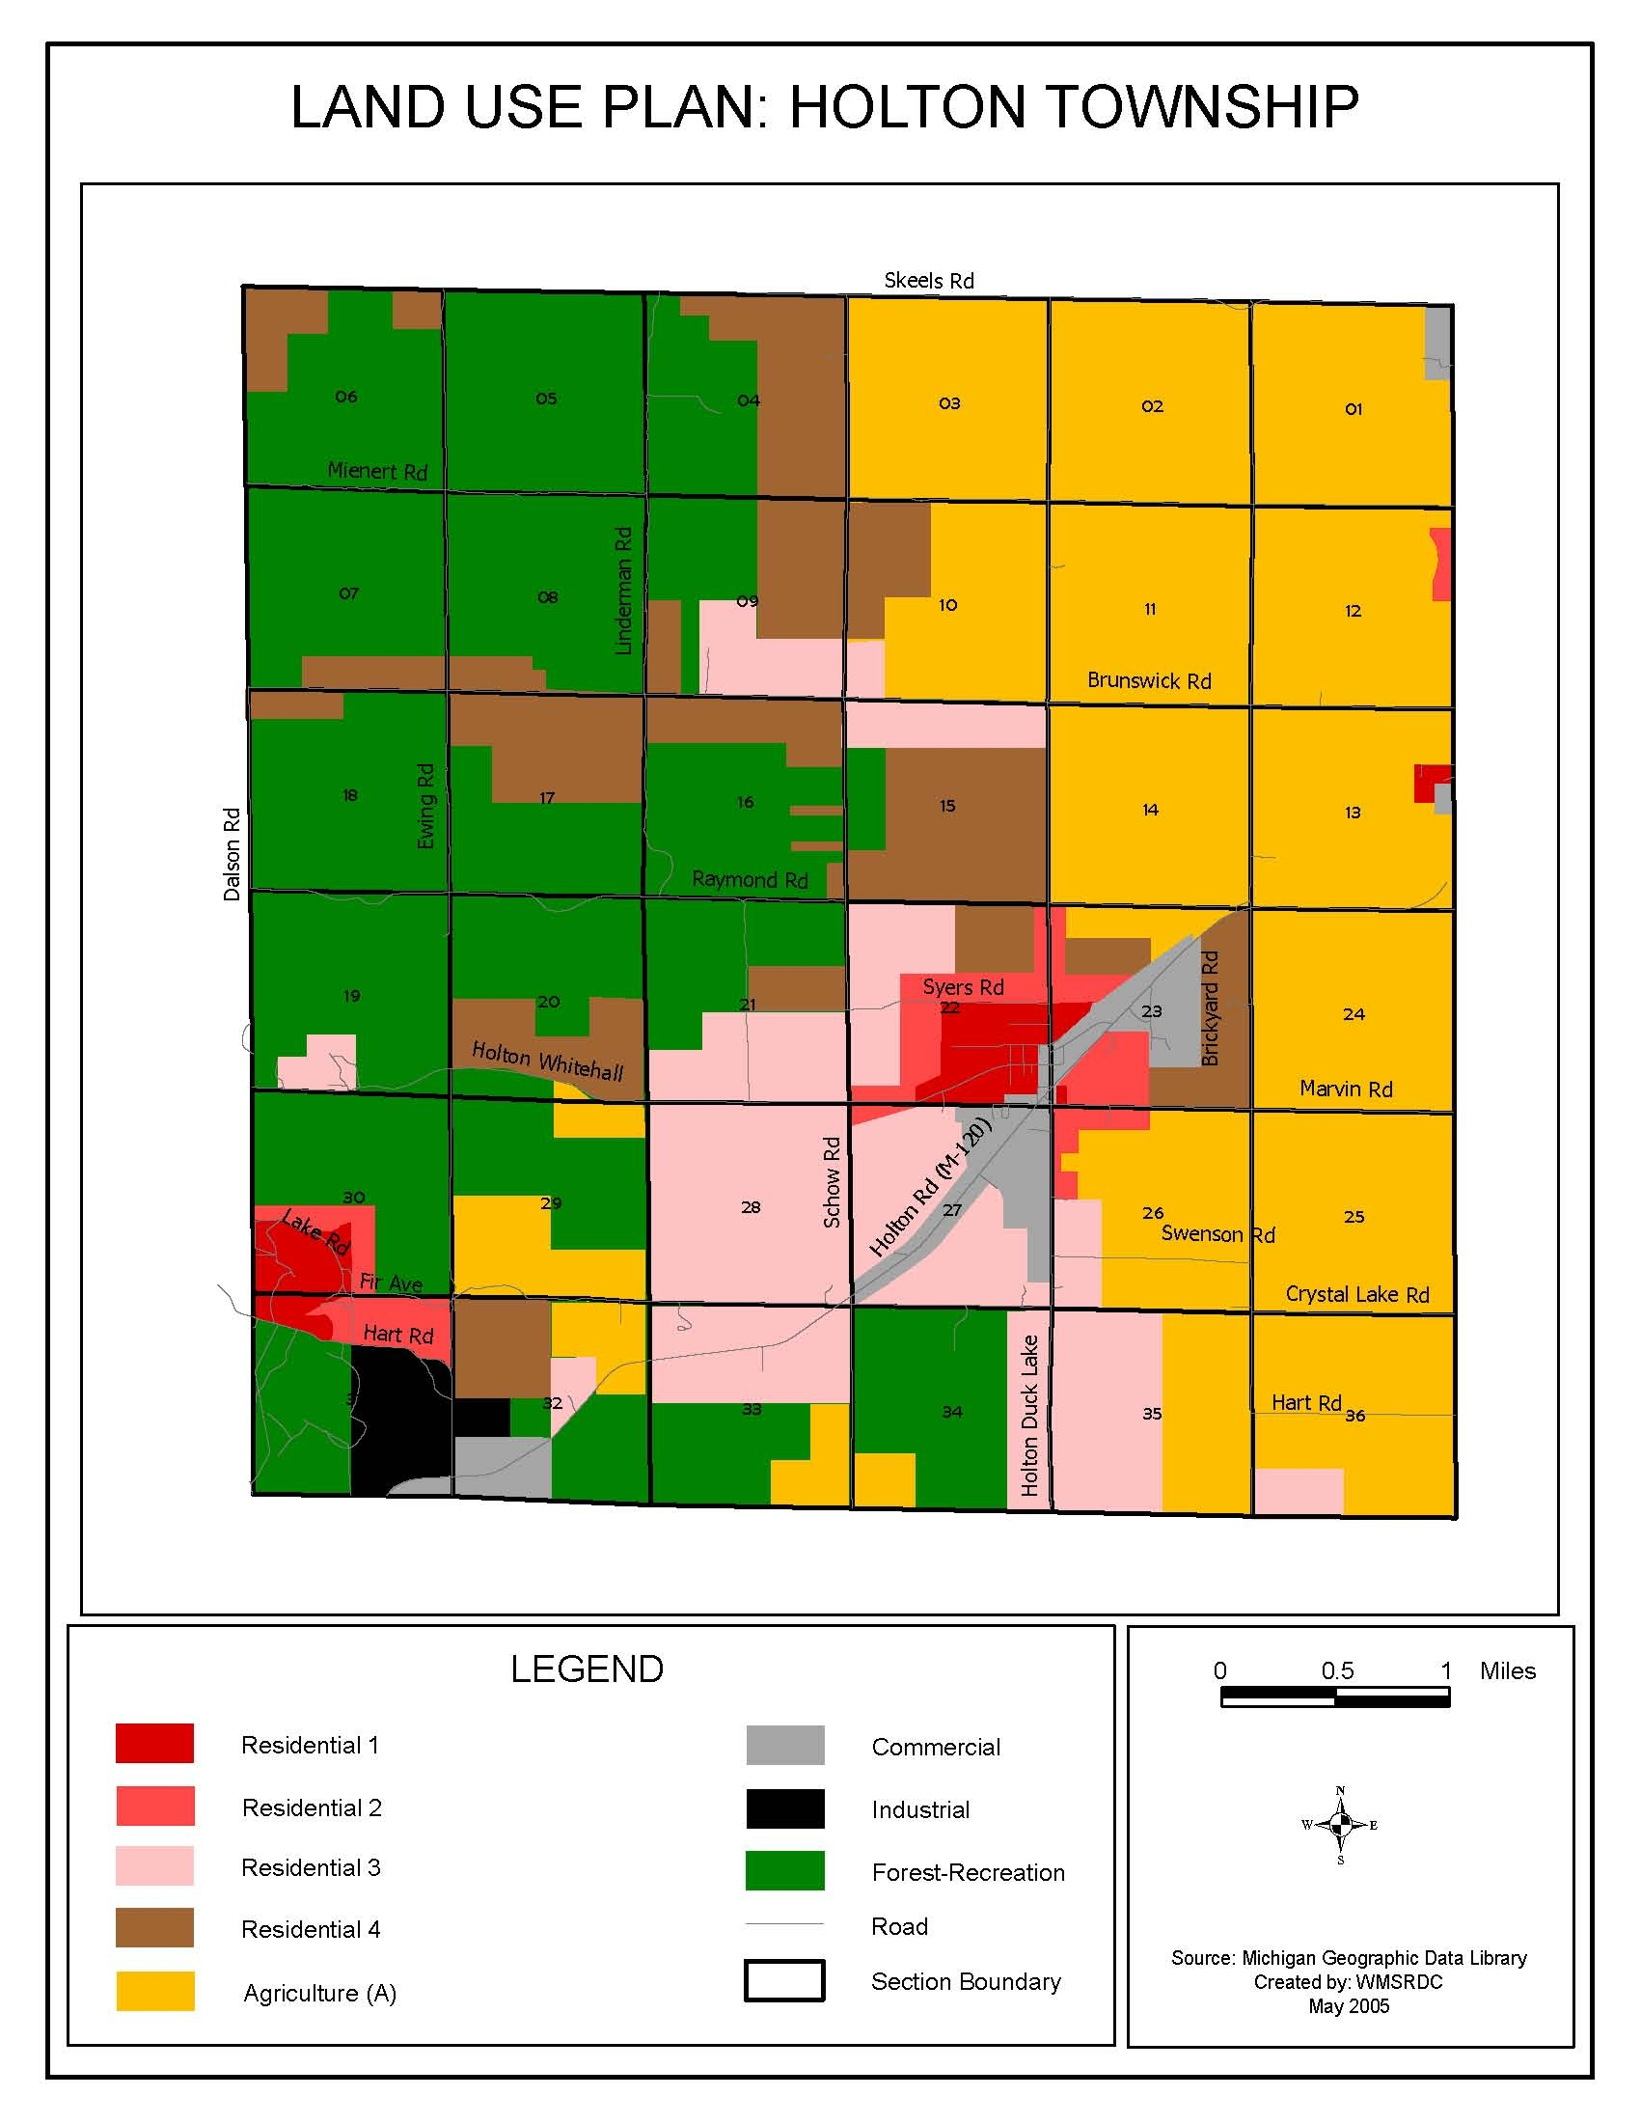

Map #8
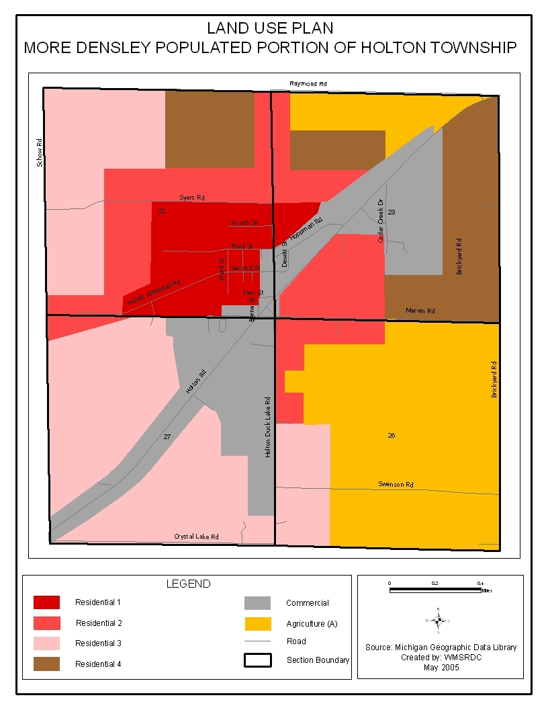
Planning Implementation Tools and Techniques

The ultimate goal of planning, of course, is implementation. Implementing the ideas generated through the planning process is the culmination of the analysis, goal setting, and interaction activities, which took place during the creation of the Future Land Use Plan. This portion of the Plan is designed to guide the community in taking the actions necessary to achieve its goals and objectives.

The Plan is intended to be a working document that provides the township’s decision makers with information on the goals desired by the community. The Plan should, therefore, be consulted whenever policy issues arise, especially those relating to land use.

Successful implementation requires a continuous effort on the part of the Planning Commission, Township Board, and the community at large. It is essential that each member of the Planning Commission and Township Board understand the Plan, know their own role as it relates to the Plan, and promote implementation of the Plan by their Township Planning Commission, Township Board, and appropriate agencies, community groups, and citizens.

The goals and objectives of the Holton Township Land Use Plan can be implemented through the use of the following described tools and techniques that Holton Township can utilize. The following list of tools and techniques are certainly not an exhaustive list, however, some are more applicable to the Township than others. Many of the tools and techniques can be used for multiple purposes by Holton Township to achieve its goals and objectives, even though they are listed under specific headings.

Zoning Ordinance

A zoning ordinance is the primary regulatory tool used to implement future land use plans. Following the adoption of the Plan, Holton Township should complete an internal inventory and review its priorities. From these, they should then amend the Holton Township Zoning Ordinances.

This will ensure that the zoning ordinance will be consistent with the completed Holton Township Land Use Plan. The zoning ordinance itself will reflect the Holton Township Land Use Plan: however, the zoning map does not necessarily reflect the future land use map.

Public Involvement

In preparing the Holton Township Comprehensive Land Use Plan Update, several means of soliciting public input were used. To begin the process, a “Notice of Intent to Plan” letter was mailed to each of the adjoining townships and counties informing them of the Land Use Plan Update. A public meeting was also held on March 15, 2005 in order to gain input from the community. The community was invited and encouraged to attend the meeting through a notice published in The Muskegon Chronicle, a paper of local circulation two weeks prior to the meeting. The meeting was conducted by Regional Commission staff. Participants were presented with demographic and economic information relevant to Holton Township. In addition, participants were taken through a Strengths, Weaknesses, Opportunities, and Threats (SWOT) Analysis which assisted in identifying the community’s goals and objectives. Results of the SWOT Analysis can be found in Appendix A.

Upon completion of the draft Land Use Plan, a two week public viewing period was held from November 14 through November 28, 2005. The draft document was displayed at the Holton Township Hall and the Holton High School Library. Following the two week public viewing period, a Public Hearing was held to receive public comment. Notice of the public viewing period and Public Hearing were published in The Muskegon Chronicle prior to the viewing period. No public comments were received.

Finally, the draft Holton Township Comprehensive Land Use Plan Update was sent to the adjoining townships and counties for the required 90-day review period. During the review period, comments were received by Bridgeton Township, Newaygo County. A copy of the comments can be found in Appendix A. A second Public Hearing was held on June 20, 2006 to receive comments from the 90-day review period. Notice of the Public Hearing was published in The Muskegon Chronicle both four weeks and two weeks prior to the Hearing.

Copies of all letters, notices, meeting handouts/exercises, public comments, and meeting minutes from throughout the development of the Holton Township Comprehensive Land Use Plan Update can be found in Appendix A.

- CONCLUSION

The aspirations for change included in a land use plan will occur as a result of cumulative private and public decisions about such things as opening a business, locating a residential development, and installing a public park. That is, the inter-workings of investments by private actors, individual entrepreneurs, as well as, development decisions by public and quasi-public agencies, bring about physical change to a municipality. If properly used, the Land Use Plan can inform government about where public development, such as playgrounds, should go. It can give potential investors a general sense of where the community would prefer residential, commercial, and industrial development to be located. In short, the purpose of a land use plan is to offer guidance to any and all actors whose decisions affect land. In more particular terms, this plan offers several professional suggestions for achieving commonly held aspirations for the Township’s future development.

This Land Use Plan provides a clear vision for Holton Township’s future growth and development. It describes where various types of future land uses, through the Future Land Use Map, and where development should be located, as well as provides guidance as to the form, characteristics, and appearance that are desired for future development. However, the vision embodied by the Plan is but the first step in making those visions a reality.

Beyond this Plan, is the need for a commitment by the Township to dedicate the necessary resources for review of the Land Use Plan at a minimum of every five years. This will enable the Planning Commission to track progress of implementation, while taking the pulse of the community to determine whether the goals are still appropriate and if additional goals should be added.

The Plan should be consulted regularly, as it is a guide for land use decisions, and should be updated accordingly as the local situation warrants. It is important to note that change is inevitable, and managing that change will be the key to Holton Township’s success in the control of development and the desired build-out of the Township.

Bibliography

United States Department of Commerce, Bureau of the Census. 2000 Census of Population and Housing. Washington D.C.: GPO, June 2002.

United States Department of Agriculture, Natural Resource Conservation Service and Forest Service. Soil Survey of Muskegon County, Michigan. Washington D.C.: GPO, 1968.

United States Department of Commerce, Economics and Statistics Administration, Bureau of Economic Analysis, Regional Economic Measurements Division. Regional Economic Information System: 1969 – 1993. Washington D.C. GPO, May 1995.

West Michigan Shoreline Regional Development Commission. Crystal Township Land Use Plan. 2004: 6.

West Michigan Shoreline Regional Development Commission. Holton Township Master Plan. 1992.

Michigan Department of Labor & Economic Growth. Lansing, MI, 2004.

Sources used in compiling the Community History section include:

Community Brochure, Holton Business and Civic Association Community Brochure, 1989.

Hackley Library, Muskegon, records.

Holton Public Library records.

Holton Area Centennial, 1871 to 1971.

Holton School PTA Centennial Cookbook, 1971.

One Hundred Years of Grace, The Lutheran Church Centennial Book, including the 1979 update.

Trygstad Family Recipes, 1987.

Appendix A

Public Notices and Plan Approval Process

316 Morris Avenue - Suite 340 - PO Box 387 - Muskegon, MI 49443-0387
Telephone: 231/722-9362 - Fax: 231/722-9362
www.wmsrdc.org - wmsrdc@wmsrdc.org

