WEST MICHIGAN METROPOLITIAN TRANSPORTATION PLANNING PROGRAM (WESTPLAN) POLICY COMMITTEE MEETING

MEETING MINUTES
February 17, 2015

- CALL TO ORDER
Chairperson Roger Bergman called the meeting to order at 1:30 p.m.

ATTENDANCE
- Members Present
Roger Bergman, Ottawa County (Chairperson)
Edd Whalen, City of Whitehall (Vice-Chairperson)
Kay Beecham, City of Norton Shores
Betty Gajewski, Ottawa County Road Commission
Elmer Hoyle, Ravenna Township
Susie Hughes, MATS
Jack Kennedy, Muskegon County Road Commission
Melissa Klos, City of Roosevelt Park
John Lanum, MDOT Lansing
Bonnie McGlothin, City of Muskegon Heights
Robert Monetza, Harbor Transit
Mark Powers, Village of Spring Lake
Dennis Scott, City of Grand Haven
Jason Kolkema, Village of Fruitport

- Members Not Present
Chuck Woods, City of North Muskegon
Kim Arter, Laketon Township
Dan Ruiter, City of Ferrysburg
Leon Stille, Crockery Township
Byron Turnquist, City of Muskegon (excused)
Rillastine Wilkins, Muskegon County Commissioner
Rachel Tupica, FHWA (Non-Voting)

- Others Present
Laird Schaeffer, Citizen

- Staff Present
Joel Fitzpatrick, WMSRDC
Brian Mulnix, WMSRDCS
Sgt. Doug Roesler, Michigan State Police

- APPROVAL OF THE MINUTES (NOVEMBER 18, 2015) –A motion was made to approve the minutes from the November 18, 2015 meeting as submitted. Motion approved. m/s Whalen/Klohs

- PROCEDURES FOR CHANGING SPEED LIMITS – Sgt. Roesler from the Michigan State Police spoke on the procedures necessary to change speed limits.

- PUBLIC COMMENT

No member of the public spoke.

- FY 2014-2017 Transportation Improvement PROGRAM

Mr. Mulnix reviewed the proposed Amendment L to the 2014-2017 TIP.

FY2014-2017 TIP Amendment L

City of Muskegon Heights- 2017

Delete project- Center Street, Peck Street to Baker Street, Reconstruct- Federal $99,605 State $0 Local $25,395 (STUL)

Add Project- Hackley Avenue- Park Street to Glade, Resurface, Federal $99,605 State $0 Local $37,034 Total $136,639 (STUL)

MATS- 2016

Add Project- Mobility Management Activities- Federal $80,000 State $20,000 Local $0 Total $100,000 (5310)

Add Project- Mobility Management Marketing- Federal $40,000 State $10,000 Local $0 Total $50,000 (5310)

MATS- 2017 (CMAQ)

Delete Project- Facility Development- Federal $67,584 State $16,896 Local $0 Total $84,480 (CMAQ)

Increase Funding on existing project- Outreach and Marketing- currently listed as: Federal $130,000 State $32,500 Local $0 Total $162,500

Proposed Change: Federal $197,584 State $49,396 Local $0 Total $246,980 (Additional funding will come from the deleted Facility Development project being removed from this year)

MATS – 2018 (CMAQ)(Change will be reflected in the new FY2017-2020 TIP)

Delete Project- Outreach and Marketing- Federal $60,000 State $15,000 Local $0 Total $75,000 (CMAQ)

Increase Funding on existing project- Facility Development - currently listed as: Federal $330,000 State $82,500 Local $0 Total $412,500

Proposed Change: Federal $390,000 State $97,500 Local $0 Total $487,500 (Additional funding will come from the deleted Outreach and Marketing project being removed from this year)

A motion was made to approve the proposed Amendment L to the 2014-2017 TIP. Motion approved. m/s Whalen/Kennedy

- 2017-2020 TRANSPORTATION IMPROVEMENT PROGRAM – Mr. Mulnix reviewed the project list for the 2017 -2020 TIP. It was noted that the CMAQ list was previously reviewed and approved by the committee, and that the FY2017 projects lists (all categories) will be the same in both the FY2014-2017 and 2017-2020 TIP documents.
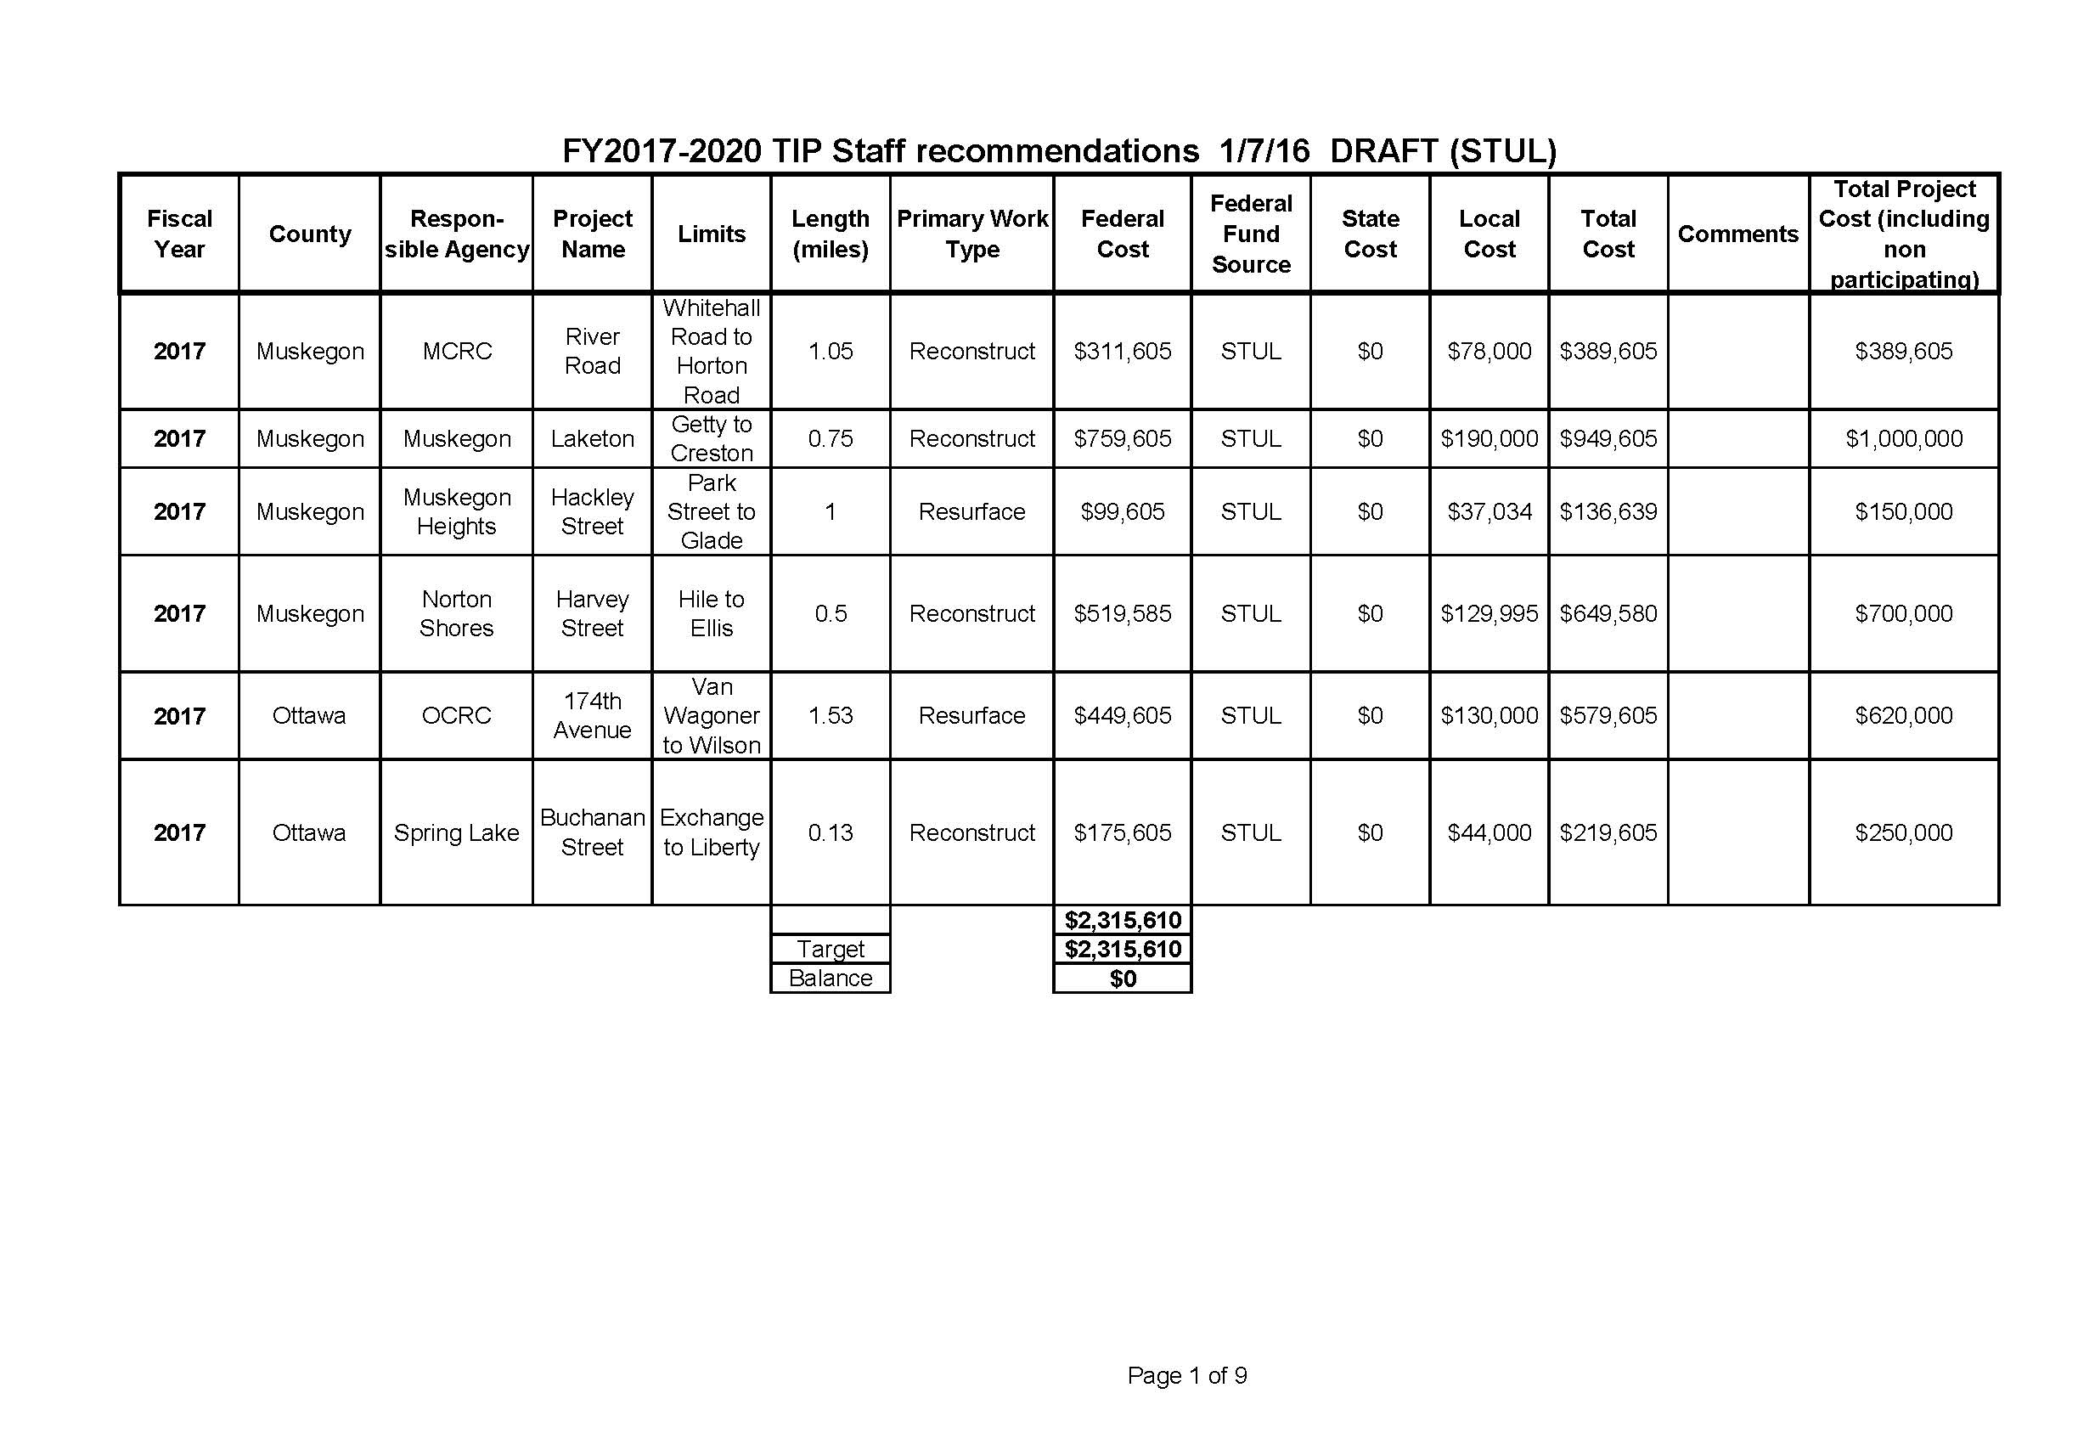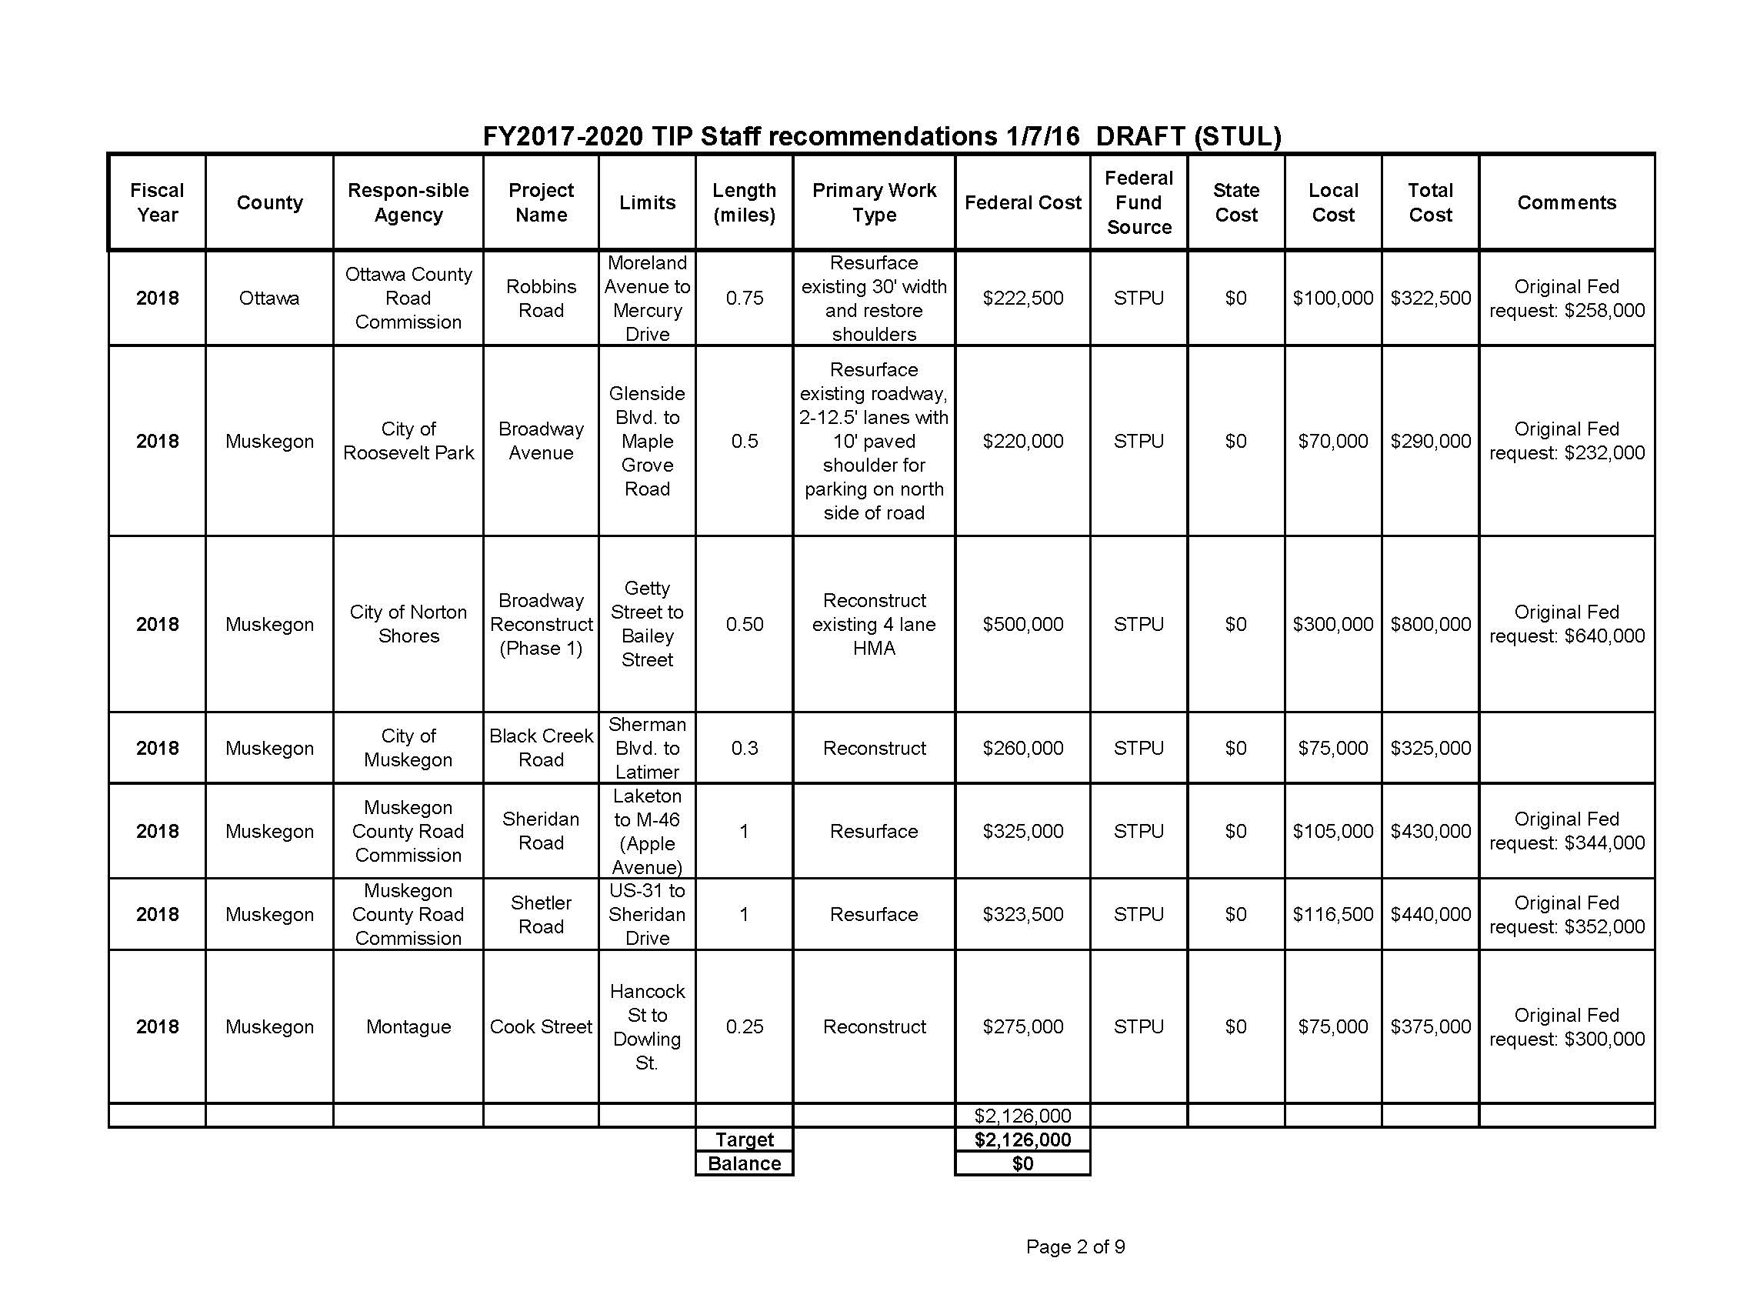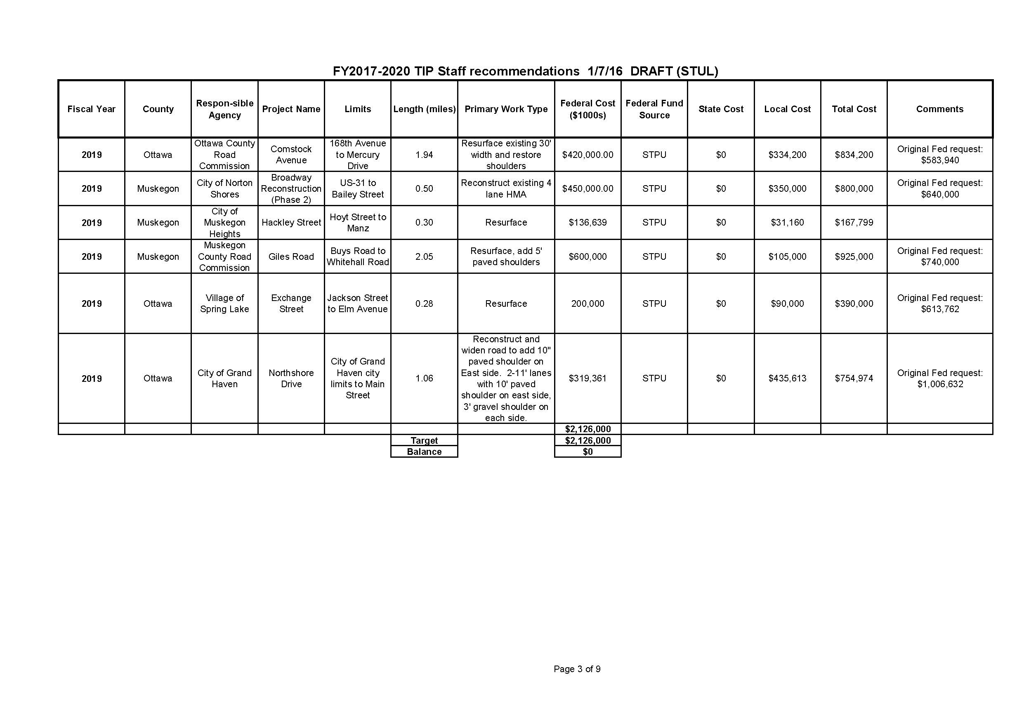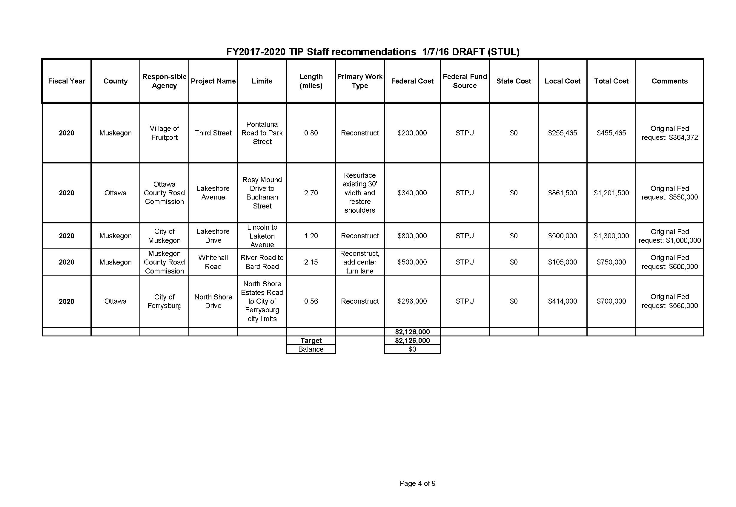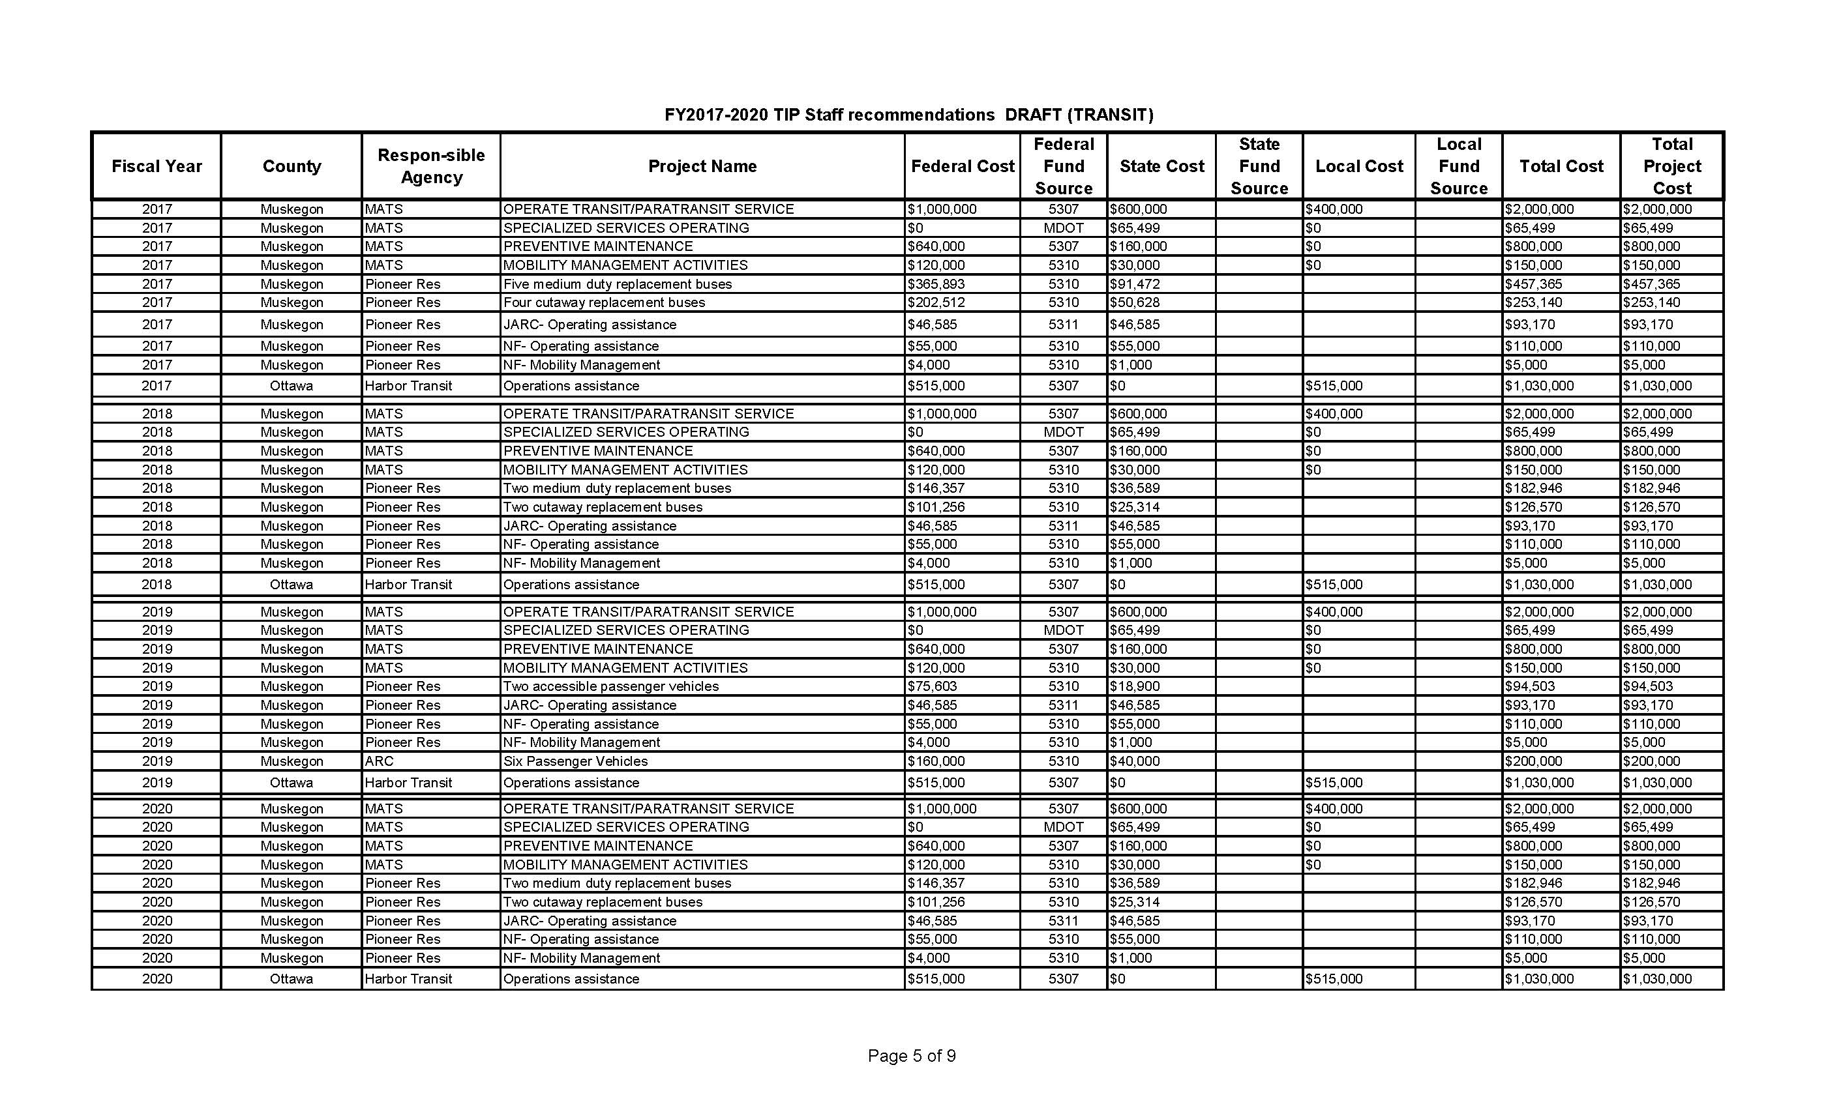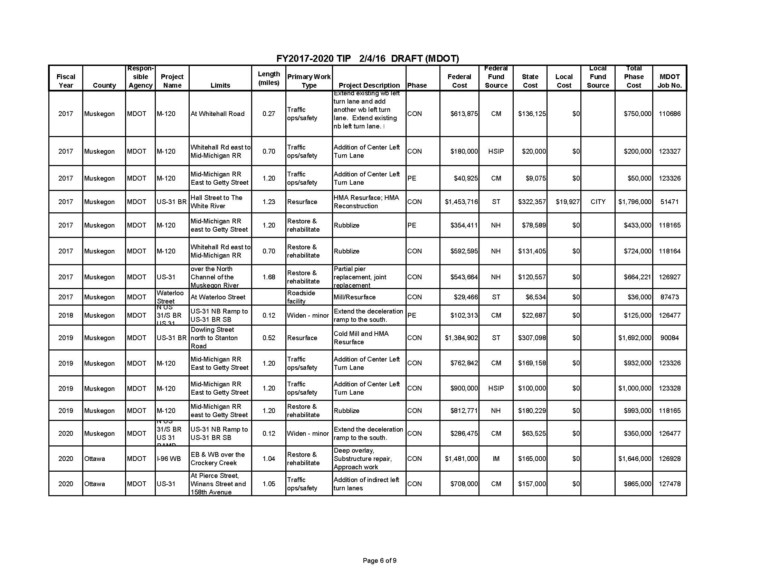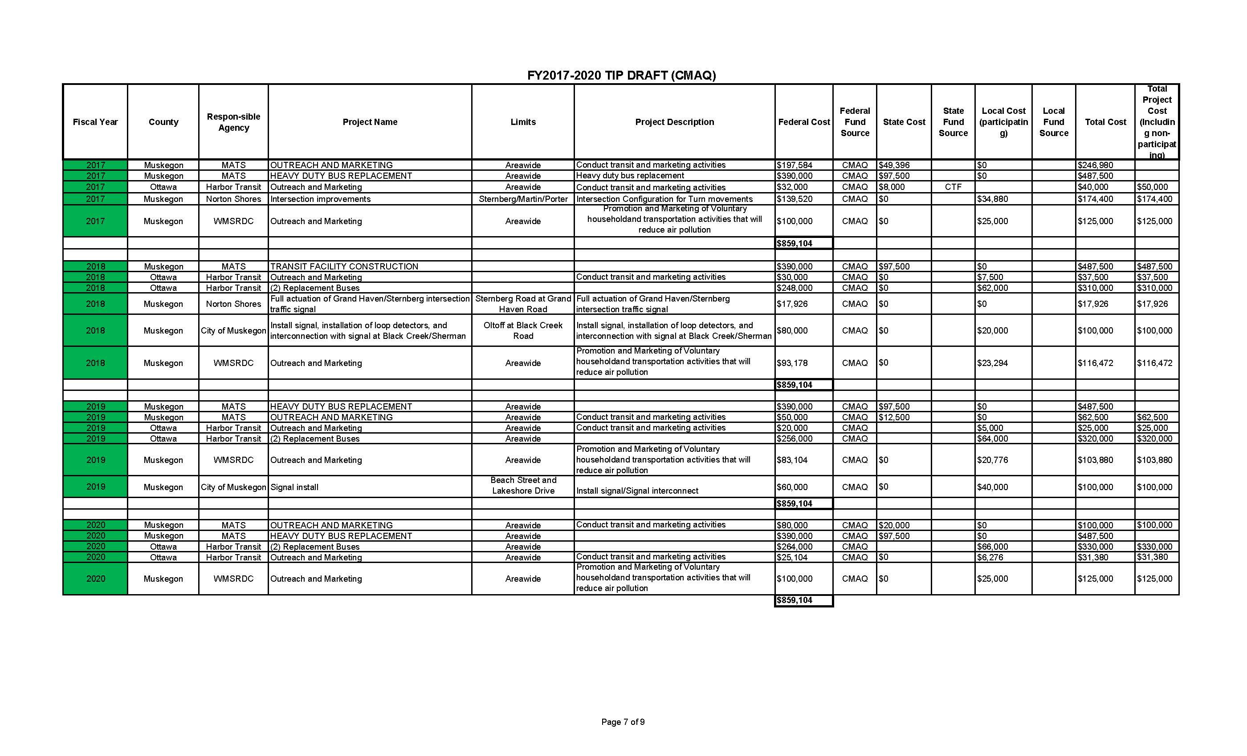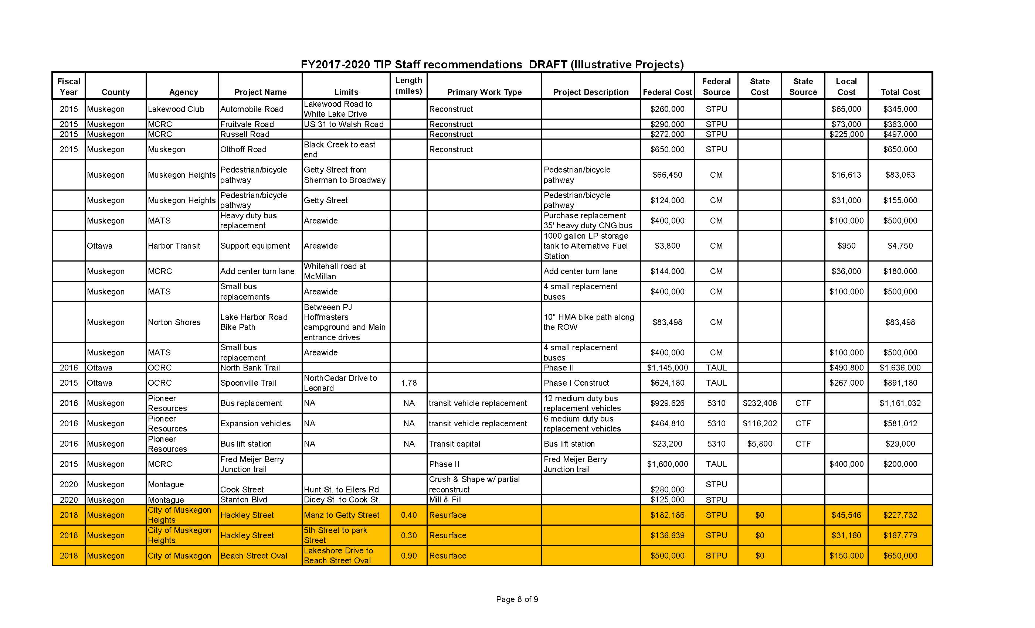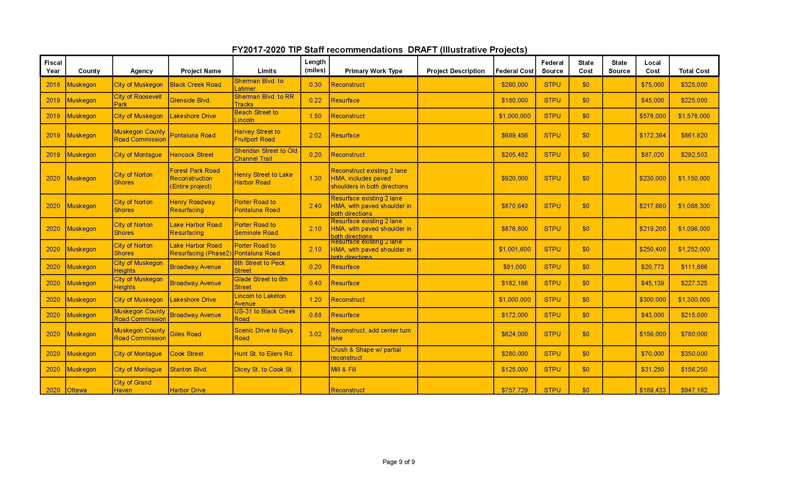

A motion was made to approve the proposed 2017-2020 TIP list. Motion approved. m/s Whalen/Klos

- MPO ROUNDTABLE /NEW BUSINESS

- Ms. Melissa Klos brought up the issue of emergency phones for pathways.
- Mr. John Lanum stated that they could be an eligible expense if there was a commitment by the local units of government for upkeep.
- Mr. John Lanum noted the e-stip system and also that staff would be meeting with MDOT for the Pre-UWP meeting in a couple of weeks.

- UNFINISHED BUSINESS – Mr. Tom Anderson noted that the Berry Junction Trail project is slated to be completed in FY 2016.

- NEW BUSINESS –Joel Fitzpatrick mentioned the upcoming Asset Management training.

- PUBLIC COMMENT – Mr. Laird Schaeffer requested a follow up on Grand Haven Township/City of Grand Haven Resiliency Plan. Mr. Dennis Scott had followed up on the matter and WMSRDC is now mentioned in the plan.

- ADJOURNMENT – A motion was made to adjourn. Motion passed. m/s Kennedy/Klos. Meeting was adjourned at 2:40 p.m.

