

2040 Long Range Transportation Plan

Approved by the WestPlan Policy Committee on June 17, 2015



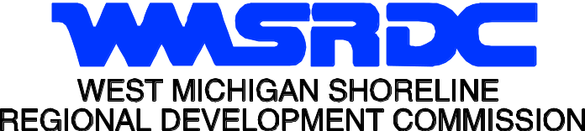
WEST MICHIGAN SHORELINE
REGIONAL DEVELOPMENT COMMISSION
(WMSRDC)

The WMSRDC is a regional council of governments representing 127 local governments in the West Michigan counties of Lake, Mason, Muskegon, Newaygo, Oceana, and northern Ottawa.

The mission of WMSRDC is to promote and foster regional development in West Michigan… through cooperation amongst local governments.

Susie Hughes, Chairperson
Evelyn Kolbe, Vice-Chairperson
James Rynberg, Secretary

Erin Kuhn, Executive Director

Project Staff:

Amy Haack, Program Manager
Brian Mulnix, Program Manager
Joel Fitzpatrick, Program Manager

TABLE OF CONTENTS
Project Staff: 2
CHAPTER 1: INTRODUCTION 1
Overview of Plan 1
Description of the MPO 2
Summary of the Planning Process 3
CHAPTER 2: REGIONAL OVERVIEW 6
Brief History of the Region 6
Transportation History of the Region 7
Geography of the Region 9
CHAPTER 3: REGIONAL GOALS AND OBJECTIVES 13
Themes, Goals, and Objectives 13
Background Preparation 15
CHAPTER 4: PERFORMANCE MEASURES 16
State Performance Measures and Targets 18
MPO Performance Measures and Targets 18
CHAPTER 5: PROGRESS SINCE LAST PLAN 19
CHAPTER 6: PUBLIC INVOLVEMENT 24
Public Participation Mailing List 24
Public Participation Outreach 24
Conclusion 26
Written Public Comment 26
Copy of Public Comment Open House Announcement 28
CHAPTER 7: EXISTING TRANSPORTATION SYSTEM FACILITIES 29
Highways and Bridges 30
Public Transit 35
Air Transportation 39
Port and Maritime Transportation 40
Rail and Freight Transportation 41
Non-Motorized Transportation 42
Safety Planning 45
Security Planning 46
CHAPTER 8: TRENDS AND PROJECTIONS 47
2010 Population/Households/Employment 47
2040 Population/Households/Employment 47
Travel Patterns 49
Land Use 52
CHAPTER 9: REGIONAL ISSUES 56
Analysis of Background Research 56
System Condition 56
System Operations 58
Trends and Issues Affecting Regional Transportation 60
CHAPTER 10: URBAN TRAVEL DEMAND MODEL 63
Network 64
Socio-Economic Data 65
Trip Generation 66
Trip Distribution 67
Mode Choice 68
Traffic Assignment 68
Model Calibration/Validation 69
Applications of the Calibrated/Validated Model 69
System Analysis for MTP 70
CHAPTER 11: DEFICIENCIES, ISSUES, AND PROJECTS 71
Identification of deficiencies 71
Deficiency Maps 71
Impact of Projects 83
Environmental Justice 83
Environmental assessment of Natural Features 91
Planning/ Design Guidelines 96
Construction/Maintenance guidelines 96
CHAPTER 12: AIR QUALITY 98
CHAPTER 13: FINANCIAL RESOURCES ANALYSIS 99
Cooperative Revenue Estimation Process 99
Anticipated Funding Sources 100
Cost Estimates 108
Demonstration of Financial Constraint 109
CHAPTER 14: CONSULTATION 111
Consultation Agency List 111
Consultation Meeting 117
Documentation of Consultation 117

CHAPTER 1: INTRODUCTION

Overview of Plan
MAP-21, the Moving Ahead for Progress in the 21st Century Act (P.L. 112-141), was signed into law by President Obama on July 6, 2012. Funding surface transportation programs at over $105 billion for fiscal years (FY) 2013 and 2014, MAP-21 is the first long-term highway authorization enacted since 2005. By transforming the policy and programmatic framework for investments to guide the system’s growth and development, MAP-21 creates a streamlined and performance-based surface transportation program and builds on many of the highway, transit, bike, and pedestrian programs and policies established in 1991.
The Clean Air Act of 1970 (CAA) and its Amendments require that the federal government review all transportation plans to assure improved air quality. These conformity requirements, first introduced in the 1977 CAA Amendments, prohibited federal approvals of actions that did not concur with state government’s State Implementation Plan (SIP) for air quality improvements. These requirements were further expanded in the 1990 Amendments to require that transportation plans conform to the SIP’s expressed purpose of eliminating or reducing the severity and number of violations of the National Ambient Air Quality Standards, and achieving expeditious attainment of such standards.
The Muskegon and Northern Ottawa County area and the State of Michigan are operating under the State Implementation Plan (SIP). This plan identifies how air quality will be protected and improved in the State. The processes for reviewing and approving Long Range Transportation Plans and projects are outlined in the SIP and are being followed in the development of transportation plans statewide.
Under the CAA, the U.S. Environmental Protection Agency has currently classified Muskegon County and Ottawa County as attainment areas for the ground-level ozone pollutant. Muskegon is classified as its own area while Ottawa and Kent Counties are classified as a two-county combined area.
The WestPlan 2040 Long-Range Transportation Plan provides for a multi-jurisdictional, multi-year look at the Muskegon/Northern Ottawa area's future transportation system. Transportation needs and resources were evaluated for the period 2014 to 2040, and appropriate plans were made for meeting long-term needs, in the best manner possible with constrained finances. The plan also includes the use of local, state, and federal transportation goals and objectives to guide transportation plans and projects. This plan covers transportation for all of the WestPlan area and, as such, is heavily flavored with input from local elected officials, municipal and road agency staff, and the citizens of the Muskegon/Northern Ottawa area.

Description of the MPO
WestPlan consists of a Policy Committee and a Technical Committee. The Technical Committee reports directly to the Policy Committee. The Policy Committee is responsible for all final decisions regarding transportation. All meetings, with the exception of special meetings, are held during normal business hours. The following local communities and/or transportation agencies and providers are members of WestPlan:
- Federal Highway Administration - City of Ferrysburg
- City of Grand Haven - Harbor Transit
- Michigan Department of Transportation - City of Muskegon
- Muskegon Area Transit System - Muskegon County Road Commission
- City of Muskegon Heights - City of North Muskegon
- City of Norton Shores - Ottawa County Road Commission
- City of Roosevelt Park - City of Whitehall
- Village of Spring Lake - City of Montague
- Village of Fruitport - Muskegon County urban twp. rep.
- Ottawa County urban twp. rep. - Muskegon County rural twp. rep.
- Ottawa County rural twp. rep. - Muskegon County
- Ottawa County
The Technical Committee usually meets every other month, but more often when deemed necessary. The Technical Committee is comprised mostly of staff members of various member agencies. Members are typically engineers, city managers, or department of public works staff. The Technical Committee acts as an advisory committee to work on issues which are primarily technical. The Technical Committee then makes recommendations to the Policy Committee.
The Policy Committee also usually meets every other month, but more often when deemed necessary. It is comprised almost entirely of local elected officials who have been appointed to the committee by their jurisdictions. The Policy Committee is responsible for all final decisions regarding transportation within the MPO.

Summary of the Planning Process
The development and management of a community’s transportation system requires various levels and degrees of planning. At one level, individual communities may develop implementation plans for a single construction season or capital improvement plans to meet needs for the next five to six years. At another level, Metropolitan Planning Organizations (MPOs) develop both Short and Long-Range Transportation Plans that cross municipal boundaries and provide a transportation vision for an entire metropolitan area.

Eight Federal Planning Factors
The continual development of this document is a cooperative effort of the local communities, transportation stakeholders, the public, and the metropolitan planning organization (MPOs). The process, explained below, includes the development of numerous elements. The development of the Long Range Transportation Plan is driven, in part, by eight Federal planning factors which have been identified by FHWA. These factors are outlined below.
- Support the economic vitality of the metropolitan area, especially by enabling global competitiveness, productivity and efficiency.
- Increase the safety of the transportation system for motorized and non-motorized users.
- Increase the security of the transportation system for motorized and non‐motorized users.
- Increase the accessibility and mobility of people and for freight.
- Protect and enhance the environment, promote energy conservation, improve the quality of life, and promote consistency between transportation improvements and state and local planned growth and economic development patterns.
- Enhance the integration and connectivity of the transportation system, across and between modes, for people and freight.
- Promote efficient system management and operation.
- Emphasize the preservation of the existing transportation system.
One of the first steps in the process involves scoping. During this scoping process, MPO committees reviewed the existing vision, goals, and objectives. A number of revisions were made in anticipation of performance based planning measures. These decisions were informed by the eight federal planning factors as well as other considerations.
The collection and analysis of data is one of the first steps of the planning process. For this effort, demographic information for the Muskegon and northern Ottawa County area was collected at a detailed “traffic analysis zone” (“TAZ”) level. This included socio-economic data items such as population, housing units, vehicles available, retail and non-retail employment, and other data. Information that was also gathered includes traffic count levels, land cover patterns, zoning ordinances, comprehensive development plans, environmental factors, and recent local developments.
In addition to the collection of current data, projections must be made for future years of the plan. Using population and employment projections, environmental and other development constraints, land use patterns, local knowledge, and many other factors, socio-economic estimates were made for the year 2040. These projections provide an estimate of how the Muskegon/Northern Ottawa MPO area may develop in the coming years.
As the socio-economic data was being compiled and projections were being made, a computer model of the WestPlan transportation network was also being further refined. The computer model, used for long-range planning and for air quality modeling, includes a complex network of simulated roadways in the WestPlan area. Each roadway in the model carries a simulated level of traffic based on the surrounding land uses, population, traffic counts, roadway types, and other socio-economic factors.
The current socio-economic data and traffic information was used as input to the model, and the model was calibrated so that the simulated traffic closely matched actual traffic patterns and data. Once the calibration process was complete, the socio-economic data estimates for the year 2040 were included in the model in order to determine if the current transportation system would be able to accommodate the growing or shifting demographics of the area. The purpose of the model is to identify roadways that are currently deficient or will be in the future.
In addition to modeled capacity deficiencies, other transportation concerns are addressed in the plan. This is accomplished through the identification of a “local concerns” list and through the development of goals and objectives. The local communities compiled the local concerns in order to address transportation needs such as safety, operational, or economic concerns that may not be shown by the capacity deficiency model. The concerns and desires of the WestPlan area are also included in the goals and objectives for this plan. These goals and objectives will guide transportation efforts into the future.
As the goals and objectives were being developed, financial resources were also being analyzed. As the plan must be financially constrained, an estimate of transportation revenues to the area must be calculated before plans for the transportation system and implementing projects can be selected. Recent funding sources and levels were used by MDOT to project future revenues, and the total amount of transportation funds that could be expected through the year 2040. This list of projects includes only those projects that significantly change the transportation network, and does not need to include resurfacing projects and other routine preservation projects. Although residential roads are important in the WestPlan area, the list of projects focuses on the broader transportation network and the more significant streets, roads, and highways.

Brief Description of Public and Stakeholder Involvement
Public and stakeholder involvement throughout the LRP planning process was ensured through a number of mechanisms:
- Press releases
- Newspaper articles
- Social media notifications
- Direct mailings of the WMSRDC newsletter
- Internet web page
- WMSRDC Annual Report
- Meetings of the WestPlan Technical and Policy Committees
- Special meetings
- Workshops
- Public meetings
MAP-21 also requires that WestPlan consult with federal, state and local entities that are responsible for:
- Economic growth and development
- Environmental protection
- Airport operations
- Freight movement
- Land use management
- Natural resources
- Conservation
- Historic preservation
A list of these transportation stakeholder agencies is located in the Consultation Chapter. The goal of this process is to eliminate or minimize conflicts with other agencies' plans that impact transportation. WestPlan staff began the consultation process by reviewing its current stakeholder list to expand and ensure that the correct types of organizations noted above were receiving information regarding the LRP. With the assistance of Federal Highway Administration, Michigan Department of Transportation, and other MPOs, additional entities are constantly being identified therefore expanding the transportation stakeholder list.
Agencies on the Consultation list were contacted when a draft list of projects was adopted by the Technical and Policy Committees.

CHAPTER 2: REGIONAL OVERVIEW

Brief History of the Region

Muskegon County
The earliest recorded history of the Muskegon area reflects that it was inhabited by the Ottawa and Pottawatomi tribes. The name “Muskegon” is derived from the Ottawa Indian term “Masquigon” meaning “marshy river” or “swamp.” The “Masquigon” river is identified on French maps as early as the 17th century, suggesting that French explorers had reached Western Michigan by that time (Yakes).
The first known Frenchmen in the area were Father Jacques Marquette, who traveled through the area in 1675 on his way to St. Ignace and a party of French soldiers under LaSalle’s lieutenant, Henry de Tonty, who passed through in 1679 (Yakes).
The earliest known resident of the county was a fur trader and trapper named Edward Fitzgerald, who settled in the area in 1748. Settlement of the area began in 1837 with the organization of Muskegon County from portions of Ottawa and Oceana Counties. At the time of its incorporation in 1859, Muskegon County had six townships (Muskegon, Norton, Ravenna, White River, Dalton, and Oceana) (Yakes).
The lumbering era put Muskegon County on the map, in economic terms. Ravenna was settled in 1844 when E.B. Bostwick built a sawmill. The city and township were named after Ravenna, Ohio, the hometown of the surveyor who platted the land. Norton Shores was settled by Colonel S. Norton in 1846. Casnovia was founded in 1850 by a tavern keeper named Lot Fulkerson. Montague was first settled in 1855 by Nat Sargent. Whitehall was platted in 1859 by Charles Mears and Giles B. Slocum. The town was originally named after Mears. In 1864 the Muskegon Log Booming Company was formed to sort logs and raft them to the mills. In 1868, Fruitport, originally Crawville, was founded by Edward Craw. It was renamed a year later when the Pere Marquette Railroad built a station in the town that was a fertile fruit growing area and a port. In 1872 North Muskegon was recorded as Reedsville, named for the first settler, Archibald Reed. It was renamed in 1881 when it was incorporated as a village. North Muskegon was later incorporated as a city in 1891 (Multi-Mag Michigan).
1890 marked the end of the lumber boom in Muskegon County. Successful area industrialists formed the Muskegon Improvement Company to stimulate the economy as it lagged at the end of the lumber boom. The Muskegon Improvement Company purchased 1,000 acres and sold the lots in a lottery, using the proceeds to underwrite new businesses. The project was successful enough that a train station was located in the area (Muskegon Heights) in 1902 to serve the Chicago & West Michigan Railroad (Yakes).
Union Depot was opened in 1885 to serve the Chicago & West Michigan; Muskegon, Grand Rapids, & Indiana; and the Toledo, Saginaw & Muskegon railroads. It was designed by A.W. Rush & Son of Grand Rapids in the Richardsonian Romanesque style. The station was closed in 1971 until it was donated to the county in 1992, restored, and reopened as the visitor’s center and museum (Historical Markers). Lakewood Club was formed as a resort association in 1912 by the Mayo brothers. It was popular enough by 1914 that a seasonal post office was set up, which became permanent in the 1940s (Multi-Mag Michigan).
The oil boom in Muskegon County was a distinct period during the city’s industrial era. The oil was found by accident in 1869 when Gideon Truesdell was looking for salt. They had been drilling in various Muskegon County locations for salt between 1869 and 1886 but the salt they found was contaminated with petroleum. In 1922, Stanley Daniloff found oil seepage in the swampland near his home, within five years he had amassed enough funds to have the site drilled and a “gusher” was located in Muskegon Township in 1927. The price of crude oil fell with the depression in 1929 and the oil boom ended (Parrish).
During the world war period, Muskegon became an “Arsenal of Democracy.” In the post war housing boom, Roosevelt Park was formed as a residential suburb in 1949 and named after Franklin Delano Roosevelt. The 1950s and 60s brought rough economic times to Muskegon County. Many workers were laid off and several local companies closed. In the 1960s and 70s, consolidation and mergers with national corporations left few locally-owned businesses in the county. In recent years Muskegon has diversified its economy to include advanced manufacturing, healthcare and tourism. Major companies include Alcoa, GE, Mercy Health, and Cedar Fair. It has the most active port on the east side of Lake Michigan and is now one of Michigan’s top tourism destinations known nationally for great fishing and boating.

Northern Ottawa County
As in Muskegon County, the Pottawattamie and Ottawa Indians lived in the Grand Haven area prior to the first white settlers. The Grand River served as a trade route for the Native American tribes. The first permanent white settler to the area was Rev. William Montague Ferry, a Presbyterian minister who moved to the area in 1834. Ferry founded the first area church as well as the town of Ferrysburg.
A plat for the City of Grand Haven was recorded in 1835. The settlement of the surrounding areas of Spring Lake and Ferrysburg followed soon after. Over the following six decades Grand Haven saw success as part of the lumbering industry due to its location as a port.
The railroad arrived in 1858 which assisted in the development of the area’s manufacturing and resort industries which took advantage of the port. In the past few decades northern Ottawa County has become a vibrant port, boating, fishing, and resort community.

Transportation History of the Region
The WestPlan MPO is located along the routes of U.S. 31 and Interstate 96, which are two major state transportation arteries linking the area to all major regional population and economic centers such as Chicago, Detroit, Grand Rapids, Lansing, Indianapolis, and Milwaukee. U.S. 31 runs north and south along the Lake Michigan shoreline from South Bend, Indiana to Mackinaw City, Michigan. However, the classification of U.S. 31 as an expressway terminates at Ludington, Michigan, where it becomes a state highway generally served by only two lanes. The course of Interstate 96 is an east-west direction from Muskegon to Detroit by way of Grand Rapids and Lansing. The Muskegon metropolitan area is provided with public transit opportunities through the Muskegon Area Transit System (MATS).
Northern Ottawa County’s transit needs are covered by Harbor Transit Multimodal Transportation System (Harbor Transit), which provides public transportation to the area through a demand-response system, as well as limited fixed routes which operate during the summer months.
Commercial air service is available at the Muskegon County Airport with daily service to Chicago’s O’Hare Airport. The Major airline that operates out of Muskegon is United Airlines. Muskegon and Grand Haven presently serves as the major deep water ports in the area. In June 2004, Muskegon began receiving car ferry service to Milwaukee, Wisconsin by way of the Lake Express. This diesel-powered catamaran-style ferry travels at speeds of up to 40 miles per hour. Service is provided numerous times a day from late April through October.
The primary inter-city bicycle route in the region is the Hart-Montague Trail State Park. The trail spans 22.5 miles from Hart in Oceana County to Whitehall in Muskegon County. Efforts are being made to construct the Fred Meijer Berry Junction Trail, which is a 10-mile stretch of trail between Whitehall and North Muskegon. This will connect the Hart-Montague Trail to the City of Muskegon’s Lakeshore Trail. This trail covers about 12 miles throughout Muskegon. Another path, the Musketawa Trail, extends 26 miles eastward from Muskegon to Marne in Ottawa County. From Marne, the trail becomes the Fred Meijer Pioneer Trail which extends to in Kent County. Additionally, efforts are underway in northern Ottawa County to complete a trail system which would connect local trails with regional trails.
The history of metropolitan transportation planning in the Muskegon area dates back to 1973, when the West Michigan Shoreline Regional Development Commission (WMSRDC) organized the Muskegon Area Transportation Planning Program as the MPO Policy Committee. In 1974, a Long-Range Transportation Plan was developed for the Muskegon Urban area. This plan was updated in 1986 and then re-certified as a Policy Document by the Muskegon Area Transportation Planning Program (MATPP) in 1990. In 1991, the plan was reviewed in light of the Clean Air Act Amendments (CAAA) of 1990 and was approved by the Environmental Protection Agency (EPA) as a conforming plan for air quality. In recent years, the effects of CAAA of 1990 and the Intermodal Surface Transportation Efficiency Act (ISTEA) of 1991 have caused changes in the scope and scale of transportation plans. In 2002, the US Census Bureau expanded the urbanized boundary for the Muskegon MPO. This action expanded the urbanized area to include Northern Ottawa County. Four townships, two cities, and one village were added to the MPO. The change was based on population density, and it was determined that the area between the Muskegon urbanized area and the Grand Haven urbanized area, also known as the “tri-cities area”, was now one contiguous urban area. This expanded MPO is now known as the West Michigan Metropolitan Transportation Planning program or WestPlan. After the 2010 Census the boundaries of the ACUB were changed yet again. With this expansion the urbanized boundary was extended south into Port Sheldon Township in Ottawa County.
WestPlan undertakes a comprehensive transportation planning program to maintain the eligibility of local governments in the area to receive federal and state transportation funds for street and road improvements, as well as subsidies for mass transit.

Geography of the Region
The WestPlan MPO area is located on the western side of Michigan, midway up the state's Lower Peninsula, along the shoreline of Lake Michigan the geography of the area is characterized by coastal plains and immense lakeshore sand dunes, inland rolling hills, and high ridges. The area, heavily dependent on tourism revenues, is home to several popular state and county parks and other tourist activities. The area is known for its abundant natural features including productive fruit orchards, expansive forests, and many miles of Lake Michigan waterfront, inland lakes, and many rivers including the Grand River and the Muskegon River.

figure 1 - Map of MPO Planning Area
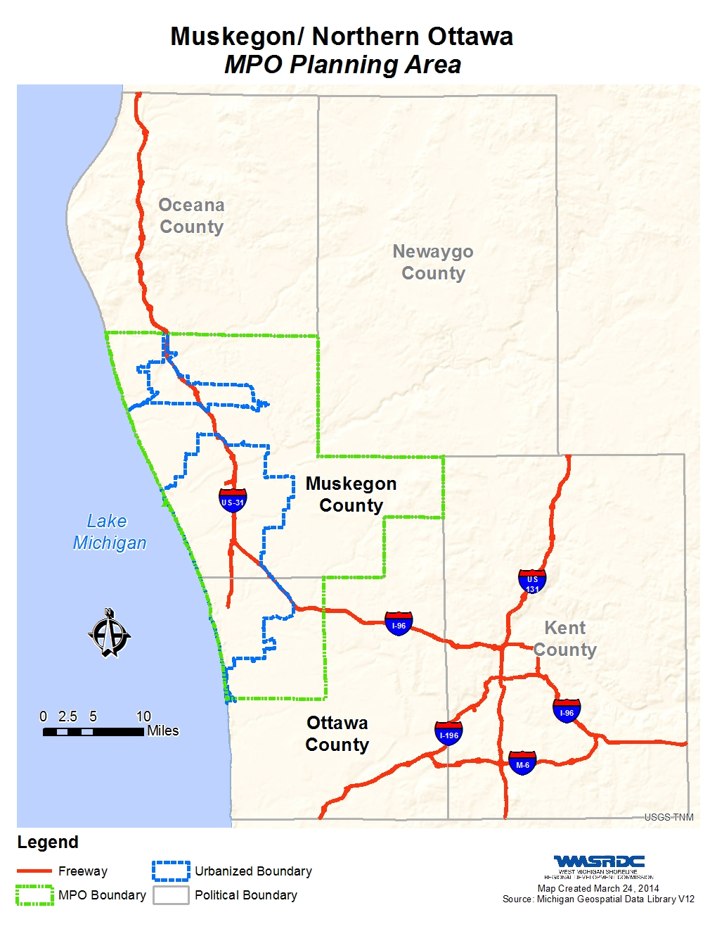

figure 2 - Map of Political Jurisdictions
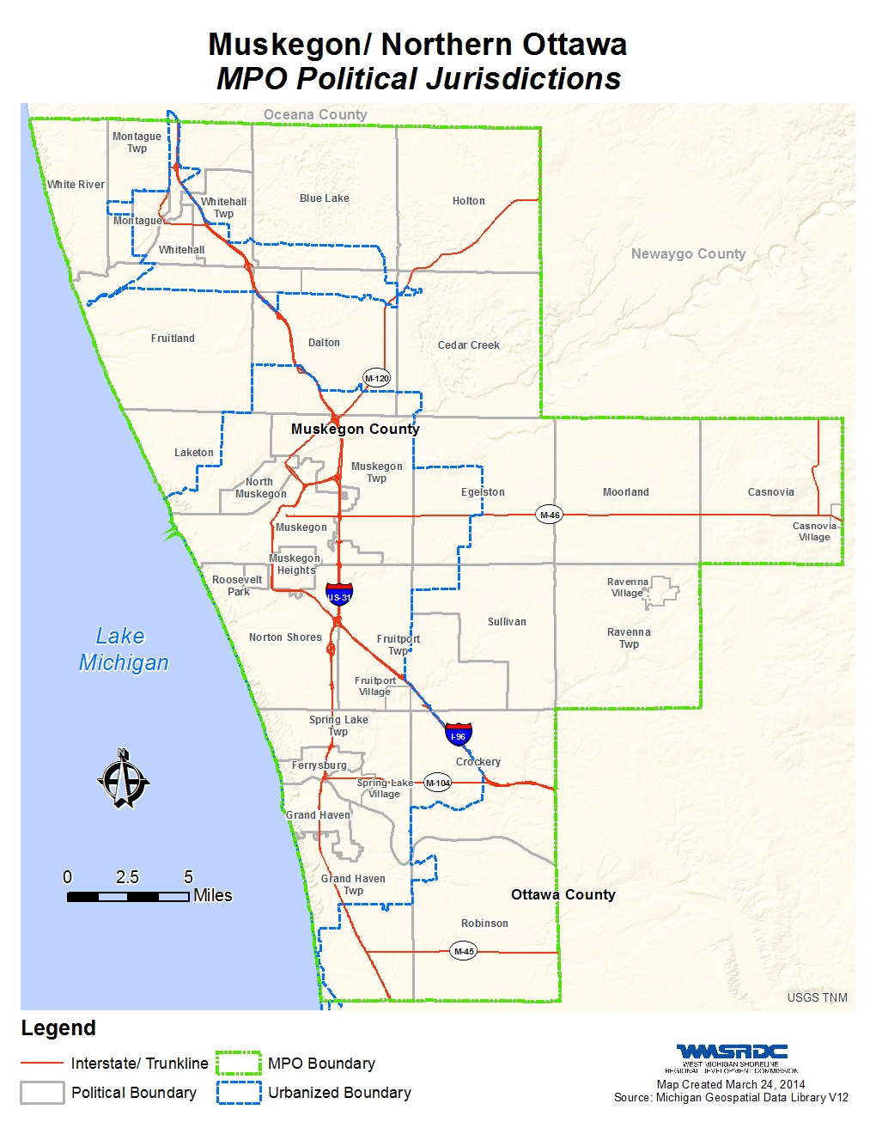

figure 3 - Map of Physical Features of the Region
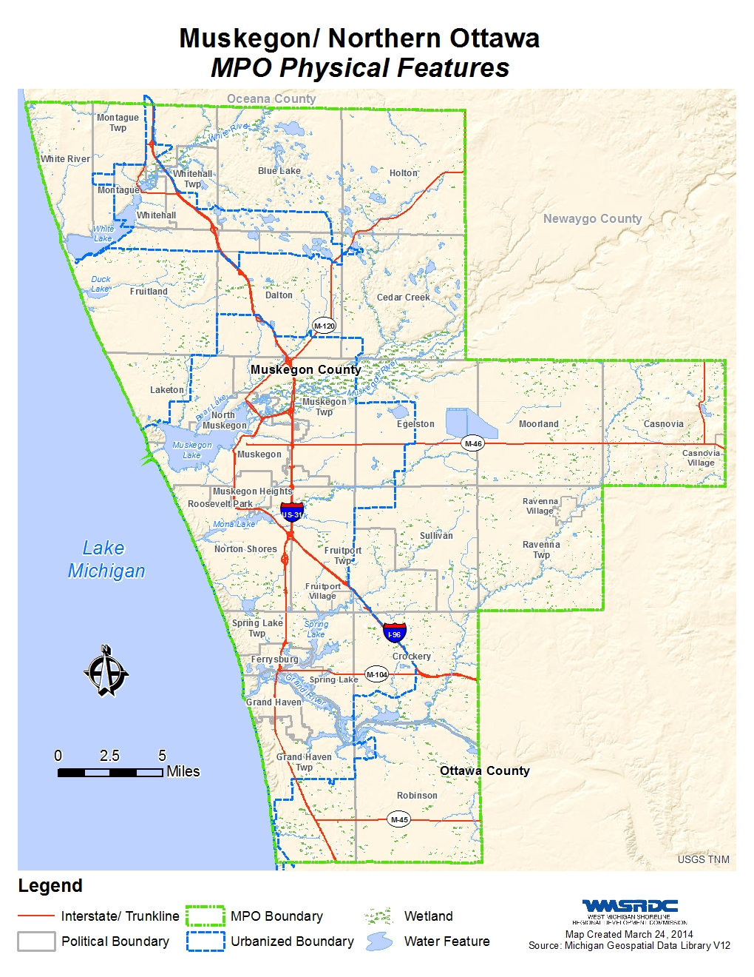

CHAPTER 3: REGIONAL GOALS AND OBJECTIVES

This update to the Long Range Transportation Plan for 2040 will serve as a policy statement and a guide for decision-making for Muskegon and northern Ottawa County MPO, funding agencies, stakeholders, and transportation partners. The plan includes an inventory of needs and deficiencies of the MPO’s transportation network. Additionally, it establishes priorities for allocation of federal funds and directs transportation improvement programming. The 2040 LRP shifts its focus to respond to new state and federal initiatives and guidance, and to position the MPO to respond to anticipated trends of new federal legislation governing transportation funding and investments.

Themes, Goals, and Objectives
The 2040 LRP will serve many purposes including setting the stage for the MPO’s Transportation Improvement Program. Additionally, it will be used to evaluate infrastructure investments and consistency with local, county, and regional land use and development goals. Understanding this as a basis, this plan includes the following goals and objectives. These goals were developed to encompass the array of users, conditions, needs, and potential solutions exclusive to the overall transportation system within the MPO. Objectives were then developed for each goal that could be used to evaluate the value of individual projects and also measure the success of the plan as a whole. In this manner, the 2040 LRP goals and objectives are organized into six primary themes that are consistent with the required federal planning factors and statewide guidance:
1. Economic Vitality
Goal: Ensure that transportation investments support the economic vitality of Muskegon and northern Ottawa County, and enable global competitiveness, productivity, and efficiency.
Objectives:
• Improve access to targeted investment areas and planned development
• Improve access to the interstate
• Improve access to major attractions
• Improve intermodal goods movement

2. Multimodal Transportation Safety
Goal: Increase the safety of the transportation system for all users
Objectives:
• Reduce the number of motorized and non-motorized crashes
• Reduce the hazard potential for roadway-rail crossings
• Improve the safety of school zones and enhance connectivity to surrounding neighborhoods

3. Multimodal Transportation Security
Goal: Increase the security of the transportation system for all users
Objectives:
• Improve traffic control devices, signage, and access management
• Improve emergency response time and access
• Address transportation concerns associated with critical facilities

4. Multimodal Choices and Connections
Goal: Increase the integration and connectivity of the transportation system across modes to increase accessibility and mobility options for people and freight
Objectives:
• Improve access and facilities for cyclists and pedestrians
• Improve access to public transportation and carpool opportunities
• Improve passenger and freight services for air, rail, waterborne transportation

5. System Sustainability and Livability
Goal: Ensure that transportation investments protect and enhance the environment, promote energy conservation, improve quality of life, and promote consistency with state and local planned growth and economic development
Objectives:
• Improve access to employment and recreational opportunities
• Reduce impacts to environmental, natural, and cultural resources
• Support locally derived land use planning initiatives
• Incorporate Smart Transportation principles into project designs

6. System Efficiency and Preservation
Goal: Ensure efficient system management and operations that emphasize preservation of the existing transportation system
Objectives:
• Improve and maintain pavement quality
• Reduce the number of structurally deficient bridges
• Improve traffic signal system operations
• Improve LOS on congested corridors and intersections

Background Preparation
To achieve these goals and objectives the development of the 2040 LRP included a comprehensive evaluation of local transportation & land use studies, municipal comprehensive plans, and county comprehensive plans, as well as coordination with key municipal, economic development officials, and other key stakeholders. This information provided a context for the development of the plan and provided participants with a better understanding of relevant statistics, issues, and trends. Results of this activity include:

- Review of Previous LRP and Discussion with Partners: A review of the previous long-range plan at the start of the plan or update process allowed staff and key stakeholders the opportunity to identify strengths and shortcomings—in process, content, or implementation—of the previous plan and adjust accordingly. While planning partners will likely have identified their own issues, there should also be the opportunity for additional stakeholders, such as MDOT, advocacy organizations, and the public, to provide additional input on how the plan and process might be improved. In addition to a critique, this discussion provides an opportunity to share lessons learned from others as well as new and evolving approaches to long-range planning.
- Review of Other Related Plans: In developing the LRP, it is important to look at the direction of other plans—both short- and long-term—that could directly or indirectly impact a region’s transportation system. This is an opportunity to factor in the results of corridor studies as well as other transportation plans and studies at the local, state, and even national levels. With a recent emphasis on ensuring consistency and linkages with other ongoing planning activities, it is also important to consider county land use plans, long-range plans of transit agencies, economic development plans, utility expansion plans, etc. Each of these external resources can provide valuable input into development of the LRP, thereby increasing the value and relevance of the document.

CHAPTER 4: PERFORMANCE MEASURES
The federal surface transportation legislation, Moving Ahead for Progress in the 21st Century Act (MAP-21) was signed into law in July of 2012. MAP-21 is a milestone for the U.S. economy and the Nation's surface transportation program by transforming the policy and programmatic framework for investments to guide the system's growth and development. MAP-21 creates a streamlined and performance-based surface transportation program and builds on many of the highway, transit, bike, and pedestrian programs and policies established in 1991. MAP-21 requires that the MPO’s develop a LRP with at least a twenty-year horizon and for the MPO’s LRP to consider projects and strategies that will strive to meet eight Planning Factors. The eight MAP-21 Planning Factors are listed below.
- Support the economic vitality of the metropolitan area, especially by enabling global competitiveness, productivity, and efficiency.
- Increase the safety of the transportation system for motorized and non-motorized users.
- Increase the security of the transportation system for motorized and non-motorized users.
4. Increase the accessibility and mobility of people and for freight.
5. Protect and enhance the environment, promote energy conservation, improve the quality of life, and promote consistency between transportation improvements and State and local planned growth and economic development patterns.
6. Enhance the integration and connectivity of the transportation system, across and between modes, people and freight.
7. Promote efficient system management and operation.
8. Emphasize the preservation of the existing transportation system.
Performance measures are a key feature with MAP-21 and is an outcome based program for states to invest resources in projects that collectively will make progress towards the achievement of national goals. The performance measures are built upon the plan goals and objectives and will allow us to review the success or our plan objectives.
The following table shows a schedule of target dates when the performance management requirements are expected to be approved.

Figure 4 - USDOT Implementation of MAP-21 Performance Provisions
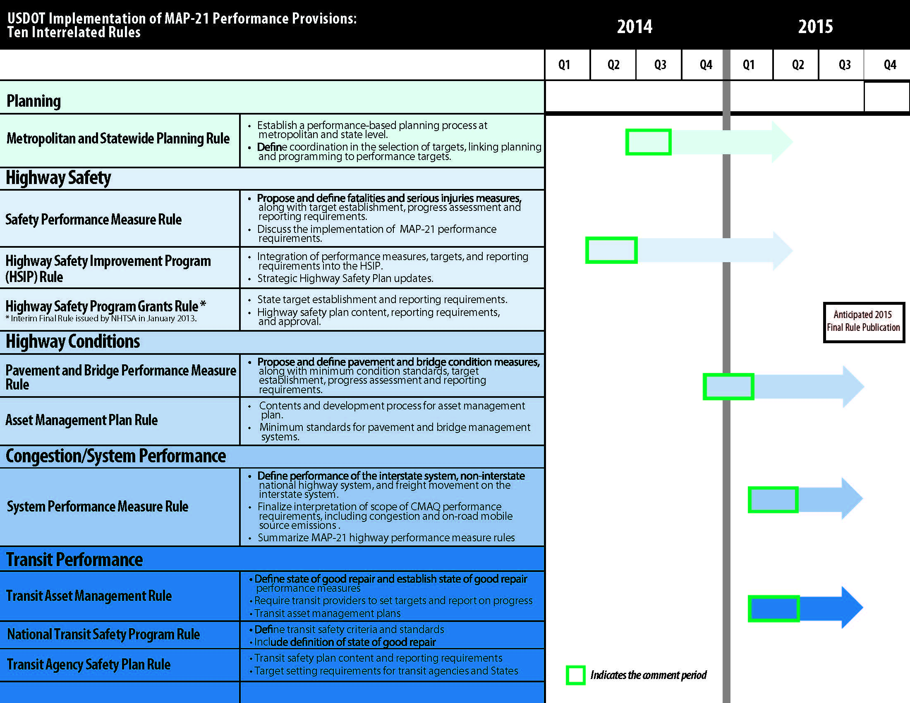
http://www.fhwa.dot.gov/tpm/about/schedule.cfm

State Performance Measures and Targets
The Michigan Department of Transportation established a Transportation System Condition Team in April 2010 which has continued to review and evaluate measures to assess the condition of Michigan’s transportation system. Driven by Excellence: A Report on Transportation Performance Measurement at MDOT, includes performance measures for four primary areas of the Michigan Transportation Plan:

- Stewardship (system condition; maintain service)
- Safety and Security (safety; reduced risk)
- System Improvement (Modernization; expand access)
- Efficient and Effective Operation (reducing delays)

MPO Performance Measures and Targets
The MPO has identified regional Goals and Objectives (Chapter 3) for the WestPlan MPO planning area. These goals were closely aligned with the federal planning factors, and will be incorporated into the performance measure strategy for the MPO. The MPO committees will work to establish targets as the final rules and guidance becomes available.
The MPO currently manages and participates in many comprehensive studies and working committees that look at strategies and factors, which are used in planning for not only Metropolitan and Rural Transportation, but also for land use planning, environmental planning, homeland security planning, non-motorized planning, port planning, transit planning, and economic development planning. All of these emphasis areas have common components and can be used in developing strategies for identifying and fulfilling performance measures and performance based outcomes. Some examples of performance based planning that the MPO can incorporate into future decision making include asset management, non-motorized planning, and comprehensive transit planning.

CHAPTER 5: PROGRESS SINCE LAST PLAN
WestPlan is committed to the region-wide promotion and implementation of a safe, convenient, and seamless passenger and freight multimodal transportation system that includes highway, rail, bus, bicycle, and pedestrian mobility networks. Attaining this vision will require modernizing the region's existing transportation infrastructure and identifying additional funding sources.
Preservation of existing roadways and facilities has been the emphasis of the MPO, with significant commitments from federal, state, and local sources committed to funding transit, highway, and non-motorized projects. With that, there is still a need to address congestion and level of service issues with network expansion projects. Since the last plan was adopted, there has been an investment of over $185,000,000 on highway and transit capacity and service expansion. The M-231 By-Pass has incurred approximately $180,000,000 of that amount. This important project will provide a much needed crossing over the Grand River in Ottawa County, and will provide an alternate route for travelers around the City of Grand Haven and the US-31 Drawbridge, which is a common area for congestion during peak traffic. The City of North Muskegon and Ferrysburg also committed to several regional expansion type projects with approximately 4 million dollars in investments to add capacity to their roads.
There have been several large scale transit investments and service expansions in the MPO area. The Muskegon Area Transit System (MATS) added nearly 400 dedicated stops to the countywide routes between 2011 and 2014. MATS also added several handicap accessible covered shelters to the busier stops in the metropolitan areas. MATS also expanded their service hours into the evenings and added weekend service for the metropolitan area. In 2014, MATS started on a multi-million dollar investment to rebuild the downtown Herman Ivory Terminal, which will be completed in 2015. The new terminal will include expanded restroom facilities, room for more customer service staff, an indoor waiting area and a plaza next to the building on Second Street. MATS also expanded service in 2014 to include several rural areas in the county with daily service. The Muskegon Area Regional Connections (MARC) is an initiative by MATS to provide public transportation route services throughout Muskegon County. New routes in Montague, Holton, Ravenna and the White Lake area are now available. The White Lake area will also now have a dedicated route that circulates daily throughout the Whitehall and Montague area.
The Harbor Transit Multi-Modal Transportation System (HTMMTS) also made significant investments since the last plan on route expansion and facility improvements. In 2013, HTMMTS upgraded the current transit facility in the City of Grand Haven with a nearly two million dollar investment. The Grand Haven Memorial Airport was also renovated in 2014 to provide a better facility for public and municipal workers. In 2011, HTMMTS received over $600,000 to expand current service into the Grand Haven Township area of Ottawa County. In 2014, public voters approved another expansion that will be funded with a millage to cover all of Spring Lake Township.
The WestPlan MPO also planned and implemented the expansion of several non-motorized trail facilities in the area. Both Ottawa and Muskegon Counties have shown a commitment to fund these types of projects. The MPO also created an MPO Non-Motorized Plan to help guide current and future planning for non-motorized facilities. In Ottawa County, the Northbank Trail and the Musketawa Trail have seen significant investment and are near completion. These trails connect regionally to a statewide network of trails. In Muskegon County, the Lakeshore Trail and the Fred Meijer Berry Junction Trails have been funded through state, local, and federal funding sources. Chapter 7 gives a more detailed summary of these projects as well as the highway and transit projects.

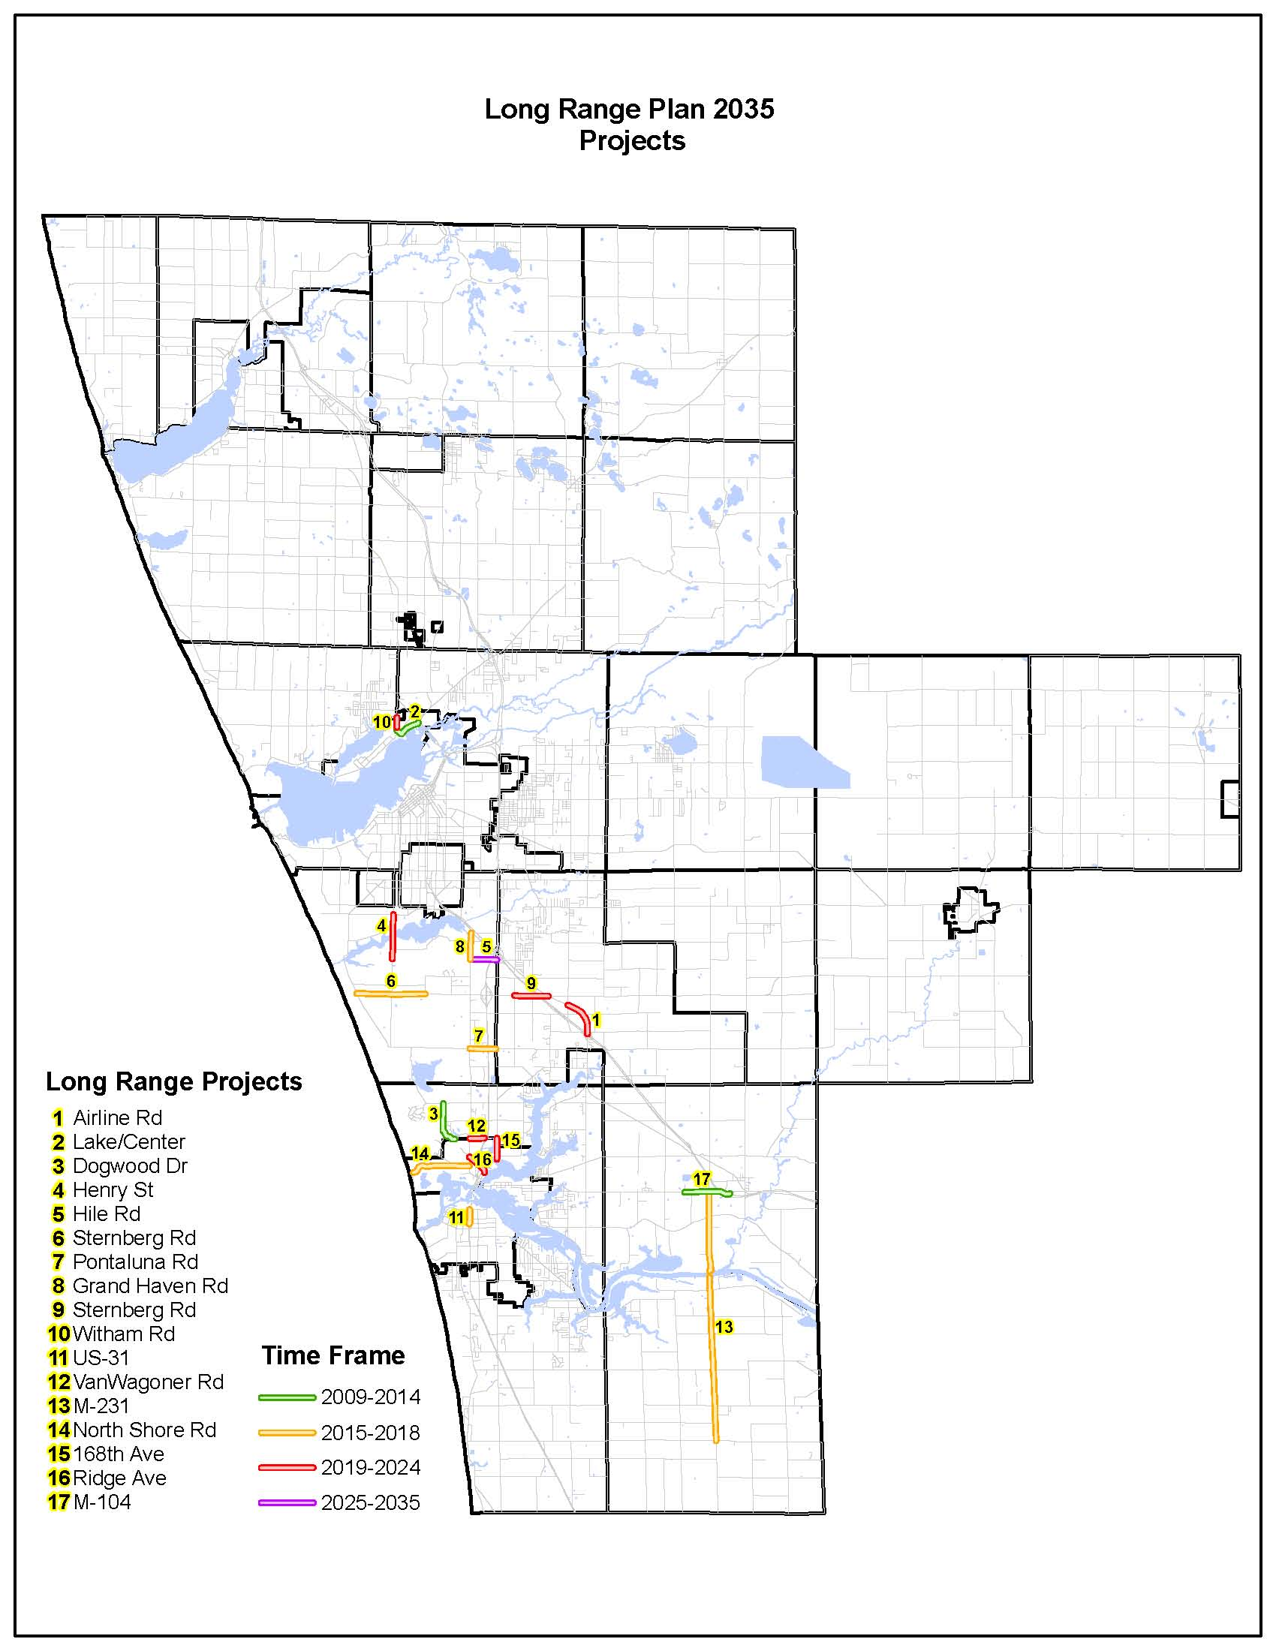
figure 5 – Long Range Plan 2035 Projects

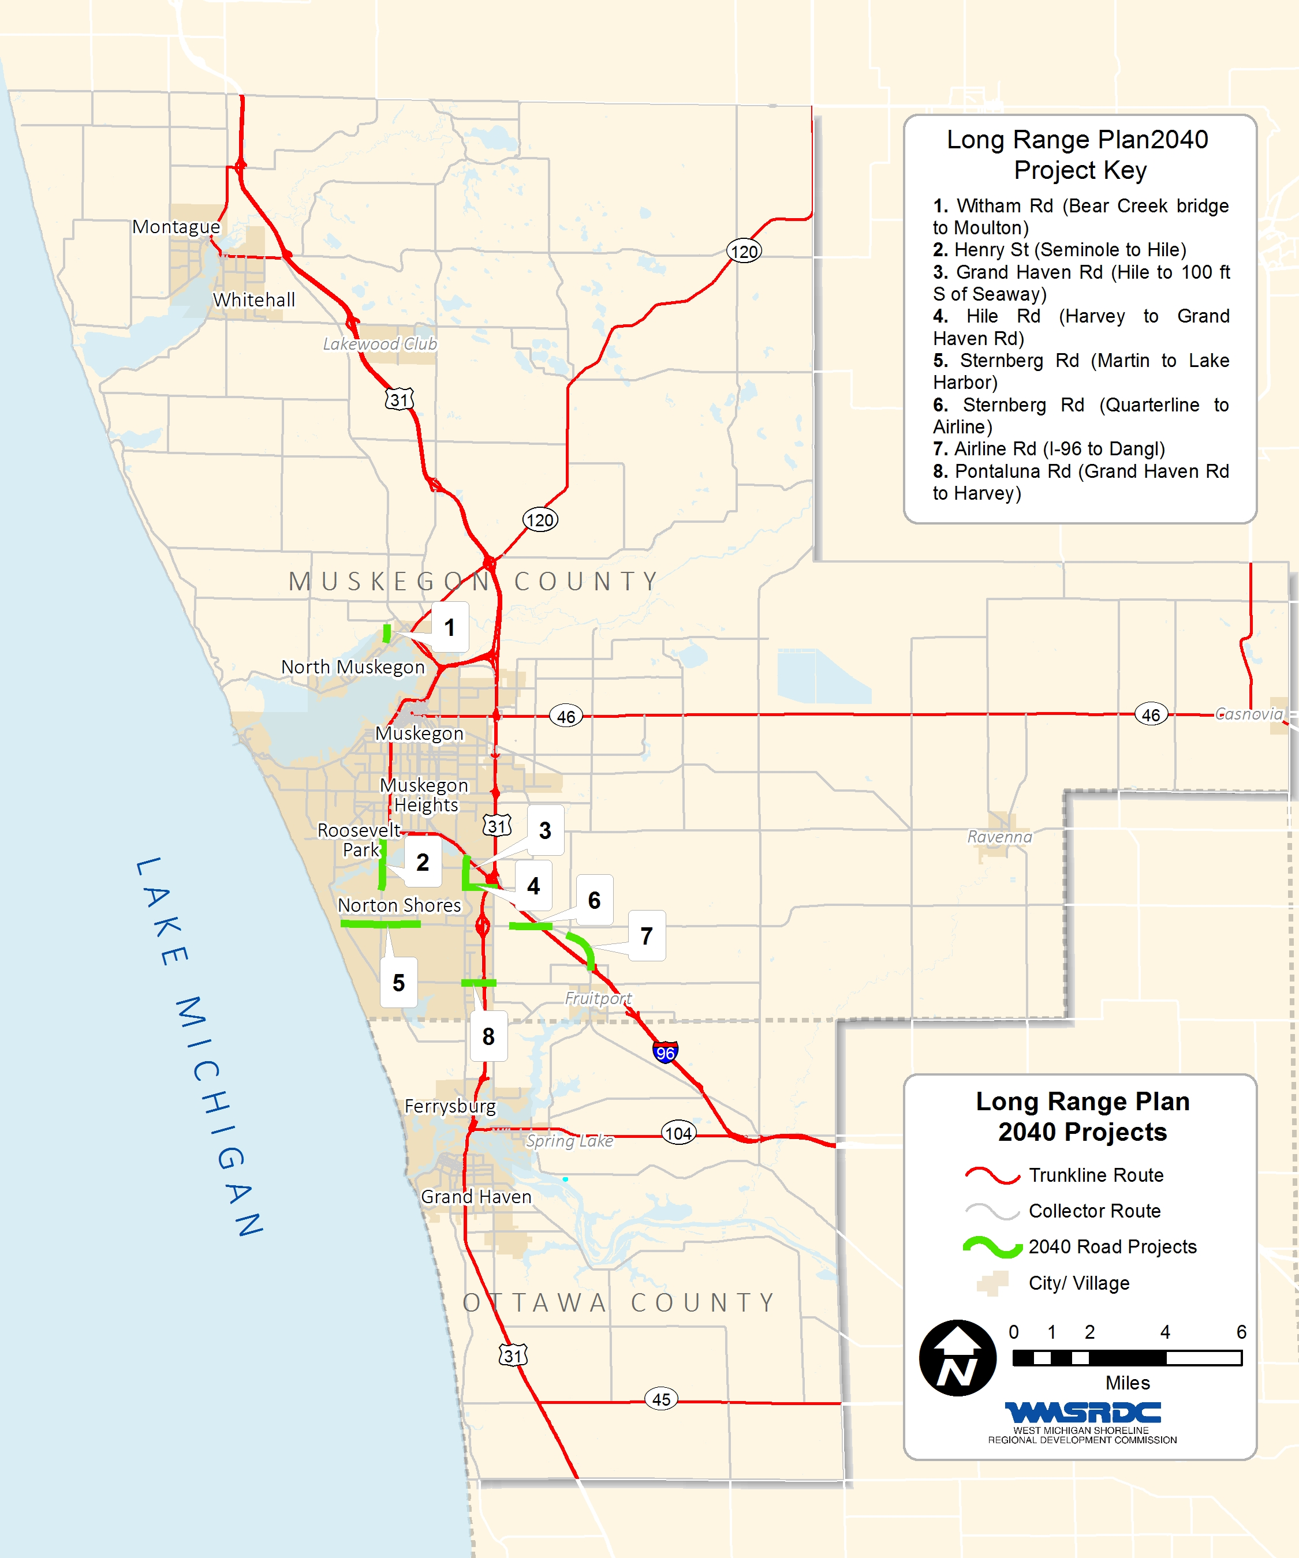
figure 6 – Long Range Plan 2040 Projects

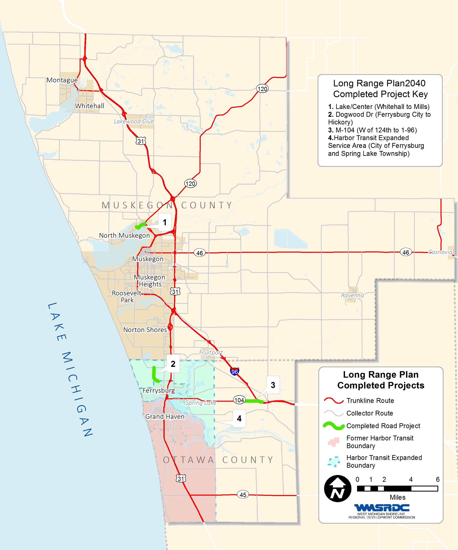
figure 7 – 2040 Long Range Plan Completed Projects

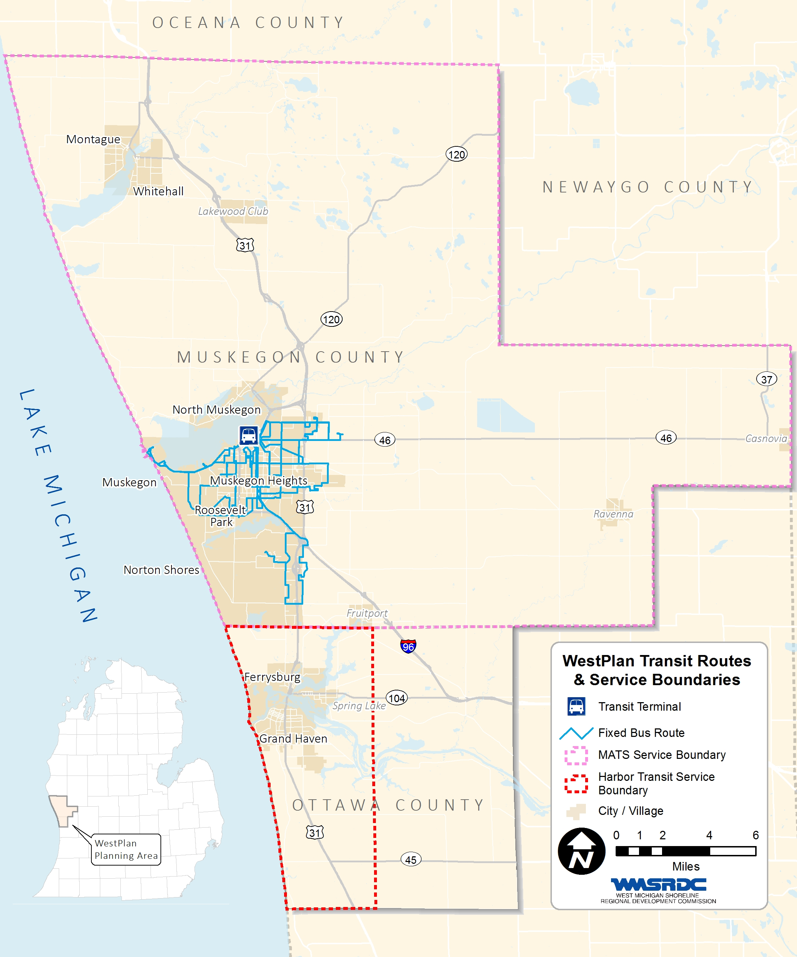
figure 8 – WestPlan Transit Routes & Service Boundaries

CHAPTER 6: PUBLIC INVOLVEMENT
WestPlan is committed to ensuring that citizen input will figure prominently throughout the planning processes and contribute to transportation problem identification through public comment periods, public meetings, open houses, and review of the draft document.
WestPlan, as the Metropolitan Planning Organization (MPO), is also federally required to explicitly set forth public participation policies. The standards for this process are found in Title 23 CFR 450.316 which requires that the public have reasonable opportunity to comment on transportation plans and programs. These policies are laid out in the Public Participation Plan in Transportation Decision Making, which can be found on the WMSRDC website at www.wmsrdc.org and as an appendix to this document.
The Public Participation Plan for Transportation Decision Making document describes all of the public participation goals and requirements for WestPlan, including specific details regarding the development of the Long Range Transportation Plan (LRP). These guidelines were followed by WestPlan throughout the development of the 2040 LRP. The update of the 2040 LRP was a lengthy process—nearly two years in the making—that involved a variety of public outreach tools, including an update of the Public Participation Plan, announcements on social media, direct emails, public meetings, and an open house.

Public Participation Mailing List
WestPlan maintains an extensive public participation emailing list that is used to provide information and notice to the public regarding transportation planning activities. The Interested Citizen/Agency list includes many representatives. The list of interested cities and agencies broken down by type includes businesses, chamber of commerce, community organizations (including non-profits, faith-based organizations, etc.), concerned citizens, educational organizations, elected officials, environmental organizations, government entities and organizations, media, organizations serving the disabled, organizations serving senior citizens, transportation related organizations, and tribal organizations. This list is continually maintained and updated regularly and can be found in the Consultation Chapter of this document.

Public Participation Outreach
The LRP process included a re-evaluation and update of the Public Participation Plan with input sought from the Technical and Policy Committees. Staff reviewed past public participation practices used by WestPlan and also reviewed plans written and followed by other Michigan MPOs to understand which worked well and discover new practices which could improve WestPlan’s efforts. The updated Public Participation Plan in Transportation Decision Making was approved by the WestPlan Policy Committee on November 19, 2014 after a 45 day public comment period regarding the Public Participation Plan was conducted and concluded. All comments made during the public review period were incorporated into plan prior to WestPlan Policy Committee approval.
To provide the public with fast, easy access to all things related to the LRP update, staff continued to maintain the wmsrdc.org website throughout the planning process. This included posting announcements for all public participation opportunities, the Public Participation Plan, other relevant background information, past planning documents, and MPO Technical and Policy Committee meeting materials.
The update of the 2040 LRP began with a notice and LRP information announced on the WMSRDC website, emails to interested citizen/agency list, press release to local media, and notice on social media. A LRP informational meeting to gain input on goals and objectives and gather other public input regarding the LRP was held in conjunction with the Muskegon Area-wide Plan Advisory Committee Meeting on April 29, 2014. This meeting took place in downtown Muskegon on the 7th floor of the Terrace Plaza Building which is located across the street from the Muskegon Area Transit System’s (MATS) transfer facility making transit access to the meeting available. At this meeting, WestPlan staff gave a visual and oral presentation explaining the development of the LRP (and the TIP), various elements of the documents and planning process, the Clean Air Action Program, and other public involvement opportunities available to utilize to comment on and/or get involved with the LRP and other MPO related activities. A SWOT (strengths, weaknesses, opportunities, and threats) Analysis of the MPO’s transportation system was also undertaken by MPO staff during the meeting. MPO contact information was made available at the meeting for those who did not wish to speak to staff in person, and it was explained that public comments will be accepted throughout the LRP development process.
Once the draft LRP document, environmental justice, and identification of deficiencies was complete, a 14-day public comment period was held from May 22 through June 5, 2015. Notices of the public comment period were posted on the WMSRDC website on May 21, 2015 and sent to all on the Interested Citizen/Agency List. Announcements were also made on social media and the WMSRDC website. Throughout the 14 day public comment period, the draft document was made available for the public to view upon request at every local unit of government, the Muskegon and Ottawa County Road Commissions, the Muskegon Area Transit System, Harbor Transit, MDOT offices, as well as on the WMSRDC website. In addition a hard copy of the Draft 2040 LRP was available at the WMSRDC office with staff available to respond directly to any public questions or concerns.
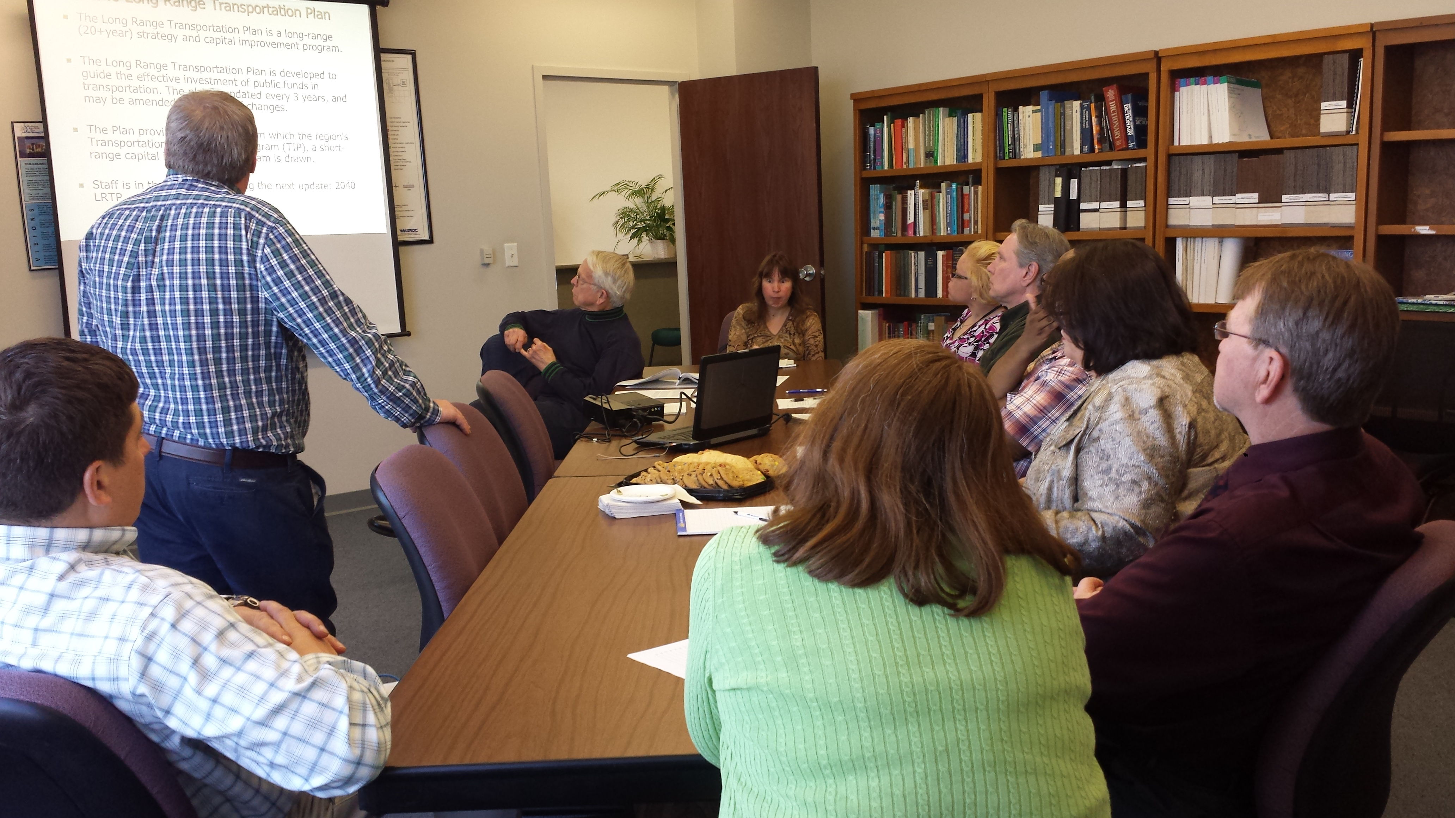
On June 1, 2015 an open house regarding the draft 2040 LRP Update was held at the WMSRDC office. The draft 2040 LRP Project List, Environmental Justice, and Environmental Mitigation Analysis results, and the complete draft of the 2040 LRP were available at these meetings, as well as a staff PowerPoint presentation.
The open house was held from 1 p.m. to 3:00 p.m. at the WMSRDC office. The WMSRDC office is located in an ADA accessible building, which is located along fixed-route bus service lines to increase ease of access. An announcement of the open house was sent to the Interested Citizen/Agency List on May 21, 2015. The announcement included information on how to access the document and other related materials. Concurrent with the meeting announcement mailing, the meeting information, methods for making public comment, and a draft plan were posted on the WMSRDC website. A copy of that announcement appears at the end of this chapter. Approximately a dozen people participated in the open house and shared very important feedback on the draft plan and other transportation related issues and concerns.
In addition to the public meetings, opportunities for public comment are available at monthly Technical Committee, Policy Committee, and WMSRDC Board meetings. Agendas and minutes for these meetings are regularly posted on the wmsrdc.org website. All written public comments received during the kick-off meeting, as well as during the official public comment period, including comments received at the public meetings, can be found at the end of this chapter. All written public comments received were provided to the WestPlan Technical and Policy Committees for consideration, and in some instances the inquirer was directed to the respective road or transit agency for more project-specific details.
All documents, events, and public comment opportunities were published on the WMSRDC website throughout the LRP development process and were also made public through press releases to local media. Additionally, to provide ample time for staff to incorporate comments received, WestPlan Policy Committee approval is not anticipated until June 17, 2015 which is 7 days after the close of the public comment period.

Conclusion
Throughout the 2040 LRP development, all pertinent public participation information was taken to the WestPlan Technical and Policy Committees for their review and consideration. This committee review aided staff during the process, helping to make decisions regarding the plan along the way.
All comments received were reviewed and incorporated into the LRP when and where appropriate. Specifically, all written public comments were recorded at the end of this chapter along with staff responses if any written response. It is interesting to note that the majority of verbal public comment on the plan was in regards to the need to have transit available between the counties of Muskegon and Ottawa. An evaluation of the 2040 LRP public participation efforts will be made through our Public Participation Plan process to identify areas of success and areas that can be improved upon for future plan development.

Written Public Comment
The following written comment was submitted by Laird Schaefer, Interested Citizen: M231 will not alleviate traffic issues. It will not greatly reduce drive time. The 231 bridge as built is a “bridge to nowhere.” $180 mm has not substantially reduced US31 traffic through Grand Haven, the two lane M231 highway is approx. 6 miles east of US31.
The following written comment was submitted by Cindy Larsen, President of the Muskegon Chamber of Commerce: Hi Amy, I started reading this and I had to stop at the history. Don’t take this personally because this happens all the time. This is in part why we have image problems. People use this Yakes paper yet it is decades old and references companies like Brunswick. We are no longer struggling to diversify our economy. We have all kinds of job here in all sectors. Right now we have about 2000 openings. And the last sentence describing Ottawa is totally untrue. “A vibrant port community for boat and fishing??” As you know, our port is more vibrant with much better fishing and boating. And last year we had 1.4 million tourist visit Muskegon County. So can we change that last paragraph regarding our history….
In recent years Muskegon has diversified its economy to include advanced manufacturing, healthcare and tourism. Major companies include Alcoa, GE, Mercy Health, Michigan’s Adventure. It has the most active port on the east side of Lake Michigan and is now one of Michigan’s top tourism destinations known nationally for great fishing and boating. Thanks! Cindy
Staff response: Thank you for your honest feedback. I appreciate it. We will certainly revise the last paragraph of the Muskegon County history section per your comments.

Copy of Public Comment Open House Announcement
Here’s your chance to help steer our transportation system for the next 20 plus years. The Muskegon and Northern Ottawa County Metropolitan Planning Organization (MPO) invites you to learn more about and comment on the Long Range Transportation Plan (LRTP) for the Muskegon and Northern Ottawa County area. Learn about key initiatives to improve the transportation system and share your thoughts on options for highways, transit, bicycles, pedestrians, and more.
Review the Plan: The Draft Plan is available for review through online viewing at http://www.wmsrdc.org/Download/Draft%202040%20LRP.pdf 2040 LRP.pdf or a hard copy can be made available at any local government or library upon request by calling (231) 722-7878 x 19 or by email at ahaack@wmsrdc.org.
Attend the Open House: A public information open house will be held on Monday, June 1, 2015 at the office of the West Michigan Shoreline Regional Development Commission located at 316 Morris Avenue, Suite 340 in downtown Muskegon, Michigan. The open house will be held from 1:00 p.m. to 3:00 p.m. Project lists, maps, and a draft plan will be available for review and MPO staff will be available to answer questions. Light refreshments will be provided.
Comment on the Plan by Friday, June 5, 2015. Your involvement in the transportation planning process is vital. Provide your feedback in one or more of the following ways:
- Attend Open House
- Mail: WMSRDC, 316 Morris Avenue, Suite 340, Muskegon, Michigan 49440
- Email: ahaack@wmsrdc.org
- Facebook: https://www.facebook.com/pages/West-Michigan-Shoreline-Regional-Development-Commission-WMSRDC/137733963934
- Phone: (231) 722-7878 x 19
- Fax: (231) 722-9362

As the MPO for the Muskegon/Northern Ottawa County Area, the West Michigan Metropolitan Planning Organization (WestPlan) is required to produce a Long Range Transportation Plan (LRTP) with, at a minimum, a twenty-year planning horizon. The LRTP must include both long and short-range strategies/actions that lead to the development of an integrated, intermodal transportation system that facilitates safe and efficient movement of people and goods, while addressing current and future transportation demands. Throughout the plan development, deficiencies are identified on the county transportation system and improvements are planned to mitigate those problem areas. This list of projects is included in the plan. In accordance with federal regulations set out by the Moving Ahead for Progress in the 21st Century Act (MAP-21), WestPlan, as a part of the LRTP development process, is required to seek public comment and input from agencies that are responsible for environmental protection, historical preservation, natural resource management, transportation services, economic development, human services, land use planning, etc. You have been identified as an interested individual or agency of this type.

CHAPTER 7: EXISTING TRANSPORTATION SYSTEM FACILITIES
The Muskegon/Northern Ottawa MPO area has a very diverse multi-modal transportation system. The network includes a mix of highway, public transportation, non-motorized, as well as freight, rail, port and air transportation. With such a complex system, there is a continuing need to identify and plan for this regional and global asset.
The map below gives a snapshot of the muilti-modal transportation system and its connectivity to the WestPlan MPO area as well as the entire West Michigan region.

Figure 9 – Multi-Modal Map
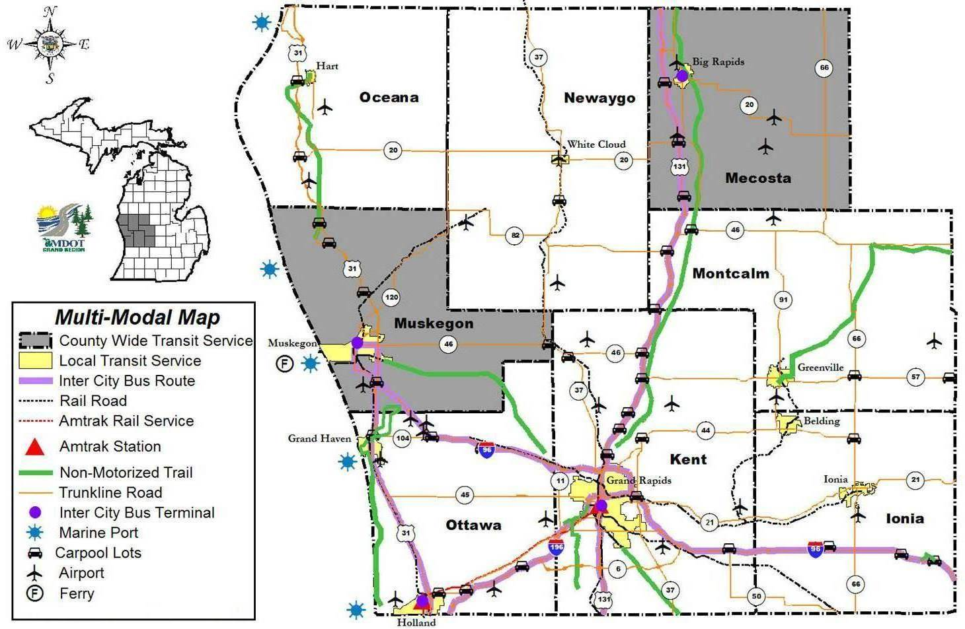

Highways and Bridges
There are approximately 2,257 miles of public roads in the WestPlan MPO area, of which, 860 are maintained through federal transportation money, as designated through the National Functional Classification System (NFC). Approximately 425 miles are NFC classified as Arterial, Interstate, or other Freeway. These routes include US-31, I-96, M-120, M-37, M-46, and M-104. Also included with these routes are all “Business Routes” (BR). These routes are generally considered “Trunkline” routes and are under the jurisdiction of the Michigan Department of Transportation. There are approximately 435 miles of NFC classified Major and Minor Collectors in the MPO area. Collectors are generally under the ownership of the local road agencies; road commissions, cities, or villages. The remaining 1,398 miles are considered “Local” and are not funded with federal transportation money, but are eligible for PA51 funding and are also under the supervision of local road agencies.
National Functional Classifications of roadways reflect a roadway’s balance between providing land access versus mobility. Functional classification is the process by which public streets and highways are grouped into classes according to the character of service they are intended to provide. Classifications of roadways play an important role in the planning, funding, and management of the transportation network. The Federal Highway Administration (FHWA) provides specific guidelines when assigning roadway classifications. If a road is not federally classified, the road may not be eligible for federal funding. In that case, local money may be used for maintenance or improvements.
Arterials are the highest classified roads, and are regulated by state and federal agencies. Cities, villages and road commissions maintain all other roads down to the local level. Other local governments that are not road agencies, such as townships, do not receive federal funding for road projects. In these cases the county road commission would have jurisdiction over the road and would work with the local government on projects. The classification system includes Interstates, Other Freeways, Arterials, collectors, and locals. In order to receive federal funding, a road must be classified higher than a “local” road. A general summary of the selected classifications are as follows:

FHWA Hierarchy of National Functional Classification roadways:
Arterials (Principle and Minor): These roads serve major centers of activity within the metropolitan area. Principle and Minor Arterials should carry the majority of non-freeway traffic within the network. Minor Arterials provide service for trips of moderate length, serve geographic areas that are smaller than their higher Arterial counterparts and offer connectivity to the higher arterial system. In an urban context, they interconnect and augment the higher arterial system, provide intra-community continuity and may carry local bus routes. In rural settings, they are identified and spaced at intervals consistent with population density, so that all developed areas are within a reasonable distance of a higher level arterial.
Interstate Highways: Interstates are the highest classification of Arterials and were designed and constructed with mobility and long distance travel in mind. Interstate roads are generally limited access, divided highways offering high levels of mobility while linking major urban areas of the United States. These roads are always four-lane limited access highways, whose primary function is high speed travel. I-96 and most of US-31 serve under the Interstate Highway Network in our region.
Other Freeway- These roads may look and function similar to Intestate roads. These roads will also have directional travel lanes separated by some type of physical barrier, and their access and egress points are limited to on- and off-ramp locations or a very limited number of at grade intersections.

Other Principal Arterial (Urban and Rural) - These roadways serve major centers of metropolitan areas, provide a high degree of mobility and can also provide mobility through rural areas. These roadways are designed to serve abutting land uses directly with driveways and at grade intersections.
Collectors (Major and minor): Collectors distribute trips from the arterial system to ultimate destinations. These roads usually provide traffic access and circulation to residential, commercial and industrial areas.
Local Roads: These roads offer the lowest level of mobility and provide access to both land and higher roadway systems within the network.

WestPlan MPO roads that are classified as Arterials:
I-96
Interstate 96 (I-96) connects Muskegon County with Detroit, and several cities along the way. I-96 merges into BR-31 near the US-31 interchange in the City of Norton Shores. The original connection between the existing I-96 near Coopersville and US-31 in Muskegon County was established in the early 1960’s. This route replaced the previous route known as US-16 through Muskegon County. There are several access points along this five mile stretch. Exits 4 and 5 provide access on and off from I-96 to the Fruitport area, and there is an exit farther west at the Hile Road area. There is a connection to US-31 that allows travelers to go north or south on US-31. This is a most important junction because of the Lakes Mall and all of the adjacent development around the mall, as well as the Muskegon County Airport that is in the vicinity. There is an ongoing effort to provide a more efficient transition from the I-96 corridor to the US-31 corridor by means of an additional access point along I-96. Several studies have looked at the possibility of adding an interchange at the intersection of I-96 and Sternberg Road, in Fruitport Township. MDOT has indicated that funding and federal requirements have delayed any potential projects from moving forward at that location.
US-31
US-31, in its entirety, traverses from southern Alabama to Michigan. In the MPO area, US-31 is a north/south limited access route that runs from the southern border of Grand Haven Township in Ottawa County, to the northern border of Muskegon County near Montague. The route changes characteristics in Ottawa County, where at grade crossings are common at most major intersections. In Muskegon County, the route has limited access, and there are eleven access points along the roughly 28 mile stretch inside Muskegon County. Most of the interchanges have development around them, but there are a few in the northern county that remain undeveloped. The most heavily developed areas are around the Sternberg Road area, the Laketon and Sherman areas, the M-46 area, and the M-120 area. There is also some development in the White Lake area around the Colby Road interchange. There are two business route portions of US-31 in Muskegon County. Starting in the south, there is BR-31 that extends from the western termination of I-96 near the US-31/I-96 Interchange, north to M-120 near the B.C. Cobb power plant in The City of Muskegon. The second BR-31 is in the White Lake area, near the Cities of Whitehall and Montague. This route begins at the Colby Road/US-31 interchange and travels through the City of Whitehall and into the City of Montague, terminating at the Fruitvale Road/US-31 interchange, north of Montague.
M-37
M-37 is another north/south route that traverses a large area in the state, but in Muskegon County, only about five miles. The Muskegon portion begins near the Village of Casnovia and heads north through Bailey before entering Newaygo County. Most of the road in that area is two lanes, with a few added turn lanes or flares for accommodating turn movements. There are a few pockets of commercial activity along the route, but most of the land use is agriculture based.
M-45
M-45 (Lake Michigan Drive) starts near Lake Michigan at an intersection with Lakeshore Drive near the Grand Rapids water filtration plant. The road runs east to an intersection with US 31 in Agnew, where the M-45 designation begins. The road runs through rural Ottawa County to Allendale, where it passes through the main campus of Grand Valley State University M-45 ends at the interchange with I-196. Lake Michigan Drive continues east to its end where it becomes Pearl Street near the Grand River in downtown Grand Rapids.
M-46
M-46 (Apple Avenue) is a major trunk line route in Muskegon County, and provides east-west travel through the entire county. From the east, at the intersection of M-37, the road runs west to the City of Muskegon and terminates just west of US-31. M-46 has experienced considerable growth with Muskegon Community College and Baker College now located in the same vicinity, along with the Orchard View School District and the campus of Mercy Hospital.
M-104
The western terminus of M-104 is at US 31 in Ferrysburg at the north end of the drawbridge spanning the Grand River north of Grand Haven. The highway runs along Savidge Street and crosses a bridge over the channel that connect the river with Spring Lake. On the opposite shore, the trunkline continues along Savidge Street, running between the river to its south and Spring Lake to its north. M-104 crosses the central business area of the Village of Spring Lake. East of downtown, the highway transitions to follow Cleveland Street which continues due east to Nunica. The eastern terminus of M-104 is located at the exit 9 interchange along I-96 just west of Nunica.

M-120
M-120 (Holton Road) begins in the City of Muskegon, near the border with the City of North Muskegon, and heads in a north-easterly direction into Oceana and Newaygo County near the Holton area. Most of this roadway is two lanes, other than a few areas where turn lanes have been added to accommodate turn movements. There are approximately 20 miles of road that are designated as M-120 in Muskegon County. The most heavily developed areas are in the southern portion of the road, in the Charter Township of Muskegon, and in Dalton Township.
M-231
M-231 is currently under design and construction. The route is to begin along M-45 (Lake Michigan Drive) in Robinson Township near the intersection with 120th Avenue. It will run due north and cross the Grand River into Crockery Township. After crossing the river, M-231 will have a grade–separated junction with Leonard Road south of M-104. M-231 and M-104 will intersect near the existing M-104 eastern terminus at I-96, and M-231 will continue north to its own northern terminus at a new interchange with I-96. M-231 will be a scaled-down bypass of US 31 through Grand Haven, even though it does not physically connect to that highway
Currently, in order to cross the Grand River, travelers must either use US 31 through Grand Haven or 68th Avenue through Eastmanville. This new road will provide a river crossing almost equidistant between the two, greatly reducing drive times between areas north and south of the river. Currently, a drive from Nunica to Robinson is a 20-mile trip, the new highway will provide a route closer to 7 miles in length.

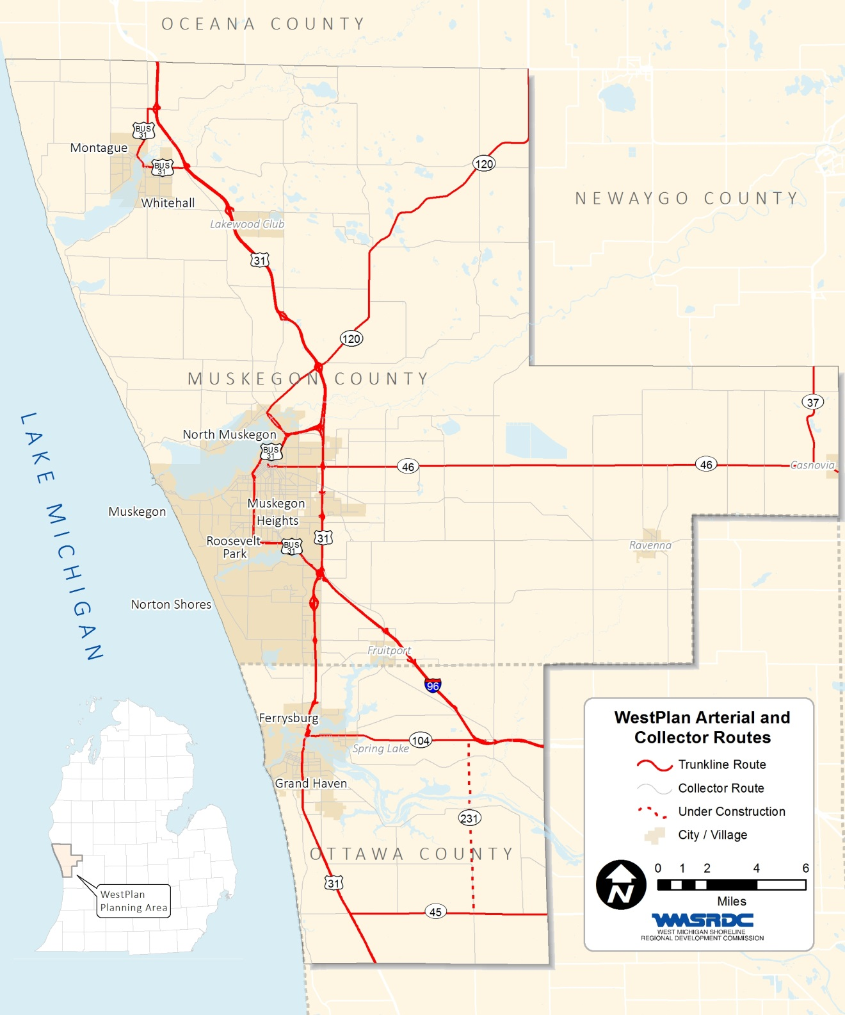
figure 10 – WestPlan Arterial and Collector Routes

Public Transit
Within the WestPlan area there are two major transit providers, as well as a number of smaller transit providers. In Muskegon County, the Muskegon Area Transit System is the major provider and The Harbor Transit Multi Modal Transit System is the primary transit agency in northern Ottawa County.

Muskegon Area Transit System (MATS)
The Muskegon Area Transit System (MATS) is a department of the County of Muskegon. Since 1974, MATS has provided public transportation in the Muskegon community on behalf of the local communities. MATS operates a network of fixed route bus services in the Muskegon area and demand-response services throughout the County. As the public transportation provider in the community, MATS also participates in transportation planning to improve the community and coordinates various transportation efforts.
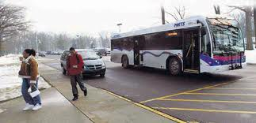
MATS has a total of 36 vehicles and employs 70 people. In fiscal year 2014, MATS traveled 766,149 miles, served 708,461 passengers and operated 55,162 vehicle hours.
MATS currently operates service on 13 fixed-routes serving urbanized and regional areas consisting of the cities of Muskegon, Muskegon Heights, Roosevelt Park, Norton Shores, Muskegon Township, Whitehall, Montague, Holton and Ravenna. MATS also provides paratransit services throughout Muskegon County to meet public demand. The hours of operation are Monday through Friday, 6:30 am to 10:40 pm and Saturdays 9:30 am to 6:00 pm.
Another service provided by MATS, the Beach Towne Trolley, is operational from Memorial Day to Labor Day, 9:30 a.m. – 5:36 p.m., Monday to Saturday. The Beach Towne Trolley provides service between the City of Muskegon’s downtown area and Pere Marquette Beach on Lake Michigan and makes stops at the Hackley/Hume historic site, the Lake Express ferry, and the Silversides submarine along with other destinations. MATS also provides paratransit services to meet the public demand.
Major improvements are planned for the Herman Ivory Terminal, located on Morris Street in the City of Muskegon. These improvements began in fall of 2014 and should be completed in mid-2015.
Muskegon Area Regional Connections MARC (MATS)
Muskegon Area Regional Connections (MARC) is an initiative of Muskegon Area Transit System (MATS) to provide public transportation route services throughout the rural areas of Muskegon County. New routes in Montague, Holton, Ravenna and the White Lake area started in November of 2014.

Harbor Transit Multi Modal Transportation System
Harbor Transit has been serving the public transportation needs of the Tri-Cities area since 1975. It was reorganized into the Harbor Transit Multi-Modal Transportation System in January of 2012 which coincided with the expansion of the service area to include all of Grand Haven Charter Township. In 2014 the residents of Spring Lake Township approved a ballot proposal to add Spring Lake Township to the service area. The total service area now covers 55.5 square miles and includes the cities of Grand Haven and Ferrysburg, the village of Spring Lake, and Grand Haven Township. In 2013, a $700,000 building rehab and renovation project was completed that will allow for better customer service and operation areas.
The system employs 40 full and part-time employees and operates a fleet of 23 buses along with two seasonal trolleys. The fleet is powered by four diesel and fifteen gasoline motor vehicles along with four L. P. powered buses. In a normal month, buses will travel 35,000 miles and will consume approximately $17,000 in fuel.
The Grand Haven Harbor Transit partners with the Federal Transit Administration (FTA) for federal operating and capital funds, and the Michigan Department of Transportation (MDOT) for operating and capital funds. Local partners include the City of Grand Haven, City of Ferrysburg, the Village of Spring Lake, Spring Lake Township and the Township of Grand Haven contributes the local share operating funds and small capital projects.

Other Transit Providers
In addition to MATS and Harbor Transit, there are a number of other non-profits within the MPO which provide specialized transit services. Many of these non-profits access funding through the 5310 program. Examples of these providers are the American Red Cross, Pioneer Resources, and Goodwill Industries.
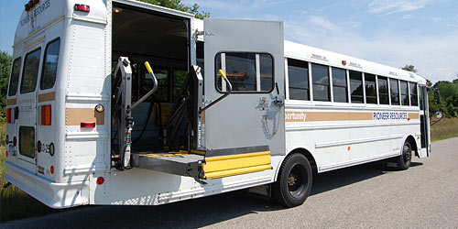
Pioneer Resources
Pioneer Resources offers services for people with mobility impairments, developmental disabilities, senior citizens and others facing transportation barriers. Services are provided along the lakeshore in western Michigan (Ottawa and Muskegon counties). Pioneer Resources can also assist eligible passengers or organizations with field trips and special events.

American Red Cross
The Red Cross Senior Transportation Service is a service for Muskegon County seniors who are living on limited incomes and need transportation to get to their medical appointments.

Intercity Bus Service
Greyhound operates two daily arrivals and departures out of a terminal on Morris Avenue in Muskegon. The terminal is open Monday through Saturday. Service is available to a variety of cities. Muskegon is part of the Greyhound Great Lakes region.

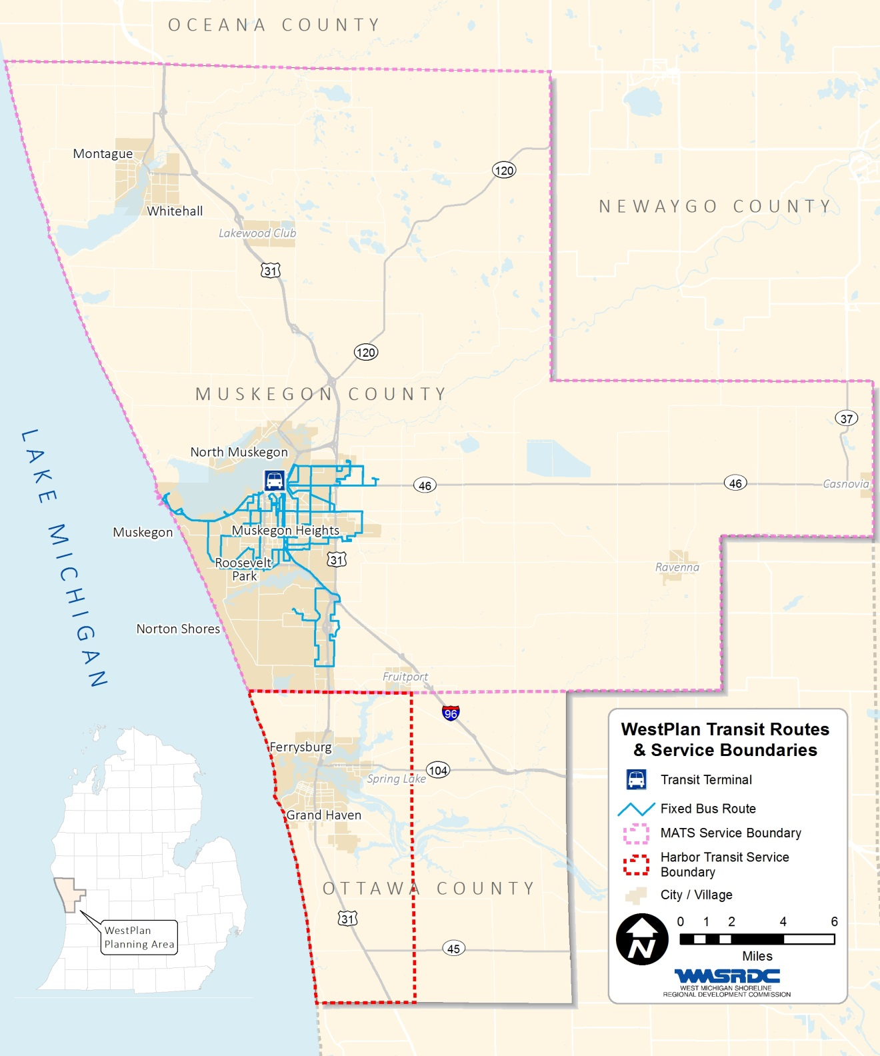
figure 11 – WestPlan Transit Routes & Service Boundaries

Air Transportation
Muskegon and Ottawa County (City of Grand Haven) both provide different levels of Air service to the MPO area and surrounding region.

Muskegon County Airport
The Muskegon County Airport is a safe, clean and modern commercial air facility serving West Michigan. The Muskegon County Airport was established at its current site in 1929 when the Muskegon County Board of Supervisors voted to purchase 242 acres of land in Norton Township as a site for the new County Airport. Since that time, the Airport has been developed into a major regional air transportation facility, providing direct access to the air transportation system to an MSA of nearly 500,000 residents.
The airport is included in the Federal Aviation Administration’s (FAA) National Plan of Integrated Airport System (NPIAS), making it eligible for both entitlement and discretionary funding as a primary commercial service airport. Approximately 95% of the aircraft operations are general aviation/corporate in nature, and the remaining 5% is commercial airline service.

The Airport is open 24 hours per day, 7 days per week, providing a base for varied services, including, but not limited to, daily United Airlines jet service to Chicago O’Hare, U.S. Coast Guard Search and Rescue, medical life flights, flight training, casino charter flights, airframe/power plant/avionics repair, and private/corporate aircraft storage. On site firefighting, per Federal Aviation Regulation Part 139, is available, as is law enforcement support through an agreement with the Muskegon County Sheriff Department.

Grand Haven Memorial Airport

The Grand Haven Memorial Airport provides the Grand Haven area with a convenient, accessible and safe Airport for business and recreational small aircraft users. Grand Haven Memorial Airport is a U-5 General Aviation all-weather facility, licensed by the Michigan Bureau of Aeronautics. The Airport is served with a paved primary runway 3,750 feet long and a paved cross-wind runway 2,100 feet long. The Airport is operated through a management agreement with Benz Aviation of Grand Haven that provides a Fixed Base Operator (FBO) for service, maintenance and general day-to-day airport management.
The Airport has a 1,360 square foot administration building, a maintenance and community hangars. The Airport has 68 rental hangars. Hangars are available for lease.

Port and Maritime Transportation

Port of Muskegon
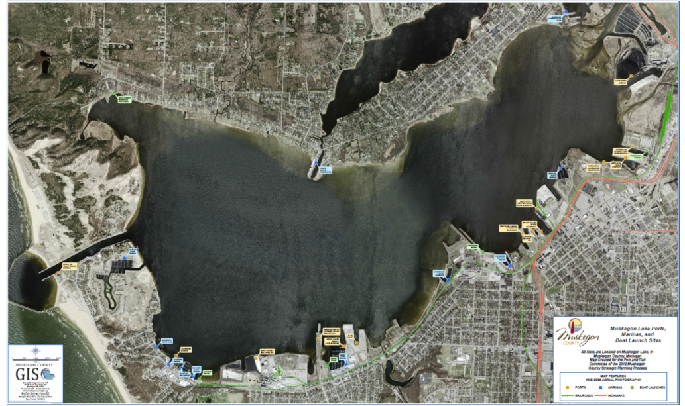
Muskegon County offers five commercial docking facilities providing a variety of shipping, logistics support, storage, towing, and ship repair services for corporations. Convenient options are available to deliver and receive goods from the Port of Muskegon, and move those goods to market, nationally and internationally.
Muskegon Lake is the largest natural deep-water port in West Michigan. The Port of Muskegon handles over 1 million tons of freight, aggregate, coal and salt every year.
The United States Army Corps of Engineers provides funding for dredging of the Muskegon Lake Channel to provide year-round access to port facilities.
In addition to the commercial port facilities, 12 recreational marinas operate on Muskegon Lake and over 20 charter fishing operations call Muskegon Lake home. White Lake, about 7.5 nm north of the Muskegon Lake Channel, has 8 recreational marinas and 12 charter fishing operators. A scenic cruise ship, the Port City Princess, offers leisure and dinner cruises on Muskegon Lake and Lake Michigan from its berth on Muskegon Lake.
Building on its tradition as a Port City, Muskegon County is also served by the Lake Express Ferry, a high-speed ship carrying passengers and vehicles across Lake Michigan from Milwaukee to Muskegon in just 2.5 hours, offering two runs every day during its May-October season.

Port of Grand Haven/Ferrysburg/Village of Spring Lake
At the mouth of the Grand River, lies the cities of Grand Haven and Ferrysburg, as well as the Village of Spring Lake. There is limited shipping activity in this area, primarily of aggregates, but a majority of the activity is recreational based. There are adequate modes of transportation to accommodate shipping activities, but water depth fluctuation plays an important role, and being the mouth of Michigan’s longest river, there are a lot of deposits occurring in that area. The average depth of the harbor is around 16-20 feet, which make it difficult for deeper draft vessels to use the port. The US Army Corps of Engineers provides annual funding for dredging of the channel to allow for deeper draft vessels that deliver to the Grand Haven Board or Light and Power, as well as the docks in Ferrysburg. Fishing and boating are the primary uses of this waterway, but Grand Haven is also the home to the United States Coast Guard's "Group Grand Haven," which coordinates all Lake Michigan Coast Guard activities.
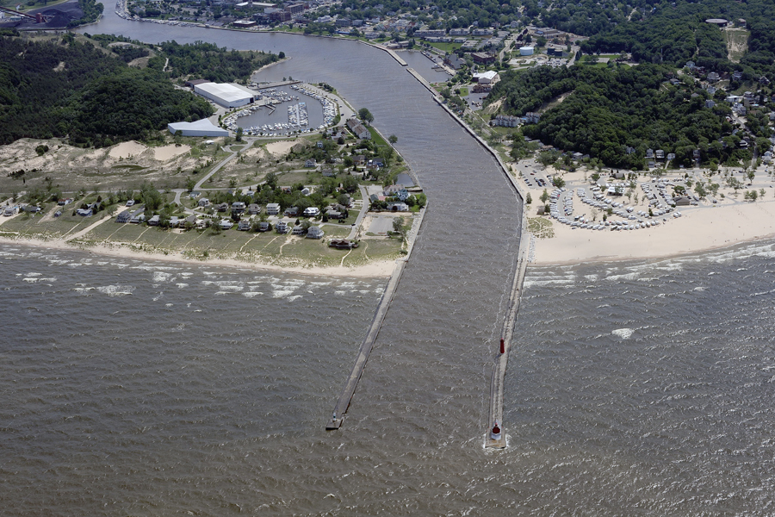

Rail and Freight Transportation
Genesee-Wyoming Inc. operates a short rail line in the Muskegon-Northern Ottawa area, which connects to several other regional lines throughout the state. The Michigan Shore Railroad (MS) is located along the shore of Lake Michigan and interchanges with the CSXT. The MS operates a line with more than 7,000 cars per year, primarily consisting of sand and chemicals.
At this time there is no rail passenger service in the MPO Area, but the region is served by Amtrak and there are ongoing discussions with local and state leaders about expanding Amtrak services that exist in Holland and Grand Rapids, into the MPO area. Amtrak’s Pere Marquette route connects these two cities with Chicago.

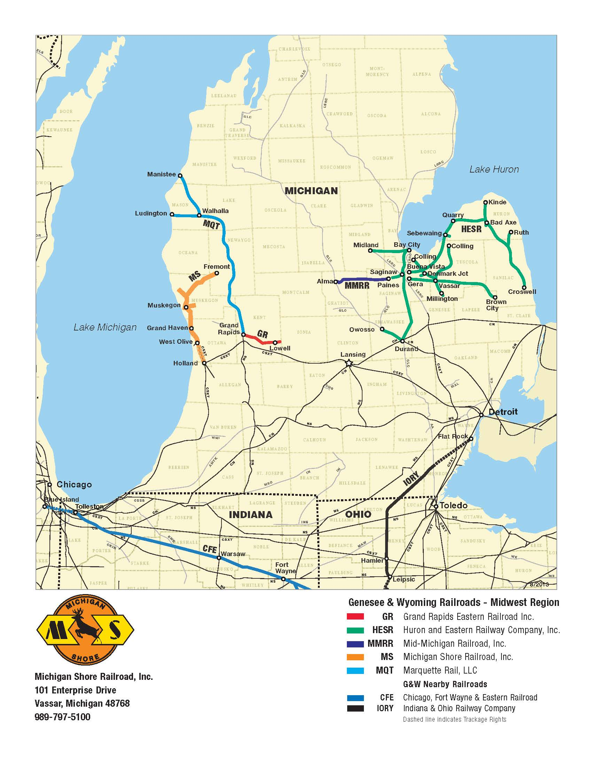
Figure 12 – Railroad Locations

Non-Motorized Transportation
Regional efforts are focused on a strategic approach to creating safe and easily identified routes throughout the area, as well as connecting to other regional facilities. The Region currently has numerous pedestrian and bicycle transportation facilities. These existing and proposed networks should be linked, if possible, to encourage their use by casual travelers, commuters, and for recreational purposes. An extensive bicycle and pedestrian network not only stimulates single-mode trips (walking or biking alone), but also encourages the use of public transit. Transit agencies have provided crucial links to the non-motorized system in the area by adding bicycle racks to the busses that service the Muskegon urbanized area and the Harbor Transit Multi Modal Transportation System service area.
Pedestrian facilities include sidewalks, bike lanes, greenways, and trails. Sidewalks are common in a majority of the cities and villages within the Region, but are less common in the rural areas. Many of the communities in the Region also utilize expanded lanes on the roadway for bikers and walkers.
The MPO recently completed a Non-Motorized plan for the MPO area. The plan outlines the trails, bike paths, and paved shoulders, as well as traffic data along roadways with wide shoulders. The plan is available on the WMSRDC website.
Lakeshore Trail System (Muskegon County)
This system of trails in the City of Muskegon was started in 1998. The trail system is approximately 13 miles in length, and offers a variety of routes throughout the city. Future plans include linking the Laketon Avenue section with the Musketawa Trail to the east. There are also plans on connecting the Shoreline Route with another connector in North Muskegon, which will link this system up with the Muskegon State Park and the Hart-Montague Trail.
Musketawa Trail (Muskegon County)
This trail system contains approximately 26 miles of paved recreational trail, which extends from the City of Marne in Ottawa County, west to the City of Muskegon, in Muskegon County. This trail is used by bikers, horseback riders, inline skaters, cross country skiers, wheelchair travelers, and nature lovers. Future plans include linking up with other trail systems in Muskegon County.
Hart-Montague Trail (Muskegon County)
This trail system runs from Hart, Michigan, south to Whitehall. It is approximately 24 miles in length. The trail ends at the Whitehall southern city limits, where the Phase I of the Fred Meijer Berry Junction Trail continues south in to Dalton Township.
Meijer Berry Junction Trail (Muskegon County)
Phase I of this trail was completed in 2011 and connects the southern end of the Hart-Montague Trail to McMillan Road in Dalton Township. Efforts are under way to construct Phase II of Fred Meijer Berry Junction Trail, which will ultimately connect the Hart-Montague Trail to the Lakeshore Trail and the Musketawa Trail, as well as several other large regional networks. The Fred Meijer Berry Junction Trail Commission has been meeting regularly to complete the last section of this trail. In all, Phase I and Phase II will add approximately 13 miles of trail.
North Bank Trail (Ottawa County)
The North Bank Trail (NBT) is a proposed 18 mile non-motorized, multipurpose pathway located generally along the former Grand Trunk Railroad that extends from Spring Lake to Coopersville. The proposed path would connect the east end of the Village of Spring Lake Bike Path to the east end of the Musketawa Trail and serve as a regional link between the beaches of Grand Haven/Spring Lake area and the Grand Rapids metro area. Spring Lake Township is part of the “Friends of the North Bank Trail” committee that has been meeting since August of 2006 to support and strategize NBT completion. In addition, the four-mile Spoonville Trail would run across the new M-231 bridge and connect the Grand River Greenway to the North Bank Trail. The 28-mile Grand River Greenway would run on the south side of the Grand River and eventually connect with Allendale trails, which connect to Grand Rapids

Lakeside Trail (Ottawa County)
The Lakeside Trail runs on the north side of Savidge Street from N. Fruitport Road to the east to Old Boy's Brewhouse on the west. A cross country skiing/snowshoeing trail is located in the wooded area north of the trail. It begins at N Buchanan, proceeds to Fruitport Road and continues along the North Bank Trail, which is a continuation of the Rail-Trail that extends east 3.3 miles into Spring Lake and Crockery Townships. The North Bank Trail is a planned regional trail that will eventually extend to Nunica, Coopersville, Marne and Grand Rapids and will connect to the Musketawa Trail and the future Spoonville Trail.
In addition to these major trails there are a number of other local trails, pathways and other non-motorized facilities within the MPO. The following map shows current and planned trails in the MPO area. The information is from the West Michigan Trails and Greenways Coalition 2014 trails publication.

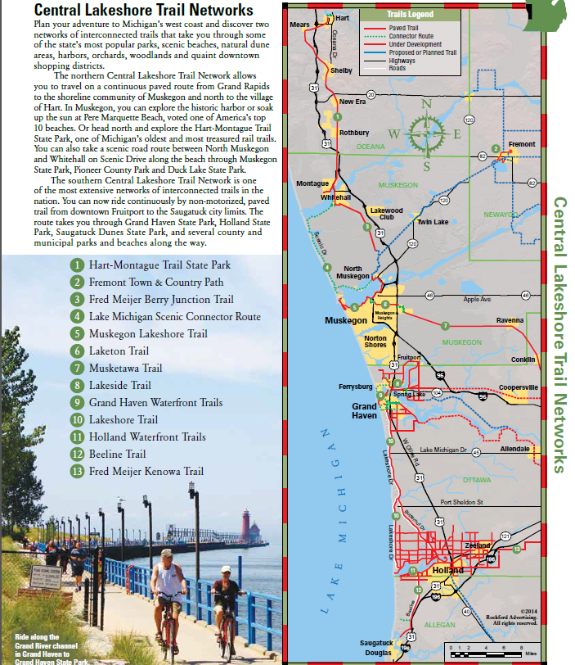
figure 13 – Trail Networks

Safety Planning
Safety planning is one of the key criteria which is examined during the project selection process of TIP and LRP development. In addition to road and transit projects that have safety components, MPO committees have approved a number of projects which are primarily safety related projects. Most notably these include various Safe Routes to School projects. Also, many of the non-motorized trail and Transit projects have key safety components.
The West Michigan Shoreline Regional Development Commission (WMSRDC) is responsible for Hazard Mitigation Planning for the entire region, which includes Muskegon County. Similar planning is done for Ottawa County by the State of Michigan. Hazard Mitigation Plans are developed to identify, reduce and eliminate long-term risks to people and property from natural or manmade hazards. Planners work directly with the Michigan State Police and the Federal Emergency Management Agency, as well as local emergency managers and stakeholders.
Some of the transportation related issues identified through this program include weather related hazards such as fog and winter storms. With the proximity to Lake Michigan, the MPO area is prone to these types of hazardous weather conditions. Also identified in these plans are issues such as hazardous material incidents, which could be uncontrolled releases of hazardous materials along the transportation network. An infrastructure failure is another potential hazard identified in these plans. The failure of critical public or private infrastructure could result in temporary loss of essential functions and/or services. The Michigan Department of Transportation has identified and posted emergency routes along the major trunklines in Muskegon and Ottawa Counties, primarily on US-31 and I-96.

Security Planning
WMSRDC houses the MPO, and also serves as the Region 6 Homeland Security fiduciary. With that, WMSRDC is responsible for the management and administration of the homeland security program for the counties of Clare, Ionia, Isabella, Kent, Lake, Mason, Mecosta, Montcalm, Muskegon, Newaygo, Oceana, Osceola, and Ottawa. Through that program, emergency and homeland security training events take place periodically throughout the region. In FY2014, the Center for Emergency and Homeland Security Training conducted a Joint Port Security Incident Exercise aboard the Paul H Townsend ship docked at the West Michigan Dock and Market Property in the Downtown Muskegon Harbor. Muskegon County is better prepared in the event of an actual port incident with the lessons learned during this extensive exercise and training.
Also through this program, Ottawa County purchased upgraded weather station equipment used to assess, identify and determine severe weather conditions and warnings for the public. This equipment was purchased Homeland Security funds. Ottawa County also purchased an information transfer upgrade for their outdoor warning siren system. These outdoor sirens warn the public in Ottawa County of impending severe weather or other emergencies that potentially pose a threat to human life, property, and may impact travel in the region. Several high tech boats were also purchased through this program for the police and fire activities in the Port of Muskegon and Grand Haven.

CHAPTER 8: TRENDS AND PROJECTIONS

2010 Population/Households/Employment
MDOT and WestPlan staff worked together to update Transportation Analysis Zones (TAZs) boundaries for the MPO area and to produce a list of 2010 population, household, and employment data for each jurisdiction in the WestPlan MPO area. The data was distributed to the WestPlan Technical Committee in March of 2013 for their review and updates. Meetings were also held with local units of government in May of 2013 in order to review 2010 base socioeconomic data. The socioeconomic data is a major input into the regional travel demand model, used to calculate trip productions and attractions. The following table represents population, household, and employment estimates for the year 2010. These figures were reviewed at the local level and were approved by the WestPlan Policy and Technical Committees in May of 2013. These figures were then used as base year inputs in the regional travel demand model and assisted the Technical Committee to identify deficiencies in the regional transportation system.
The Nielsen Company (formally Claritas) and Hoovers, Inc. are both private market research firms providing several consumer and business databases which are continuously updated and regularly verified. MDOT purchased geocoded business employment data from both firms and then merged the files into a single MDOT employment database. This data includes the physical street address, employment level, and NAICS code for each record. MDOT cleaned this merged database by researching and editing records with missing or incorrect addresses, incorrect NAICS codes, duplicate records, and incorrect employment levels. This base year employment data was reviewed by local agencies and MPO staff and approved through the MPO committee process.

2040 Population/Households/Employment
Working from the 2010 population, households, and employment totals that were approved by the WestPlan Technical Committee and Policy Committee, several sources were used to identify growth rates and prepare the future estimates. The West Michigan Shoreline Regional Development Commission (WMSRDC) develops demographic and economic projections for Lake, Mason, Muskegon, Newaygo, Oceana, and Northern Ottawa Counties for the years 2015 through 2040 (population) and 2014 through 2018 (employment). The population forecasts were developed using variations of the traditional cohort survival technique of population forecasting and historical trends. This method examines trends in population as provided by the U.S. Census Bureau. The employment projections developed by WMSRDC are by place of employment (not residence), and are based on data from the Regional Economic Information System (REIS) published by the U.S. Department of Commerce, Bureau of Economic Analysis and the Michigan Department of Career Development/Employment Services Agency, Labor Market Analysis Section. The economic projections were also based on data provided by the Institute for Research on Labor, Employment, and the Economy at the University of Michigan through the Regional Economic Models, Inc. (REMI) economic and demographic forecasting and simulation model. The projection methodology utilizes past trends, existing economic activity, and anticipated growth to estimate employment totals for each county. The county totals are also separated into specific economic sectors.
Also WestPlan members and local officials submitted information on planned future development which was incorporated into the base year data. This allowed known future development to be placed into the correct TAZ. Socio-economic data was then projected out to 2040 utilizing the 2010 TAZ data. Future year projections of employment by type used the 2040 REMI forecast, as a control total by MCD. The additional employment was distributed into each zone using a weighted average by current number of employees plus known development.

figure 14 – 2010 and 2040 population, households, and employment
Minor Civil Division | Approved 2010 Population | Estimated 2040 Population | Approved 2010 Occupied Households | Estimated 2040 Occupied Households | Approved 2010 Total Emp | Estimated 2040 Total Emp
Blue Lake Twp | 2360 | 2785 | 810 | 981 | 529 | 670
Casnovia Twp | 2805 | 2905 | 944 | 1040 | 690 | 660
Cedar Creek Twp | 3186 | 3203 | 1207 | 1281 | 305 | 303
Dalton Twp | 9300 | 10561 | 3368 | 4099 | 1543 | 1667
Egelston Twp | 9909 | 10122 | 3620 | 3940 | 2439 | 2702
Fruitland Twp | 5543 | 5747 | 2097 | 2435 | 858 | 960
Fruitport | 1093 | 1162 | 440 | 519 | 573 | 673
Fruitport Twp | 12505 | 13331 | 4663 | 5547 | 5884 | 6156
Holton Twp | 2515 | 2451 | 916 | 961 | 555 | 608
Laketon Twp | 7563 | 7642 | 2922 | 3315 | 1064 | 1253
Montague | 2361 | 3064 | 1006 | 1322 | 1930 | 1608
Montague Twp | 1600 | 1513 | 618 | 642 | 407 | 377
Moorland Twp | 1575 | 1500 | 574 | 629 | 304 | 293
Muskegon | 38602 | 36689 | 14025 | 14112 | 22882 | 25629
Muskegon Heights | 10856 | 9584 | 3996 | 3635 | 5281 | 5377
Muskegon Twp | 17641 | 17220 | 6750 | 7213 | 6745 | 7444
North Muskegon | 3784 | 3478 | 1620 | 1693 | 1544 | 1768
Norton Shores | 23994 | 25233 | 9977 | 11573 | 14032 | 14603
Ravenna | 1323 | 1320 | 486 | 519 | 534 | 542
Ravenna Twp | 1582 | 1572 | 552 | 578 | 628 | 613
Roosevelt Park | 3831 | 3705 | 1731 | 1754 | 3722 | 3550
Sullivan Twp | 2441 | 2357 | 932 | 1013 | 397 | 357
White River Twp | 1335 | 1292 | 524 | 547 | 324 | 334
Whitehall | 2706 | 3141 | 1153 | 1403 | 3874 | 3570
Whitehall Twp | 1778 | 1849 | 685 | 774 | 955 | 1252
Crockery Twp | 3960 | 4077 | 1510 | 1678 | 1637 | 1855
Ferrysburg | 2892 | 2697 | 1287 | 1286 | 1061 | 1340
Grand Haven | 10447 | 10356 | 4781 | 5290 | 13236 | 16547
Grand Haven Twp | 15143 | 17069 | 5535 | 6930 | 6010 | 6757
Robinson Twp | 6084 | 6527 | 2065 | 2430 | 1382 | 1452
Spring Lake | 2323 | 2404 | 1067 | 1198 | 1716 | 1827
Spring Lake Twp | 12229 | 12833 | 4837 | 5495 | 4701 | 5741
Total | 225266 | 229389 | 86698 | 95832 | 107742 | 118488

Travel Patterns
There is a significant amount of commuting in the WestPlan area for employment. 2010 County-to-County commute data illustrates significant worker flows into and out of the WestPlan area to neighboring counties. Utilizing the American Community Survey (ACS) data from the U.S. Census Bureau, the extent of commute flows can be seen from one county to another.
Muskegon County draws 5,156 workers from Ottawa County, 1,435 from Kent County, and 1,308 from Newaygo County. Conversely, 9,780 workers travel to Ottawa County, 3,936 workers commute to Kent County, 1,201 workers to Newaygo County, and 664 workers travel to Oceana County.
Ottawa County draws 9,780 workers from Muskegon County and 5,156 Ottawa County workers travel to Muskegon County.
See the following map for commuting flow information.
The American Community Survey Data (ACS) also provides information about the average commute times to work. The mean travel time for Muskegon County workers is 21.0 minutes while the mean travel to work for Ottawa County workers is 20.2 minutes. The state of Michigan average is 24.0 which is 3 or more minutes higher than the WestPlan MPO area.

Figure 15 – 2040 Long Range Plan Commuting Flows
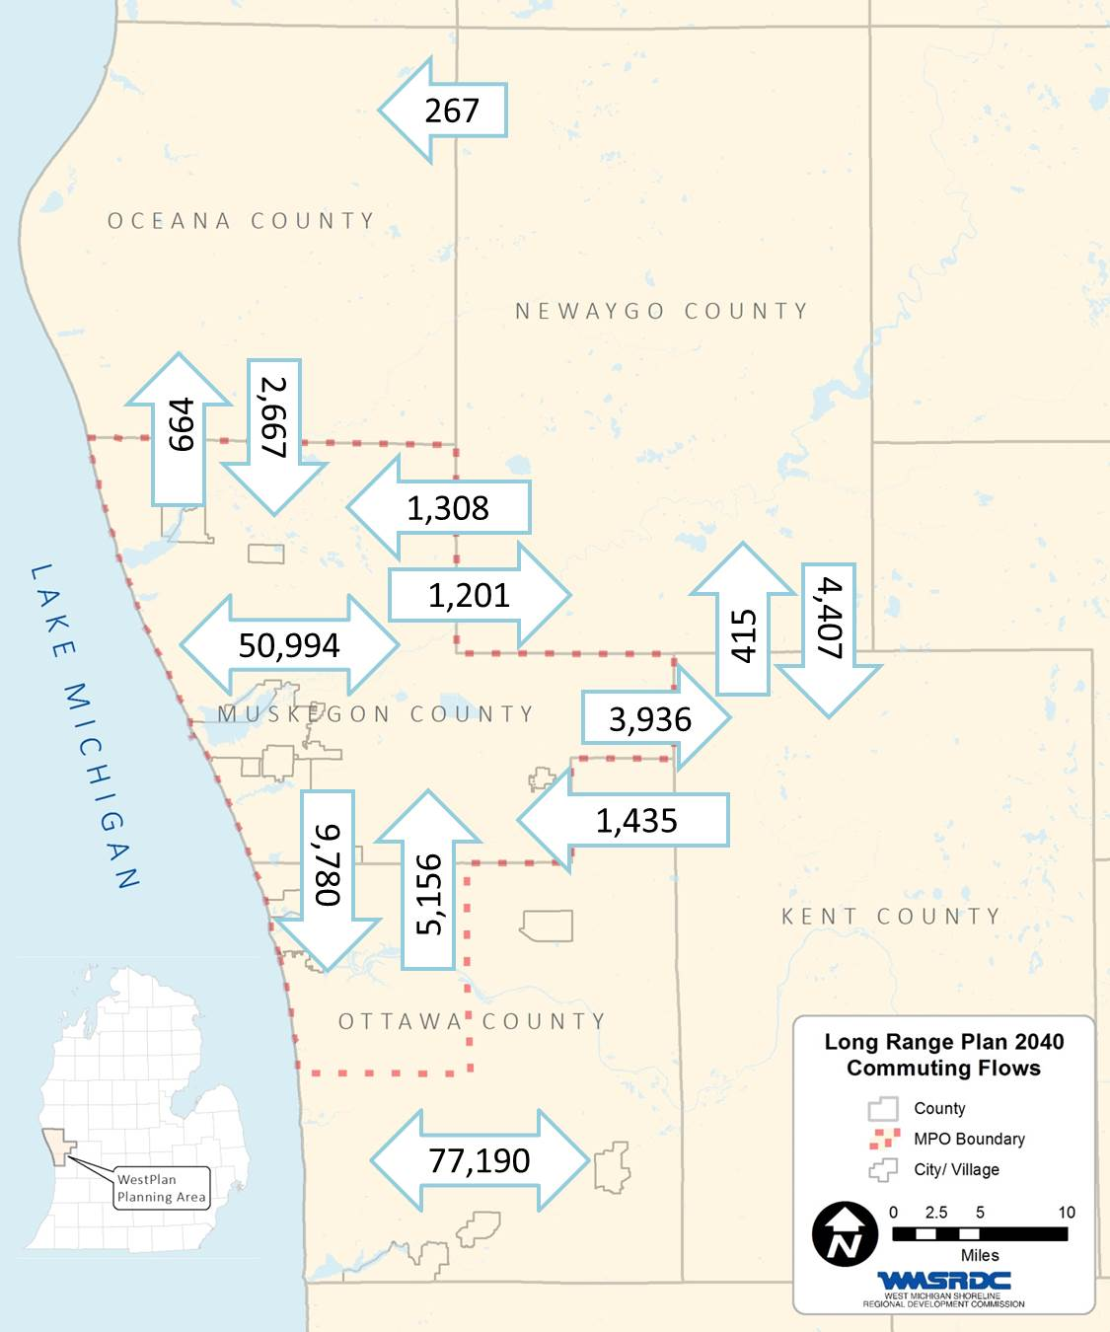

Land Use
Forested land, agriculture, developed land are the three most common land uses in the WestPlan Area. An inventory of existing land cover was prepared in 2001 and updated in 2011. See the table below for more detailed information regarding land cover and the changes in land cover that have taken place between the years 2001 and 2011.
 | LAND COVER | 2001 Acres | 2011 Acres | Difference in acres
 | Open Water | 17,775 | 17,958 | 183
 | Developed, Open Space | 38,427 | 38,243 | -184
 | Developed, Low Intensity | 29,333 | 29,548 | 215
 | Developed, Medium Intensity | 10,549 | 11,450 | 902
 | Developed, High Intensity | 4,290 | 4,847 | 558
 | Barren Land | 4,044 | 4,012 | -32
 | Deciduous Forest | 116,225 | 115,252 | -973
 | Evergreen Forest | 23,013 | 22,375 | -637
 | Mixed Forest | 15,633 | 15,415 | -218
 | Shrub/Scrub | 5,726 | 5,657 | -69
 | Herbaceuous | 25,298 | 25,922 | 624
 | Hay/Pasture | 13,966 | 13,853 | -113
 | Cultivated Crops | 71,278 | 71,151 | -127
 | Woody Wetlands | 36,728 | 36,556 | -172
 | Emergent Herbaceuous Wetlands | 9,212 | 9,256 | 45
What should the future look like? Recognizing the significant investment that WestPlan has made to develop the MPO’s transportation system, there is a clear priority to maintain the transportation network and resurface existing roads. Another priority is to ensure that the planning process will accommodate future growth and provide opportunities for future employment. During the original Muskegon Area-wide Plan (MAP) that concluded in 2005 and the update to the Plan that concluded in 2013, Muskegon County stakeholders and interested citizens used keypad polling and other ways to communicate priorities and topics of interest. Some of the key findings were:
- There is too much sprawl.
- We need to preserve open space and farmland.
- Density should be increased.
- We need to redevelopment the inner cities.
- What is the impact on existing infrastructure?
- What is the cost of new infrastructure?
- We need to develop around existing infrastructure

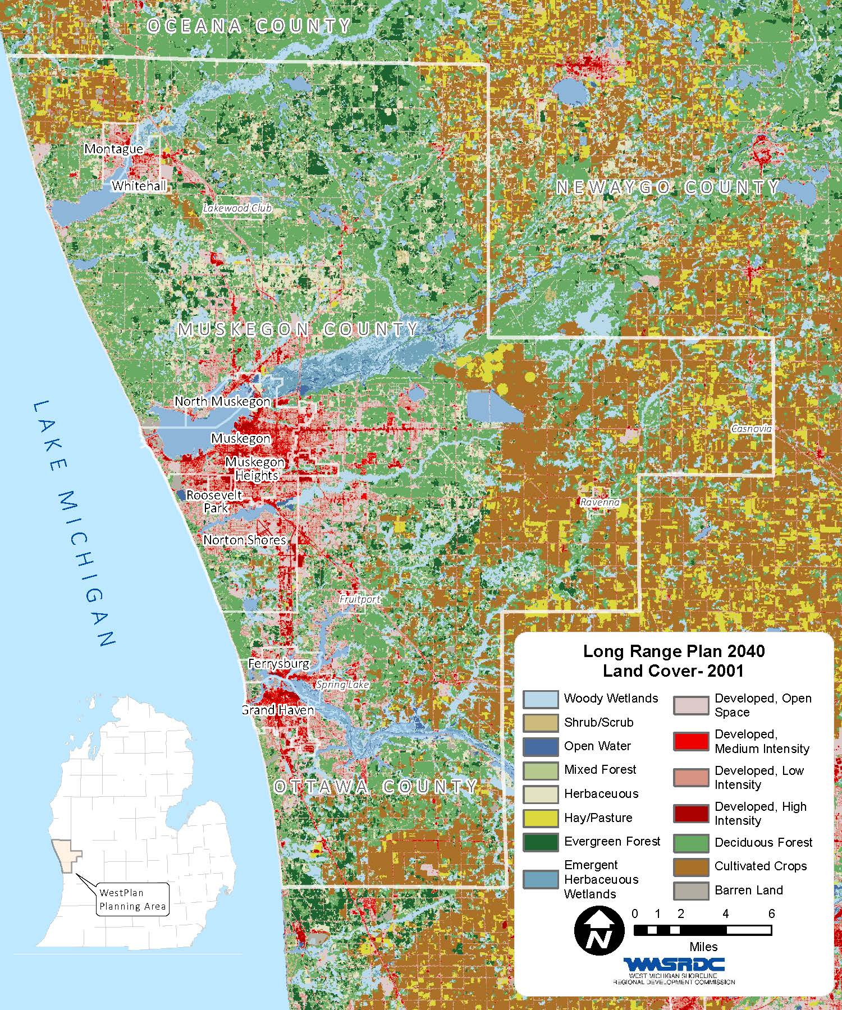
figure 16 – 2040 Long Range Plan Land Cover in 2001

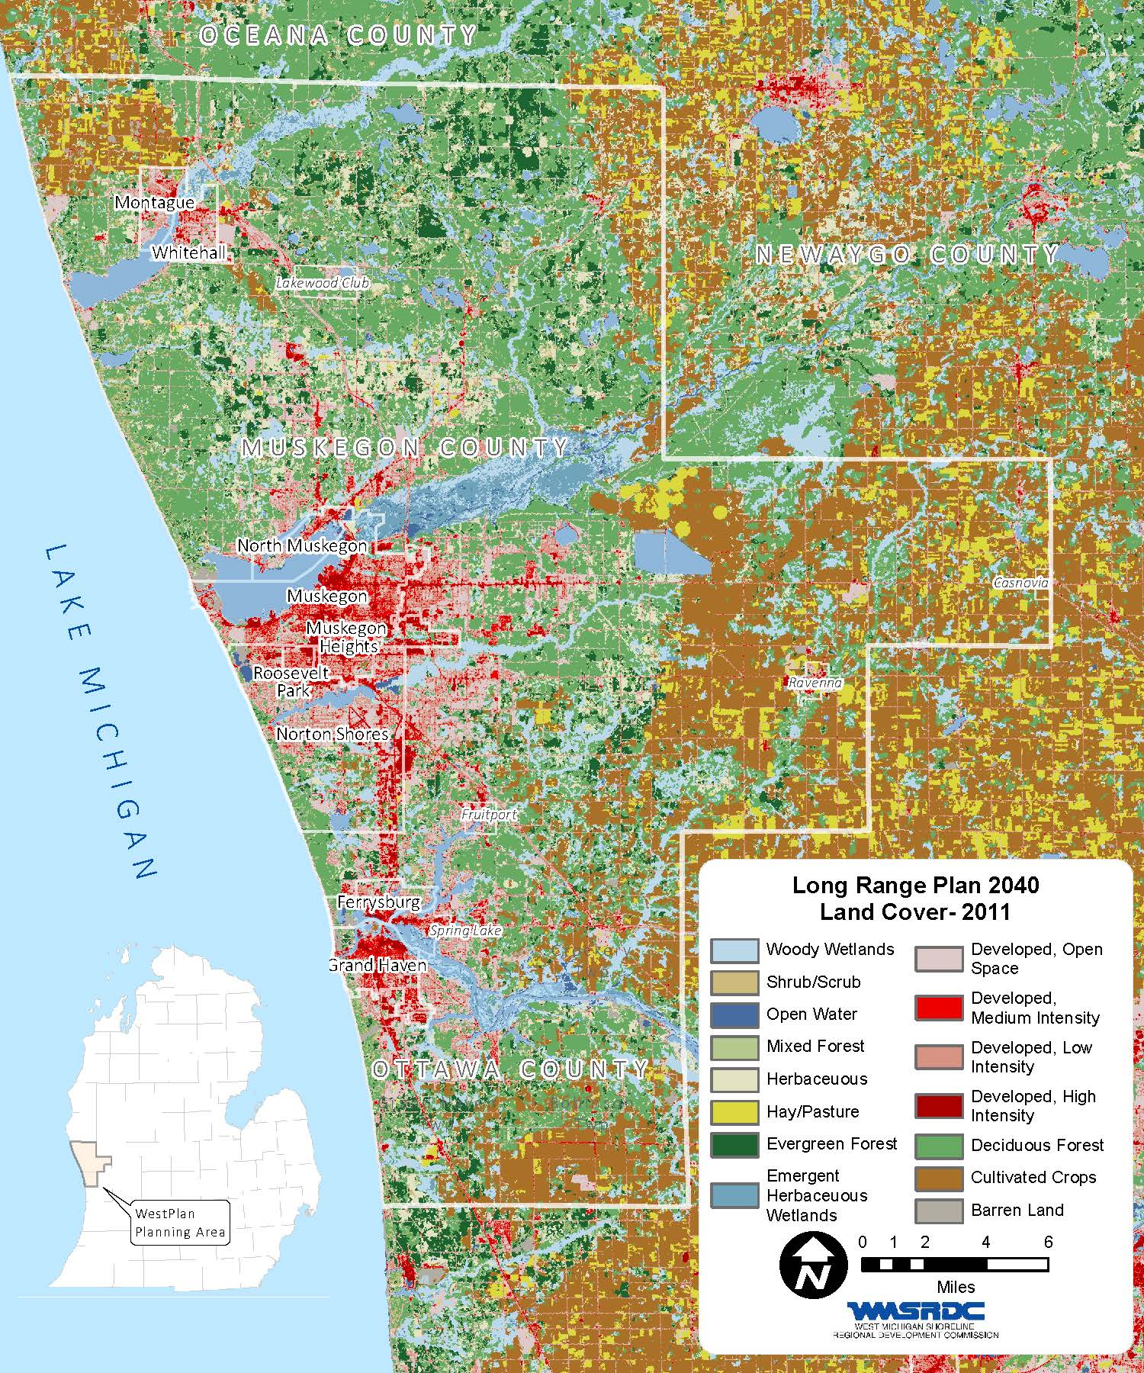
figure 17 – 2040 Long Range Plan lane Cover in 2011

CHAPTER 9: REGIONAL ISSUES
While the modeled capacity deficiencies of the transportation system are addressed in Chapter 11 - Deficiencies, Issues, and Projects, there are a number of other transportation concerns which have been identified for inclusion in the LRP. These include system condition, system operations, and a variety of other trends and issues impacting transportation in the WestPlan MPO. The MPO communities, as well as the public, assisted in compiling the local concerns list in order to address transportation needs such as operational, livability, or economic concerns that may not be shown by the capacity deficiency model.

Analysis of Background Research
Through background research and discussion with various local agencies and individuals throughout the planning process, a number of local concerns and issues relating to transportation in the WestPlan area were identified. Trends and issues were researched through the review of various local plans, review of Federal websites and publications, and local workshops with the public and local elected and appointed officials.
During the LRP process a number of opportunities were provided for public input on the plan. These are further outlined in greater depth in Chapter 6 – Public Involvement.

System Condition
Knowledge of the condition of the transportation system is important in making an informed decision on potential alternatives to address the transportation needs of the MPO. In addition to the deficiencies outlined in Chapter 11 – Deficiencies, Issues, and Projects, WestPlan also tracks pavement condition through its Asset Management program as well as being directly involved in Non-motorized planning for the MPO.

ASSET MANAGEMENT
WMSRDC staff is directly involved in monitoring the road conditions within the MPO through its Asset Management program. Asset Management is a concept in the transportation industry that is emerging as an important planning tool for public officials, planners, engineers, and others. Asset Management is based on an inventory of each local road network within the region. It provides data that allows transportation officials to monitor, plan, and strategically improve the road network. This strategic method of investment marks a break from the traditional “tactical” method of fixing roads that have the most severe problems.
In 2002 the Michigan Transportation Commission formed an Asset Management Council, with the objective to implement a state law that enacted the Asset Management Program. The Council is appointed by the Transportation Commission and answers directly to the Commission and legislature. Its five main elements include: Policy goals and objectives, data collection, planning and programming, program delivery, and monitoring and reporting. Its goal is to inventory all 39,000 miles of federal aid eligible roads within the State of Michigan, and according to the data collected, determine future distribution of ACT 51 transportation funds. In the future, the Asset Management Council may implement a similar initiative to collect similar information on the remaining local road network.
The purpose of this task is to help satisfy the requirements of P.A. 499 of 2002, which establishes an Asset Management Council and charges it to develop an Asset Management Process for the State of Michigan. Regional transportation planning agencies play a significant role in this process as outlined in the task assignments below.
The Asset Management Council has developed a statewide process that will result in approximately 50 percent of federal aid eligible roads in the state to be rated per year using the PASER system. Each year, WMSRDC staff, along with the Michigan Department of Transportation (MDOT) and a county road commission employee, collects this data within the MPO as well as the rest of the five-county region.
WMSRDC staff also assists local units of government by collecting the same data on their local road systems.

NON-MOTORIZED PLANNING
In addition to monitoring the road conditions within the MPO, WMSRDC staff is also heavily involved in monitoring the non-motorized system. In 2013, the MPO desired to undertake a study to develop a non-motorized plan for the MPO area. The study included an examination of existing non-motorized trails within the MPO boundaries and identified new connections to fill in the gaps between existing and proposed, but not yet constructed, trails. This plan provides a guide for the MPO, Muskegon County, northern Ottawa County, and the various municipalities and townships, to develop trail connections that will provide an interconnected system for the entire MPO area. In addition to identifying desirable trail connections, the plan identified potential funding sources and priorities. The consulting firm Progressive AE worked with representatives of the MPO to analyze existing data and develop plans identifying these new connections. Input was sought from various MPO partners in development of the plan. The MPO identified these partners and determined the extent of their involvement.
To commence the project, Progressive AE met with MPO representatives to collect and review the existing base data, review the project schedule, and begin to identify issues and opportunities as they related to the potential trail connections and alignments. It was determined that the study area would include all of the applicable communities within Muskegon County and northern Ottawa County in the MPO. The base data that was collected included:
- GIS mapping
- Township tax parcel mapping
- MIRIS base data
- Applicable city, village, and township recreational/other master plans
- MPO’s Transportation Improvement Plan
- MPO’s Long Range Transportation Plan
- Muskegon and Ottawa County Master Plans and Recreation Plans

The various master plans, transportation plans, and recreation plans were reviewed for any pertinent non-motorized transportation components. These components provided the foundation for future recommendations and were included in the Muskegon/Northern Ottawa Non-motorized Plan. Utilizing the existing base information, Progressive AE completed a complete system reconnaissance within the MPO and performed a review and verification of existing system conditions, as needed. Existing non-motorized transportation facilities and currently planned connections were confirmed for creation of a comprehensive system. Maps illustrating the various existing non-motorized systems were created. In addition, these plans identified potential new non-motorized trail connections. Progressive AE met with MPO representatives to review the preliminary non-motorized trail connections and support plans/documents. Revisions and corrections to the preliminary plans suggested by MPO representatives were noted. Based on input from the previous tasks, the preliminary non-motorized trail connections and support plans/documents were revised and resubmitted.
The MPO then sent the plans to various municipalities within the study area, as well as pertinent advocacy groups to solicit their input and comments regarding the existing, proposed, and suggested non-motorized trail connection design. Comments, suggestions, and concerns received back from these groups were then incorporated into the final plans. In addition, preliminary prioritization of various non-motorized trail connections was developed along with preliminary order of magnitude cost estimates. Potential funding sources were identified, as well as potential partners in the development of trial sections.
Finally, mapping of existing and proposed facilities was broken out by community to make the document more usable for each MPO constituent related to their own particular non-motorized facilities. An overview of the WESTPLAN non-motorized system can be found in Chapter 7 - Inventory of Existing Transportation System. In addition the entire Non-Motorized plan is available from WMSRDC.

System Operations
With so many road agencies and transit agencies responsible for their own portion of the transportation operations it can be difficult to get a full picture of how the system operates. However, there are a number of examples of where the MPO is coordinating system level programs which enhance operations.

TRAFFIC COUNT PROGRAM
One example of systems operation within the MPO is the coordination of traffic counting services. The WMSRDC operating as the staff for the MPO has taken over a MPO-wide traffic count system. In addition to the traffic counting itself, the MPO has become the repository and access site for traffic counts within the MPO.
Every year the MPO contracts with a consultant to collect approximately 100 traffic counts. Once completed these counts are uploaded onto a user friendly database site which can be accessed through WMSRDCs website.

AIR QUALITY PROGRAM
Another example of systems operations within the MPO is the Air Quality program which is coordinated by WMSRDC. WMSRDC is a member of the West Michigan Clean Air Coalition (WMCAC). Formed in 1995, the WMCAC is a partnership of businesses, academic institutions, government agencies, industry, and non-profit organizations in Kent, Ottawa, Muskegon, and Kalamazoo counties working together to achieve cleaner air in the region through the education and promotion of voluntary emission reduction activities. The coalition works to educate the public and to promote voluntary emission reduction activities. Individuals and businesses can help the coalition by making clean air choices on Clean Air Action Days. The coalition tries to limit the health and environmental damage that excessive ground level ozone can cause, by encouraging organizations and the general public to alter their lawn maintenance activities, refueling habits, and travel methods. West Michigan residents can stay informed about air quality year round by calling the West Michigan Clean Air Action hotline at 1-800-656-0663, signing on to Enviroflash as described above, or by visiting www.deqmiair.org.
A Clean Air Action Day is called when weather forecasters have predicted that conditions will be conducive to the formation of ozone or fine particulate matter. On a Clean Air Action Day, West Michigan residents will be asked to take certain voluntary actions to protect their health and reduce emissions. These voluntary actions may include limiting physical activity, carpooling, taking mass transit, and delaying lawn mowing (summer only).

HPMS
The Highways Performance Monitoring System (HPMS) program is a national highway information system that monitors data on the extent, condition, performance, use, and operating characteristics of the nation's highways. HPMS data is used extensively at the federal level in the analysis of highway system condition and performance, but more importantly in the appropriation of Federal Highway dollars and in support of federal efforts to secure increased transportation funding.

Trends and Issues Affecting Regional Transportation
As has previously been discussed there are a number of trends and issues which affect transportation within the WESTPLAN MPO.

Port Access and Expansion
As identified in Chapter 7 - Inventory of Existing Transportation System, both the City of Grand Haven and the City of Muskegon have deep water ports. Due to changes in ownership of waterfront parcels as well as the imminent closing of the Consumers Energy Cobb plant, there is a great deal of concern within the MPO about the future of port freight movement on Muskegon Lake.

Transit Connections
Another concern which continues to be discussed is the lack of transit connections not only connecting to areas outside the MPO but internal connections as well. Currently, the Muskegon Area Transit System operates within Muskegon County and the Harbor Transit Multimodal Transportation System, operates in northern Ottawa County. At this time there is no connection between the routes of the two systems. However, Harbor Transit has recently added Spring Lake Township to their service area so the two service areas are now adjacent.
Secondly, there is a lack of connections between transit systems in the MPO and other population/job centers. Specifically, area leaders and many making comment on this plan during the public comment phase are interested in a connection between the Muskegon/Grand Haven area and Grand Rapids and Holland. A study was conducted by MP2Planning, LLC and submitted to Ottawa County in June of 2012 that concludes that such routes are not feasible. There however, continues to be strong interest in the subject.
According to the West Michigan Transit Linkages Study Technical Memorandum 2 Needs Assessment (Extent of Demand) submitted to Ottawa County and conducted by MP2Planning, LLC in June of 2012, “The analysis and information presented in this report suggests that demand for commuter bus service will be limited. This is due to a number of factors. The West Michigan region outside Grand Rapids has low density development, is very spread out, and there is limited local transit service. Because most of the people who live in Kent County work in Kent County, the likelihood of Grand Rapids commuters traveling west is low. The greatest potential suggested by the data will be commuters traveling from Holland to Grand Rapids. Based on the stakeholder analysis and the general public survey results, there is interest is some type of regional connector service. But, this would likely be more for medical, shopping and other uses rather than work trips. With less than ten percent of respondents to the general public survey stating they have used transit in West Michigan in the last six months and the short travel times to work or school (less than 20 minutes in the Holland and Grand Rapids areas) the reality of people doubling (or more) their travel time to use transit is not great.”

More recently, in 2015, WMSRDC and the MPO began working with MDOT on a planning and assessment initiative to better understand and improve regional transit service in the region and in Michigan. On June 2, 2014, Governor Snyder released a special message to the legislature on the topic of aging, titled “Making Michigan a Great Place to Live Well and Age Well.” The special message included the following language regarding access to transportation: “Michiganders, including many older adults, need regional mobility and transit providers need to become more regionally focused. This is both an urban and rural issue.” In that message, the Governor asked MDOT to partner with MPOs and regional planning agencies to work on the issue of regional transit mobility. WMSRDC and the MPO have been working with MDOT to undertake a planning assessment effort beginning in 2015. To date, MDOT has requested the assistance of WMSRDC, the MPO and others in obtaining data related to the transit systems across the Governor’s Regional Prosperity Initiative Region 4 (RPI Region 4). The information will assist the Governor with the “Making Michigan a Great Place to Live Well and Age Well” initiative. The primary purpose of the survey is to document the need and the ability of individuals to make use of available local transit services for trips that cross county lines and/or transit service areas. Future activities planned to go along with this initiative include regional plan updates where WMSRDC and the MPO will work with the Michigan Association of United Way (MAUW) as MAUW undertakes an effort to create regional local-human service coordinated transportation plans. MAUW has received a federal grant to enhance the transportation functionality of their 211 Call Centers. As a requirement of the grant, MAUW must update existing local human service coordinated plans. Keeping the Governor’s emphasis on regionalization, rather than updating the existing local plans, MAUW will grow them into regional plans following the RPI boundaries. Participation by WMSRDC and the MPO and similar agencies in other areas will be critical in developing these regional plans. MAUW has hired a consultant, the KFH group, to assist with this effort. After the MAUW plans are complete, MDOT and planning agencies will develop action plans for addressing the highest priority needs within each prosperity region. WMSRDC and the MPO and other similar planning agencies across the state will work with transit agencies to narrow those gaps that can be addressed through better coordination. In addition, MDOT and WMSRDC and other similar agencies across the state will identify the highest needs statewide and develop an action plan for addressing statewide priorities.
Passenger Rail Issues
Along the same lines, there is an interest in providing some type of connection to passenger rail service. Currently the closest service is Amtrak in Holland, MI. One solution which has been proposed is to provide bus service from Muskegon to Holland.
This plan recommends the continued promotion of passenger rail (Amtrak) service in the Muskegon/ northern Ottawa area through participation in the Westrain Collaborative. It also recognizes the vital need to study passenger rail service options for West Michigan. WESTPLAN, in partnership with other stakeholders, will participate in efforts directed at analyzing different service options.
The existing transit systems are further detailed in Chapter 7 - Inventory of Existing Transportation System.

ENVIRONMENTAL/Livability Issues/ Climate Change
The impacts of transportation projects on the environment and livability of the WESTPLAN area were identified as a concern by members of the public.
There are a number of potential impacts of climate change on transportation infrastructure, including: accelerated pavement deterioration, flooded roadways, bridge damage, increased maintenance, and increased storm-water and drainage issues.
Environmental issues including livability and climate change are factors which are evaluated during the project selection process. During the goal setting process, outlined in Chapter 3, both the Technical and Policy Committees selected the following goal related to Sustainability and Livability as one of their six goals:
Goal: Ensure that transportation investments protect and enhance the environment, promote energy conservation, improve quality of life, and promote consistency with state and local planned growth and economic development
Funding
The lack of adequate funding levels was another issue which was brought up by members of the public at multiple meeting throughout the process of creating the 2040 Long Range Transportation Plan. Specifically, a desire to see Act 51 revisited was mentioned often. An in depth look at funding is examined in Chapter 13 – Financial Resource Analysis. In particular, the lack of funding for local roads was seen as impacting the transportation system as a whole. Although the financial analysis the 2040 Long Range Transportation Plan is financially constrained, there is not enough funding available to adequately maintain the transportation system.

CHAPTER 10: URBAN TRAVEL DEMAND MODEL
The urban area travel demand modeling process for the Muskegon County and Northern Ottawa County area was a cooperative effort between WestPlan, being the MPO, and the MDOT, Statewide and Urban Travel Analysis Section. MDOT provided the lead role in the process and assumed responsibility for modeling activities with both entities reaching consensus on selective process decisions. The local transportation planning agency is the MPO, comprised of representatives of local governmental units and is the umbrella organization responsible for carrying out transportation planning in cooperation with MDOT and the Federal Highway Administration. This is typically accomplished by full coordination of the local agencies with the MPO.
The results of the modeling effort provide an important decision making tool for the MPO Long Range Transportation plan development as well as any transportation related studies that might follow. The modeling process is a systems-level effort. Although individual links of a highway network can be analyzed, the results are intended for determination of system-wide impacts. At the systems level, impacts are assessed on a broader scale than the project level.
The travel demand modeling for WestPlan has been completed through the use of TransCAD software utilized by MDOT. The model is a computer simulation of current and future traffic conditions and is a system-level transportation planning model.
The current WestPlan model was developed for the 2010-2040 plan. The boundary includes all of Muskegon County and the Northwestern portion of Ottawa County that is in the WestPlan Planning Boundary.
The urban travel demand forecasting process used has seven phases:
- Data Collection, in which socio-economic and facility inventory data are collected.
- Trip Generation, which calculates the number of trips produced in or attracted to a traffic analysis zone (TAZ).
- Trip Distribution, which takes the trips produced in a TAZ and distributes them to all other TAZs, based on attractiveness of the zone.
- Mode Choice, which assigns person trips to a mode of travel such as drive alone, shared ride 2, shared ride 3+, and transit.
- Traffic Assignment, determines what routes are utilized for trips.
- Model Calibration/validation, which involves verifying that the volumes (trips) simulated in traffic assignment replicate observed traffic counts.
- System Analysis, tests alternatives and analyzes changes in order to improve the transportation system.

There are two basic systems of data organization in the travel demand forecasting process. The first system of data is organized based on the street system. Roads with a national functional class (NFC) designation of "minor collector" and higher are included in the network. Some local roads are included to provide connectivity in the network or because they were deemed regionally significant. The unit of analysis is called a "link." Usually, a link is a segment of roadway which is terminated at each end by an intersection. In a traffic assignment network, intersections are called "nodes." Therefore, a link has a node at each end.
The second data organization mechanism is the TAZ. TAZs are determined based upon several criteria, including similarity of land use, compatibility with jurisdictional boundaries, the presence of physical boundaries, and compatibility with the street system. Streets are generally utilized as zone boundary edges. All socio-economic and trip generation information for both the base year and future year are summarized by TAZ.
The two data systems, the street system (network) and the zone system (socio-economic data), are interrelated through the use of "centroids." Each zone is portrayed on the network by a point (centroid) which represents the weighted center of activity for that zone. A centroid is connected by a set of links to the adjacent street system. That is, the network is provided with a special set of links for each zone which connects the zone to the street system. Since every zone is connected to the street system by these "centroid connectors,” it is possible for trips from each zone to reach every other zone by way of a number of paths through the street system.

Network
A computerized "network" (traffic assignment network) is built to represent the existing street system. The WestPlan network is based on the Michigan Geographic Framework version 12 and includes most streets within the study area classified as a "minor collector" or higher by the national functional classification system. Other roads are added to provide continuity and/or allow interchange between these facilities.
The WestPlan 2010 calibrated/validated network includes approximately 922 miles of roadway (excluding centroid connectors) with the following classifications:
• 85 miles of freeways (trunklines)
• 21 miles of ramps (trunklines)
• 22 miles of other trunklines
• 68 miles of local major arterials
• 228 miles of minor arterials
• 498 miles of collectors and local roads
Transportation system information or network attributes required for each link include facility type, area type, lane width, number of through lanes, parking available, traffic counts (where available), and volumes for level of service E (frequently described as its capacity). If the information is not the same for the entire length of a link, the predominant value is used. The network attributes were reviewed by the respective road agencies, with the exclusion of link capacity. The link capacity was determined by utilizing a look up table developed as part of the Urban Model Improvement Project undertaken by MDOT Urban Travel Analysis Staff. The table is based on the highway capacity manual taking into account the network attributes and sets a capacity that would approximate a level of service “E”. This level of service is characterized by: stop-and–go-travel, reduced flow rates and severe intersection delays. A volume to Capacity ratio of one or greater would represent a level of service E or greater which typifies unacceptable or deficient traffic conditions.
The street network is used in the traffic assignment process. The traffic assignment process takes the trip interactions between zones from trip distribution and loads them onto the network. The travel paths for each zone-to-zone interchange are based on the minimum travel time between zones. They are calculated by a computer program which examines all possible paths from each origin zone to all destination zones. The shortest path is determined by the distance of each link and the speed at which it operates. The program then calculates travel times for all of the possible paths between centroids and records the links which comprise the shortest travel time path.
Speeds used to calculate minimum travel times are based on each link's area type, facility type, number of travel lanes, Lane width, and parking. Speeds represent a relative impedance to travel and not posted speed limits.

Socio-Economic Data
Travel demand models are driven, in part, by the relationship of land use activities and characteristics to the transportation network. Specific inputs to the modeling process are land use activity including the number of households, population-in-households, vehicles, and employment located in a given transportation analysis zone (TAZ). The modeling process translates this data into vehicle trips on the modeled transportation network. Socio-Economic data were developed for the 2010 base year, 2015, 2020, 2030 and the 2040 forecast years.
It is important to remember that socio-economic forecasting is essentially a matter of judgment. Judgment is required in selecting the type of forecast to be implemented; in determining the procedures for making the forecast; and, the process used in reviewing the effects of the factors that induce changes in population and employment. The establishment of a large new industry or the loss of a similar size industry can lead to considerable impact on an area’s development.
Therefore, although socio-economic projections are a useful and required tool in the planning of an area’s future growth and development, it is important to note that the projections are not infallible and should be modified as time progresses to better reflect development impacts occurring in the WestPlan planning area.
The TAZ’s were created from the 2010 census blocks and constrained by the network, Minor Civil Division (MCD) boundaries, and physical barriers. Values for population and occupied households were aggregated from the 2010 census blocks. MDOT staff used this and MCD projections as well as input from MPO staff and local officials to develop the TAZ values for the forecast years of 2015, 2020, 2030 and 2040. The TAZ values were then reviewed by local agencies and MPO staff and approved through the MPO committee process.

Establishing employment totals for the study area presented a challenge because of a lack of reliable and complete data sources. Determining the number of jobs located in the WestPlan area was the most difficult of the data inputs to estimate and project accurately. In transportation planning, the concern in gathering employment data is determining travel to and from employment sites.
The Nielsen Company (formally Claritas) and Hoovers, Inc are both private market research firms providing several consumer and business databases which are continuously updated and regularly verified. MDOT purchased geocoded business employment data from both firms and then merged the files into a single MDOT employment database. This data includes the physical street address, employment level, and NAICS code for each record. MDOT cleaned this merged database by researching and editing records with missing or incorrect addresses, incorrect NAICS codes, duplicate records, and incorrect employment levels. This base year employment data was reviewed by local agencies and MPO staff and approved through the MPO committee process.
WestPlan members and local officials submitted information on planned future development which was incorporated into the base year data. This allowed known future development to be placed into the correct TAZ. Socio-economic data was then projected out to 2040 utilizing the 2010 TAZ data. Future year projections of employment by type used the 2040 REMI forecast, as a control total by MCD. The additional employment was distributed into each zone using a weighted average by current number of employees plus known development.
WestPlan staff and committees reviewed the estimates and projections and made adjustments given their local knowledge and greater understanding of the unique local circumstances in each TAZ.

Trip Generation
The trip generation process calculates the number of person-trips produced from or attracted to a zone, based on the socio-economic characteristics of that zone. The urban transportation forecasting models do not consider travel characteristics such as direction, length, or time of occurrence as part of trip generation. The relationship between person-trip making and land activity are expressed in equations for use in the modeling process. The formulas were derived from MI Travel Counts Michigan travel survey data and other research throughout the United States. Productions were generated with a cross-classification look-up process based on household demographics. Attractions were generated with a regression approach based on employment and household demographics. In order to develop a trip table, productions (P's) and attractions (A's) must be balanced also referred to as normalization.
The WestPlan travel demand model also has a simple truck model that estimates commercial and heavy truck traffic based on production and attraction relationships developed from the Quick Response Freight Manual I (QRFM I). The QRFM I uses the employment data from the TAZs in its calculations.
Trips that begin or end beyond the study area boundary are called "cordon trips." These trips are made up of two components: external to internal (EI) or internal to external (IE) trips and through-trips (EE). EI trips are those trips which start outside the study area and end in the study area. IE trips start inside the study area and end outside the study area. EE trips are those trips that pass through the study area without stopping; this matrix is referred to as the through-trip table.

Trip Distribution
The process which connects productions to attractions is called trip distribution. The WestPlan travel demand model utilizes a "gravity model" which was originally derived from Newton's Law of Gravity. Newton's Law states that the attractive force between any two bodies is directly related to the masses of the bodies and inversely related to the distance between them. Analogously, in the trip distribution model, the number of trips between two areas is directly related to the level of activity in an area (represented by its trip generation) and inversely related to the distance between the areas (represented as a function of travel time).
Trip distribution involves the use of mathematical formula which determines how many of the trips produced in a zone will be attracted to each of the other zones. It connects the ends of trips produced in one zone to the ends of trips attracted to (in) other zones. The equations are based on travel time between zones and the relative level of activity in each zone. Trip purpose is an important factor in development of these relationships. The trip relationship formula developed in this process is based on principals and algorithms commonly referred to as the Gravity Model.
Research has determined that the pure gravity model equation does not adequately predict the distribution of trips between zones. In most models the value of time for each purpose is modified by an exponentially determined "travel time factor" or "F factor" --also known as a "Friction Factor." "F factors" represent the average area-wide effect that various levels of travel time have on travel between zones. The "F factors" used were developed utilizing an exponential function validated to the 2005 MI Travel Counts Household Survey data. The matrix is generated in TransCAD during the gravity model process.
The primary inputs to the gravity model are the normalized P’s & A's by trip purpose developed in the trip generation phase. The second data input is a measure of the temporal separation between zones. This measure is an estimate of travel time over the transportation network. Zone-to-zone travel times are referred to as "skims."
In order to more closely approximate actual times between zones and also to account for the travel time for intra-zonal trips, the skims were updated to include terminal and intra-zonal times. Terminal times account for the non-driving portion of each end of the trip and were generated from a look-up table based on area type. They represent that portion of the total travel time used for parking and walking to the actual destination. Intra-zonal travel time is the time of trips that begin and end within the same zone. Intra-zonal travel times were calculated utilizing a nearest neighbor routine.
The Gravity Model utilizes the by-purpose P’s & A's, the by-purpose "F factors", and the travel times, including terminal and intra-zonal.

Mode Choice
The number of person trips and their trip starting and ending point have been determined in the trip generation and trip distribution steps. The mode choice step determines how each person trip will travel. The WestPlan travel demand model uses a simplified mode choice method that was developed as part of the Urban Model Improvement Project conducted by MDOT urban travel analysis staff.
The process uses a qualitative measure of transit network service at the zonal level to estimate transit mode shares. Transit shares are a function of trip purpose, production zone average autos per household and attraction zone area type. Transit service is represented with zonal yes/no flags, so transit shares are only estimated where both the production zone and attraction zone have transit service.
Auto mode shares are a function of trip purpose, production zone average autos per household, attraction zone area type, and trip distance. The split between single occupancy vehicles (SOV) and shared ride trips (SR2 & SR3+) is based on the average auto occupancy for the applicable trip purpose. After transit shares are estimated, the auto shares are scaled proportionally to keep the average auto occupancy consistent at the trip interchange level.

Traffic Assignment
The WestPlan travel demand model has 4 time periods that were developed to match the peak periods observed in traffic counts.
The following period were used:
AM Peak (7a - 9a)
Mid-Day (9a - 3p)
PM Peak (3p - 6p)
Night Time (6p – 7a)
A fixed time of day factor method was utilized. The factors were developed from the MI Travel Counts Michigan travel survey data and vary by trip type. Default factors from the Quick Response Freight Manual I (QRFM I) were used for truck trips.
The traffic assignment process takes the trips produced in a zone (trip generation) and distributed to other zones (trip distribution) and loads them onto the network via the centroid connectors. A program examines all of the possible paths from each zone to all other zones and calculates all reasonable time paths from each zone (centroid) to all other zones. Trips are assigned to paths that are the shortest path between each combination of zones. As the volumes assigned to links approach capacity, travel times on all paths are recalculated to reflect the congestion and the remaining trips are assigned to the next shortest path. This process continues through several iterations until no trip can reduce its travel time by taking the next shortest path. This is a user equilibrium assignment method and reflects the alternative routes that motorists use as the shortest path becomes congested. The assignment produces an assigned volume for each link.

Model Calibration/Validation
The outputs of each of the four main steps, Trip Generation, Trip distribution, Mode Choice and Assignment, are checked for reasonableness against national standards. Modifications can be made at each step before moving on to the next.
The final model calibration/validation verifies that the assigned volumes simulate actual traffic counts on the street system. When significant differences occur, additional analysis is conducted to determine the reason. At this time additional modifications may be made to the network speeds and configurations (hence paths), trip generation (special generators), trip distribution (F factors), socio-economic data, or traffic counts.
The purpose of this model calibration phase is to verify that the base year assigned volumes from the traffic assignment model simulate actual base year traffic counts. When this step is completed, the systems model is considered statistically acceptable. This means that future socio-economic data or future network capacity changes can be substituted for base (existing) data. The trip generation, trip distribution, mode choice and traffic assignment steps can be repeated, and future trips can be estimated for systems analysis. It is assumed that the quantifiable relationships modeled in the base year will remain reasonably stable over time.

Applications of the Calibrated/Validated Model
Forecasted travel is produced by substituting forecasted socio-economic and transportation system data for the base year data. This forecasted data is reviewed and approved through the MPO committees. The same mathematical formulae are used for the base and future year data. The assumption is made that the relationships expressed by the formulae in the base year will remain constant over time (to the target date).
After either base year or future trips are simulated, other types of modeling studies can be conducted.
- Network alternatives to relieve congestion can be tested for the 2035 Long Range Transportation Plan. Future traffic can be assigned to the existing network to show what would happen in the future if no improvements were made to the present transportation system. This process is often referred to as "deficiency analysis." From this, improvements can be planned that would alleviate demonstrated capacity problems.
- The impact of planned roadway improvements or network changes can be assessed.
- Links can be analyzed to determine what zones are contributing to the travel on that link. This can be shown as a percentage breakdown of total link volume.
- The network can be tested to simulate conditions with or without a proposed bridge or new road segment. The assigned future volumes on adjacent links would then be compared to determine traffic flow impacts. This, in turn, would assist in assessing whether the bridge should be replaced and/or where it should be relocated.
- Road closure/detour evaluation studies can be conducted to determine the effects of closing a roadway. This type of study is very useful for construction management.
- The impacts of land use changes on the network can be evaluated.
Two issues are critical in using the modeling tools and processes:
- The modeling process is most effective for system level analysis. Although detailed volumes for individual intersection and "links" of a highway are an output of the model, additional analysis and modification of the model output may be required for project level analysis.
- The accuracy of the model is heavily dependent on the accuracy of the socio-economic data and network data provided by the local participating agencies, and the skill of the users in interpreting the reasonableness of the results.

System Analysis for MTP
Generally three different alternative scenarios are developed for the Long Range Transportation Plan:
- Existing trips on the existing system or base year. This is the "calibrated," existing network/scenario. This is a prerequisite for the other two scenarios.
- Future trips on the existing plus committed (E + C) network. Future trips are assigned to the existing network with the addition of capacity projects that are currently in the Transportation Improvement Program (TIP). This alternative displays future capacity and congestion problems if no improvements in addition to the TIP are made to the system. This is called the "No Build" alternative.
- Future trips on the future system. This scenario is the future Metropolitan Transportation Plan network. It includes capacity projects listed in the MTP.

CHAPTER 11: DEFICIENCIES, ISSUES, AND PROJECTS

Identification of deficiencies
A Capacity deficiency occurs when traffic volumes exceed that which the roadway was designed to handle. Each link was assigned a volume to capacity ratio for each of the Scenarios listed in the previous chapter.
It is important to remember that the volume to capacity ratio reflects a volume for a specified time period and a capacity for that same period of time. It does not reflect deficiencies that only occur briefly at certain short time periods or because of roadway geometrics, or roadway condition. Capacity deficiencies are identified in attached maps and in and the table below.
The Travel Demand Model provided by MDOT provided a list of segments where capacity deficiencies may occur through 2040. A Capacity deficiency occurs when traffic volumes exceed that which the roadway was designed to handle. Each link was assigned a volume to capacity ratio for each of the Scenarios listed above. The WESTPLAN Technical and Policy committees reviewed these modeling results and took them into consideration as the Long Range Transportation Plan Improve and Expand project list was created.
It is important to remember that the volume to capacity ratio reflects a volume for a specified time period and a capacity for that same period of time. It does not reflect deficiencies that only occur briefly at certain short time periods or because of roadway geometrics, or roadway condition. Capacity deficiencies are identified in attached maps and in the table on the following page.

Deficiency Maps
The maps on the following pages show the location of the capacity deficiencies listed in the table below. There are maps of Daily, AM Peak, and PM Peak capacity deficiencies for 2010 base year, 2040 No-build, and 2040 build model scenarios. No maps were created for the Mid-day or Night Time periods because there are no capacity deficiencies for these time periods.

figure 18 – 2040 long range plan Travel Demand Model Capacity Deficiencies

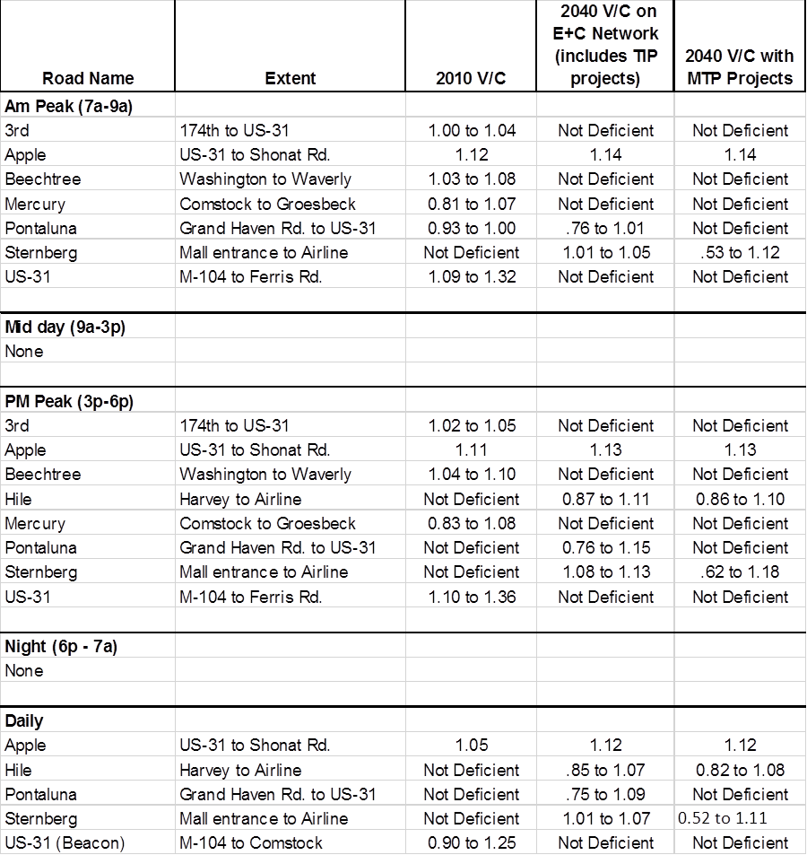

figure 19 -2010 PM peak deficiencies
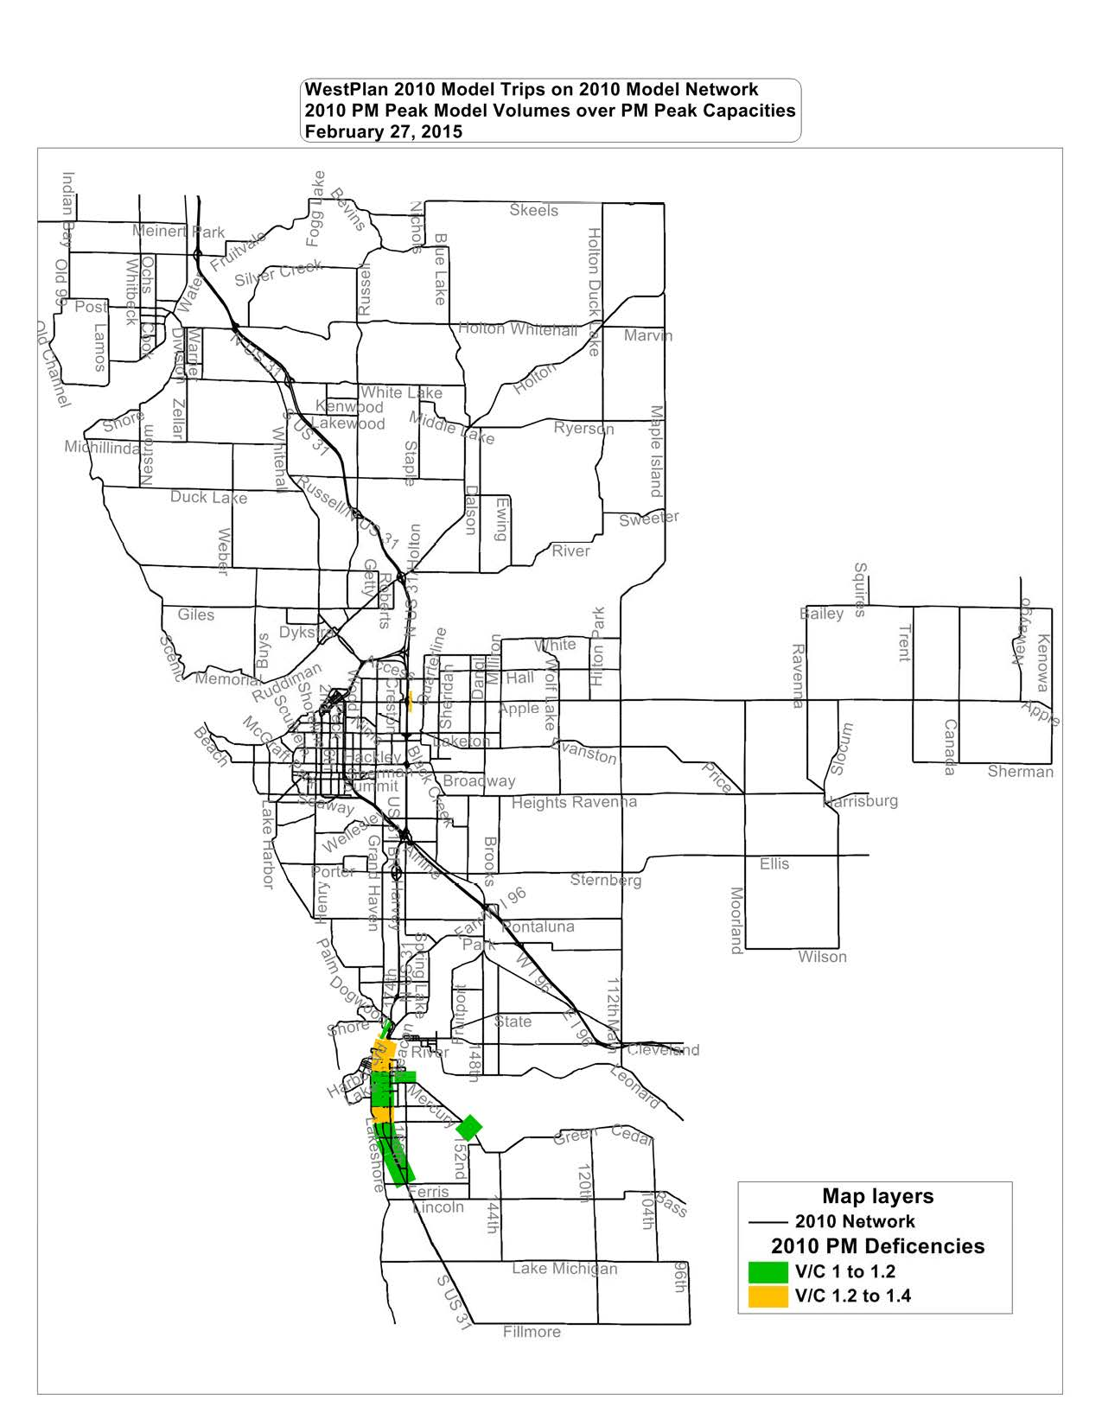

Figure 20 – 2010 daily deficiencies
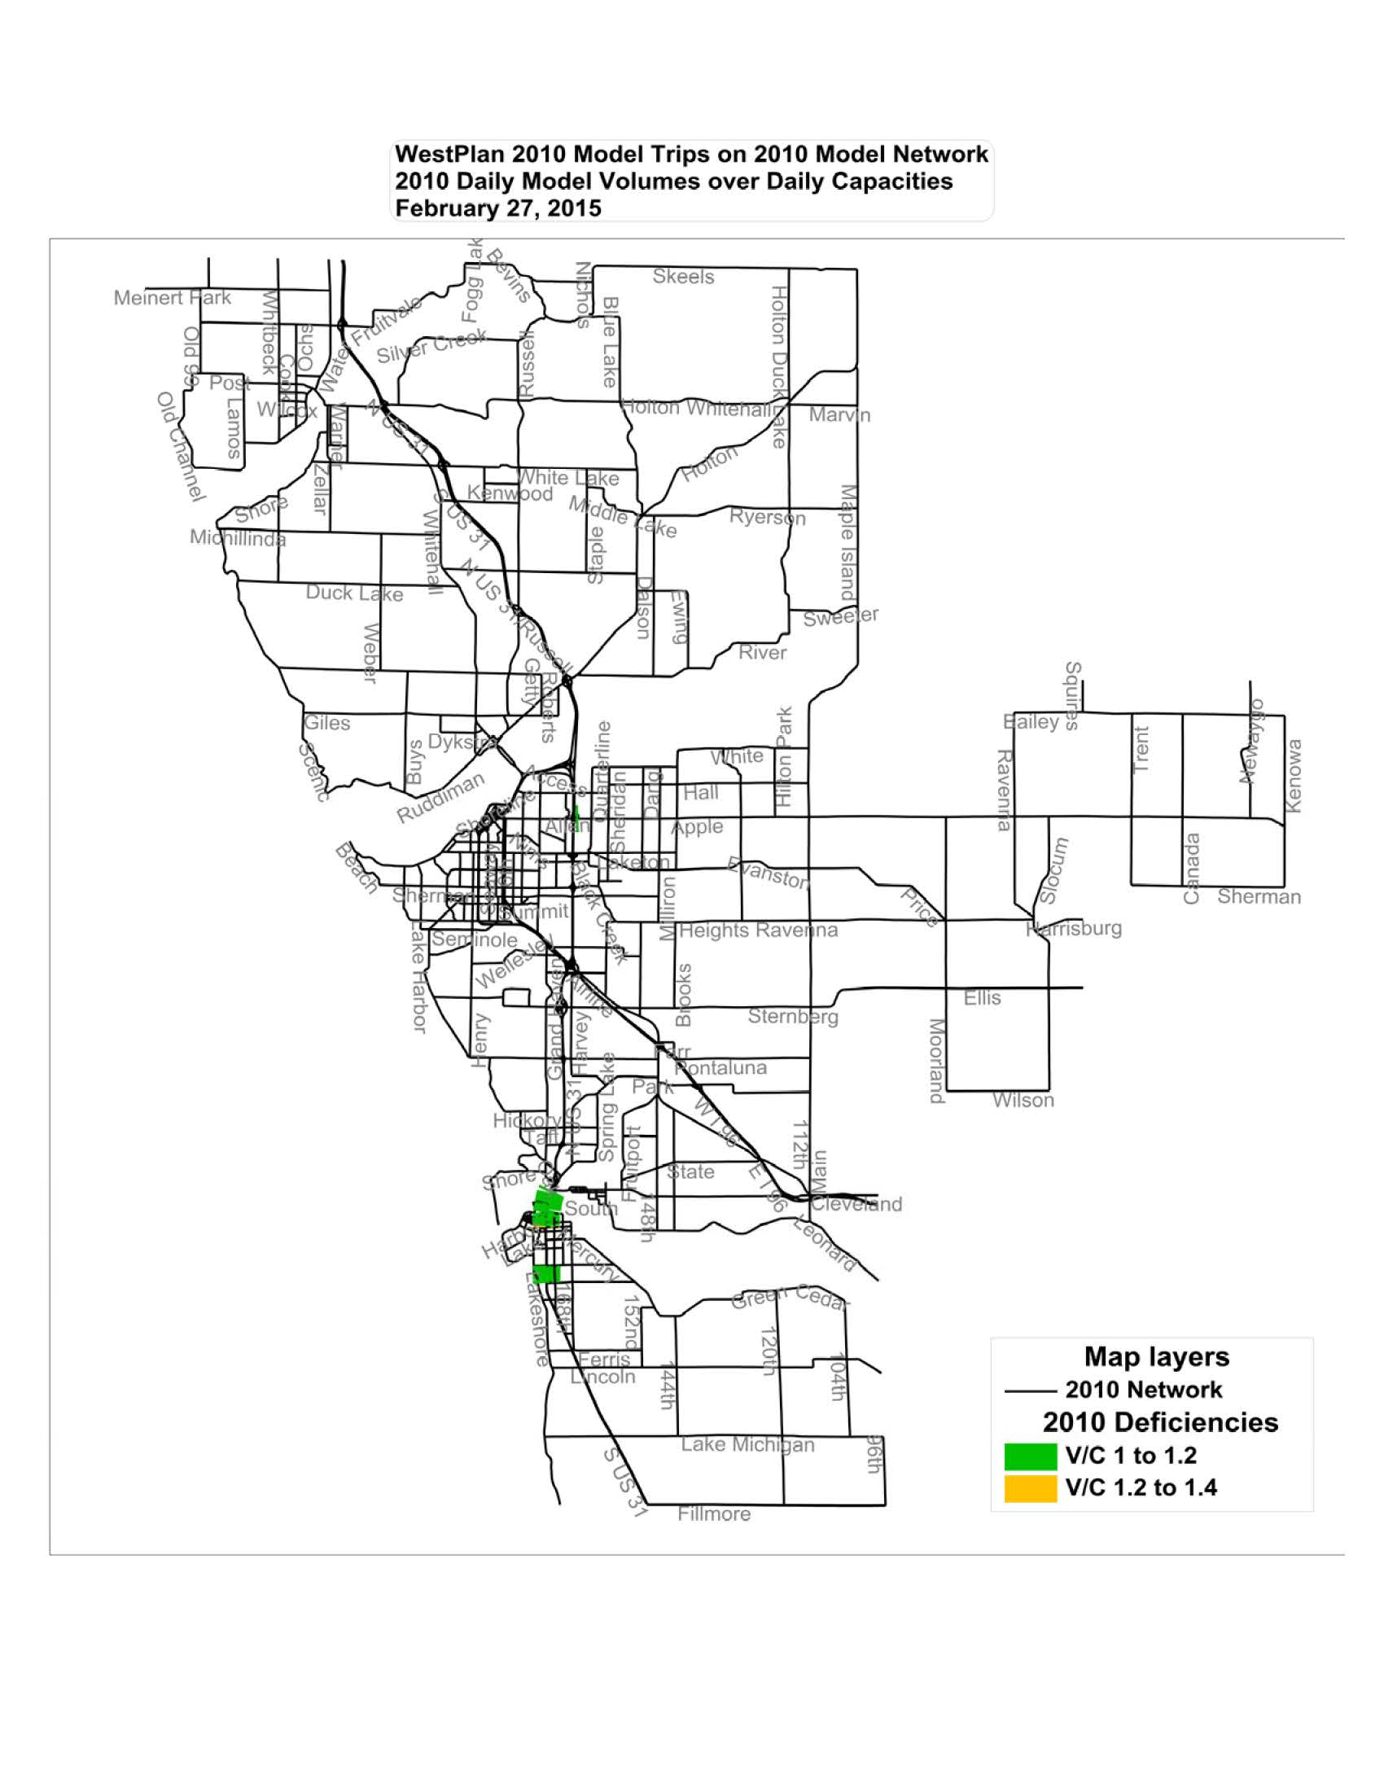

Figure 21 – 2010 am peak deficiencies

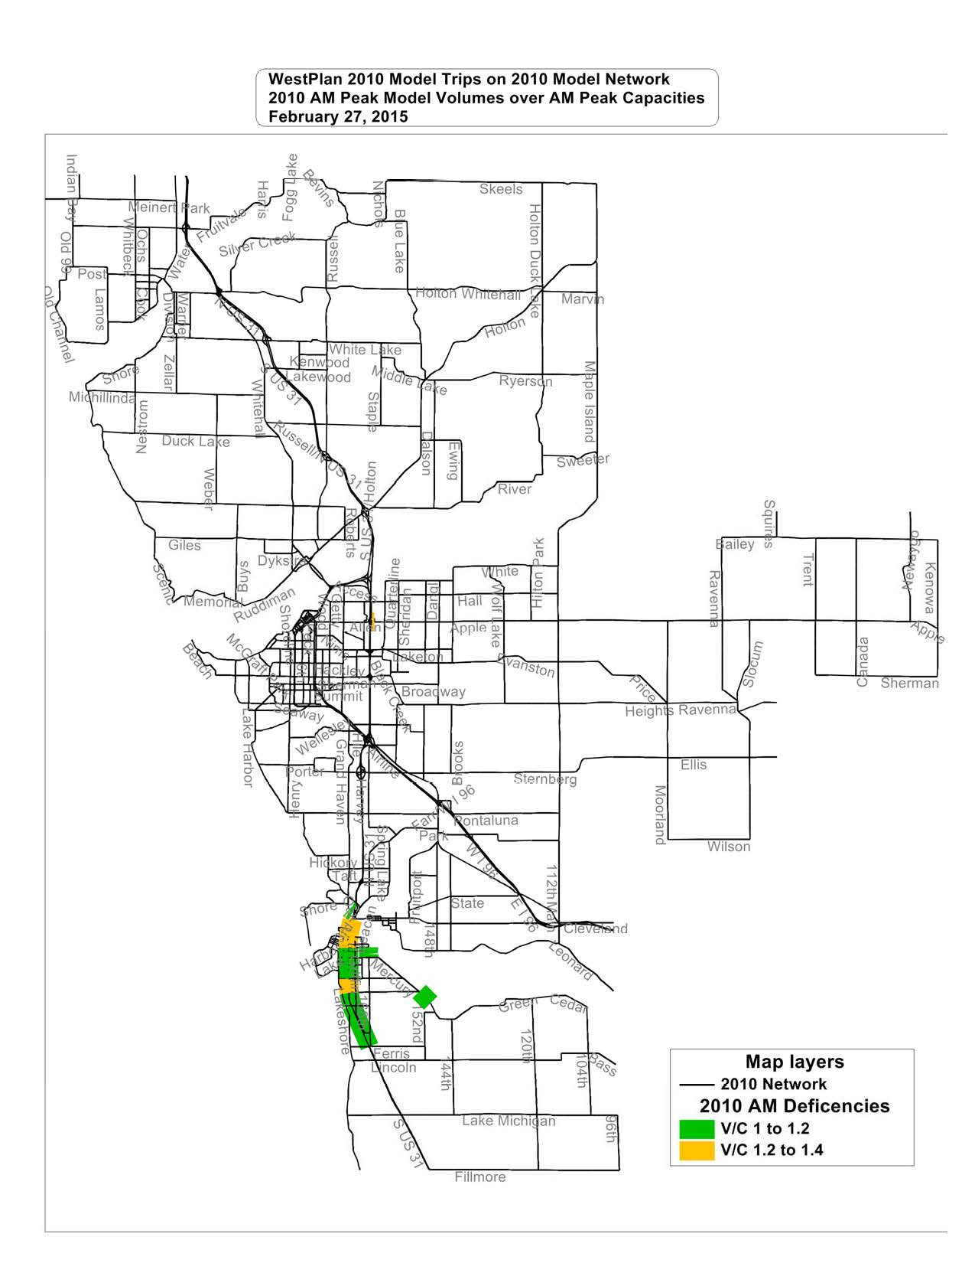

Figure 22 – 2040 AM Peak Deficiencies
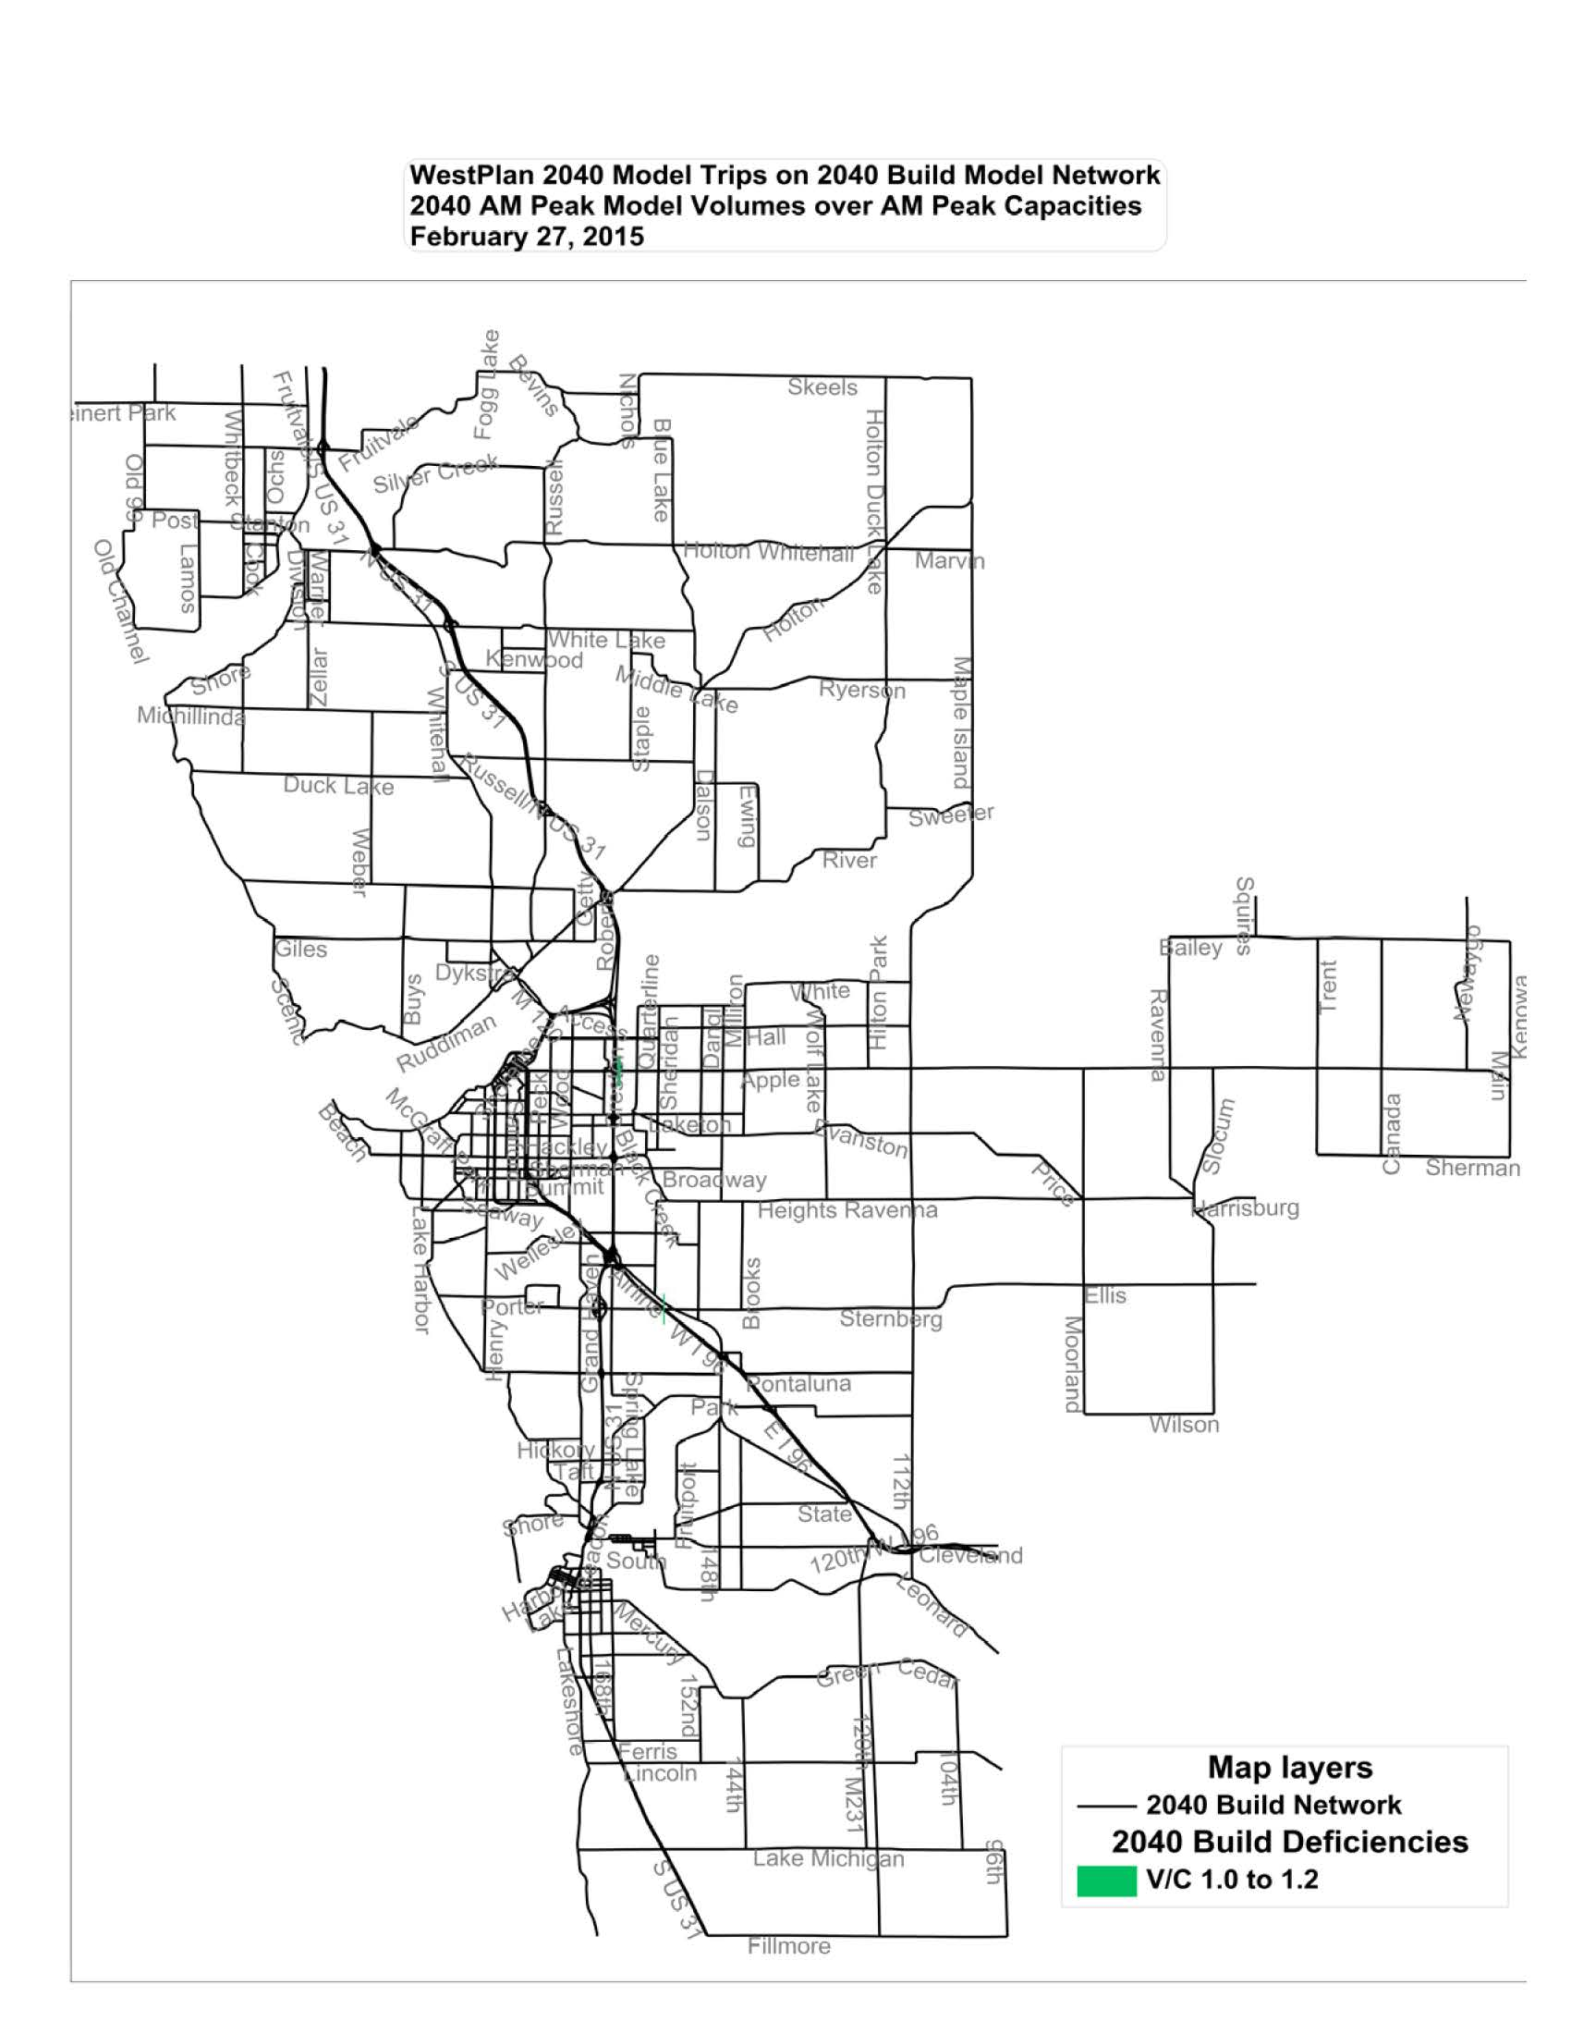

Figure 23 – 2040 PM peak no build deficiencies
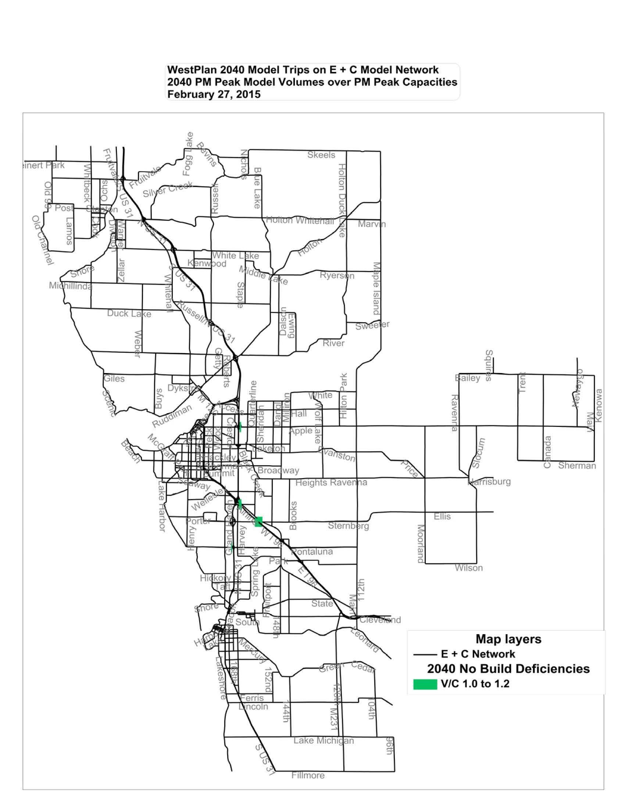

Figure 24 – 2040 daily no build deficiencies

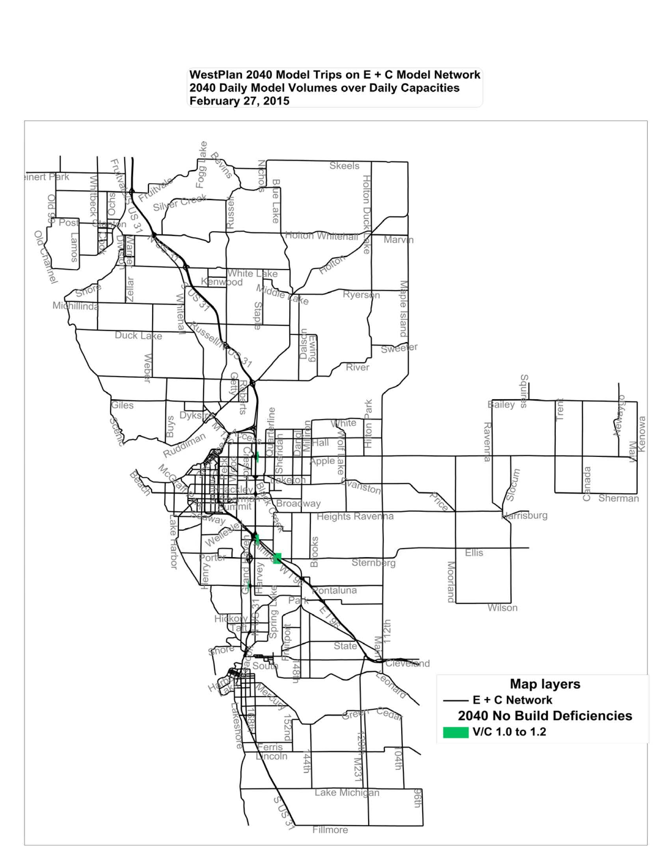

Figure 25 – 2040 aM peak no build deficiencies
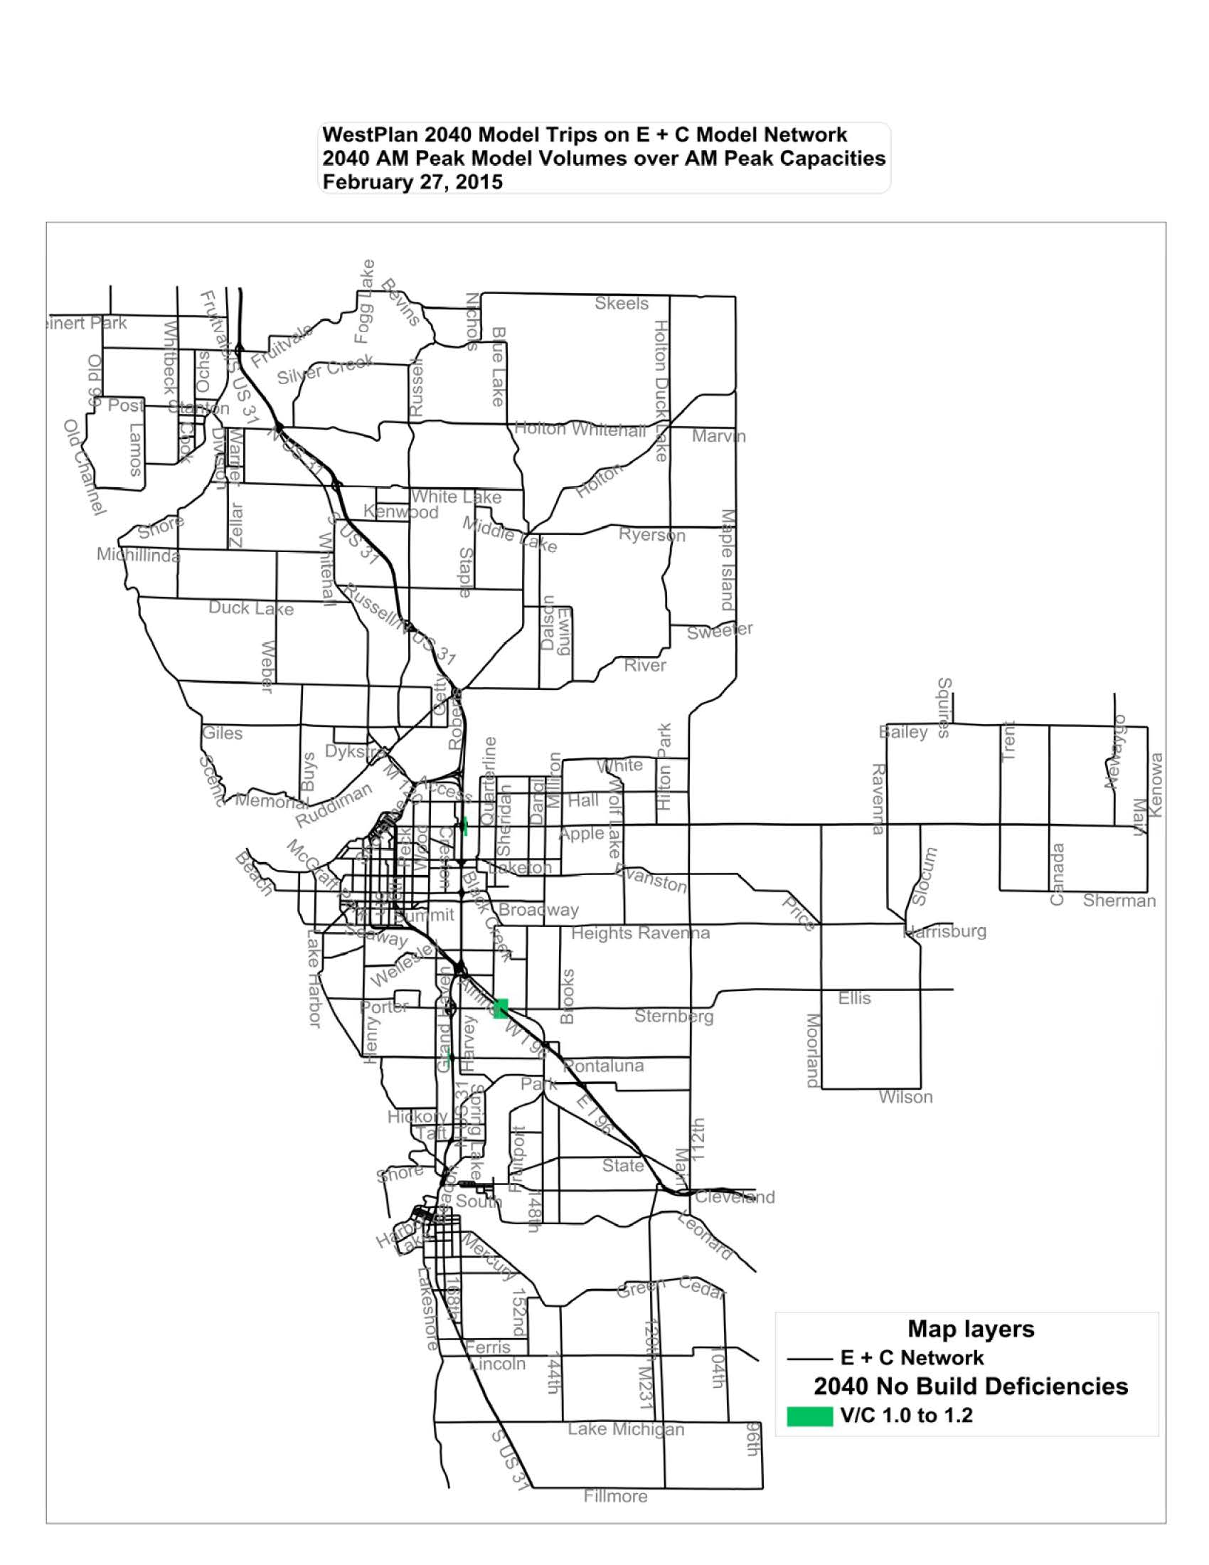

Figure 26 – 2040 PM peak build deficiencies
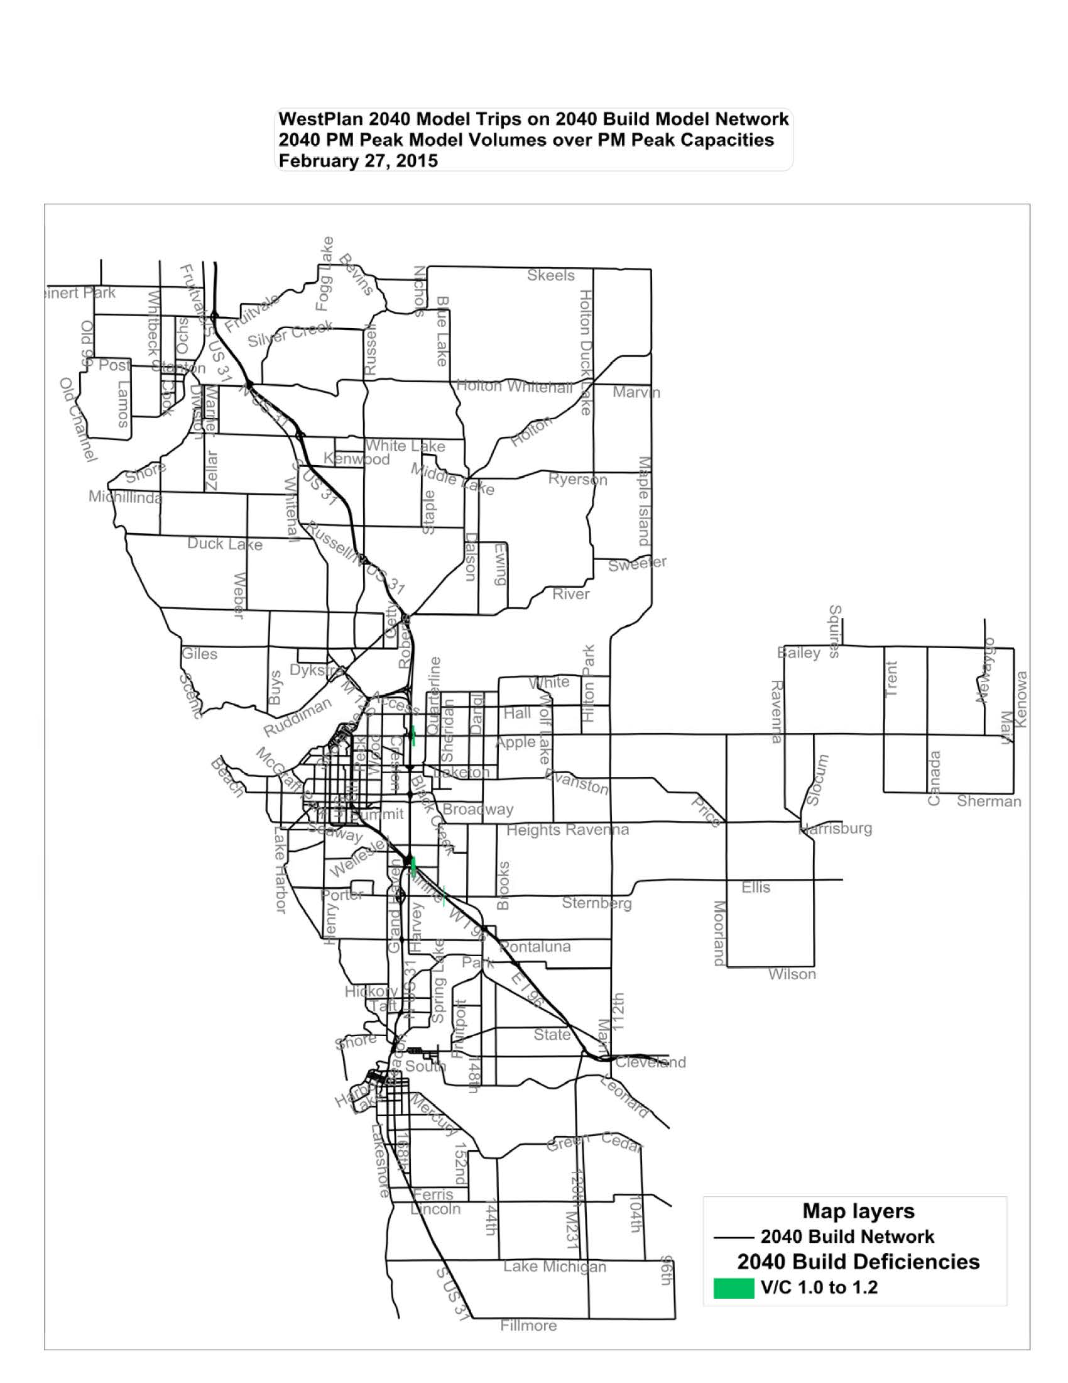

Figure 27 – 2040 daily build deficiencies
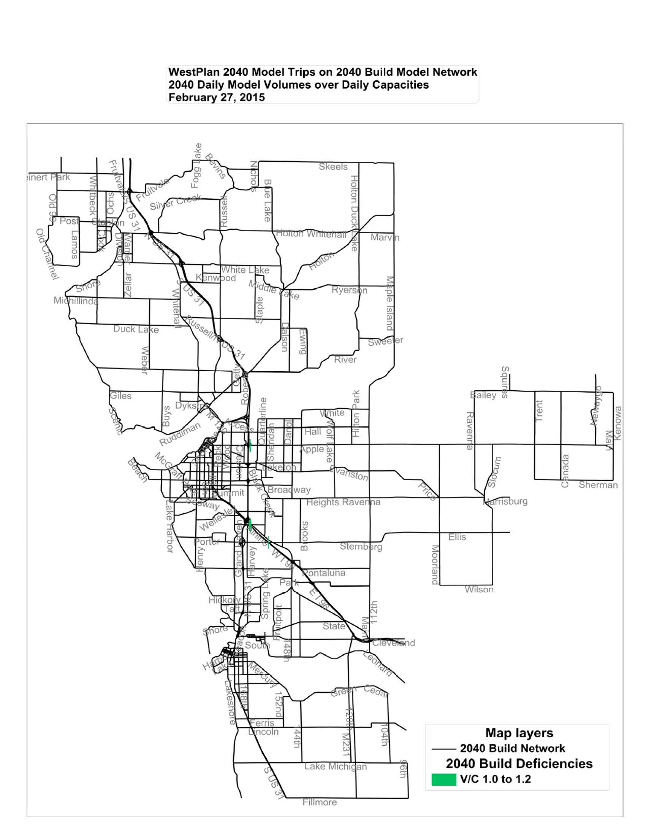

With knowledge in hand of available funding and the transportation system needs and deficiencies, the WestPlan Technical and Policy Committees have selected improve and expand projects for the life of the plan. The capacity deficiencies and local concerns as determined by the computer model and the local communities lay the groundwork determining where improvements should occur in the coming years. Some of the deficiencies and concerns require further study before the right solution is identified. Others may have work already planned from previous plans, or may have a relatively simple solution. Those projects that have been identified as possible solutions are identified here.
The following table indicates specifically listed Improve and Expand projects. These are generally projects that increase capacity on a roadway. Examples of improve and expand projects may be the addition of traffic lanes, turn lanes, or the construction of a new roadway. These projects are funded with federal, state, local funds or any combination of the three, depending on the needs of the organization that is involved in the project. During the process of determining projects, both Harbor Transit and the Muskegon Area Transit System were involved and asked to submit long term Improve and Expand type projects, or projects that could benefit identified deficiencies in the system. There were no projects submitted by either of the MPO transit agencies.
- Airline Road, from I-96 to Dangl Road, Reconstruct from 2 to 3 lanes
- Henry Street, from Seminole to Hile, Reconstruct from 2 to 3 lanes
- Sternberg Road, from Quarterline Road to Airline Road,
- Witham Road, from Bear Creek Bridge to Moulton Road
- Sternberg Road, Martin Road to Lake harbor Road, new two lane road
- Pontaluna Road, Reconstruct from two to three lanes, .75 miles with bike lanes
- Grand Haven Road, from Hile Road to 100 ft. south of Seaway Drive, Reconstruct from 2 to 3 Lanes
- Hile Road, Harvey Street to Grand Haven Road, excludes US-31 bridge, Reconstruct from 2 to 3 lanes with bike lanes
As stated previously, a number of potential deficiencies were identified. A number of these deficiencies occur on State trunkline roads. After reviewing the list with MDOT and the other members of the technical committee, it was determined that deficiencies on these roadways did not merit inclusion as projects at this time.
General maintenance projects and projects that do not add capacity to the transportation system are not specifically listed in this plan, but are of primary importance to maintaining the system and receive support under the goals and objectives of the plan.

Impact of Projects
The general impact of the construction of the majority of these projects will be to alleviate congestion. If the projects were not to be constructed it is anticipated that congestion would increase in the identified corridors further impeding the flow of persons and goods within the MPO area.

Environmental Justice
The projects in this plan must meet the principles of Executive Order 12898 relating to environmental justice (EJ). Specifically, the plan must identify and address any disproportionately high and adverse human health or environmental effects of its programs and policies on minority populations and low-income populations.
The process undertaken in analyzing that the principles of Executive Order 12898 included mapping the areas of impoverished and minority population concentrations. These concentrations were overlaid with the LRP’s projects and subjected to a visual analysis of potential impacts.
Analysis of potential impacts center on three potential major areas of concern:
- Disproportionally high adverse impact to impoverished and minority areas
- Minimizing/blocking access of low income areas and minority areas to the transportation system
- Neglect of the transportation system in low-income areas and minority areas.

Identification of Minority Groups Utilizing 2010 Census Data
Minority population groups identified in this study included individuals who self-identified as being part of a minority racial or ethnic group in the 2010 U.S. Census. These figures were taken from the 2010 Census-Profile of General Population and Housing Characteristics. For this analysis, individuals belonging to a minority group were grouped into one category: minority. These aforementioned groups include individuals who self-identified as:
Race (Not Hispanic or Latino)
- Black or African American
- American Indian or Alaska Native
- Asian
- Native Hawaiian or Other Pacific Islander
- Some other Race
Hispanic or Latino (Of Any Race)
- Cuban
- Mexican
- Puerto Rican
- South or Central America
- Other Spanish culture or origin
The analysis performed utilized a methodology developed by the Michigan Department of Transportation (MDOT) which, unlike methods performed in the past, compares a local community with a reference community such as the state. In past analysis, concentrations of minority or impoverished communities were determined as a simple ratio of the local communities’ population. The state’s methodology utilizes the Location Quotient (LQ) statistical technique, which strives to show if a local economy has a greater share than expected of a given economy, using the average of the local economy against the average of the larger economy.
The statistical notation for LQ is:
EJ Zone = No. of Minority Group in a Census Tract / Total No. of that Minority Group in the State
Total Pop. in that Census Tract Total Pop. in the State
The method of interpreting the resulting calculated values are as follows:
LQ < 1.0: Such census tracts are considered Non-EJ zones. This implies that such census tracts having values less than one (1) have insufficient minority population in the state as such will not be considered an EJ zone.
LQ = 1.0: Such census tracts have populations that are just sufficient for their constituents, or are exactly comparable to the state’s concentration of these groups.
LQ > 1.0: Places with LQ greater than one (1) provides evidence that these groups have racial populations greater than their expected EJ populations. These census tracts would represent the selection set considered being EJ zones.

Identification of Impoverished Populations Utilizing 2013 American Community Survey Data
The analysis performed to identify impoverished groups followed the same general methodology as the methodology used to determine LQ for minority populations. Impoverished populations were identified based on 2013 American Community Survey 5-year Estimates of poverty status for a 12 month period of time. The Census Bureau uses a set of money income thresholds that vary by family size and composition to determine who is in poverty. If a family’s total income is less than the family’s threshold, then that family and every individual in it is considered in poverty. Official poverty thresholds do not vary geographically, though they are updated for inflation using Consumer Price Index (CPI-U). (United States Census Bureau) No grouping was necessary for this analysis as totals were available for the population living below the poverty level.
The statistical notation used to determine Location Quotient (LQ) for impoverished populations is as follows:
EJ Zone = Impoverished Population in a Census Tract / Total Impoverished Population in the State
Total Pop. in that Census Tract Total Pop. in the State
The method of interpreting the resulting calculated values are as follows:
LQ < 1.0: Such census tracts are considered Non-EJ zones. This implies that such census tracts having values less than one (1) have insufficient impoverished populations in the state as such will not be considered an EJ zone.
LQ = 1.0: Such census tracts have populations that are just sufficient for their constituents, or are exactly comparable to the state’s concentration of these groups.
LQ > 1.0: Places with LQ greater than one (1) provides evidence that these groups have impoverished populations greater than their expected EJ populations. These census tracts would represent the selection set considered being EJ zones.

Analysis
Analysis of potential impacts center on three potential major areas of concern:
1. Disproportionately high adverse impact to low income areas and minority areas
- Minimizing/blocking access of low income areas and minority areas to the transportation system
- Neglect of the transportation system in low-income areas and minority areas.

Disproportionately high adverse impact to low income areas
Of the identified projects contained in the WestPlan 2040 Long-Range Transportation Plan, none of the projects are contained in or near the low income areas. Since none of these projects are located in low income areas, there will be no negative impacts from noise, right of way acquisition, or pollution.
Neglect of the transportation system in low income areas:
As previously stated, there are no projects located in low income areas. While this may seem to show that there is some neglect of the transportation system in the low income areas, after closer analysis it has been determined that there is no neglect of the transportation system in the low income areas. The projects listed in the Long Range Plan address deficiencies or expansion in the system. At this point in time there are very few deficiencies in the system within low income areas.
Also an analysis of the areas covered by transit was overlain with the identified low income areas. This analysis shows that all of the identified low income areas are covered by the existing transit coverage areas.
Minimizing/blocking access of low-income areas to the transportation system:
Minimizing access can be characterized as closing of streets or eliminating access to transit. As previously stated, none of the identified projects are located within minority areas. Therefore none of the projects will block access to the transportation system.
Disproportionately high adverse impact to minority areas
Of the identified projects contained in the WestPlan 2040 Long-Range Transportation Plan, none of the projects are contained in or near the minority areas. Since none of these projects are located in minority areas, there will be no negative impacts from noise, right of way acquisition, or pollution.
Neglect of the transportation system in minority areas:
As previously stated, there are no projects located in minority areas. While this may seem to show that there is some neglect of the transportation system in the minority areas, after closer analysis it has been determined that there is no neglect of the transportation system in minority areas. The projects listed in the Long Range Plan address deficiencies or expansion in the system. At this point in time there are very few deficiencies in the system within minority areas. Minority areas within the WestPlan MPO tend to be within urbanized areas which are essentially built out.
Also an analysis of the areas covered by transit was overlain with the identified minority areas. This analysis shows that all of the identified minority areas are covered by the existing transit coverage areas.
Minimizing/blocking access of minority areas to the transportation system:
Minimizing access can be characterized as closing of streets or eliminating access to transit. As previously stated, none of the identified projects are located within minority areas. Therefore none of the projects will block access to the transportation system.

Environmental Justice Conclusions
In conclusion, this analysis finds that the proposed roadway and transit projects do not result in violations of Executive Order 12898. Furthermore, to supplement the analysis done here, WestPlan's continuing public participation process undertaken during the design of the WestPlan 2040 Long-Range Transportation Plan made a concerted effort to reach out to traditionally disadvantaged populations to ascertain the potential effects and or impacts of the proposed projects.

figure 28 - Environmental Justice Chart
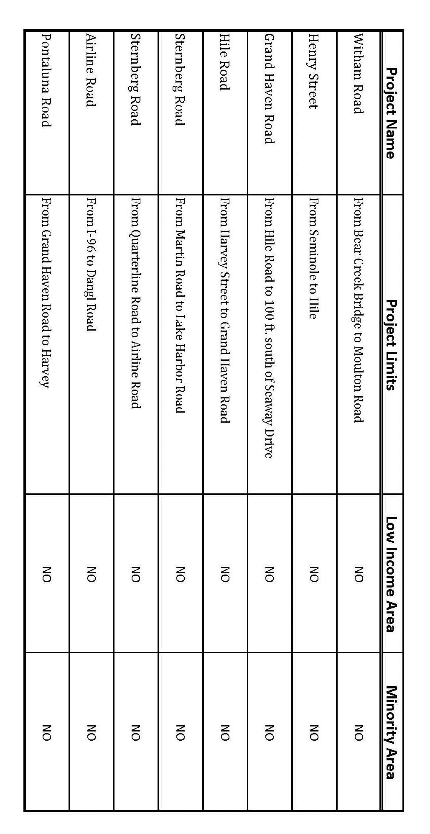

figure 29 – 2040 long range plan environmental justice minority areas
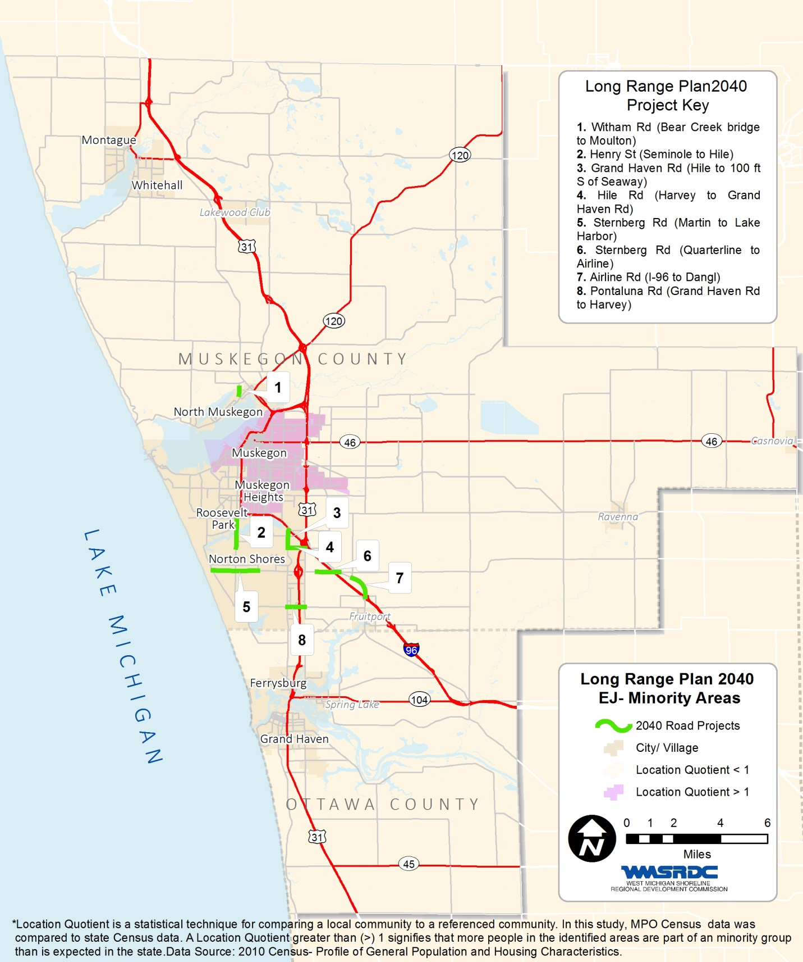

figure 30 – 2040 long range plan environmental justice impoverished areas
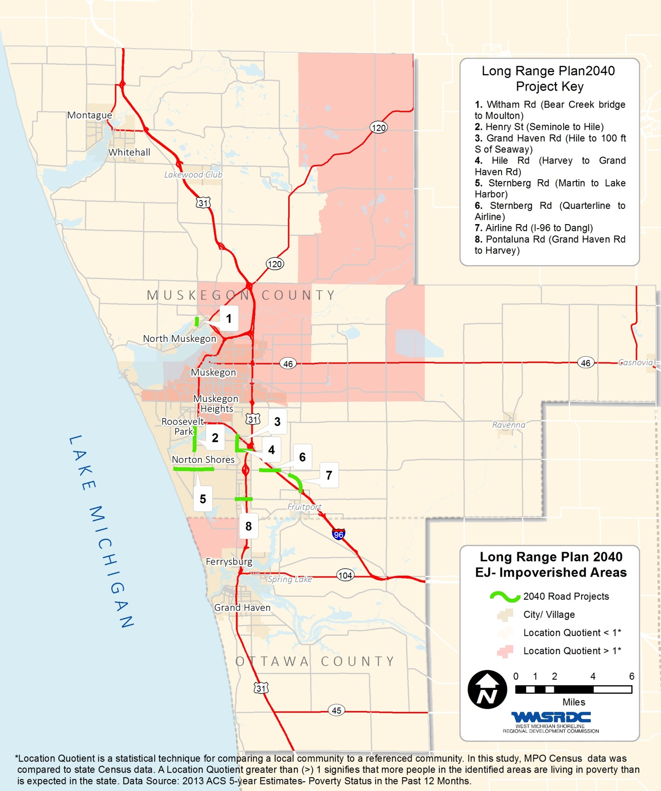

figure 31 – transit routes & service boundaries – ej minority area

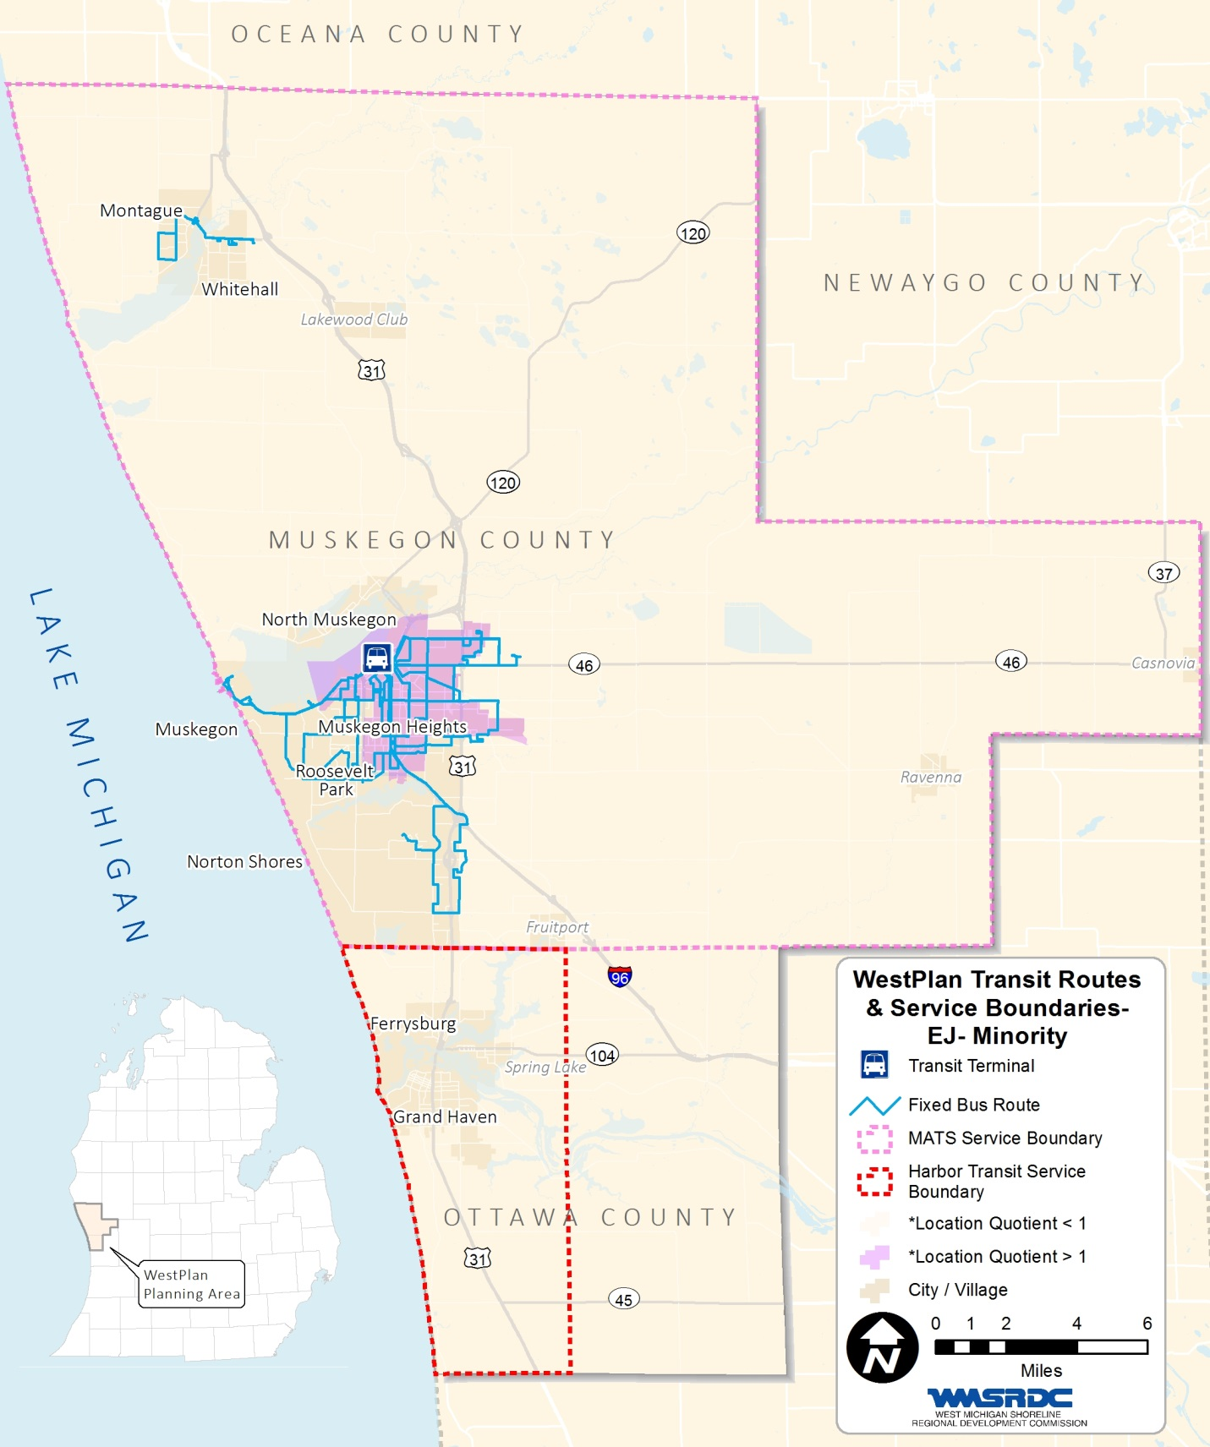

figure 32 – transit routes & service boundaries – ej poverty area
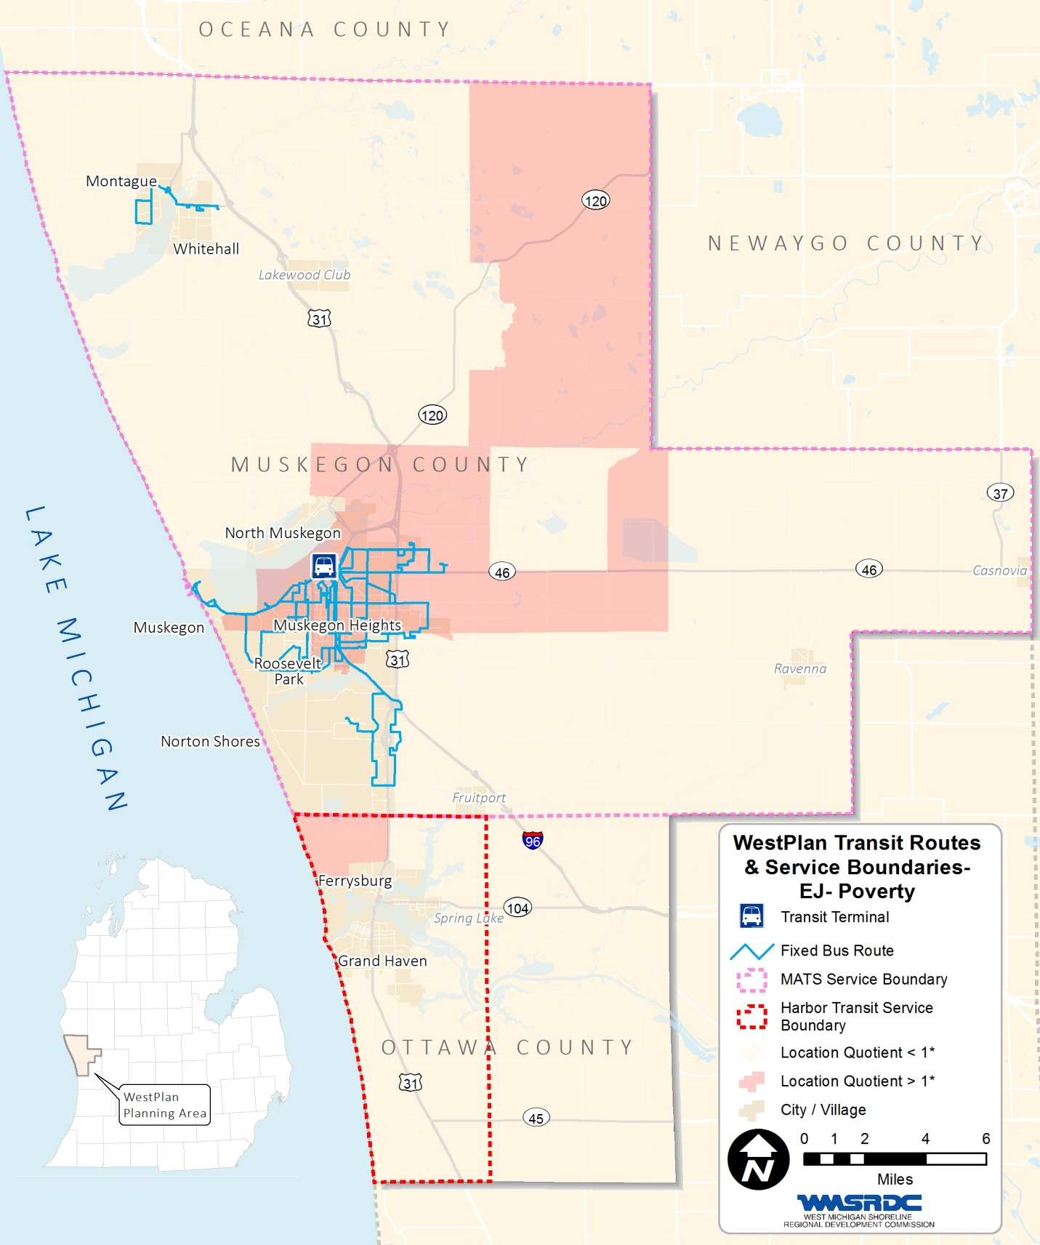

Environmental assessment of Natural Features
Federal transportation legislation contains a requirement that the Long Range Transportation Plan include “a discussion of types of potential environmental mitigation activities and potential areas to carry out these activities, including activities that may have the greatest potential to restore and maintain the environmental functions affected by the plan.” The goal is to balance transportation needs with environmental protection.
The WMSRDC staff has conducted a preliminary assessment of transportation projects included in the 2040 Long Range Plan to identify any projects which may have negative environmental impacts. This assessment is done at this point so that communities can be notified well in advance that there may be impacts on the environment.

Factors Used in Environmental Assessment
WMSRDC staff compiled a list of each proposed transportation project in the plan and evaluated each listing using the following list of environmental factors.
- Floodplains - Use of the land adjacent to a stream has a major impact on protecting water quality, avoiding flood damage, and maintaining wildlife habitat. This area adjacent to the stream channel serves as a natural reservoir for storing excess water during a flood.
- Wetlands - Wetlands play a vital role in water resource protection, recreation, tourism, and the economy in West Michigan. Specifically, wetlands provide:
- Flood and storm control via hydrologic absorption and storage capacity;
- Wildlife habitat for breeding, nesting, feeding grounds, and cover for many forms of wildlife.
- Protection of subsurface water resources, valuable watersheds, and recharge for groundwater supplies
- Erosion control by serving as a sedimentation area and filtering basin, absorbing silt and organic matter.
- Critical Dune Areas - Preservation of historic resources can contribute to economic development and tourism, and an overall higher quality of life for citizens. The goal is to create a balance by integrating historic preservation into community and transportation planning.

Factors Not Evaluated
There are a number of other potential environmental factors which were considered for use in evaluating the projects in the Long Range Plan. However, complete and accurate data is not available for many of these factors. Listed below are a number of other potential factors which could be evaluated, should more complete information become available in the future.
- Threatened and Endangered Species – The data available is insufficient to accurately map. As part of the consultation phase the Fish and Wildlife Service was contacted. In response, they noted that the following threatened and/or endangered species may be present in the WESTPLAN MPO: The Indiana bat, the Karner Blue Butterfly, Bald Eagles, Pitcher’s Thistle, the Piping Plover, and the Eastern Massassauga Rattlesnake.
- Archeological sites – There is no complete data that is available to the public.
- Unique habitat - The data available is incomplete and insufficient to accurately map.
- Heritage Routes - There are no designated Heritage Routes within the MPO boundaries.

Environmental Assessment Findings
The map and chart on the following pages show which projects are adjacent to the environmental features that were examined. This inventory in no way substitutes a project sponsor’s responsibility to complete a more in depth environmental assessment.
From the preliminary review, it does appear that some of the projects are adjacent to the environmental features which were examined. Project sponsors are encouraged to follow the best practices which are outlined in the following sections.
Environmental factors may need to be examined in more detail in order to mitigate any negative impacts. These features may also influence project costs and timing. As previously stated, this assessment does not prevent any project from moving forward, but rather is to be used to identify potential problems.

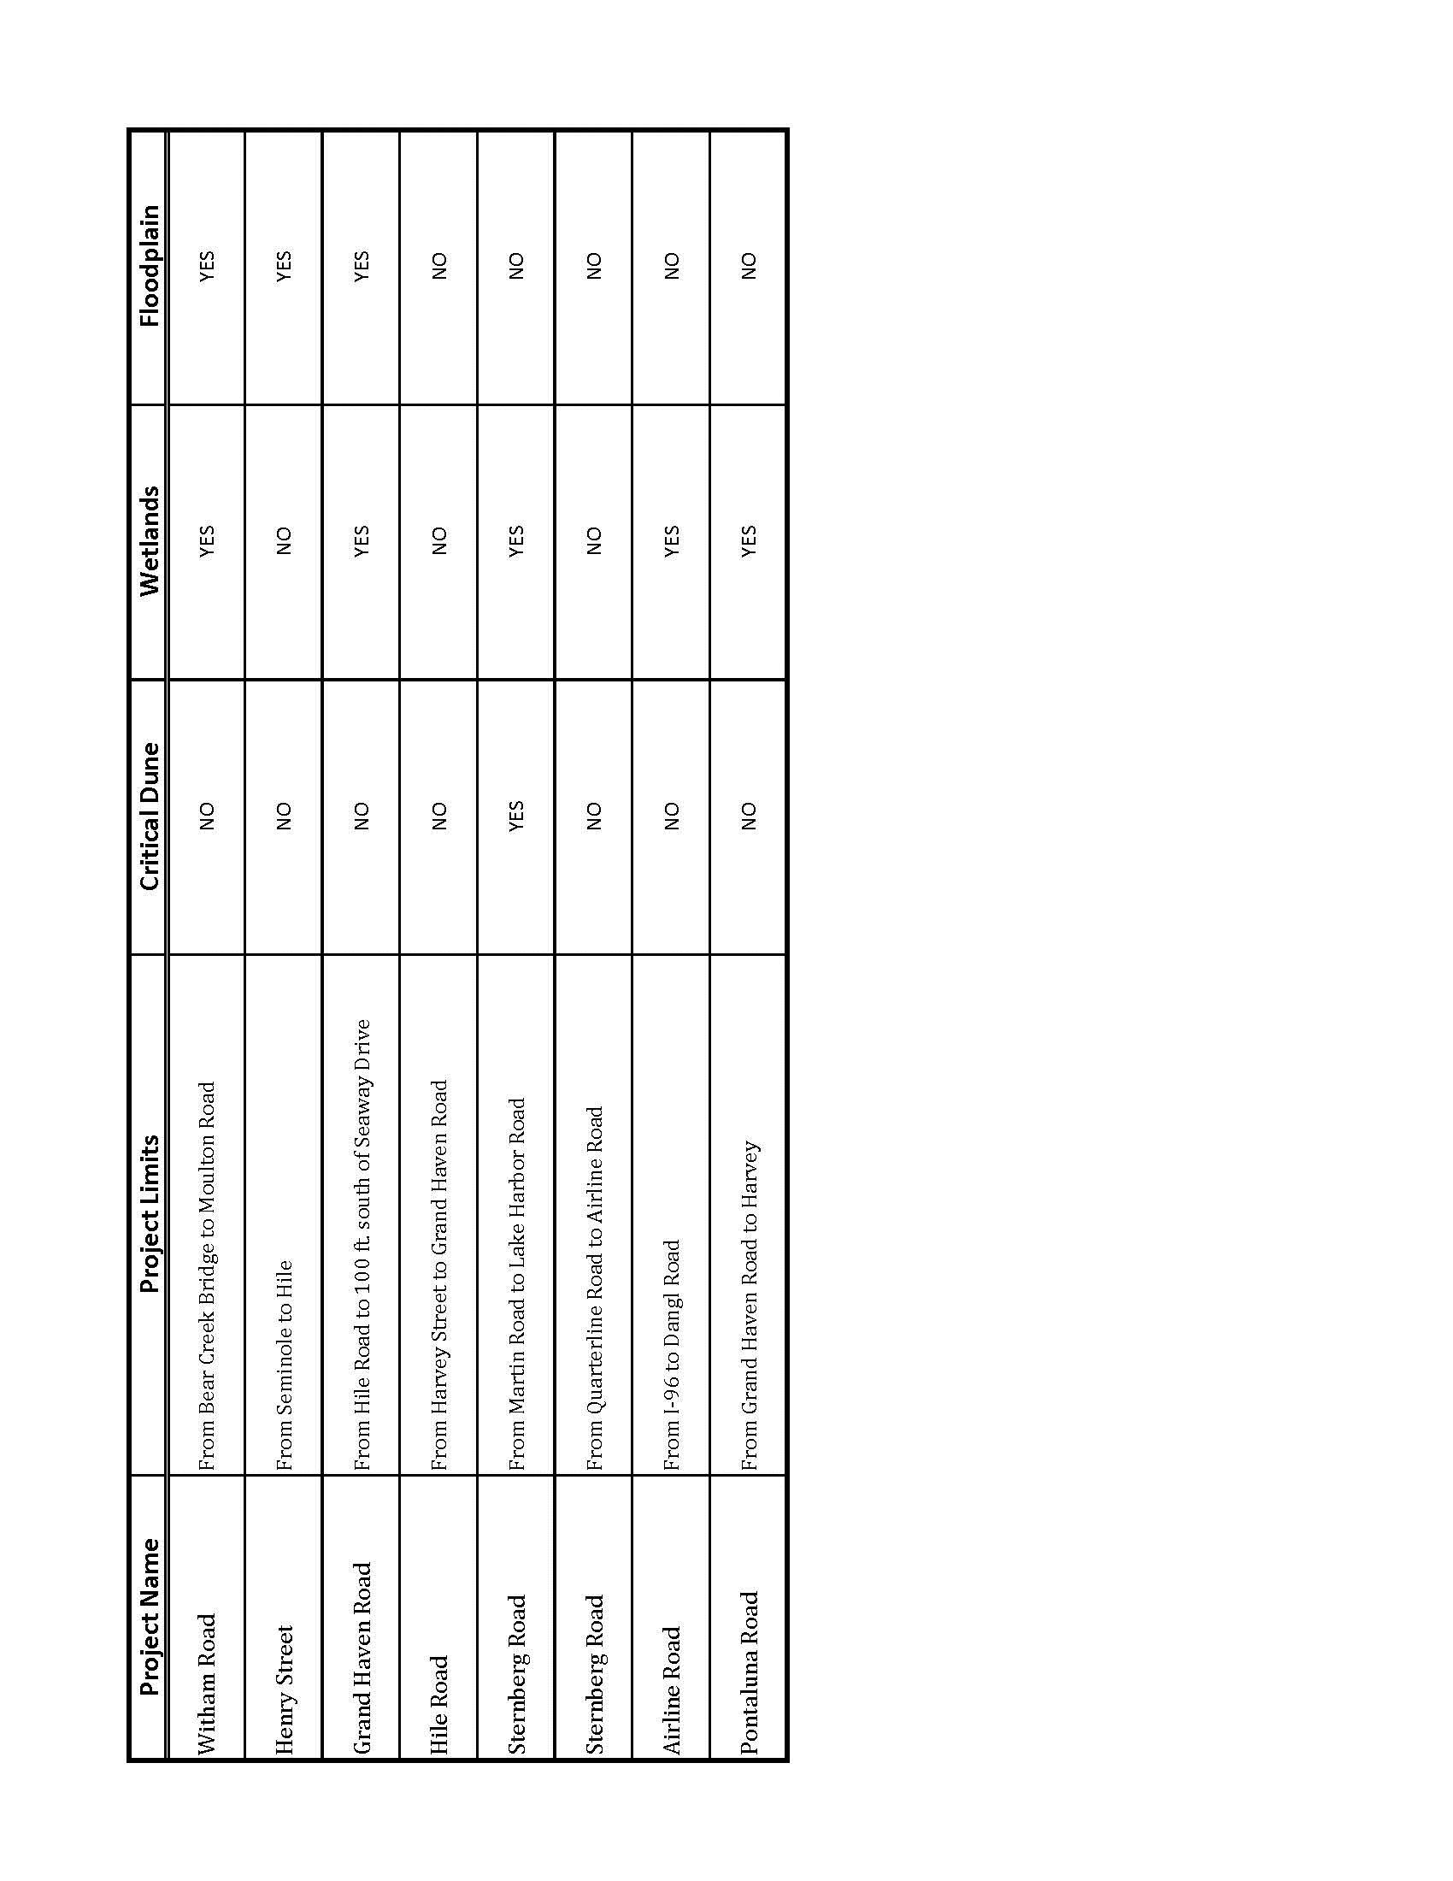
figure 33 – 2040 long range plan projects adjacent to environmental features

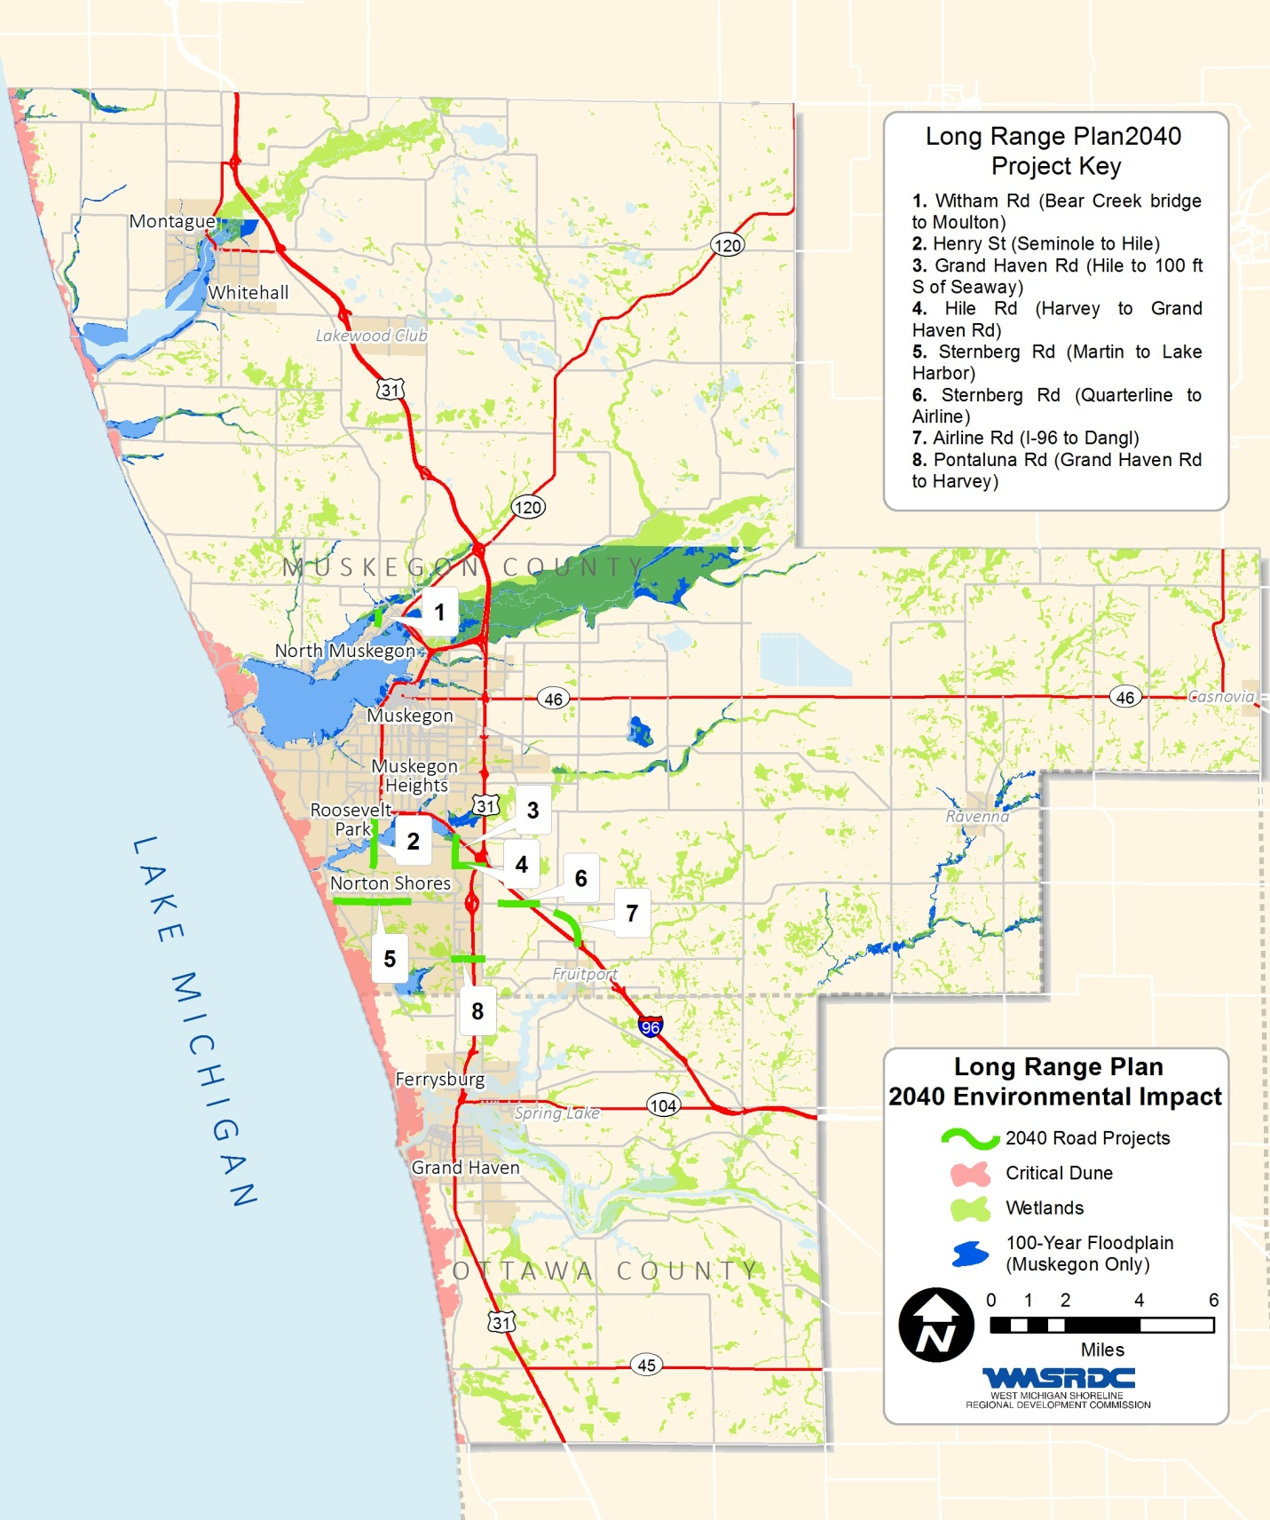
figure 34 – 2040 long range plan project environmental impact areas

Planning/ Design Guidelines
Regardless of the type of project or the resources that may be impacted, the following guidelines should be considered during the planning, design, construction, and maintenance of transportation projects. They represent good planning practice and will help ensure a blending of sound construction techniques with desired environmental protection goals.
- Employ context sensitive solutions (CSS) principles from the earliest point possible in project development.
- Identify the area of potential impact related to the transportation project, including the immediate project area, anticipated borrow/fill areas, haul roads, prep sites, and other contractor areas, as well as other related project development areas.
- Conduct an inventory to determine if any environmentally sensitive resources could be impacted by the project.
- Conduct a pre-construction meeting with local community officials, contractors, and subcontractors to discuss environmental protection.
- If possible, avoid impacts to environmental resources by limiting the project scope or redesigning the project
- Where impacts cannot be avoided, mitigate them as much as possible.
- Integrate stormwater management into the design of the site. If appropriate, utilize low-impact development practices that infiltrate stormwater into the ground (e.g., swales, rain gardens, native plantings).

Construction/Maintenance guidelines
- Insert special requirements addressing sensitivity of environmental resources into plans, specifications, and estimates provided to construction contractors
- Confine construction and staging areas to the smallest necessary and clearly mark area boundaries.
- Install construction flagging or fencing around environmental resources to prevent encroachment.
- Sequence construction activities to minimize land disturbance at all times, but especially during the rainy or winter season for natural resource protection and during the high-use season for resources open to the public.
- When utilizing heavy equipment, pay close attention to the potential of uncovering archeological remains.
- Before site disturbance occurs, implement erosion control best management practices to capture sediments and control runoff.
- Incorporate stormwater management into the construction phase.
- Properly handle, store, and dispose of hazardous materials (e.g., paint, solvents, epoxy) and utilize less hazardous materials when possible.
- Keep equipment in good working condition and free of leaks. Avoid equipment maintenance or fueling near sensitive areas. If mobile fueling is required, keep a spill kit on the fueling truck. Avoid hosing down construction equipment at the site, unless the water is contained and does not get into the storm drain system or waterways.
- Identify and implement salt management techniques to reduce the impacts of salt on area waterways.
- Conduct on-site monitoring during and immediately after construction to ensure environmental resources are protected as planned.

CHAPTER 12: AIR QUALITY
On July 20, 2013, the United States Environmental Protection Agency (EPA) partially revoked the 1997 8-hour 0.080 parts per million (ppm) ozone standard. Only the regulations related to regional transportation conformity were revoked, all other requirements are still in effect.
Also on July 20, 2013, the EPA designations for the new 2008 8-hour 0.075 ppm ozone standard took effect. WestPlan was designated attainment under the 2008 standard.
Thus, effective July 20, 2013, as a result of both the partial revocation of the 0.080 Ozone standard and the designation of attainment for the 0.075 ppm Ozone standard, the WestPlan MPO was no longer required to demonstrate transportation conformity of Long Range Plans (LRP) or Transportation Improvement Program (TIP). However, other planning requirements of a maintenance area are still in place, for example LRP’s must be prepared every four years.
On November 25, 2014, EPA proposed lowering the Ozone standard between 0.070 and 0.065 ppm. EPA anticipates setting the ozone level standard by October 2015 with preliminary designations in October 2016.
On April 6, 2015 EPA revoked completely the 1997 ozone standard, so all requirement related to this standard were removed. And the WestPlan MPO is in attainment for the existing ozone standard, thus, there are no requirements for conformity. However, the MPO will continue to be responsive to the connection between air quality and transportation.

CHAPTER 13: FINANCIAL RESOURCES ANALYSIS
MAP-21 requires the 2040 LRP to be financially constrained, making for a plan which is more useful in guiding decision making for the future. It is required that the LRP show that projects planned can be reasonably funded by the expected revenues. This means that the sum of the costs for the planned projects cannot exceed all reasonably available financial resources available to the WestPlan MPO area. This analysis of the financial resources chapter of the plan will show that WestPlan is constraining its plans to the amount of funds realistically expected. The revenues for operation and maintenance of the transportation system come primarily from taxes and user fees at the local and state level.

Cooperative Revenue Estimation Process
The revenue estimates in this chapter were derived through a cooperative process which included the FHWA, MDOT, MTPA, MPO staff and committees, as well as local road and transit agencies. Local revenues were derived through review of Act 51 reports, historical TIP data, and in consultation with local agencies. State and Federal revenue estimates were provided by MDOT and FHWA.

Revenue Growth Rate
The following revenue growth rates were adopted by the Michigan Transportation Planning Association (MTPA) in April of 2014. WESTPLAN MPO concurs with these estimates and has used them in the development of this plan.

Figure 35 – revenue growth rates
 | Timeframe | Growth Rate
Federal
 | 1st Two Years | 0.00% (flat)
 | Remaining Years | 2.39%
State
 | 1st 5 Years | 0.40%
 | Remaining Years | 2.16%

These growth rates were developed by the MDOT Statewide Planning Division and were then adopted by the MTPA. The interim growth rates developed reflect the current economic conditions, as demonstrated by no-growth growth rates for the first two years and a conservative growth rate of 2.39% for the remaining years for Federal funds.
There is a great deal of uncertainty with both Federal and State funds. These growth rates remain conservative based on the current revenue outlook.

Year of Expenditure (Inflation) Factor
As noted in Chapter 11: Transportation Deficiencies, Issues, and Projects, all project costs are listed in Year of Expenditure dollars. The WESTPLAN MPO is using the Financial Workgroup Sub-team’s recommended inflation factor of 4% for project costs. This is the factor which was used by the Ohio DOT as well as recommended by FHWA guidance as a default factor if better information is not available.

Anticipated Funding Sources

FEDERAL FUNDING SOURCES
Funds through the federal gas and diesel tax are deposited in the Federal Highway Trust Fund through the current federal surface transportation bill, MAP-21. Michigan receives most of its federal highway funding from the following programs: The Interstate Maintenance Program, the National Highway System Program, the Surface Transportation Program, the Highway Bridge Replacement & Rehabilitation Program, and the Congestion Mitigation & Air Quality Program. State and local governments have substantial flexibility in the use of some of their federal transportation funds, to choose the best mode or combination of modes where their dollars will be invested. The most commonly used federal-aid programs within the WestPlan area are described below.

STP-Urban (STUL) (Muskegon/Northern Ottawa County MPO)
The Surface Transportation Program will continue to provide funds for urban projects through this category. The small MPO program is funded for areas of population between 50,000 and 200,000. Based on recent annual TIP expenditures, it has been estimated that revenues averaging $2,125,000 per year would be made available for this category over the life of the plan.

STP-Small Urban (ST) (WHITEHALL AREA)
The Surface Transportation Program will continue to provide funds for projects through this category through the Small Urban Committee. This funding category is available for communities that have a population between 5,000 and 50,000. Based on current annual TIP expenditures, it has been estimated that revenues averaging $125,000 per year would be made available for this category over the life of the plan.

STP-Rural
The Surface Transportation Program will continue to work through the Rural Task Forces to provide funds for rural projects through this category. Rural Task Force 14, which covers Muskegon, Ottawa, and Oceana Counties, has significant responsibilities for transportation programming in non-metropolitan areas. Based on current annual TIP allocations, it has been estimated that revenues averaging $350,000 per year would be made available for these categories over the life of the plan.

Highway Safety
The Safety category of funds is a statewide competitive category. The anticipated size of these safety projects range from approximately $100,000 to $200,000 each. There are no Safety projects in the current TIP. Safety projects have not been a historically large portion of the funding within the MPO. It has been estimated that revenues averaging $0 per year would be made available for this category over the life of the plan.

STP-Transportation Alternatives
Enhancement funds are distributed on a competitive basis among states and local agencies. The Surface Transportation Program Enhancement category has provided funding for a number of transportation enhancement activities in recent years, including bike and pedestrian facilities, landscaping and streetscaping, historic preservation projects, and highway run-off prevention. As this is a statewide competitive category of funds, a funding target is not guaranteed. Based on past annual TIP allocations and estimates, it has been estimated that revenues averaging $180,000 per year would be made available for this category over the life of the plan.

Local/Critical Bridge (BRT)
The local bridge program is a statewide highly-competitive program where funds are available to replace bridges within the state. Based on current annual TIP allocations, it has been estimated that revenues averaging $75,000 per year would be made available for this category over the life of the plan.

Congestion Mitigation Air Quality (CM)
As an attainment/maintenance area for ozone, the MPO is eligible for a portion of the Congestion Mitigation Air Quality funds which the State of Michigan receives. These funds are intended for transportation projects, which reduce traffic congestion or in other ways improve air quality in an area. The MPO expects to continue to receive a portion of the CMAQ funds allocated to the state. Based on current annual TIP allocations, it has been estimated that revenues averaging $1,720,000 per year would be made available for this category over the life of the plan.

Trunkline (STUL)
Funds that the Michigan Department of Transportation (MDOT) spends on highway repairs are not allocated at a specific level of funding every year to each geographic area. Priorities are set on a statewide basis depending on the condition of the state trunkline system. These funds can be used for such things as rehabilitation, reconstruction, bridge repair, passing relief lanes, capacity improvements, new roads, or roadside projects. Based on figures given by MDOT, the total estimated trunkline revenues over the 27-year period are $377,085,571.

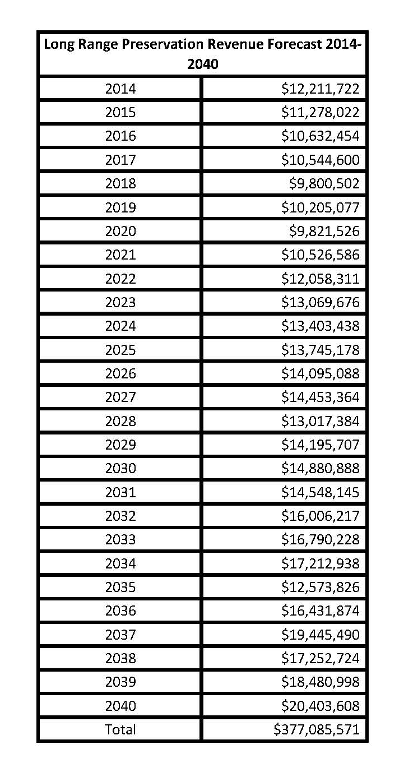
Figure 36 – long range preservation forecast 2014-2040

FEDERAL TRANSIT FUNDING
The public transit program funding is based on the following FTA-funded transit programs.

Transit Section 5307 Operating
The Federal Transit Administration provides operating assistance to the Muskegon Area Transit System and Harbor Transit. Based on current annual TIP expenditures, it has been estimated that revenues averaging $2,063,543 per year would be made available for this category over the life of the plan.

Transit Section 5310 Capital
The Federal Transit Administration provides funds for acquisition of capital items (5310) to private nonprofit organizations or public transit agencies to meet the special needs of the elderly and disabled. Based on current annual TIP expenditures, it has been estimated that revenues averaging $1,000,074 per year would be made available for this category over the life of the plan.

Transit Section 5311
The Formula Grants For Other than Urbanized Areas (5311) is a rural program that is formula based and provides funding to states for the purpose of supporting public transportation in rural areas, with population of less than 50,000. The goal of the program is to provide services to communities with population less than 50,000.Based on current annual TIP expenditures, it has been estimated that revenues averaging $11,646 per year would be made available for this category over the life of the plan.

Transit Section 5316
The Job Access and Reverse Commute (5316) also known as JARC, program was established to address the unique transportation challenges faced by welfare recipients and low-income persons seeking to obtain and maintain employment. Many new entry-level jobs are located in suburban areas, and low-income individuals have difficulty accessing these jobs from their inner city, urban, or rural neighborhoods. In addition, many entry level-jobs require working late at night or on weekends when conventional transit services are either reduced or non-existent. Based on current annual TIP expenditures, it has been estimated that revenues averaging $23,292 per year would be made available for this category over the life of the plan.

Transit Section 5317
The New Freedom formula grant program (5317) aims to provide additional tools to overcome existing barriers facing Americans with disabilities seeking integration into the work force and full participation in society. The New Freedom formula grant program seeks to reduce barriers to transportation services and expand the transportation mobility options available to people with disabilities beyond the requirements of the Americans with Disabilities Act (ADA) of 1990. Based on current annual TIP expenditures, it has been estimated that revenues averaging $52,520 per year would be made available for this category over the life of the plan.

Transit Section 5339
This category section of funding provides capital funding to replace, rehabilitate, and purchase buses and related equipment and to construct bus related facilities. Based on current annual TIP expenditures, it has been estimated that revenues averaging $527,587 per year would be made available for this category over the life of the plan.

STATE FUNDING SOURCES

ACT 51 And Other funds
Collection and distribution of gasoline and diesel fuel taxes in Michigan is regulated under State Act 51 of 1951. Michigan's fuel tax of $0.19 per gallon is collected and deposited into the Michigan Transportation Fund (MTF). Most states, as well as the federal government, distribute all or some portion of the tax for support of highways and mass transit improvements. MTF dollars are distributed to MDOT, county road commissions, cities and villages, and the Comprehensive Transportation Fund (CTF). The CTF was established to fund public transportation systems. In Michigan, a portion of the registration fees for automobiles and trucks are also deposited in the MTF.
In regards to other state funds, MDOT has previously conducted long-term revenue forecasts, using a model based on expected travel and tax structure data. Travel data includes the registered number of vehicles and forecasted vehicle miles of travel to predict revenue from gasoline taxes, diesel fuel taxes, liquid petroleum gas fuel taxes, vehicle registrations, and other related fees. These revenues contribute to the Michigan Transportation Fund (MTF). After portions of this fund are taken off the top, up to 10% is reserved for transit and deposited into CTF.
The remainder of the MTF is distributed by a specific formula established in the State of Michigan Public Act 51. MDOT receives 39.1%, county road commissions receive 39.1%, and 21.8% goes to cities and villages. None of this money goes directly to townships. Public roads in townships are under the jurisdiction of the respective county road commissions. MTF funds are the primary source for making the general 20% local match to 80% federal funds for transportation, and may also be used for a wide variety of transportation projects, including mostly small, light maintenance projects. Regular maintenance needs must also be funded both within cities and villages, and on county roads. Activities such as snow plowing, salt and sand application to road surfaces, lawn mowing, and tree trimming related to roadways, are categorized as maintenance. Maintenance may also include those activities that improve the quality of a road surface, but do not completely resurface a roadway such as filling potholes, improving signage, or road painting and marking.
State raised funds include, TEDF, Winter Maintenance, Local Bridge, and other funds. In order to estimate State funding revenues, planners obtained Act 51 reports from each of the MPO member agencies. Averages were computed and extrapolated out to 2040. Based on current annual funding levels, it has been estimated that revenues averaging $20,455,301 per year would be made available for this category over the life of the plan.
State Transit Operating Assistance and State Transit Capital Assistance (Comprehensive Transportation Fund)
The Michigan Department of Transportation provides a percentage of the local match for operating assistance and for assistance for the purchase of capital equipment by the Muskegon Area Transit System and Harbor Transit. While this funding can increase with large purchases in any given year, based on recent allocations, this source provides approximately $1,507,685 to the MPO area annually.

Local Funding Sources
Cities and villages may provide additional local funding for transportation improvements. Typical funding sources at this level include a community's general fund, millages, general obligation bonds, contributions from county governments and other communities, tax increment financing, and special assessment districts. Local governments at this time are not permitted by the State of Michigan to assess or impose a gasoline tax or a vehicle registration fee. Some communities also accumulate interest on MTF revenue after it has been distributed to them. County road commissions supplement their budgets through contributions from townships. Some enter into maintenance agreements with MDOT for work on state trunklines within the county.
Several local communities allocate general fund money to assist in transportation projects. These funds are used in a variety of ways, including local road repairs, matching grants, transit assistance, non-motorized projects, and other transportation-related improvements, including general maintenance. The amount of funds provided by the local units of government can vary widely based on needs. However, it is estimated that local units of government on transportation projects may utilize approximately $11,904,806 per year, based on recent allocations. Also, Local Transit funding sources are estimated at approximately $2,300,000 per year.

Alternative Funding Sources
Several non-traditional sources of transportation funding may exist for use in appropriate occasions. There are sources related to historical or recreational uses that may pay for transportation improvements to a significant location or facility. There are also numerous community or civic foundations that may be willing to contribute to unique transportation endeavors, particularly of a transit or public service nature.
The private sector has also become a substantial source of funds in some areas, primarily when a developer pays for the construction of drives or access roads leading to a development. Improvements of this type are often included in the overall plans and cost of development. However, it is difficult to identify and project-in-advance the precise location and value of such private improvements to the system, which will be actuated by various market forces. These non-traditional funding sources have not played a significant role within the WESTPLAN MPO so no estimates have been projected.

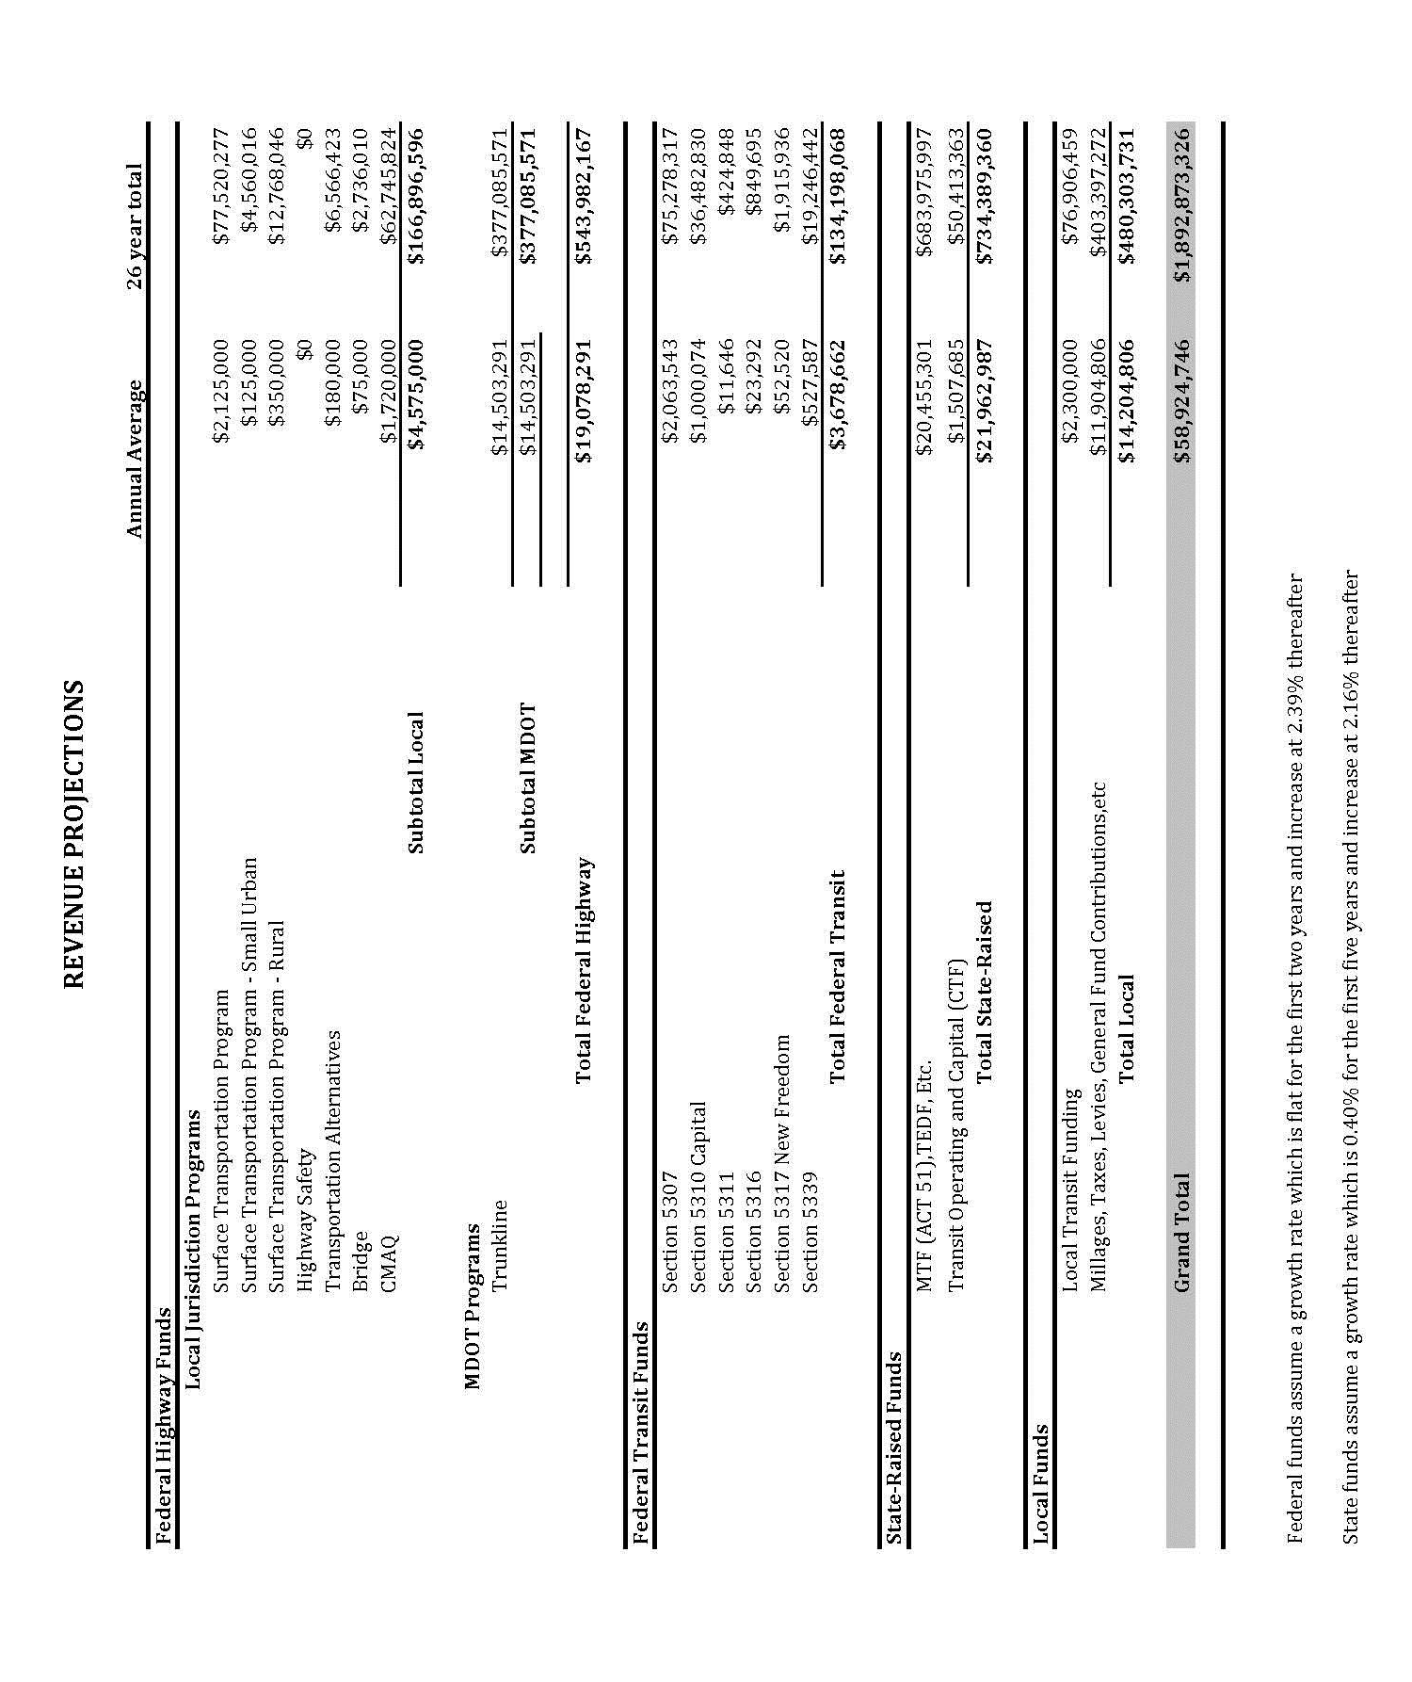
Figure 37 – revenue projections

Cost Estimates

Improve And Expand Projects
Through the planning process a number of improve and expand projects were identified for the WESTPLAN 2040 Long Range Transportation Plan. These projects are discussed in more detail in Chapter 11. The total costs of these projects come to $11,070,000.

Operations and Maintenance Of Local Roads
Activities such as snow plowing, salt and sand application to road surfaces, lawn mowing, and tree trimming related to roadways, are categorized as maintenance. Maintenance may also include those activities that improve the quality of a road surface, but do not completely resurface a roadway such as filling potholes, improving signage, or road painting and marking. Cost estimates for the Operations and Maintenance of Local Roads were developed in consultation with the local units of government. Act 51 reports were obtained for each entity and annual averages were extrapolated out through 2040. Based on recent cost averages, these costs are estimated to be around $900,941,472 for the MPO area over the life of the plan.

Operations and Maintenance Of State Trunklines
Cost estimates for the Operations and Maintenance of State Trunklines were developed in by MDOT which in turn forwarded the figures on to MPO staff. Based on these figures it is estimated that costs would be $282,854,845 through 2040.

Operations and Maintenance Of Transit /Transit Projects
Costs for Transit needs, including replacement of vehicles and the construction, purchase, and renovation of an operations facility, as well as operations and maintenance must also be considered. The transit fleets will need to be replaced during the lifetime of this plan. Transit project costs were estimated by analyzing the transit costs in the current TIP, along with consultation with the transit agencies within the WESTPLAN MPO. Based on current annual TIP expenditures, it has been estimated that transit costs will be $394,907,887 over the life of the plan.

Other Projects
Planning regulations suggest that pedestrian walkway and bicycle facilities, highway and transit enhancement activities; and safety improvements be included in the transportation plan. At this time, no future projects of this type have been identified.

Demonstration of Financial Constraint
This information is provided in order to present funding sources available in a summarized fashion. The information here is a summary of the preceding sections regarding federal, state, and local funding categories, as well as estimated expenses. Based on the analysis that was done with these estimates, the WestPlan MPO has determined that there is sufficient money to maintain the current system in the MPO area. The estimates also indicate that there is a significant balance in available funding for I/E projects. Based on this conclusion, the WestPlan Long-Range Transportation Plan is financially constrained.

Figure 38 – federal, state, and local funding category summary
Total Federal, state, and local revenues estimated to be available for roadway construction, transit capital/operating and local road operations and maintenance | $1,892,873,326
Expenditures for Long Range Plan Improve and Expand Projects | ($11,070,000)
Expenditures for Operations/Maintenance of State Trunkline Roads | ($282,854,845)
Expenditures for Operations/Maintenance of Local Roads | ($900,941,472)
Expenditures for Transit Projects/Operations/Maintenance of Transit | ($394,907,887)
REMAINING BALANCE | $303,099,122

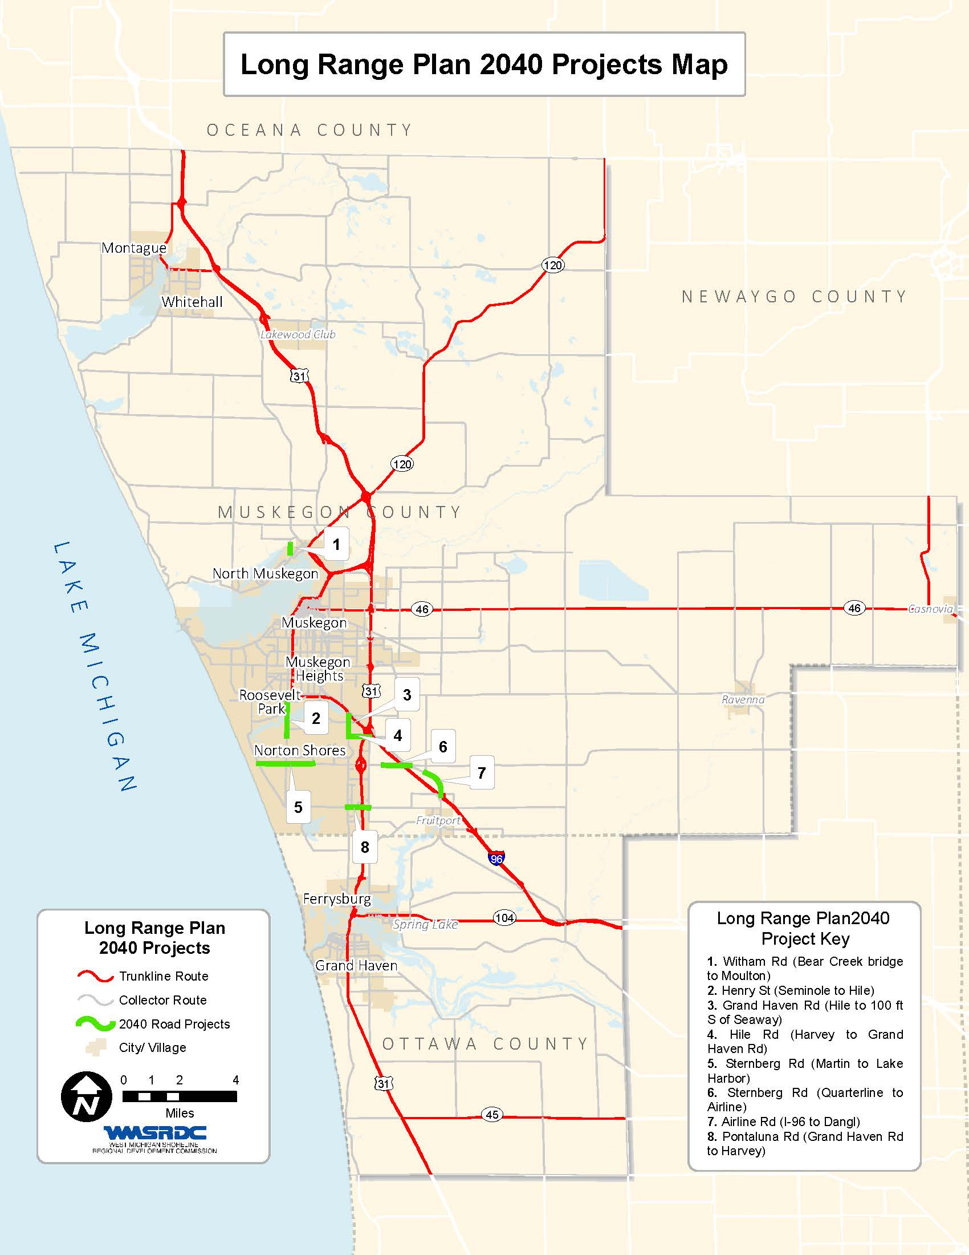
figure 39 – 2040 long range plan projects map

CHAPTER 14: CONSULTATION
The Consultation Process is considered to be a separate process from the general public participation process and is meant as a way to better consider the needs of “consulted” agencies. There are specific requirements that outline what types of agencies or stakeholders need to be consulted during the transportation planning process and the type of information that needs to be shared with these interested parties. It is suggested that contacts with state, local, Indian Tribes, and private agencies responsible for the following areas be contacted:
- Economic growth and development
- Environmental protection
- Airport operators
- Freight movement
- Land use management
- Natural resources
- Conservation
- Historical preservation
- Human service transportation providers
The overarching goal of this process is to eliminate or minimize conflicts with other agencies’ plans, programs, or policies as they relate to the Long Range Transportation Plan. By consulting with agencies such as Tribal organizations or land use management agencies during the development of the LRP, these groups can compare the LRP project list and map with other natural or historic resource inventories. WestPlan will also be able to compare the draft LRP to any documents received and make adjustments as necessary to achieve greater compatibility.
The consultation process that WestPlan undertook is based on recommendations from the Federal Highway Administration and the Michigan Department of Transportation.

Consultation Agency List
The organizations from the Interested Citizens/Agencies list that WestPlan maintains for transportation public participation was used as a starting point for the consultation process, as this list encompasses many of the types of agencies and contacts targeted for this process. The Consultation List is as follows:
- American Cancer Society
- American Red Cross
- Area Agency on Aging for West Michigan
- Baker College
- Blue Lake Township
- Busy Bee Taxi
- Casnovia Township
- Cedar Creek Township
- City of Ferrysburg
- City of Grand Haven
- City of Montague
- City of Montague Police Department
- City of Muskegon
- City of Muskegon Heights
- City of Muskegon Heights Fire Department
- City of Muskegon Police Department
- City of North Muskegon
- City of Norton Shores
- City of Norton Shores City Clerk
- City of Roosevelt Park
- City of Whitehall
- Community Foundation for Muskegon County
- Consumers Energy
- Consumers Energy
- County Administrator, County of Muskegon
- Dalton Township
- Dalton Township Fire Department
- Dalton/Twin Lake Library
- Davita
- Disability Awareness Council
- Egelston Township
- Egelston Township Building Inspector
- Egelston Township Department of Public Works
- Egelston Township Library
- EPA-Region 5
- Fish and Wildlife Service
- Frontier Communications
- Fruitland Township
- Fruitland Township Fire Department
- Fruitland Township Zoning Administrator
- Fruitport District Library
- Fruitport Township
- Fruitport Township Police Department
- Goodwill Industries of West Michigan
- Grand Haven Chamber of Commerce
- Grand Haven Township
- Grand Haven Tribune
- Grand Valley State University
- GVSU AWRI
- GVSU Michigan Alternative & Renewable Energy Center (MAREC)
- Harbor Transit
- Holton Branch Library
- Holton Township
- Laketon Township
- Laketon Township Zoning Administrator
- Little River Band of Ottawa Indians
- Loutit District Library
- Michigan Department of Agriculture
- Michigan Economic Development Corporation
- Michigan Hall of State Archaeologist
- Michigan Loves Mfg.Com
- Michigan State Police
- Montague City Library
- MSU Extension
- Muskegon Community College Library
- Musk Lake Watershed Partnership
- Muskegon Area Chamber of Commerce
- Muskegon Area District Library
- Muskegon Area First
- Muskegon Area Transit System
- Muskegon Chronicle
- Muskegon Community College
- Muskegon Conservation District
- Muskegon Convention & Visitors Bureau Director
- Muskegon County Airport
- Muskegon County Airport Manager
- Muskegon County Board Secretary
- Muskegon County Community Mental Health
- Muskegon County Cooperating Churches
- Muskegon County Drain Commissioner
- Muskegon County Environmental Health
- Muskegon County Equalization
- Muskegon County Health Department
- Muskegon County Public Works
- Muskegon County Road Commission
- Muskegon County Road Commission
- Muskegon County Road Commission
- Muskegon County Wastewater Management
- Muskegon Heights Library
- Muskegon NAACP
- Muskegon Township
- Muskegon Township Fire Department
- Muskegon Township Library
- Muskegon Township Planning and Zoning
- National Trust for Historic Preservation
- North Musk/Walker Memorial Library
- North Muskegon Department of Public Works
- North Muskegon Police Department
- Norton Lakeshore Examiner
- Norton Shores Branch Library
- Ottawa County Road Commission
- Pioneer Resources
- Public Info Officer, Mi Dept of Community Health
- Ravenna Independent News
- Ravenna Library
- Ravenna Township
- Robinson Township
- Senior Resources
- Senior Resources of West Michigan
- Spring Lake Township
- Superintendent Muskegon Area Intermediate School District
- The ARC
- Times Indicator
- U.S. Forest Service
- USDA Michigan State Office
- USGS-Lansing District Office
- Village of Casnovia
- Village of Lakewood Club
- Village of Spring Lake
- WBLV
- West MI Lakeshore Association of Realtors
- WGVU
- White Lake Beacon
- Whitehall Township Zoning Administrator
- WMKG
- WSHZ
For those agencies targeted for consultation, a process of notification and information was undertaken. The following materials were sent to the consulted agencies on February 18, 2015: 1) an email explaining the consultation process, the Long Range Transportation Planning process, and the role of the WestPlan; 2) an invitation to a meeting on March 3, 2015 at the WestPlan office; 3) directions on how to provide input on the planning process and the project list, as well as how to contact WestPlan staff; 4) a link to the 2040 LRP Project List; and 5) a link to map of the LRP projects.
The Consulted Agencies were contacted prior to the general Public Participation comment period in order to provide additional time for their review and to give WestPlan the opportunity to make changes to the LRP before the official public comment period begins. The Consulted Agencies’ were asked to have all comments to WestPlan by March 3, 2015.

Consultation Meeting
WestPlan hosted a Consultation meeting on March 3, 2015 at the WestPlan Offices to provide a formal opportunity for WestPlan to directly speak with consulted agencies and to gain their input on the proposed LRP prior to its public release. At the meeting, the LRP project list and map were presented, reviewed, and discussed with regard to other ongoing land use, environmental, or community plans, to explore how the transportation projects or programs might interact. WestPlan staff also prepared a Powerpoint presentation that provided an overview of the MPO Transportation Planning Process which includes the development of the LRP, the Transportation Improvement Program (TIP), the Unified Work Program (UWP), the Public Participation Plan in Transportation Decision Making, etc. Consulted agencies were encouraged to submit their comments to WestPlan for consideration during the LRP planning process.
Notes were taken during the meeting and were submitted to the Technical and Policy Committees for their review. These notes appear at the end of this chapter.

Documentation of Consultation
The intent of the consultation requirement is to exchange information with the consulted agencies and compare knowledge, plans, maps, and inventories developed with the LRP to ensure compatibility. To document this exchange, comments from consulted agencies, notes from the consultation meeting, and information distributed as part of the consultation process may be found at the end of this chapter. As a result of the consultation outreach, WestPlan received one phone call and four emails from interested citizens and agencies.

Email Comments Received During Consultation and WestPlan Response
- Thank you for this information. Please try to get announcements to us as soon as you can. That way we can get them on the air as soon and as often as we can...WMKG TV. Muskegon only television station. Broadcasting 24/7 on channels 49.1...49.2...49.3...49.4... For advertising information or to place advertising pleases call 231 733-4040. WestPlan response: Thank you.
- Amy/Brian, Please add me to all of your transportation mailing lists. I will be responsible for most, if not all, projects coordinated through WMSRDC and the MPO for Grand Haven Township. Thank you, Stacey Fedewa, Grand Haven Charter Township, Planning & Zoning Official, (616) 604-6326, sfedewa@ght.org . WestPlan response. Will do. Thank you.
- Amy, please include me on your email list. I believe my supervisor would like to be removed from the list and have me substitute in for her. Thanks, John P. Brack, P.E., System Engineer Lakeshore & Northwest Area, Consumers Energy, (231) 332-2606. WestPlan response: Thank you for your interest.
- Hi Brian, We are planning on submitting written public comment on the long range transportation plan. Which upon review looks primarily to be road construction projects. I am wondering if there is a more appropriate forum for us to submit our comment on transportation? Best, Tamera Collier, Executive Director, Disability Network West Michigan, 27 E. Clay, Muskegon, MI 49442, Phone: 231-722-0088, Fax: 231-722-0066, Website: www.dcilmi.org. WestPlan response: Hi Tamera, Thank you for your input, the Long Range Plan is not complete and ready for comment yet. We expect the entire document to be ready for review and comment in the coming months. At that time we will host an open house and have a period set aside for public comments before our committees approve the document. Projects in the LRP are generally large scale; improve and expand projects, intended to reduce congestion and traffic issues. All projects in the LRP undergo a detailed Environmental Justice analysis as well as a Mitigation analysis, and are subject to all Federal requirements. The plan does discuss all modes of transportation, as well as safety and security. Projects are submitted to us by the local transit and road agencies, so I would direct specific project questions to those individuals if you have any. Feel free to give me a call if you have any questions.

Verbal Comments Received During Consultation and WestPlan Response
- Laird Schaefer, an interested citizen, telephoned the WMSRDC office to inquire about why the U.S. 31 project in the city of Grand Haven was removed from the Long Range Transportation Plan project list. During his telephone conversation with Brian Mulnix, Mr. Schaefer commented that he disagreed with removing the project and commented that he thought the best option would be to widen U.S. 31 through the city of Grand Haven. West Plan response: We will make sure that your comments are duly noted to the MPO committees and in the Long Range Plan document.

Comments Received AT Consultation Meeting on March 3, 2015 and WestPlan Response
- Robert Lukens, Muskegon County Community and Development Director, suggested a project be undertaken on the bridge over U.S. 31 on Pontaluna Road. WestPlan response: We will make sure that your comment is duly noted to the MPO committees and in the Long Range Plan document.
- Mary Seeger, WMSRDC Executive Assistant, asked several constuction related questions regarding the new Muskegon Area Transit System transfer station was being built. WestPlan response: The constuction question were answered and WesPlan thanked her for her input and will make sure the comment is noted in the Long Range Plan document.
- Syndi Copeland, WMSRDC Receptionist, commented that she appreciated the visualization techniques prepared by the WMSRDC staff for the LRP Consultation Meeting. WestPlan response: Thank you for your input we will make sure your comment is noted in the Long Range Plan document.
- Kathy Evans, WMSRDC Environmental Program Manager, asked several questions during the power point presentation, and stated that she was impressed with the collaboration aspects of MPO planning. WestPlan response: Thank you for your input we will make sure your comment is noted in the Long Range Plan document.

Figure 40 - Consultation Email Distributed to Consulted agencies
February 18, 2015
Dear Consultation Agency:
As the Metropolitan Planning Organization (MPO) for the Muskegon/Northern Ottawa County Area, the West Michigan Metropolitan Planning Organization (WestPlan) is required to produce a Long Range Transportation Plan (LRP) with, at a minimum, a twenty-year planning horizon. The LRP must include both long and short-range strategies/actions that lead to the development of an integrated, intermodal transportation system that facilitates safe and efficient movement of people and goods, while addressing current and future transportation demands. Throughout the plan development, deficiencies are identified on the county transportation system and improvements are planned to mitigate those problem areas. This list of projects is included in the plan. In accordance with federal regulations set out by the Moving Ahead for Progress in the 21st Century Act (MAP-21), WestPlan, as a part of the LRP development process, is required to consult with agencies that are responsible for environmental protection, historical preservation, natural resource management, transportation services, economic development, human services, and land use planning. You have been identified as an agency of this type.
WestPlan is seeking input on its 2040 Long Range Transportation Plan list and map of proposed projects. The list and map are available at the West Michigan Shoreline Regional Development Commission (WMSRDC) website at www.wmsrdc.org. Click on the 2040 Long Range Transportation Plan list and map of proposed projects for consultation. Please review the map and list of proposed projects.
A comment session to allow dialogue on any comments will be held on:
Tuesday, March 3, 2015
2:00 p.m. to 4:00 p.m.
WMSRDC office in the Terrace Plaza Building in downtown Muskegon
316 Morris Avenue, Suite 387,
Muskegon, MI 49440-1140
Please provide any written comments by Tuesday, March 3, 2015 to the address above or by email to Brian Mulnix, Program Manager at bmulnix@wmsrdc.org. For questions or verbal comments, please call (231) 722-7878 ext. 20.
Your comments are an integral part of the transportation planning process.
Sincerely,
Brian Mulnix, Program Manger

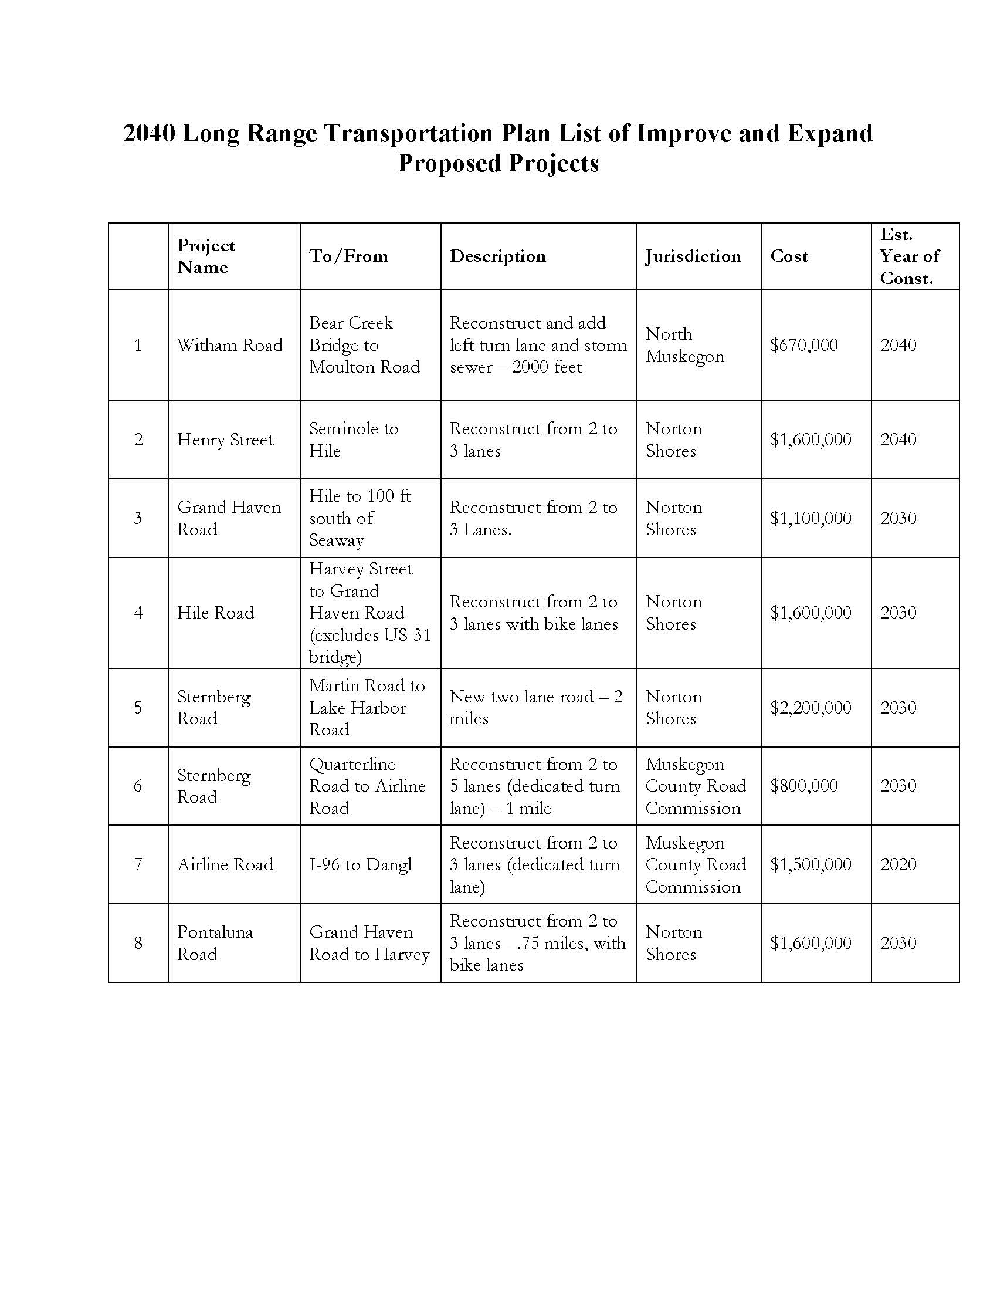
Figure 41 – project list contained in Email Distributed to Consulted agencies

Figure 42 – map contained in Email Distributed to Consulted agencies

316 Morris Avenue - Suite 340 - - Muskegon, MI 49440-1140
Telephone: 231/722-9362 - Fax: 231/722-9362
www.wmsrdc.org

