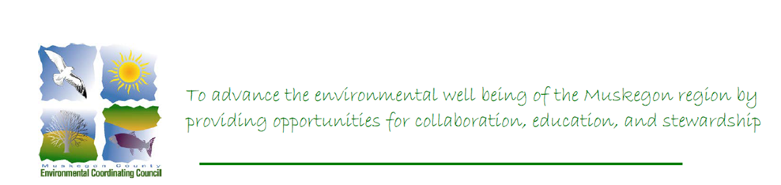
MUSKEGON COUNTY ENVIRONMENTAL COORDINATING COUNCIL
Meeting Minutes – December 12, 2023 – WMSRDC
In attendance: Vicki Luthy, Chris Qew, Jill Koebbe, Doug Wood, Kim Wood, Janet Vail, Lora Swenson

Call to Order by Luthy
- Additions/Changes to Agenda: None
Acceptance of Minutes from June and September 2023 meetings. Motion by Qew, Second by Vail. Motion Carried.
- Approval of Treasurer’s Report: Balance as of June 2023, $1079.27. $20 payment to LARA for Nonprofit Registration. Balance as of December 2023, $1059.27. Motion to approve by Luthy, Second by Vail, Motion Carried.
- New Business – Doug Wood elected Chair of the MCECC.
Per Section 4.5 of the MCECC Bylaws, “The chair shall be the chief executive officer of the Council, but the chair may from time to time delegate all or any part of his or her duties to the executive Council Member, if one is employed or appointed, or to the vice chair; the chair shall preside at all meetings of the Council Members; the chair shall have general and active management of the business of the Council, and shall see that all orders and resolutions of the Council are carried into effect. The chair shall execute all bonds, mortgages, conveyances, and other instruments entered into pursuant to the powers of the Council as set forth in the Articles of Incorporation with the authority of the Council. The chair shall be an ex officio member of all standing committees, and shall have the general powers and duties of supervision and management of the Council.”
Per the above, Mr. Wood shall have full banking authority, including online banking and signatory rights.
- Presentation by Kim Wood, Waggle Dance Honeybees – Beekeeping basics, Swarms and Response: Learn to be a Bee Keeper (problems happen when people just get some bees without an education). The Honeybee Democracy by Thomas Seeley is recommended reading. Check the Muskegon Area Beekeepers Facebook page for more information and link to register for the 2024 Bee School in Holland on February 10, 2024.
- President’s Plans
- 2024 Meeting Calendar: February 13th, May 14th, August 13th, November 12th
- Round Table Updates
- Adjourned
Stay Tuned for Meeting Methods and Venues
Next Meeting February 13, 2023

