MUSKEGON COUNTY ENVIRONMENTAL COORDINATING COUNCIL
Meeting Minutes – September 26, 2023 – Heritage Landing
In attendance: Vicki Luthy, Lora Swenson, Molly Halse, Isaae Brown, Brandon Shumaker, Martin Clark, Susan Cook, Bernie Camp

Regular meeting tabled due to absence of regular membership.

Presentation:
Luthy – History of Heritage Landing Use, Cleanup and What Still Lurks….
Swenson – Current initiatives to keep the native plantings maintained and encourage use by the nearby residents.

Round Table Updates – Tao Chi Classes Saturday and Sunday South of the Bridge – Moves to Water’s Edge Fitness when the weather gets bad.

Attendees (and a cute couple just hanging out) filled several garbage bags on the landing and by kayak along the shore.

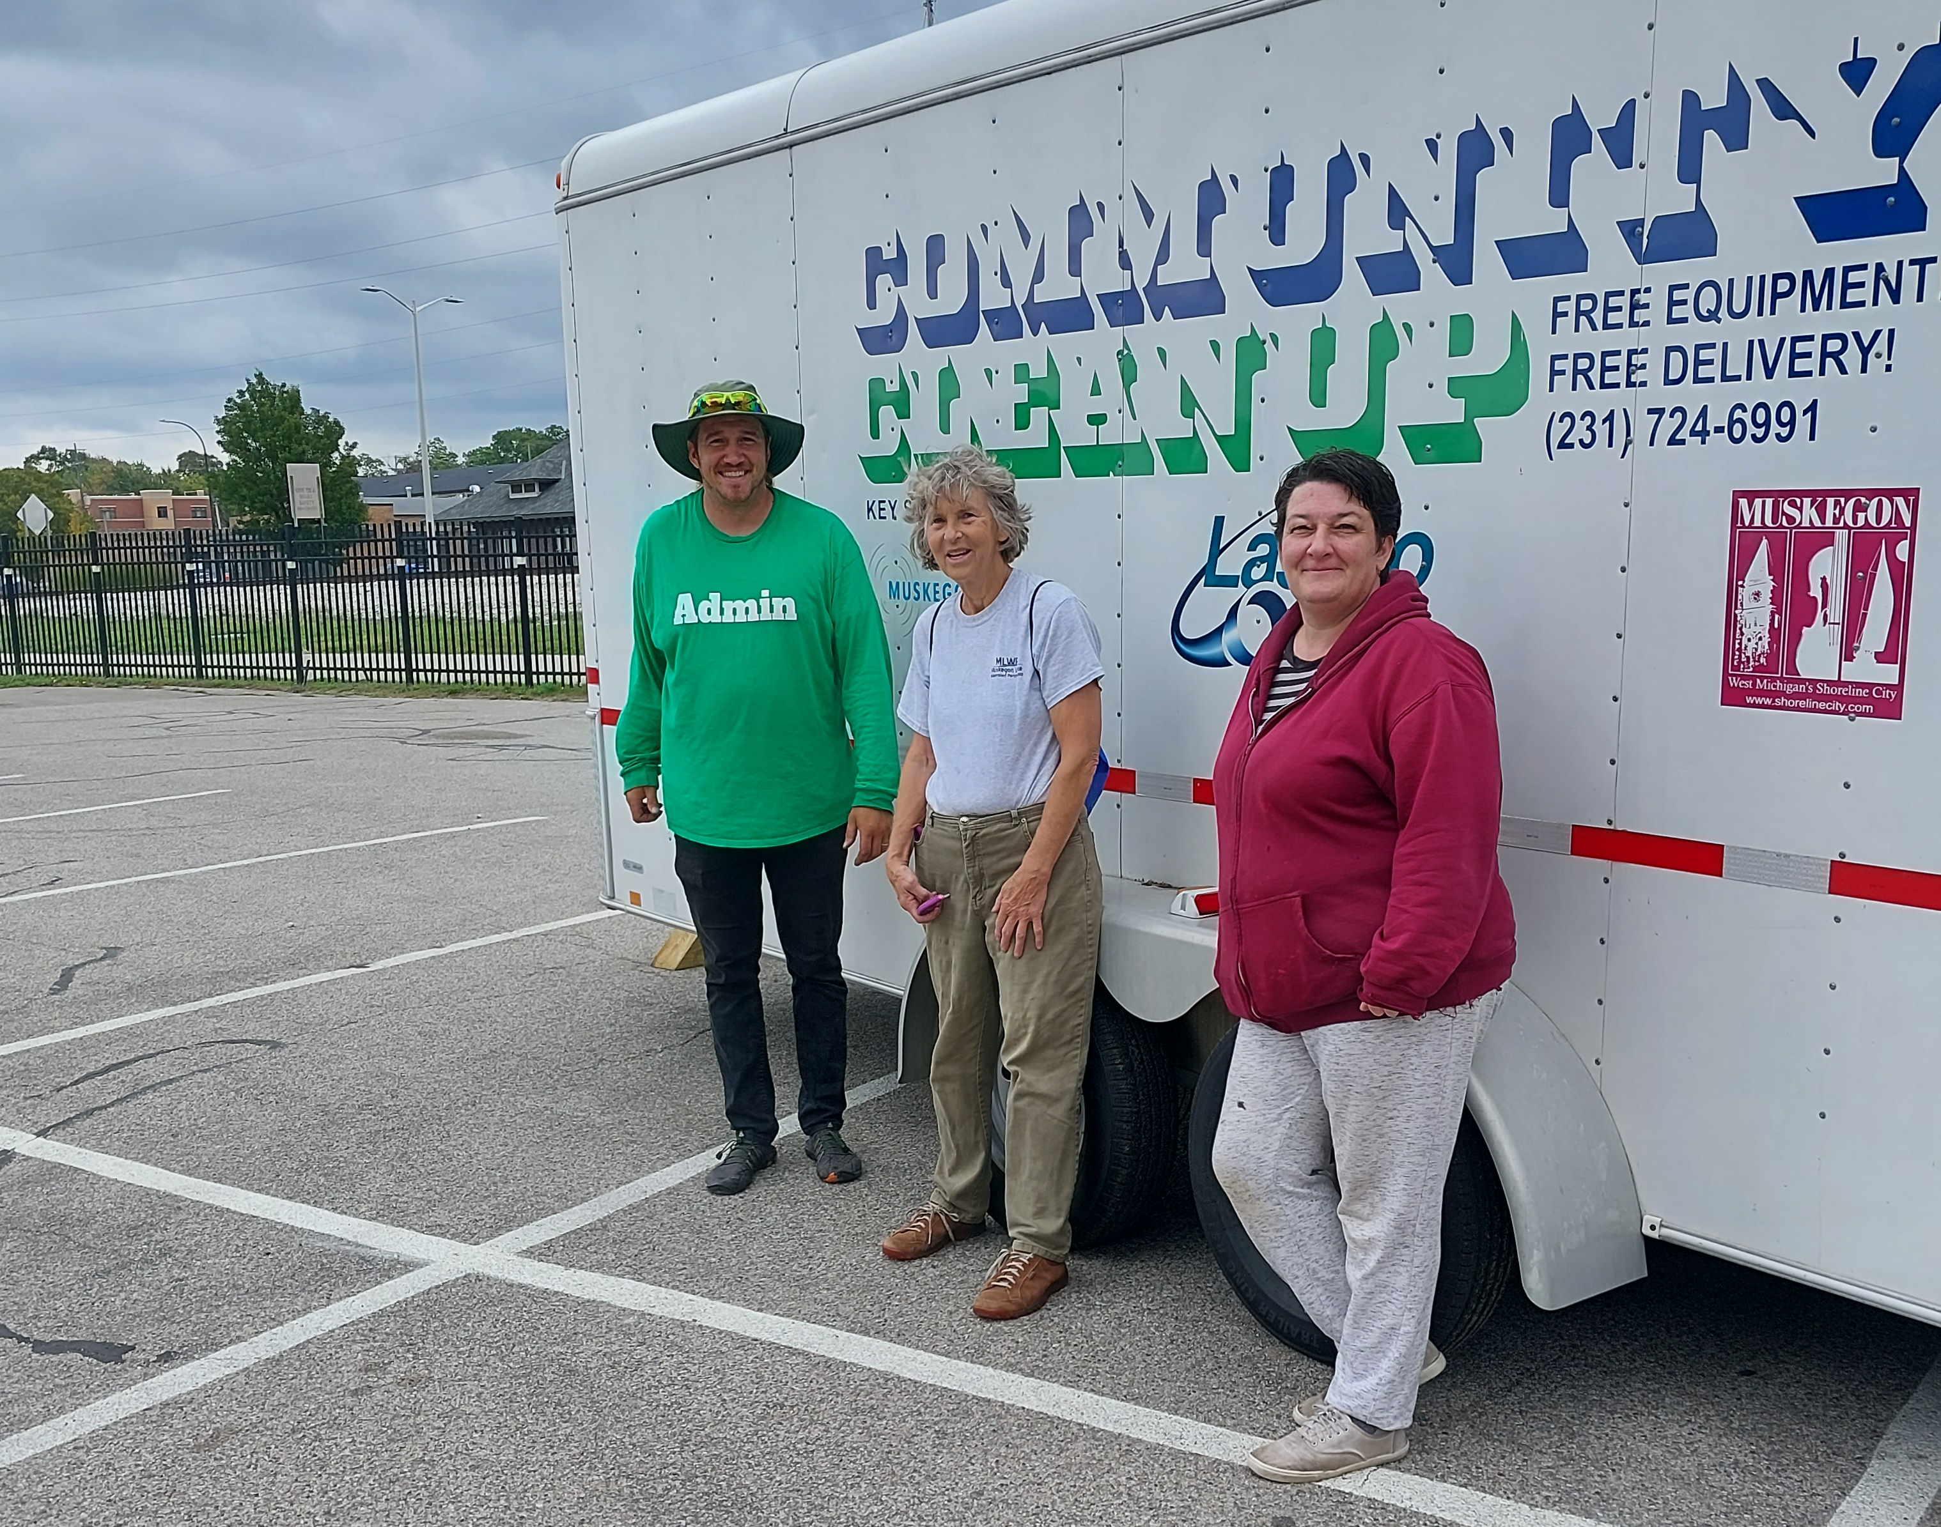

Stay Tuned for Meeting Methods and Venues

